Methodology for the Revision of the second draft of EAPN Strategic Plan 2015-2018
The first draft of the EAPN Strategic Plan was presented on 6 March 2015 and resent to the ExCo Members who then discussed the amendment of the content in a workshop at which participants were divided into working groups. Each working group discussed one Strategic Objective and the corresponding Expected Outcomes. After the workshop, the comments were documented and served as a basis for producing the second draft of the Strategic Plan. The second draft was sent to EAPN Members on 30 April 2015. A questionnaire was attached to the plan which asked whether the members agreed or disagreed with the proposed items (specifically Strategic Objectives and Expected Outcomes) and/or whether they would suggest a reformulation of the wording. In total, three questionnaires with replies to all questions were received. These questionnaires also included suggestions for improvement or rewording of some items; a detailed evaluation of agreements, proposals for change and the way they were incorporated in the third draft of the Strategic Plan are presented in the following chapter.
Additionally, two members sent brief overall comments which mainly concerned the reordering of Strategic Objectives and hence, an overall agreement with the content of the second draft of the EAPN Strategic Plan may be assumed.
Furthermore, two members included comments in the draft document of the Strategic Plan; notably, one of them also submitted the questionnaire and it may therefore be assumed that uncommented items of the second draft version were generally agreed on. One member submitted detailed suggestions for an overall revision of the entire structure of the second draft of the Strategic Plan (notably, the filled in questionnaire was also submitted by the same member).
In view of the scarce response rate and the quality of data submitted, the following results represent opinions submitted by the three members who returned the questionnaire, but do not include data from the three members, who sent general comments and seemed to generally agree with the plan, nor does it include the one narrative input which voiced general critical remarks.

Strategic Objective (SO) 1: EAPN empowers people with experience of poverty and social exclusion to become active citizens promoting social and human rights.
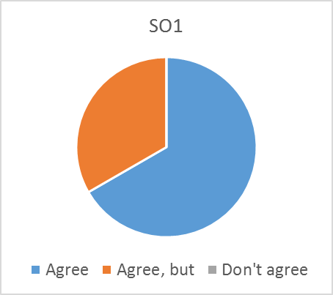
Agree but…
EAPN Ireland:
While what EAPN does is based on human rights, the promotion of rights is much wider i.e. using a human rights approach.
We suggest changing to “EAPN empowers people with experience of poverty and social exclusion and their organisations to influence policy on policy and social exclusion.”
- Comment has been cross-checked with comments to previous draft versions and the wording of this SO has been rephrased to “More people with experience of poverty and social exclusion are actively promoting social and human rights.”
- The proposed change of wording in the comment is a good example of an action to achieve EO 1.1. (see below). This action could be included in the operational plan (i.e. how can EAPN contribute to achieving EO 1.1.? By empowering people (= action/output). What could this action consist of? E.g. specific trainings, publications, outreach campaigns etc. (= output indicators).
This should be moved to Objective 2.
- Unclear comment.
We need to be clearer on how EAPN delivers on this and that the actions are clear and meaningful.
- Actions are part of operations planning. In the Strategic Plan, EAPN decides what it would like to achieve by 2018 (strategic objectives); once decided, EAPN plans actions to achieve or contribute to the achievement of these objectives (operational plan). Previous actions may already contribute to these objectives; therefore, the Strategic Plan therefore also help to focus and explain why certain actions are undertaken, or which ones are needed.

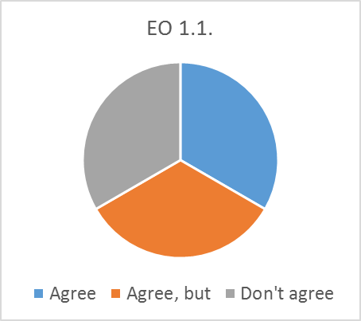
Expected Outcome (EO) 1.1.: People with experience of poverty and social exclusion are more aware of their rights.
Agree but…
FEANTSA: How is that going to be measured? I think the outcome is too vague and goes beyond the capacity of EAPN.
- Some indicators for this EO have been suggested in the annex of the Strategic Plan. However, all of them were quantitative and there have been calls for more qualitative indicators; one specific suggestion includes “a survey of people with experience of poverty and social exclusion at GAs of national networks”. Once the Strategic Plan has been decided (and this EO is included), EAPN has to decide on the type of indicators as well as the data collection method and frequency. At that stage, it should be taken into account that EAPN is likely only able to measure the level of awareness of people it has reached through its actions and/or the number of actions it has undertaken. Such measurement would not be representative but indicative.
Don’t agree
EAPN Ireland: This is very wide. EAPN mme3bedrs on the ground make a contribution to awareness by people experiencing poverty, but we are by no means the main agents iu this.
- It is not necessary that EAPN is the main agent to do this but it is important to decide whether this is an objective that the network would like to achieve (through its actions). See also comment below.
EAPN as a European network can empower members to be more effective in this.
- The last comment (“EAPN as a European network can empower members to be more effective in this.”) is an action (or suggestion for action) to achieve this result/expected outcome. Such action would be part of operational planning (i.e. “what can EAPN do to achieve this outcome?”). EAPN has to decide whether awareness raising on rights of people with experience of poverty and social exclusion is a priority/desired objective for the next 5 years and, if so, which overall objective it would like to achieve by doing so (this is the Strategic Objective of this expected outcome).

Expected Outcome (EO) 1.2.: People with experience of poverty and social exclusion are more empowered to actively engage in the policy making and monitoring processes.
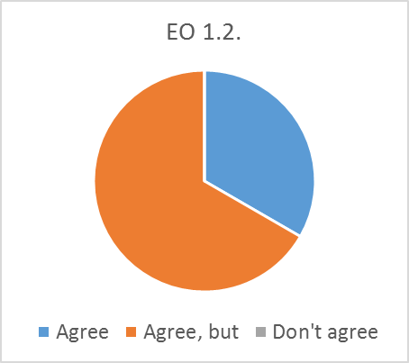
Agree but…
FEANTSA: Issue of measurement here as well…
- Some quantitative and qualitative proposals for indicators, including collection methods, were included in the annex. More suggestions included:
  - It t would be useful to hear opinion of random selection of pep’s what they think of EAPN documents/positions and if they reflect well there views.
  - Why not ask pep’s about the nature of participation processes in EAPN (such as the PEP event) – and not only insiders but also outsiders.
  - An audit of EAPN national networks and EOs and there commitments in theory and practice to participation of pep’s
EAPN Ireland: Agree, but we would need be clear on how we do this. We assume this is within/through EAPN at EU and in its members.
- This comment refers to operational planning which is a separate process (and may be done annually). EAPN has to decide whether its actions should aim to achieve this goal. An idea for an example action could be “EAPN demonstrates the importance/impact of participating in the policy making process and demonstrates the added value to people with experience of poverty and social exclusion”. Important: if EAPN cannot think of any potential actions to achieve this expected outcome, this EO should be deleted.

Expected Outcome (EO) 1.3.: EAPN is a platform that facilitates a forum for people with experience of poverty and social exclusion to actively participate in the policy-making and monitoring process.
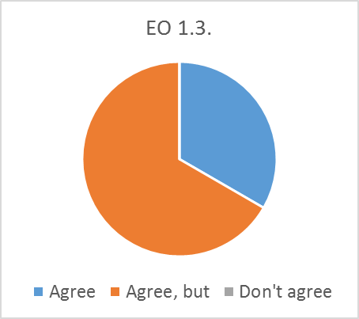
Agree but…
FEANTSA: Yes - but EAPN should also use/promote the expertise and tools EOs have related to participation of PeP. This would require a substantial evaluation/rethink of the annual PeP meeting in which EOs have a too marginal role.
- This could be an action (to promote the expertise and tools of EOs etc.) to achieve this result (operational).

EAPN Ireland: How is this different from 1.2?
- In EO 1.2., the objective is not that people with experience of poverty do not necessarily participate in EAPN in order to engage in the policy making and monitoring process (but e.g. EAPN may provide them with tools and capacity to do so also through other channels; e.g. how do I formulate a petition letter to my local government, how do I organise an online campaign etc.).
How will this be delivered on in a meaningful way?
- This would be part of operation planning if this EO is decided on. Some ideas of examples are listed above.

Strategic Objective (SO) 2: The EU and national policy frameworks provide more adequate conditions for and solutions to fight poverty and social exclusion as well as its causes throughout Europe.
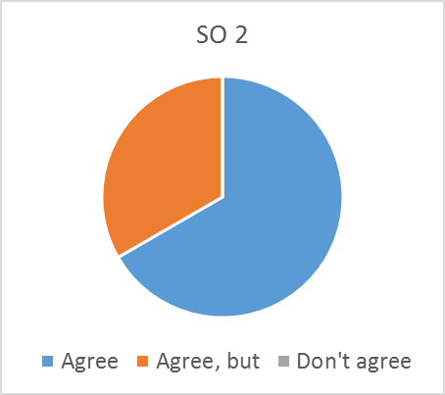
Agree, but…
EAPN Ireland: Agree, but this is an objective that is outside our control. The objective could be to advocate and influence the EU and national policy to bring this about. The Strategic Plan needs to outline actions for bringing it about.
- Actions are operational planning (the proposed action is a good example for EO 2.1.). Through its actions, EAPN intends to contribute to this overall objective. EAPN cannot claim single credit for this objective but it could claim that it has contributed to it in the future.
Should delete the word ‘frameworks’.
- Action taken: changed “policy frameworks” to “policies”
Should there be an outcome which covers some of EAPN’s priorities to be covered e.g. minimum incomes, lobby for an integrated EU anti-poverty strategy (as in our manifesto for the European Parliament elections?
- That is a possibility and more EOs could be included for specific policy goals by 2018. If no agreement on policy priorities could be reached, these policy goals may still be reflected as EAPN actions under EO 2.1. (see below). EAPN has to decide whether to include specific policy goals and add EOs on them.

Expected Outcome (EO) 2.1.: All policies serve more social and sustainable societies in Europe.
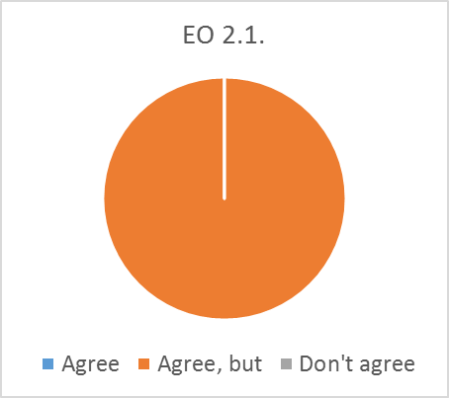
Agree but…
FEANTSA: Too ambitious. Will force us to report failure too often… Which should build in some more concrete/tangible outcomes which can be more directly related to the input from EAPN.
- Action taken: changed “all policies” to “more policies” and deleted “more” from societies. Note that this could be measurable. Also, in its operational plan, EAPN could set itself the objective to advocate for specific policies which are its priority (e.g. adequate minimum income).
HAPN: All policies serve more social and sustainable societies in Europe on a base of complex programs/processes.
- Due to change of wording (see comment above), the suggested addition does not appear adequate.
EAPN Ireland: This is a very ambitious outcome and more like a vision which is difficult to argue with. This outcome is very much outside our control and even if achieved, how can we claim any credit for it, particularly the ‘sustainable’ element? Could the objective be more about our contribution to this?
- See also first comment for this EO (change of wording). Again, it is not necessary that EAPN claims direct credit for it, if achieved. But, if this is an aim, the actions (operational) EAPN plans to promote it are credit for the network’s contribution to promote this goal. Important: EAPN has to decide whether the EO is achievable by 2018. If not, the EO should be deleted.
- Action taken: “sustainable” has been changed to “inclusive” as this appears to be more in line with EAPN’s activities.

Expected Outcome (EO) 2.2.: Policy makers have a better understanding of all dimensions of the current causes of poverty and social exclusion in Europe and are willing to convey these messages.
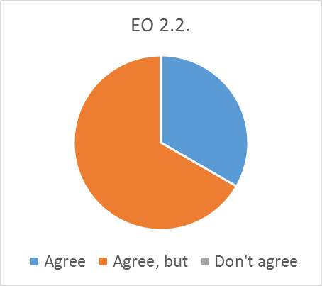
Agree but…
FEANTSA: Very ambitious. We might want to select a few dimension instead of doing everything at the same time – this strategy usually pleases the membership but does not lead to much policy change. Why not focus on “extreme poverty” as an important and overlooked dimension of poverty which is of concern to most EOs actively member of EAPN…
- From the above comment, we understand that the word “dimension” could lead to different interpretations of the original wording for this EO. The referred term “dimensions of poverty” has been taken up in the revision of wording for this EO which now reads: “Policy makers have a better understanding of the causes of different dimensions of poverty and social exclusion in Europe and are willing to convey these messages.”
- Focusing on a particular dimension (e.g. the causes of extreme poverty) could be a good example for operational planning for this EO. For operational planning (note: different process), this would mean that EAPN would have to decide which dimensions to raise awareness of in a set time period. Examples of these dimensions might change over the years (e.g. Operational: “In 2016, EAPN rose awareness among policy makers about the causes of extreme poverty etc.; in 2017, about in-work poverty, homelessness, in 2018…”; Strategic: “From 2015 to 2018, EAPN contributed to raising awareness among policy makers about the causes of extreme poverty, homelessness, in-work poverty; by the end of 2018, X policy makers/institutions have conveyed messages on the causes of poverty which are in line with EAPN’s position.” Etc.).
EAPN Ireland: Similar to comments on 2.1 even if achieved, how can we claim any credit for it? Could the objective be more about our contribution to this i.e. to influence policy makers?
- Correct, but this part of operational planning. “To influence policy makers” is an action EAPN undertakes to achieve this EO 2.2.. As regards claiming credit, see previous comments.

Expected Outcome (EO) 2.3.: The policy-making process concerning all EU and national policies is more transparent and democratic.
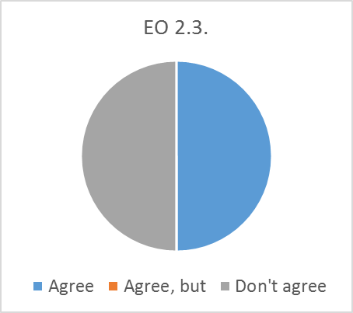
Don’t agree
FEANTSA: This is beyond the influence of EAPN. We might want to focus on more transparent and democratic decision making processes inside EAPN…
- EAPN has to decide whether this EO is an achievable result by 2018. Does EAPN (plan to) undertake any actions which aim to achieve this goal? If so, this EO should remain in the plan. If not, it should be deleted.

Strategic Objective (SO) 3: The implementation of any policies and their positive or negative impact on poverty and social exclusion is monitored more effectively throughout Europe at all levels.
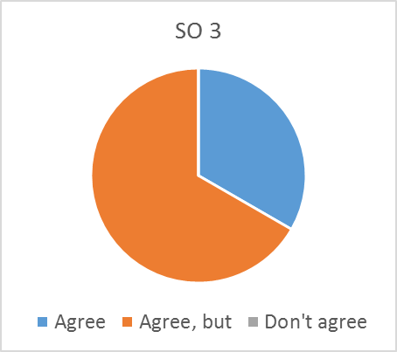
Agree but…
FEANTSA: Overly ambitious – not the least because of lack of expertise inside EAPN to cover such broad array of policy areas – we need to be more selective.
- If the ambitious part refers to the word “any”: it was suggested to include this word in the ExCo workshop. There, the need to broaden the spectrum to policies that do not explicitly focus on poverty reduction (especially those which do not at all) was highlighted. EO 3.3. also addresses this issue. The argument that EAPN may have a lack of expertise to perform such monitoring may be justified; therefore, EAPN has to decide which policies it wants to monitor in the future (i.e. specific ones or any that might have a certain impact).
EAPN Ireland: If monitoring is a focus then a key measure here should include influencing measures to improve the monitoring of all policy.
- Action taken: changed wording of EO 3.1. which now reads “The implementation of policies and their impact on poverty and social exclusion are monitored more effectively.” The suggested measure is a good example for an action to achieve EO 3.1.
Other comments:
EAPN UK: Do we mean that EAPN becomes more effective in monitoring? Or do we mean that policy makers ‘at all levels’ do it more effectively? I think ‘at all levels’ is too broad also.
- Both: EAPN monitors more effectively and uses its findings to advocate for policy adjustment with policy makers. Policy makers monitor more effectively because EAPN provides them with their monitoring observations which helps them take adequate decisions. Ideally…
- EAPN has to decide whether to delete “at all levels”
Expected Outcome (EO) 3.1.: EAPN increases its relevance as a key actor in monitoring the implementation of policies and their impact on poverty and social exclusion.
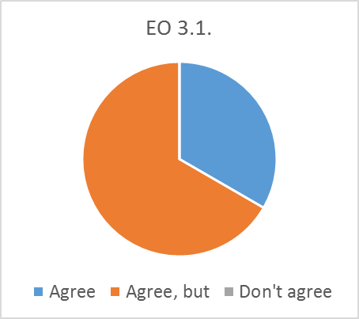
Agree but…
FEANTSA: Key actor for policy makers but also for the membership. Building more on the thematic expertise of EOs.
- Unclear comment. “to build on thematic expertise of EOs” could be a possible action (operational) to improve EAPN’s monitoring efficiency (see also comments below).
EAPN Ireland: We play an important ongoing role in monitoring policy and its implementation. Possibly put the emphasis on doing this more effectively.
- Action taken: changed wording and focused on efficiency. Further comments under SO 3 (see above) were also taken into account when changing the wording of this EO.
Being on monitoring bodies may not be the goal for many members.
- If that is the case, suggest not using the proposed indicator on monitoring bodies but rather converting this into an action (operational planning: to increase representation of EAPN members in monitoring bodies; e.g. target: X national, X European). But there are many other possible actions that could aim to improve monitoring efficiency. The action suggested under SO3 (i.e. “influencing measures to improve the monitoring of all policy”) is another example.

Expected Outcome (EO) 3.2.: Financial allocations and expenditure of EU and national funds that aim to reduce poverty and social exclusion are monitored efficiently.
Agree but…
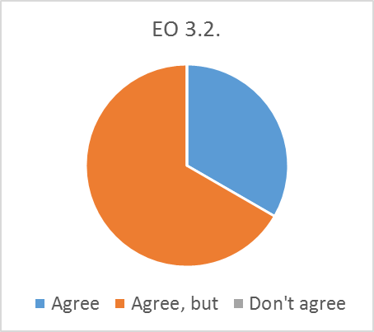
FEANTSA: I would concentrate on EU funds.
- EAPN has to decide whether to delete “national” from the wording of this EO.
We need to agree when we think the allocation is effective – a simple quantitative monitoring is pretty useless
- Unsure what is meant by this comment. Monitoring allocation means “are the funds allocated to a certain policy adequate/sufficient to reduce poverty and social exclusion?”; monitoring expenditure means “are the allocated funds actually spent (on the intended purpose)?”. Such an evaluation can be quantitative and qualitative. For instance, underspending of EU Structural Funds was a major concern in several Member States in the previous programming period; some policies might be considered adequate to fight poverty and social exclusion but not enough funds may be allocated and/or spent to implement them (e.g. EC recommendations on active inclusion, investing in children etc.) Nevertheless, EAPN has to decide whether it wants to/has the capacity to contribute to the monitoring of financial instruments. If not, this EO should be deleted.
EAPN Ireland: This is a focused outcome but looking at what is to be measured it could be very technical.
- EAPN has to decide whether its (planned) activities contribute to this outcome or whether it has the capacity to undertake activities that promote this EO. If not, it should be deleted.
On Structural Funds the focus should not just be limited to ensuring the 20% expenditure, but on how it is being spent. Maybe focus on capturing the effectiveness of social protection and minimum income in addressing poverty and social exclusion?
- Monitoring expenditure and allocation of funds are two separate things (see comment above). EAPN has to decide whether it wants to/has the capacity to monitor either one or both. The suggested “capturing of the effectiveness of social protection and minimum income” could be an action to monitor the allocation of funds. But it may also be an action of policy monitoring (EO 3.4. and/or EO 3.3.).

Expected Outcome (EO) 3.3.: If a negative impact of any current policy can be observed, policy makers make the necessary adjustments in order to mitigate a further deterioration of poverty and social exclusion (“negative policy adjustment”).
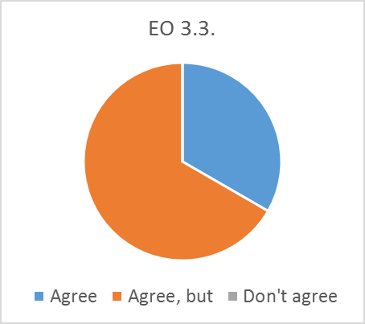
Agree, but…
FEANTSA: I would focus on EU level – is already difficult enough…
- Not advisable but EAPN has to decide whether to include a specific reference to the EU level.
EAPN Ireland: This seems very linked to 3.1. Can they be joined up?
- They are related but the results are different and would require different actions (note that the wording of EO 3.1. has been changed). Actions for EO 3.1. would include anything related to the strengthening of EAPN’s monitoring capacity/skills (e.g. how to demonstrate that certain policies are (not) working etc.; i.e. capacity building). Actions for EO 3.3. would include activities focused on effective advocacy (e.g. how to convey messages, monitoring findings etc.).
Other comments:
EAPN UK on the word “adjustment”: This could be clearer.
- Action taken: wording changed from “negative policy adjustment” to “adjustment of negative policies”. The same change was applied to the wording of EO 3.4.

Expected Outcome (EO) 3.4.: If a policy that has the potential of reducing poverty and social exclusion is not being implemented as planned, the implementing bodies (public authorities, institutions etc.) make the necessary efforts to achieve its intended positive impact (“positive policy adjustment”).
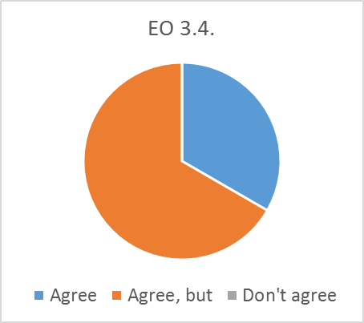
Agree, but…
FEANTSA: focus on EU level
- See comment for previous EO. EAPN has to decide whether to include.
EAPN Ireland: Again seems to be very linked to 3.1
- See comment for previous EO. Note that different monitoring skills/capacities are required to advocate for the adjustment of positive (EO 3.3.) or negative policies (EO 3.4.). Therefore, the actions for 3.1. might overlap with those for EO 3.3. and EO 3.4. but this would not be problematic as one action may aim at several results (EOs).
Other comments:
EAPN UK: Not sure that I understand what we are saying with this outcome
- For example, EAPN agrees with the potential positive impact of a specific policy that has been approved (e.g. the active inclusion recommendation). EAPN monitors the implementation of this policy and detects that the policy is not being implemented as intended, hence its potential positive impact is not achieved. EAPN highlights this implementation failure to policy makers and provides concrete recommendations on what needs to be done to achieve the intended positive impact on poverty reduction. These are examples of actions EAPN could undertake to achieve this result (EO 3.4).

Strategic Objective (SO) 4: EAPN is a member-driven organisation that is recognised as a key civil society actor fighting poverty, social exclusion and inequalities.
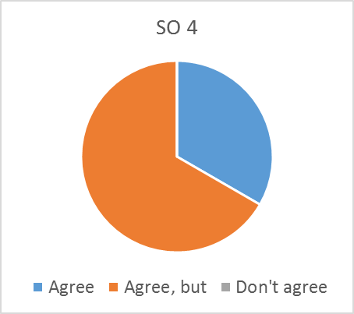
Agree, but…
FEANTSA: By whom? Should definitively also/mainly be amongst its own members – including EOs (which is currently not (sufficiently) the case)
- The “recognition part” focuses mainly on public opinion and policy makers. However, a new EO could be created internal recognition by members is considered important. Another option would be to include this as an action that contributes to the new EO 4.1.. EAPN has to decide how to apply this comment.
EAPN Ireland: Should the objective to be ‘recognised’ or to be ‘effective’?
- Please see comment under 4.2. The idea of this formulation was to increase recognition of EAPN but if this is not desired, then the SO (and EO 4.2. and 4.3.) would have to be reformulated (or respective EOs even deleted).
- Action taken: in view of this comment and the suggested change of wording for EO 4.1. (see comments below), the words “more effective” have been included in the formulation of this SO which new reads “Strategic Objective (SO) 4: EAPN is a more effective member-driven organisation that has increased its recognition as a key civil society actor fighting poverty, social exclusion and inequalities.”
Capacity building of members should be included under this objective.
- Capacity building of members could be an action under the new EO 4.1. (see also comment below). The purpose of such capacity building word have to be included in the formulation of the action.
The Outcomes seem to be focused on ‘improved’, ‘more’, ‘higher’ ‘increased’ etc. In the context they are mentioned this seems to emphasise quantity over impact or how effective we are. Maybe being lead too much by what is seen as measurable.
- Comparative adjectives are needed to demonstrate any kind of change. This may be quantitative but most of all qualitative. An idea for an alternative method to periodic monitoring of expected outcomes (indicators) could be a questionnaire with qualitative answers on each EO at the beginning and at the end of the strategic planning period. Comparatives will allow to evaluate whether any progress has been made on the objectives between 2015 and 2018. Also note that effectiveness and impact can be measured and “being more effective” in something can be an objective.

Expected Outcome (EO) 4.1.: EAPN members have an improved/high (NOTE: formulation depends on target and baseline value) level of interaction and better support each other.
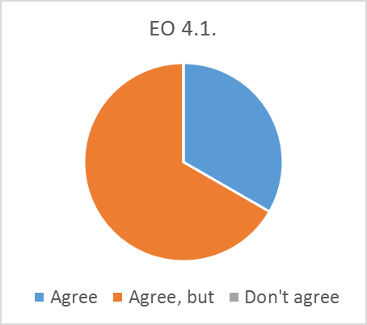
Agree, but…
FEANTSA: Which means that there needs to be a proactive involvement of the membership (and their priorities), and not only reaction when input is made available by the membership…
- Note: EO has been rephrased (see comment below). The proposal could be an example of a possible action for the new EO.
EAPN Ireland: This outcome is not clear. Could be refocused on building the capacity of members or on operating effectively as a network of members.
- Action taken: changed wording to “EAPN operates more effectively as a network of members.” To increase level of interaction and mutual support between members could be actions of this new EO. To build capacity of members is another possible action to achieve this EO.

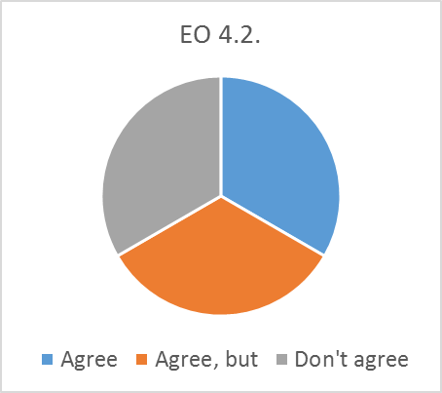
Expected Outcome (EO) 4.2.: EAPN receives higher public recognition as key player in subjects related to poverty, social exclusion and inequalities.
Agree, but…
EAPN Ireland: Could change to EAPN is effectively able to engage the wider public in the fight against poverty and social exclusion.
- This would be an entirely new EO, as the current formulation focuses on increasing public recognition but not engagement. EAPN has to decide whether to create a new EO for the proposal.
- It is suggested to include this EO (and the next) on increasing public recognition, as it is also a way of increasing policy pressure through public opinion. However, EAPN has to decide whether it plans to undertake corresponding actions to increases its public recognition (see also comments under next EO). If no actions are planned/feasible, this EO should be deleted.
Don’t agree
FEANTSA: Overlaps with other outcomes. Impact is the key issue – recognition as an aim in itself not useful.
- There is no overlap: EO 4.2. focuses on increasing public recognition. EO 4.3. focuses on increasing the audience of policy makers. As regards “impact”, please see next comment.

Expected Outcome (EO) 4.3.: More policy makers recognise EAPN’s expertise in the area of poverty, social exclusion and inequality
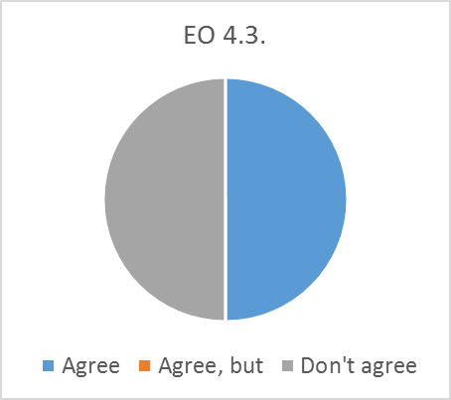
Don’t agree
FEANTSA: Recognition shld not be an objective. Recognition comes with impact.
- This may be argued: recognition is also obtained by the quality of outputs produced. Presenting evidence, formulating clear arguments for the solution of different problems (or even the way they are presented) is an important quality factor that may let policy makers evaluate whether to take up a certain proposal/recommendation or not (and also whether to take future proposals into account). Therefore, recognition may be an important factor to achieve a desired impact.

Expected Outcome (EO) 4.4.: The impact of EAPN’s advocacy efforts is increased by the synergies created through strategic coalitions with other civil society actors and/or strategic partners.
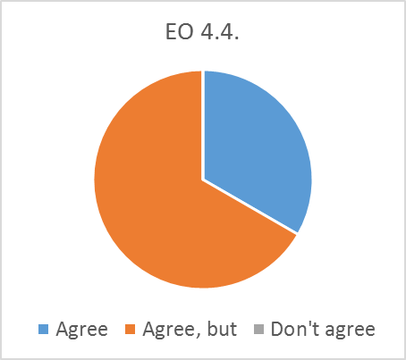
Agree, but…
FEANTSA: And these synergies have to be sought first and foremost inside EAPN – also with the European membership…
- This could be an example of an action for this EO.
EAPN Ireland: Agree but maybe leave out ‘by the synergies’. Also ‘strategic is mentioned twice.
- EAPN has to decide whether to delete “by the synergies created”.

Expected Outcome (EO) 4.5.: EAPN has adequate resources to ensure active membership engagement.
