EXCO Doc N 11

Practical Information

The venue of the Executive meeting and General Assembly in Tallinn from 26-28 June 2014 is the following:

Soko Hotel Estoria
Viru Väljak 4
EE- 10111 TALLINN

https://www.sokoshotels.fi/en/tallinn/sokos-hotel-estoria

http://www.ehrl.ee/en/hotel-estoria-enters-hotel-market-with-a-new-concept

The check-in time at the hotel is at 14.00h.

The hotel is 5 km away from the airport. There are 2 arrival options to the hotel from the airport:

- Public Transport
Bus No. 2 which leaves from the airport. The bus stop is located on floor 0, by the car park that is located at the front of the airport, next to the so-called lower entrance. From bus stop 1, bus no. 2 departs towards the city center. Tickets can be bought from the bus driver when entering the bus. If you buy the ticket on the bus it will cost 1.60€.
Get off the bus after 6 stops at the stop called “A. Laikmaa”, which is located at the side of the hotel building. From “A. Laikmaa” bus stop it is a 200 m walk to the hotel (3 minutes).
- Taxi
Taxis are available in the arrivals hall, the taxi from the airport to Solo Sokos Hotel Estoria costs approximately 8 €. Please note that EAPN reimburses a forfeitory amount of 20 €.

Please see the map below. The bus schedule is available here:

http://soiduplaan.tallinn.ee/#bus/2/a-b/13413-3/en

Map from the bus stop no. 2 to the hotel:
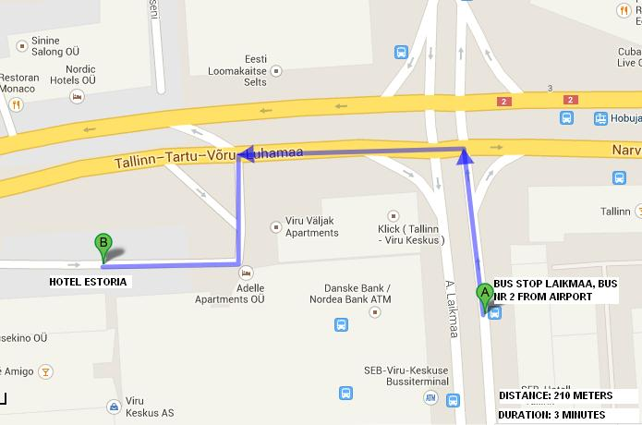

On Thursday 26 June lunch will take place from 12.00-13.30 in restaurant ‘In Vito Veritas’ (Lai 6, 10133 Tallinn) which is at a walking distance from the hotel.
Please see map below for directions:

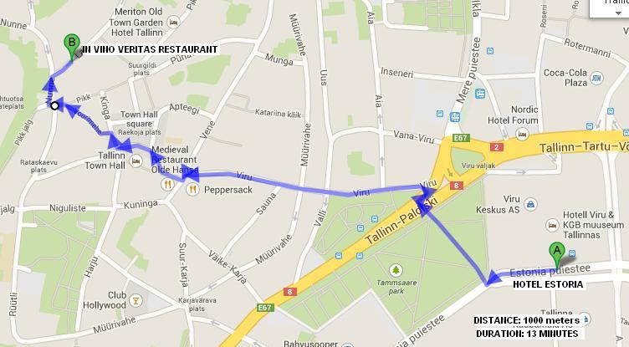

On Friday and Saturday lunch will take place at the hotel.
Dinner on Thursday 26 June will take place at Grillhaus Daube (Ruutli 11, Tallinn):
Please see map below for directions:

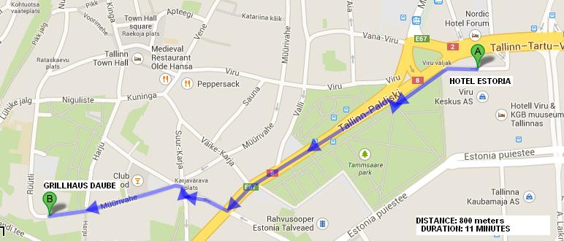

Dinner on Friday 27 June will take place at Restaurant ‘Le Château’ (Lai 19, 10133 Tallinn):
Please see map below for directions:

