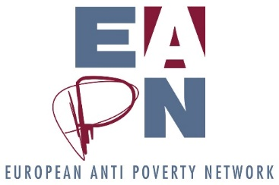
Ex Co Basic Agenda
  - April 2019
4 April
09 00 – 09 30: Welcome from local government
Management Sessions
09 30 – 09 35: Introduction, apologies etc
09 35 – 09 50: Consent agenda (explanation here)
- Minutes of last Ex Co meeting
- Director and Bureau report
- Report from EUISG
- Report from Comm’On
09 50 – 11 10: Induction session / Building the Ex Co
11 10 – 11 30: Coffee break
Strategic Sessions
11 30 – 13 30: Setting the scene for a shared understanding of how we work together on the Strategic Thinking Process (Led by Joan, EAPN Ireland)
13 30 – 14 30: Lunch
14 30 – 17 30: Strategic Thinking Session (Three separate breakouts, 40 mins per breakout, coffee available in each room! Feedback in plenary.)
- Governance / structures
- Implementation of Dutch Resolution
- Key themes for the next 5 years

17 30: Close
5 April
Mutual learning sessions
09 00 – 11 00: Potential simultaneous breakouts
- Framing and narratives around poverty (PIRC and / or Friends of the Earth to join, to introduce the idea of frames and narratives and for us to then start to work on our own agreed framing)
- European Parliamentary Elections (Exchange on where we are, what is working at national level, final push, planning for post elections)
- Future of Europe (consultation response, national level FoE discussions, events etc)
- European Funds (we have some key documents prepared to help support members understand, apply for and hopefully access relevant EU funds. We could develop a session around this)

11 00 – 11 20: Coffee break
Final Management Sessions
11 20- 11 50: Financial update and contract explainer
11 50 – 13 00: Membership Development (electing the new MDG, agreeing mandate / ToR, linking it to Strategic Thinking process etc. Initial discussions of new group?)
13 00 – 14 00: Lunch
14 00: People start to leave for flights back

