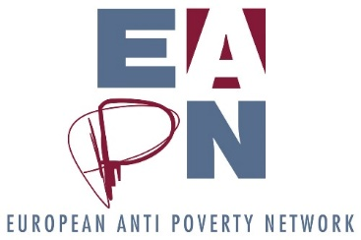
Bureau Basic Agenda
  - March 2019
6 March
09 00 – 09 10: Introduction
09 10 – 10 00: Deliverables, accountabilities and updates
10 00 – 11 30: Bureau and Staff Team – Building understanding and relationship!
11 30 – 11 50: Coffee break
11 50 – 13 20: Strategic Thinking part 1 – Governance and Structures
13 20 – 14 15: Lunch
14 15 – 15 45: Strategic Thinking part 2 – Dutch Resolution / Participation
15 45 – 17 00: Social Platform Management Committee
7 March
09 00 – 10 15: EAPN finances (overview, current situation, membership contributions, reserves)
10 15 – 11 15: Ex Co planning
11 15- 11 45: Coffee break
11 45 – 13 00: Membership development
13 00 – 14 00: Lunch
There may be a meeting with MEPs from the Intergroup on Fighting Poverty after lunch, or one or two may join us for lunch – TBC.

