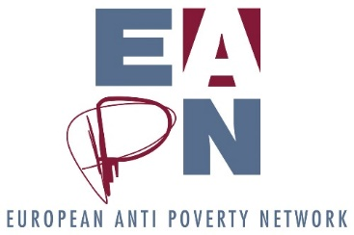

Impact Assessment of structural changes to EAPN
Differences from normal | Participation, representation and democracy | Meeting challenges and aspirations of Theory of Change | Culture and history of EAPN | Staffing | Finance | Impact
Scenario 1: Ex Co reduced in size (merge with Bureau), policy group stays same size but has fewer physical meetings. Regional representation. Strengthened GA. Thematic Working Groups. | + | + | + | + | + | +
 | - | - | - | - | - | -
Scenario 2: Reduced EUISG. Thematic Groups. Reintroduction of EAPN political training. Strengthened GA. | + | + | + | + | + | +
 | - | - | - | - | - | -
Scenario 3 – Ex Co and EUISG merged, becoming one political / strategic body, meeting once a year. Thematic groups underneath. Bureau strengthened. Strengthened GA. | + | + | + | + | + | +
 | - | - | - | - | - | -
Scenario 4: Structures are reduced naturally by allowing those who don’t see the value of being of the structures to drop out. Extra meeting of PeP National Coordinators.

