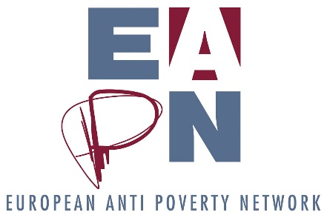

Bureau meeting 6 June 2017
Decisions and actions
Decision
D1. The Ex Co should focus on the Future of Europe rather than the FPA or the responsibilities of the Ex Co. SDG Watch and EAPN Italy papers can be the basis of a discussion.
D2. Responding to evaluation requests, the Director will include a short report of Bureau activities in the Director’s report
D3. The Bureau agrees with the proposal and will highlight the proposal to the Ex Co. If the Ex Co agree, then the Director will discuss it with the staff team.

Action point | Responsible | Deadline
A1. Leo to alter the notes of the last meeting and put them on Members Room | Leo | End June 2017
A2. Continue discussions about an advocacy briefing | Leo, Sergio, Carlos | Ongoing
A3. Prepare the session on the Future of Europe | Sergio, Carlos, Vilborg | 8 June
A4. Prepare Director / Bureau report | Leo | 15 June
A5. Prepare the session at the Ex Co | Leo | 15 June
A6. If Ex Co agrees, discuss the proposal with the staff team and feedback to Bureau | Leo | End June
A7. Share more detailed financial simulations with the Bureau on this | Leo | Asap

