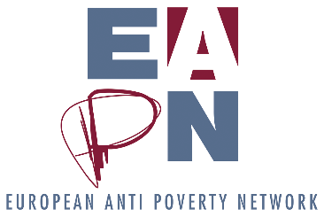

COMM’ON REPORT

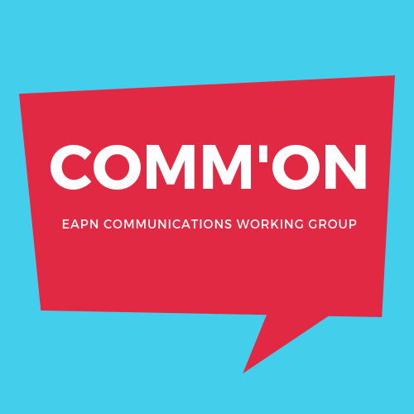

Report to the ExCo

MARCH 2019

Members of COMM’ON:
Jo Bothmer & Marianne Bonn (EAPN Netherlands), Natalia Jungrav & Pawel Pawel Ilecki (EAPN Poland), Honoratte Muhanzi, Maurice Mokulu & Eva Karlsen (EAPN Norway), Eugen Bierling-Wagner & Vera Hinterdorfer (EAPN Austria), Irene Byrne on Skype (EAPN Ireland), EAPN Lithuania, EAPN Finland, EAPN Portugal. Magda Tancau & Elke Vandermeerschen (EAPN Staff),

The first meeting of this group took place on 10-11 December 2018 in Oslo. Next meeting planned for June 2019.

Objectives

ORIGINAL OBJECTIVES:

- Make the comms work of EAPN more participative

- Amplify the voice of people experiencing poverty

- Communicate towards/for pep

ADDITIONAL OBJECTIVES, ADDED AFTER THE DISCUSSION:

- Learning from each other thanks to this working group
- Developing guidelines to link the comms work to a participative way of work
- Strengthening the visibility of EAPN, develop more effective communication work

We agreed a Work Programme for 2019, identified the specific topics to be discussed.
For all the topics, the goal will be to develop guidelines, both for the national level and the EU level.

The network leading on a specific topic is supposed to prepare and chair each online meeting, send the members a draft document and identify questions to be discussed during the webinar.

The first two online meetings took place, focusing on:
- LINK WITH PARTICIPATIVE WORK IN ALL ASPECTS AND ALL BODIES OF EAPN
- CAPACITY BUILDING AND TRAINING (ORGANISATIONS AND INDIVIDUALS)
Future online sessions will focus on

- AMPLIFYING THE VOICE OF PEOPLE EXPERIENCING POVERTY IN OUR COMMS WORK
- ACCESSIBILITY OF OUR COMMS WORK AND WHICH CHOICES TO MAKE
- PR & VISIBILITY
The output will be a series of specific ‘guidance notes’ on these topics, for consideration by the Ex Co in early 2020.

