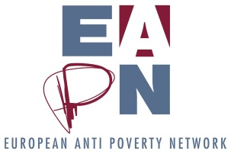

Programme
National Seminar on Social Housing
Committee of Good Will - The Olga Havel Foundation
Senovážné nám. 2, Praha 1
15th May 2014, 15 – 18:00
1) Introduction - Milena Černá, President of EAPN Czech Republic
2) Lecture I: Ilja Hradecky, FEANTSA
3) Lecture II: Jan Dobeš, former Deputy Minister of Labour and Social Affairs, the author of the concept of social housing MOLSA, Czech Republic in 2013
4) Panel discussion - Three members of a Platform for social housing NGOs
5) Conclusion
Number of participants < 20 (representatives of EAPN CR, partnership NGOs, MOLSA, members of the Working Group EU Inclusion Strategies, EAPN Europe).
Consecutive translation: Katarina Klamkova.
EAPN Czech Republic adheres to the principles of FEANTSA, especially "housing first". Their implementation is difficult in a society in which civic solidarity disappeared. Another problem is the financial resources to communities that would be given the duty to allocate flats corresponding to the target groups. The topic is not only of political and technical dimensions, but also of the social dimension of civic settings. Last year, interested NGOs created a Platform for social housing, which has become a partner organization to the authorities of the Government.
The Czech government is planning a National Conference on Homelessness in 2014. From the conclusions of the seminar a memorandum will be processed with proposals to address issues of social housing from the perspective of NGOs that deal with support and assistance to people experiencing poverty and social exclusion.

