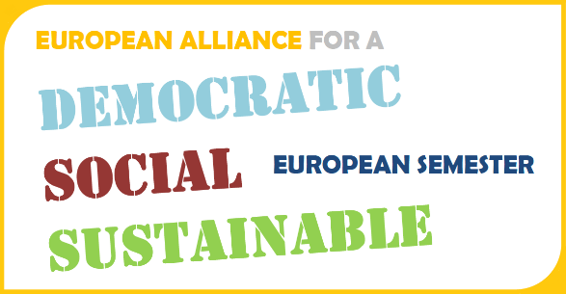
EU Semester Alliance: Capacity Building Workshop
6 June 2014, Brussels

^{Introduction}
The EU Alliance for a democratic, social and sustainable European Semester is a broad coalition bringing together 16 major European civil-society organisations and trade unions, representing thousands of member organisations at the European, national and local levels. The Alliance aims to support progress towards a more democratic social and sustainable Europe 2020 strategy, through strengthening civil dialogue engagement in the Semester at national and EU levels. (See here). This capacity building workshop has been planned as part of the Alliance work programme to support EU Alliance National and EU members to engage more effectively and work together in the European Semester Process. The workshop will bring together national and EU level Alliance members, including representatives of 3 pilot national cross-sectoral alliances (Denmark, Bulgaria and Ireland), building capacity through mutual learning and exchange, drawing on the Alliance Tool Kit (See here).
Objectives
The objectives of the workshop are to promote exchange and learning between national and EU Alliance members in order to:
- Strengthen knowledge of the Europe 2020/Semester process and results and increase the effectiveness of social and environmental NGO and Trade Union engagement
- Increase capacity to build effective alliances cross-sectorally, particularly at national level
- Increase involvement and ownership of the EU Semester Alliance.

Learning Outcomes
At the end of the workshop the participants would expect to:
- Have a clearer understanding of how Europe 2020 and the Semester works, why it’s important, how to engage and use it at national level.
- Be more aware of the opportunities/challenges of cross-sectoral working and how to go about building stronger alliances.
- Know more about the EU Semester Alliance and how they can be actively involved
Participants
The total number of participants in the workshop will be 40:
- 25 national Alliance members (3 per national pilot alliance and 1per Alliance member).
- 15 Brussels-based Alliance Members.

Practical Arrangements (See registration document)

- The workshop will take place in Brussels, on the 6th June 2014, from 9.00 to 5.30pm.
- Full costs will be covered for national members (25) including accommodation for a max of 2 nights, meals and flights.
- Lunch and coffee and evening meal on the 6th will be provided for all participants.

Capacity Building Programme (Draft)
June 6th 2014, Brussels
Progress Hotel, Rogier
Chair: Barbara Helfferich, EU Alliance Chair
9.00 – 9.30 | Welcome and Introduction (Chair)  Getting to know each other activity
Block 1: Europe 2020 and the European Semester – in a nutshell
9.30 – 10.30 | What is it? How does it work? Why is it important?  - Visual Presentation based on Tool Kit  - Input from European Commission  - Questions/Discussion
10.30– 11.00 | Coffee Break
11.00 – 1.00 | How to work with the Semester at the national level: 3 Parallel Workshops  Chair/facilitators: Sian, Amana and Tanya (and/or Alliance members).  Note takers: Rebecca, Nellie and Sigrid.  - Inputs from 3 National Pilots  - 3 national Alliance members (Green Budget Europe HU)  - Questions/Discussion  - Group interactive exercise
1.00 – 2.00 | Lunch
Block 2: Building Cross-Sectoral Alliances
2.00 -3.30 | Building Alliances - a cross-sectoral approach (in 3 workshops)  Chair/facilitators: Sian, Amana and Tanya  Note takers: Rebecca, Nellie?  - Risks and Benefits of Alliances – Group discussion about national situation  - Group interactive exercise
3.30 – 3.45 | Coffee Break
3.45-5.30 | Moving forward as an Alliance  - Feedback from Workshops am  - Role play of CSR exercise  - Feedback Discussion  - Summing up – the role of the EU Alliance.  - Evaluation
5.30 | End of Workshop
7.30 | Group Meal (for those staying 2nd night).

