Document: 8 /EXCO- March 2015

Proposal for an agenda for the EAPN Strategic Congress

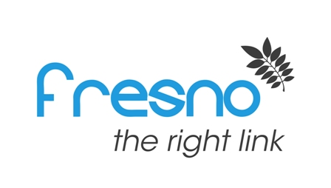

- Summarising the observations on the previous Strategic Plan (e.g. from external evaluation findings)
- Presentation of new Strategic Plan (structure, Strategic Objectives, Outcomes etc.), its context and use. Explain relation to a possible Work Programme/Road Map, which are actions that accompany the Strategy.
- 2 group sessions could be held (a similar method to the ExCo Workhop could be applied):
  - Strategic Targets: workshop on defining targets for each Outcome indicator of the Strategic Plan (likely not to be specified entirely at the ExCo workshop)
  - Road Map/Work Programme: workshop on identifying actions (Outputs) and, if time permits, Output indicators. These actions could also be prioritised and distinguished between actions at European and national level. Important: identifying a common action for Strategic Objective 4 (e.g. campaigning for or holding a common event at European and national level)

