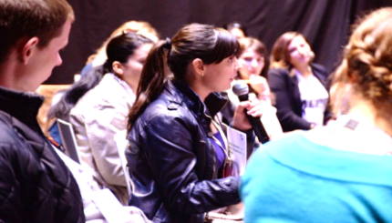CAN THE SEMESTER DELIVER ON

POVERTY AND PARTICIPATION?

#2015EAPN CONFERENCE PROGRAMME

Friday 09th October 2015 – 9.00 am - 1.00 pm

European Economic and Social Committee (EESC)

Room VMA3 | Rue Van Maerlant 2, 1040 Brussels

**8.30 Registration**

**9.00 OPENING | MARTIN SCHULZ, PRESIDENT OF THE EUROPEAN PARLIAMENT (video)**

**9.10 WELCOME AND PANEL | SETTING THE CONTEXT**

* *Pavel Trantina*, *President of SOC Section/EESC*
* *Sérgio Aires, EAPN President*
* *Derek Holliday, Poverty Alliance/EAPN UK : Experience from the ground of welfare reform*
* *Tanya Cox, Beyond 2015 Steering Group Co-chair: From Europe 2020 to Post-2015 Sustainable Development Goals*

**10.00 ROUND TABLE | CAN THE EU DELIVER PROGRESS ON POVERTY IN THE EUROPEAN SEMESTER/EUROPE 2020?**

Chair: Barbara Helfferich, EAPN Director

* *Paul Ginnell/EAPN Ireland and Chair of EAPN EU Inclusion Strategies Group: Presentation of EAPN 2015 NRP and European Semester Assessment*
* *Tom Dominique, Chair of the Social Protection Committee*
* *Outi Slotboom, European Commission DG ECFIN*
* *Sergio Prieto, MEP (S+D/Spain) rapporteur on EMPL opinion on European Semester*

**11.00 Discussion with Audience**

**11.30 Coffee Break**

**11.45 ROUND TABLE | HOW CAN THE EU INCREASE PARTICIPATION AND LEGITIMACY OF THE EUROPEAN SEMESTER?**

Chair: Peter Kelly, EAPN Vice-President

* *Graciela Malgesini/EAPN Spain: Promising practice: Structured dialogue with NGOs*
* *Johanna László/EAPN Hungary/Croatia: Raising awareness on the Semester*
* *Raquel Lucas, Cabinet of Commissioner Dombrovskis, Vice-President for the Euro and Social Dialogue: Getting ownership, strengthening social and civil dialogue*
* *Marco Cilento*, *Advisor, ETUC: How to increase accountability and legitimacy of the European Semester*

**12.30 Discussion with the Audience**

**12.50 CLOSING SPEECH | MARIANNE THYSSEN, COMMISSIONER FOR EMPLOYMENT AND SOCIAL AFFAIRS, SKILLS AND MOBILITY**



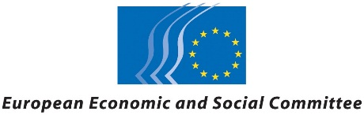EAPN in partnership with the

European Economic and Social Committee (EESC) / SOC Section

EAPN will present its Assessment of the 2015 National Reform Programmes (NRPs) and European Semester, and debate together with 150 stakeholders including 80 EAPN national members, decision-makers and other stakeholders these key questions:

**What needs to be done to ensure that the European Semester deliver on its Europe 2020 commitments to reduce poverty and promote participation?**

**How can we help the EU move forward on a social, sustainable and democratic strategy that could give hope and restore faith in the EU?**

**Participants** include Commissioner Thyssen (speaking), Outi Slotboom, DG ECFIN (speaking), Sergio Prieto, MEP (speaking), Raquel Lucas, Commissioner Dombrovskis’ cabinet (speaking), Tom Dominique, Chair of SPC (speaking), and members of the EESC, ETUC, and other civil society actors including people with direct experience of poverty. The conference will open with a video message from Martin Schulz, President of the European Parliament.

Context

In 2010, the Europe 2020 Strategy for smart, sustainable and inclusive growth set **a target to reduce poverty by at least 20 million by 2020, delivered through the coordination cycle of the European Semester**.

The strategy and process have strikingly failed to deliver so far, with 1 in 4 people now in poverty and social exclusion, an increase of 5 million since 2008.

Although the European Semester was expected to engage stakeholders in the process at national and EU level, **the experience of participation has been generally low quality**, undermining support for the EU amongst civil society, as well as the development of sustainable solutions.

The conference will **review the performance of the European Semester on the poverty target** of Europe 2020 and assess its progress in promoting effective participation with civil society.

It comes at a timely moment when revisions to the European Semester are being considered, **in the light of the 5 President’s report and worries about whether Europe 2020 will be side-lined**, putting the poverty and social targets at risk, following the delays to the Mid-Term Review.

The recent orientation debates held by the College of Commissioners led by Commissioner Thyssen and Vice- President Dombrovskis have **raised expectations of a new priority to put economic and social goals on a par**, strengthening the social dimension and commitment to engage more effectively with civil society.