
EAPN EXECUTIVE COMMITTEE
ATHENS – 09 & 10 NOVEMBER 2012
Practical information
The Greek Anti Poverty Network would like to wish you a warm “Welcome to Athens”! We hope you’ll enjoy your stay and that you have a fruitful and productive meeting.

First of all, do not worry. Not everything will be Greek to you! Street signs, direction signs, menus etc are both in Greek and English. As a rule, Athenians speak sufficient English.

INSTRUCTIONS ON HOW TO GET TO THE HOTEL TITANIA FROM THE AIRPORT

You can get from the airport to the city centre (where the hotel is) and vice versa by metro, bus or taxi.

- METRO

If you decide to use the METRO, buy a ticket and valid it at the special machine before getting on. Tickets cost €8. Journey takes about 40 minutes. Get off at Syntagma and get on the red line (Direction: Ag. Antonios) and get off at the next stop, Panepstimio. Get out at the National Library (Ethniki Vivliothiki) exit. Start walking down the street with the National Library Building on your right. The TITANIA Hotel is on your right, a few meters (a couple of blocks) down) the road.

See map here below:
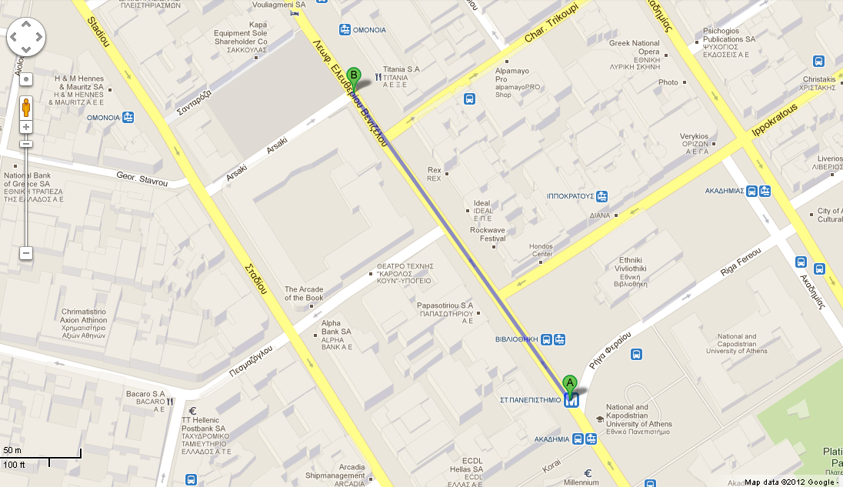

AIRPORT-SYNTAGMA
05:37, 06:03, 06:33, 07:03, 07:33, 08:03.
Service continues every 30’, last one at 23:03

SYNTAGMA –AIRPORT
05:37, 06:03, 06:33, 07:03, 07:33, 08:03.
Service continues every 30’, last one at 23:03.

- BUS

The bus service (No of bus: E95) is quite frequent. The ticket is 5 euros. That means though that you have to get off the bus at the last stop at Syntagma Square, walk to the Metro Station (not far at all, there are steps though) and take the red line. (Direction: Ag. Antonios) and get off at the next stop, Panepstimio. Get out at the National Library (Ethniki Vivliothiki) exit. Start walking down the street with the National Library Building on your right. The TITANIA Hotel is on your right, a few meters (a couple of blocks) down the road.

Minimum 4 buses per hour, from 7.00 in the morning to midnight.
Time tables at the end of the document.

HOTEL

The hotel is the TITANIA Hotel, on 52 Panepistimiou Avenue.

The actual name of this avenue is E. Venizelou but the Athenians call it Panepistimiou (meaning University) since the main University Building is on this street. So, do not get confused if you wish to be on Panepistimiou and the street sign says Venizelou. You’re on the right path!
The venue for all meetings will be in Titania Hotel.

INSTRUCTIONS ON WHERE TO EAT NICE (AND CHEAP) FOOD

Here follows a list of nice and cheap restaurants:

FASOLI (ΦΑΣΟΛΙ)

45, Emmanouil Benaki Street (ΜΠΕΝΑΚΗ), Athens, tel 2103300010

Greek cuisine, nice prices.
Open from 13.00 till late at night.

DIRECTIONS: Leave the hotel, turn right, and then turn right at the first corner, on your left after 200m.

IDEAL

46, Panepistimiou Street (same street as the hotel).

An all-time-classic restaurant. Politicians like it!
Traditional Greek cuisine. A bit more expensive than the others.

Almost next to the hotel Titania.

DIRECTIONS: Leave the hotel, turn left, a few meters away.

RIFIFI (ΡΙΦΙΦΙ)

69A Emmanouil Benaki Street & Valtetsiou. Tel. 2103300237. Around €25
Μodern tavern, traditional food from all over Greece. Open Sundays (13.00-18.00).

DIRECTIONS:
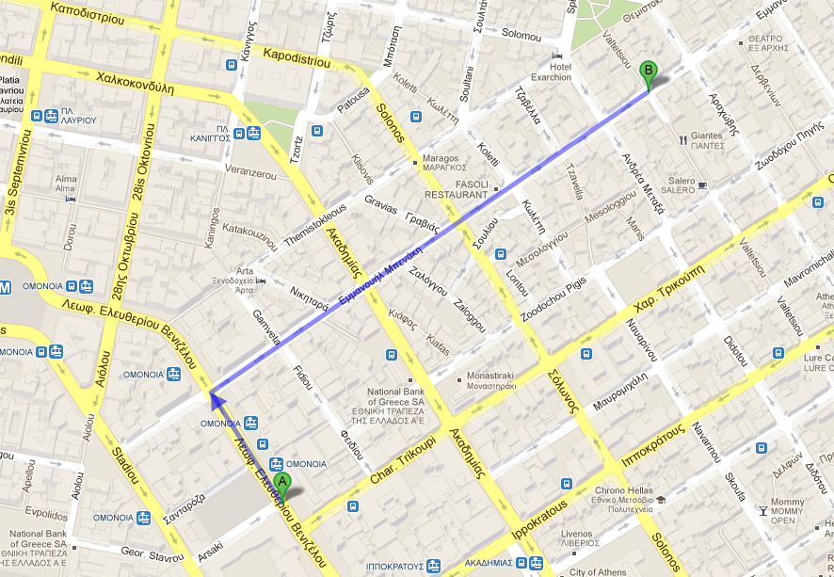
AROUND THE CITY

MUSEUMS

THE ACROPOLIS AND THE ACROPOLIS MUSEUM
Just get on the Metro at Panepistimiou (Direction: Ag. Dimitrios), get off at Acropolis and here they are: The Acropolis Hill and the Parthenon, and the Museum of Acropolis. For more info, events, tickets, opening hours, please visit: http://www.theacropolismuseum.gr/

THE BENAKI MUSEUM
Close to Syntagma Square. If you feel like walking, leave the hotel, turn left, keep walking for about 10 minutes. Turn left at Vas. Sofias Avenue. The Benaki Museum is 200m on your left. If you prefer, you can take the Metro and get off at Syntagma. For more info, events, tickets, opening hours, please visit: http://www.benaki.gr/index.asp?lang=en.
There is a lovely coffee shop on the roof of the museum which also serves excellent food (not that cheap, the quality is superb and the view is fantastic. Enjoy a cup of Greek coffee looking at the House of Parliament and the National Garden.

THE MUSEUM OF CYCLADIC ART
Very close to the Benaki Museum, just a couple of blocks away. Fine collections. For more info, events, tickets, opening hours, please visit: http://www.cycladic.gr/frontoffice/portal.asp?cpage=NODE&cnode=1

NATIONAL ARCHAELOGICAL MUSEUM OF ATHENS
Not very far away from the Hotel. It’s 15 minutes walking or you can get on a trolley in front of the hotel and get off at the Museum Stop. For more info, events, tickets, opening hours, please visit: http://www.namuseum.gr/wellcome-en.html

GAZI
Gazi means natural gas and has given its name to the area where the old factory was innovated to various buildings hosting mostly cultural events. You can walk around, it gets very busy at night, a very nice, vivid place, lots of bars, clubs, restaurants, tavernas. Have a look around and make your decision on how to spend the night! You can get there by METRO (Kerameikos Station, blue line, direction: Aigaleo).

Emergency calls:
For any help you may need call
Maria Marinakou: +30 6986332233( maria.marinakou@gmail.com )
Dina Vardaramatou +30 6977609715 (dinavardara@yahoo.gr)

Annex:
Timetables for the bus 95

From the Airport to Syntagma Square
MONDAY TO FRIDAY
05 | 25 | 45
06 | 00 | 20 | 35 | 50
07 | 05 | 15 | 30 | 40 | 50
08 | 00 | 15 | 30 | 45 | 55
09 | 10 | 25 | 35 | 50
10 | 00 | 15 | 25 | 40 | 55
11 | 10 | 25 | 40 | 55
12 | 10 | 25 | 40 | 55
13 | 10 | 20 | 35 | 50
14 | 05 | 20 | 35 | 50
15 | 05 | 20 | 35 | 45
16 | 00 | 15 | 30 | 45
17 | 00 | 15 | 30 | 45
18 | 00 | 20 | 35 | 50
19 | 10 | 25 | 40 | 55
20 | 10 | 25 | 45
21 | 00 | 15 | 30 | 45
22 | 00 | 20 | 35 | 50
23 | 05 | 20 | 40 | 55
24 | 10 | 25 | 40 | 55
1 | 10 | 25 | 45
2 | 05 | 25 | 45
3 | 05 | 25 | 50
4 | 15 | 40
5 | 05
6 | 05
SATURDAY AND SUNDAY
05 | 25 | 45
06 | 25 | 45
07 | 00 | 15 | 30 | 45
08 | 00 | 15 | 35 | 50
09 | 05 | 20 | 35 | 50
10 | 05 | 20 | 35 | 50
11 | 05 | 20 | 35 | 50
12 | 05 | 20 | 35 | 50
13 | 05 | 25 | 40 | 55
14 | 10 | 25 | 40 | 55
15 | 10 | 25 | 45
16 | 00 | 15 | 30 | 45
17 | 00 | 15 | 30 | 45
18 | 05 | 20 | 40 | 55
19 | 10 | 25 | 40 | 55
20 | 10 | 30 | 45
21 | 05 | 20 | 40 | 55
22 | 15 | 30 | 50
23 | 05 | 20 | 40
24 | 00 | 20 | 40
1 | 00 | 15 | 35 | 55
2 | 15 | 35 | 55
3 | 20 | 45
4 | 10 | 35
5 | 05
6 | 05

From Syntagma square to the Airport
MONDAY TO FRIDAY
04 | 25 | 40 | 55
05 | 20 | 30 | 40 | 55
06 | 05 | 20 | 30 | 40 | 50
07 | 05 | 20 | 35 | 45
08 | 00 | 15 | 25 | 40 | 50
09 | 05 | 15 | 30 | 45
10 | 00 | 15 | 30 | 45
11 | 00 | 15 | 30 | 45
12 | 00 | 10 | 25 | 40 | 55
13 | 10 | 25 | 40 | 55
14 | 10 | 25 | 35 | 50
15 | 05 | 20 | 35 | 50
16 | 05 | 20 | 35 | 50
17 | 10 | 25 | 40
18 | 00 | 15 | 30 | 45
19 | 00 | 15 | 35 | 50
20 | 05 | 20 | 35 | 50
21 | 10 | 25 | 40 | 55
22 | 15 | 35 | 50
23 | 05 | 20 | 35 | 50
24 | 05 | 25 | 45
1 | 05 | 25 | 45
2 | 05 | 25 | 50
3 | 15 | 40
4 | 05
5 | 05
SATURDAY AND SUNDAY
04 | 25 | 45
05 | 25 | 40 | 55
06 | 10 | 25 | 40 | 55
07 | 10 | 25 | 40 | 55
08 | 10 | 25 | 40 | 55
09 | 10 | 25 | 40 | 55
10 | 10 | 25 | 40 | 55
11 | 10 | 25 | 40 | 55
12 | 15 | 30 | 45
13 | 00 | 15 | 30 | 45
14 | 00 | 15 | 35 | 50
15 | 05 | 20 | 35 | 50
16 | 05 | 20 | 35 | 55
17 | 10 | 30 | 45
18 | 00 | 15 | 30 | 45
19 | 00 | 20 | 35 | 55
20 | 10 | 30 | 45
21 | 05 | 20 | 40
22 | 00 | 15 | 35 | 55
23 | 15 | 35 | 55
24 | 15 | 35 | 55
1 | 15 | 35 | 55
2 | 20 | 45
3 | 10 | 35
4 | 00

