2c
Briefing note

BRIEFING
on
Juncker’s EU Investment Plan and the
European Fund for Strategic Investment (EFSI)

MAY 2015, BRUSSELS

EUROPEAN ANTI-POVERTY NETWORK
RÉSEAU EUROPÉEN DE LUTTE CONTRE LA PAUVRETÉ ET L’EXCLUSION SOCIALE
SQUARE DE MEEÛS, 18 – 1050 BRUSSELS
Tel : 0032 (2) 226 58 50 – Fax : 0032 (2) 226 58 69

TABLE OF CONTENTS

1. Introduction 4
2. Putting the Investment Plan into Action 5
3. The EU Commission Proposal for the Regulation of EFSI 5
4. The EP Draft Report on the EU Commission Proposal about the Regulation of the EFSI 7
5. Strengths and Weaknesses 8
6. References 10

Introduction

As a consequence of the economic crisis, the level of investment in the EU has dropped significantly since its peak in 2007, by about 15%. The former Barroso Commission had been characterized by the austerity era, where fiscal consolidation has been over prioritized at the expense of investments, including social investment. Although the current Juncker Commission is composed of the same political coalition, the urgency of a response in terms of investment to the consequences of the economic and financial crisis seems to have become more prominent. Indeed, the shift towards investment has been one of the top priorities of Jean-Claude Juncker since his first speech in the European Parliament, when he presented the political guidelines of his mandate: “My first priority as Commission President will be to strengthen Europe’s competitiveness and to stimulate investment for the purpose of job creation.” Against this backdrop, the European Commission on 26/11/2014 issued COM(2014) 903, where the guidelines and the operational framework of the Investment Plan for Europe are presented. However, this investment priority, is strongly balanced with a continued focus on reducing debt and deficit, and restructuring (labour markets and modernising social protection).

The Plan is based on three mutually reinforcing strands:

1) Mobilizing at least EUR 315 billion additional investments at EU level
To this aim, a new European Fund for Strategic Investments (EFSI) has been created. It will multiply the effect of the existing EU funds (Connecting Europe Facility and Horizon 2020). Overall, the EFSI sets up immediately an initial contribution of EUR 21 bn at the EU level, with the potential to yield approximately EUR 315 bn of additional finance over three years (leverage effect).

2) Targeted initiatives to make sure that this extra investment meets the needs of the real economy.

3) Measures to provide greater regulatory predictability and to remove barriers to investment such as:
- new sources for long term financing including steps towards a Capital Market Union.
- eliminating barriers to investment in the Single Market. Making Europe more attractive and thereby multiplying the impact of the Plan.

Putting the Investment Plan into Action

On the 13th of January 2015, the Commission issued a proposal for regulation of the EP and the Council on the EFSI.
Basically, the EU Commission proposal sets the necessary legal framework and provides the budgetary allocations for the first two strands of the Plan in the framework of the EU's legal order under the title of the European Fund for Strategic Investment (EFSI)
The Commission proposal will then be submitted to the European Parliament for a vote at first reading on 24 June 2015 and then to the Council for final adoption. Indeed, the regulation of the EFSI has to be adopted under the "ordinary legislative procedure" (co-decision) by the European Union legislators, the European Parliament and Council. It is expected that the co-legislators agree on the text by mid-June so that the EFSI can be operational by mid-2015. On the basis of the Commission’s proposal about the regulation setting up the EFSI, the European Parliament has issued a draft report in March 2015, which supports the EU Commission initiative and provides some adjustments.

3. The EU Commission Proposals for the Regulation of the European Fund for Strategic Investments (EFSI)

Funds and where the money comes from

A guarantee of EUR 16 bn is foreseen in the EU budget to support the establishment of the European Fund for Strategic Investments (EFSI). The European Investment Bank (EIB) will commit EUR 5 bn. The graph below explains where the money of the EU guarantee comes from and how it will be multiplied through the leverage effect.

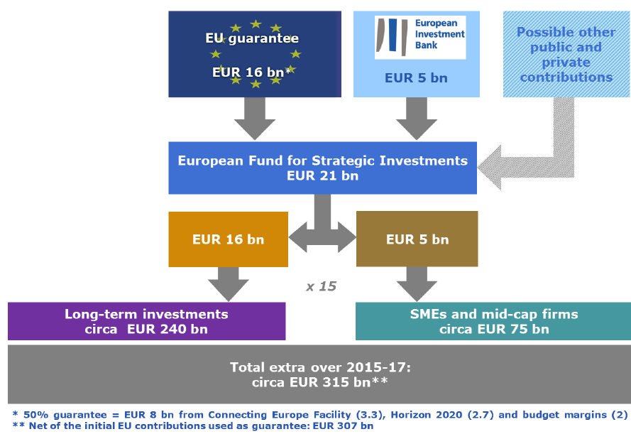
Source: COM(2014) 903, p. 7
Governance

- A Steering Board will decide on the overall orientation, the investment guidelines, the risk profile, strategic policies and asset allocation of the Fund. As long as the EIB and the Commission are the only contributors to the EFSI, the number of members and votes will be allocated based on the size of their contributions; all decisions will be taken by consensus. When other contributors join the Fund, the number and votes will remain proportionate to the contributions and simple majority will take decisions, if no consensus can be found. No decision can be adopted if the Commission or the EIB votes against it.

- An Investment Committee will be accountable to the Steering Board. The Committee will consist of six independent market experts and a Managing Director who will be in charge of the day-to-day management of the EFSI and chair the Investment Committee. The Steering Board, on a joint proposal of the Commission and the EIB, will appoint the Managing Director and his/her deputy.

- The role of European Investment Bank (EIB): as contributor to the EFSI, the EIB will have representatives in the Steering Board. As long as the only contributors to the EFSI are the European Commission and the EIB, all decisions in the Steering Board shall be taken by consensus. Since the EFSI is operating within the EIB, any project supported by the EFSI will require approval according to the EIB’s regular procedures.

- To ensure the overall accountability, the European Parliament (EP) will have the right to organize at any time hearings with the Managing Director of the EFSI on the performance of the latter. The Managing Director will also have a legal obligation to reply to questions/enquiries addressed by the European Parliament. The European Parliament can also request regular reporting by the Commission.

What kind of projects will be financed?

The Steering Board will prepare the investment guidelines, which determine the types of projects the EFSI will support. The Investment Committee will approve the EFSI financing. Investment operations shall be in line with European Union policies and support general objectives such as:
- development of infrastructure, including in the areas of transport, particularly in industrial centers; energy, in particular energy interconnections; and digital infrastructure;
- investment in education, health, research and development, information and communications technology and innovation;
- expansion of renewable energy and energy efficiency;
- infrastructure projects in the environmental, natural resources, urban development and social fields; providing financial support for the companies having up to 3000 employees, including working capital risk financing.

Criteria

- The assessment will be based on strict quality criteria and there will be no country-specific or sector-specific quotas. The criteria for assessment will be specified in the Fund's investment policy, which will be proposed by the Steering Board of the EFSI.

- They aim to ensure that high quality and economically viable projects are selected in key growth-enhancing areas. Projects will be identified according to their EU added value, economic and social viability and the possibility for the projects to start at the latest within the next three years, i.e. a reasonable expectation for capital expenditure in the 2015-2017 period.

4. The EP Draft Report on the EU Commission Proposal about the Regulation of EFSI

The EP recognizes the Investment Plan proposed by the Commission, within the regulation setting up the EFSI, as a key answer to the investment gap within the EU. However, the EP draft report drafted by José Manuel Fernandes (EPP Group, Portugal) and Udo Bullman (S&D Group, Germany) has made the following proposals to improve further the Commission’s proposal. These include:
- Ensuring the guarantee is topped up with additional co-financing, coming from private or public sector can be provided. In this context when implementing the Investment Plan local and regional expertise should be used as well.
- Concerns about the use of Horizon 2020 money, which EP wants to continue.
- The governance of the ESFI needs to be further strengthened with the involvement of the EP:

1) The EP as co-legislator needs to be appropriately involved in order to control the efficient use of EU resources.

2) The Managing Director, the Deputy Managing Director and the experts of the Investment Committee shall be elected from a shortlist presented to the EP.

- The Steering Board should adopt investment guidelines in order to ensure that the EFSI supports the European Union objectives, as a means for enhancing cohesion across the Union The determination of the European Union objectives shall be subject to a delegated act.

- The governance structure needs to ensure that the money targets projects with a higher risk profile, that projects are viable, and have a strong economic and societal added value, in particular that they ‘create sustainable jobs, promote competiveness and stimulate smart, sustainable and inclusive growth’. This should have the highest possible positive impact on quality job creation. Continuing old measures with old money should not be the objective.

5. Strengths and Weaknesses

Strengths

- Member States ‘contributions to the new investment fund will now be deducted from the calculations of their deficits and national debts.
- Investment in Education and Health care are considered as priorities.
- It will serve as support and will complement the efforts of Member States engaging in structural reforms.
- It will serve as a support for other EU initiatives (as Horizon 2020), whose implementation would have otherwise been undermined by budgetary constraints.
- “If designed right, the leverage will provide a much bigger ‘bang for the buck’. Using limited public funds to boost private investment by providing a form of public insurance is worthwhile in a situation where fiscal constraints remain binding in many countries, and where the EU level is unable to raise additional funds for investment. Even if the leverage is not fully achieved and some of the projects are not additional, it will produce a certain amount of additional private investment, which is desperately needed”. However, this is not certain .
- The EP calls for a much greater democratic involvement of the EP in the governance of EFSI as well as for the necessity to focus on projects with strong economic and societal added value, which deliver on cohesion, smart, inclusive and sustainable growth and creation of quality jobs.

Weaknesses

- Fiscal consolidation has not been shelved. The emphasis in accompanying measures is on ‘structural reforms’ and maintaining existing rules on budget deficits. This makes financing public sector projects extremely difficult.

- Europe 2020 is not even mentioned among the EU initiatives supported by Investment Plan, although the EP proposals restore some reference. It is a pity, as the Investment Plan could have served as a support for social initiatives in the framework of Europe 2020 poverty objective and the other related social targets on employment and education.

- There is no mention of social investments in people or social infrastructure, (besides a timid mention of long-term investments for education and health). The Investment Plan is rather focused on infrastructure, R&D and it is not clear exactly how many and what type of jobs may be created investing in those fields.

- The current proposal ignores the great potential strength of a plan run from the EU level. An EU fund, or institution such as the European Investment Bank (EIB), if adequately capitalized, could raise substantial finance at very low rates of interest and use it to finance investment across the EU, above all in countries in the greatest difficulty.”

- The current proposals are based on little new money, and primarily on leverage of private financing. This is not a Marshall Plan for public investment. In the areas of health and education, the investment plan may be used to support privatization and liberalization.
- Priority is not given to reducing the investment gap in the poorer countries, which are suffering most from the crisis. Indeed the majority of projects on the pilot list appear to be in the richest regions reinforcing the widening gap. This is likely to increase inequalities and imbalances between Member States, particularly the richer North and West, versus the South and East of the EU.

- While the focus on job creation has the potential of limiting unemployment trends, the Investment Plan does not target the quality of employment and the criteria and mechanisms for selection and monitoring, to achieve this goal are not explicit.

- There is a lack of social impact assessment or use of specialist advisors to ensure fund delivers on social objectives – on both content and to ensure support is given to ‘poorest Member States’

- Democratic accountability and transparency – there is very limited involvement of the European Parliament and no mention on how stakeholders will be involved.

6. References

- "An Investment Plan for Europe" - Communication from the Commission to the European Parliament, the Council, the European Central Bank, the European Economic and Social Commitee, the Commitee of the Regions and the European Investment Bank COM(2014) 903, (2014)

- "A New Start for Europe: My Agenda for Jobs, Growth, Fairness and Democratic Change" - Political Guidelines for the next European Commission - Opening Statement in the European Parliament Plenary Session, Jean-Claude Juncker (2014)

- Proposal for a REGULATION OF THE EP AND THE COUNCIL on the European Fund for Strategic Investments and amending Regulations (EU) No 1291/2013 and (EU) No 1316/2013 - COM(2015) 10 final (2015)

- DRAFT REPORT on the proposal for a regulation of the European Parliament and of the Council on the European Fund for Strategic Investments and amending Regulations (EU) No 1291/2013 and (EU) No 1316/2013 (COM(2015)0010 – C8-0007/2015 – 2015/0009(COD)) (2015)

- Myant M., (2015), Juncker’s Investment Plan: a New Deal for the EU?, European Policy Centre

- Zuleeg F., (2014), Juncker’s Investment Plan: a New Deal for the EU?, European Policy Centre

This document was drafted by Antonino Sorrenti/Stagiare with EAPN with the support of Sian Jones, EAPN Policy Coordinator and Amana Ferro, Senior Policy Officer.

INFORMATION AND CONTACT

For more information on this publication, contact
Sian Jones
sian.jones@eapn.eu – 0032 (2) 226 58 50

For more information on EAPN positions, publications and activities
www.eapn.eu

EUROPEAN ANTI-POVERTY NETWORK. Reproduction permitted, provided that appropriate reference is made to the source. May 2015.

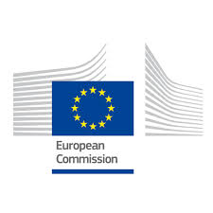
This publication has received financial support from the European Union Programme for Employment and Social Innovation "EaSI" (2014-2020). For further information please consult: http://ec.europa.eu/social/easi
Neither the European Commission nor any person acting on behalf of the Commission may be held responsible for use of any information contained in this publication. For any use or reproduction of photos, which are not under European Union copyright, permission must be sought directly from the copyright holder(s)

Zuleeg F., (2014), Juncker’s Investment Plan: a New Deal for the EU?, European Policy Centre
Myant M., (2015), Juncker’s Investment Plan: a New Deal for the EU?, European Policy Centre

