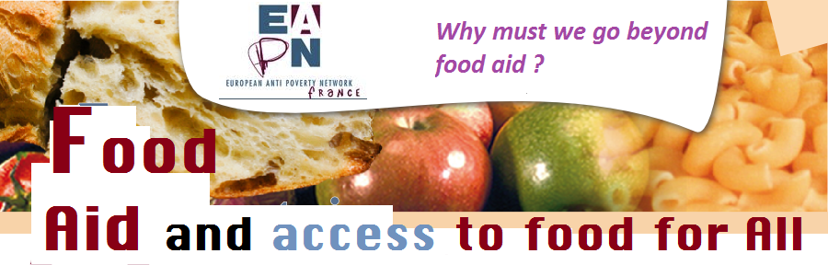

how does food aid work? The 2014 reform

Funding for European food aid has undergone an important change following the European court decree of June 2011; existing French measures in response to these change that were developed under the influence of Coluche in 1985 must be reorganised both in terms of finance and of structure.
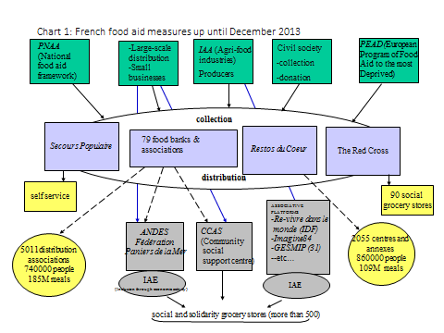
Source: inra.academia.edu/DominiquePATUREL
There have been four changes, put in place at the beginning of January 2014, that have affected both European and French measures. However, as the European mechanism has not yet been fully implemented, the French government has put transitional measures in place to avoid a disruption in distribution (chart 2):
- FEAD, which falls within the remit of European social funds, has replaced PEAD: its function is to buy food and guarantee basic material assistance, such as clothes and toiletries, in equal measure. Moreover, some of these funds are earmarked for the support of people in socially difficult situations. While in 2011, PEAD covered 20 countries, FEAD will cover every country in the European Union. Further, a co-financing rate for qualifying expenses has been fixed at 85%, and at 95% for countries more effected by the crisis.
- Together with the four traditional operators, nine national associations have been authorised by the Ministry of Agriculture, Agri-food and Forestry to receive financing from the Fund for European Aid to the Most Deprived.

- There is a second level of regional accreditation. This concerns associations which do not have national representation, but which work in the area of food aid at a local level.
- National Credit is available for the 729 social grocery shops which are excluded from European funding; funds must be used for the purchase of food that is distributed free. The state has also maintained the principle of funding for local state services directed at associations and organisations which are involved in the fight against poverty and social exclusion, and are not directly involved in food aid funding: For example, the Centres d’Hébergement et Réadaptation Sociale.
- Citizens’ initiatives have become more and more numerous and can be beneficiaries of public and private funding, receiving in-kind donations from different sources: most frequently they do not receive food aid funding but they are more and more visible nevertheless, and they promote solidarity with small-scale producers and the social tie created by direct relations.
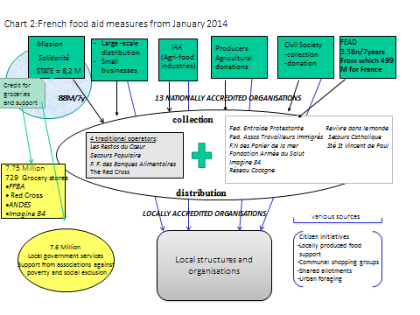
Source: inra.academia.edu/DominiquePATUREL
The four componants of a right to food

Food sovereignty can be defined in its strictest sense as the right of a people to define their own agricultural policies, or in a more general sense, “the right of peoples to healthy and culturally appropriate food produced through ecologically sound and sustainable methods, and their right to define their own food and agriculture systems”. Defenders of food sovereignty demand sustainable agriculture on a small scale (privileging local food systems) with the objective of assuring dignity and social justice.
The definition of food security has proven to be more complex because it has evolved greatly over time. This notion, which is more oriented towards quality and humanity today, describes a state “when all people, at all times, have physical and economic access to sufficient safe and nutritious food that meets their dietary needs and food preferences for an active and healthy life.” (World Food Summit. Rome, 1996). This term should be distinguished from food safety or sanitary safety for food, which are directly concerned with hygiene processes and the control of food. Conversely, the term food insecurity is used when the conditions for food security are not met.
The United Nations defines the right to adequate food as follows: “the right to adequate food is realized when every man, woman and child, alone or in community with others, has physical and economic access at all times to adequate food or means for its procurement.” The Special Rapporteur for the right to food has stressed that the right to food is a human right, recognised as such by international law, and with a precise definition: “ the right to food is the right to have regular, permanent and unrestricted access, either directly or by means of financial purchases, to quantitatively and qualitatively adequate and sufficient food corresponding to the cultural traditions of people to which the consumer belongs, and which ensures a physical and mental, individual and collective fulfilling and dignified life free of fear”.
These two definitions suggest three essential components to the right to food:
First and foremost, food availability must be insured.
Then, food accessibility must be guaranteed. This means both economic and physical access to food: economic access, as products must be sold at a reasonable price, and physical access, as everyone should be able to supply themselves with food, be they adult, child or incapacitated in any way.
Further, the food on offer must be adequate. Food must be adapted to the characteristics of populations (state of health, gender, etc.), and to their needs, and it must respect cultural codes (religious taboos, for example).
A fourth dimension is emerging: sustainability, which concerns the environment, but also relates to social justice; this aims at reconnecting food with its conditions of production (short and long distribution channels, hybridisation, etc.), and discussions at a local level over the choices which will have an impact on the way that future generations have access to wholesome food.
It equally means listening to the voices of those who are socially excluded, and not limiting the question of poverty to food aid.
Although food aid facilitates a response to some of the difficulties encountered by European citizens, it does not secure the right to food:
Yet what the figures show us is an exponential increase in people who need it, and currently the sole public discourse concerns increasing the resources for distributing this food aid at the same rate as the increase in demand. There has been a shift in the original operators’ discourse on tracking down tax loopholes that can release food contributions: this targets big producers.
Additionally, different public health surveys stress the decline in health of people living in poverty, which particularly concerns the quality of their food: 28.8% of food aid users have a problem with obesity and have a higher level of diabetes and hypertension than population at large, and their consumption of fruit, vegetables and dairy produce is lower (Abena study 2011-2012).
All these elements result in a great inequality in the access to wholesome food that is recognised as essential to the maintenance of good health today; it is in truth conditions relating to poverty that interfere with access to food, and not availability or the lack of resources for distribution. One study at the University of Cambridge attested that it cost three times as much to eat healthily in terms of both the nutritional balance and the quality of produce: 1000 calories of food that is considered to be healthy costs 9 Euro 40, as compared to 3 Euro 20 for 1000 calories from agro-industrial food products.

For the right to “sustainable” food to be realised, food aid must take its rightful place as an emergency measure, and not continue to be the only response: there are alternatives led by citizen initiatives and local associations which are still barely visible in the public arena, but which are very real.

There are many initiatives in all regions, and the examples below are just a sample of the range of projects:
- By “traditional” operators:
Locally sourced supply of fruit and vegetables at the Hérault Restos du cœur
http://www.draaf.languedoc-roussillon.agriculture.gouv.fr/Un-approvisionnement-local-pour
The ANDES network supply of groceries:
http://www.epiceries-solidaires.org/news/uniterres-des-circuits-courts-dans-le-reseau-des-epiceries-solidaires
...
- By social and social solidarity-based economy associations:
Cabas des Champs in Brittany
http://www.letelegramme.fr/local/finistere-nord/brest/quartiers/stpierre/centre-social-remise-du-cabas-des-champs-23-09-2013-2243248.php
Solid’Arles http://solidarles.free.fr/
Sésame Table Ouvert http://www.onpassealacte.fr/initiative.table-ouverte.economie.654144.html
And further, La tente des Glaneurs in Lille, Caen and Grenoble, le Zeybu solidaire in Grenoble …….

- By AMAP : many AMAP groups tend towards solidarity
La Courgette Solidaire http://www.lacourgettesolidaire.fr/qui-sommes-nous
Les Paniers Marseillais http://www.lespaniersmarseillais.org/spip.php?page=sommaire
…
- By citizen and solidarity purchase collectives
There are a great many initiatives, from the direct collection of products from supermarkets, at the end of markets and from dustbins, to family collectives and people on small budgets who pool their shopping…
- Allotments
Here also there are many shared and/or family allotment initiatives in every corner of France:
Jardins Solidaires Méditerranéen network http://www.reseaujsm.org/
Communal allotment network http://jardins-partages.org/
In Europe:
In Spain, the Can Masdeu communal allotments set up in a squat on the sight of a disused hospital.
In Germany, in Potsdam, the intercultural Schlaaz allotments, where families from different cultures can grow their own produce; a nomadic garden in Berlin where all cultures can be served.
In Greece, community allotments which are being developed in a disused military camp in Thessalonica.
Not to forget the municipal network of social canteens in Lithuania and social restaurants in Belgium.

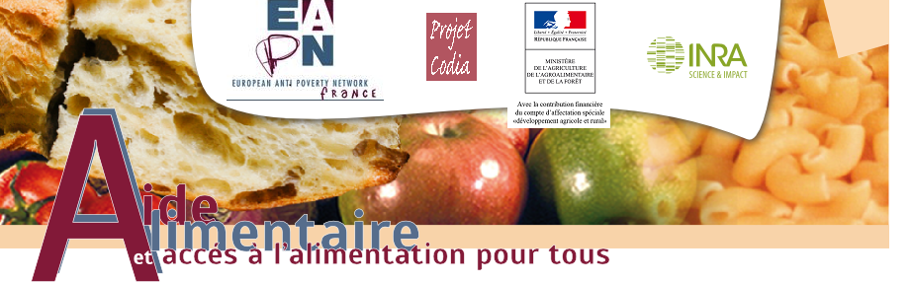

Translator’s note: French public figure who founded the food redistribution NGO Restos du Coeur
Translator’s note: Centres for housing and social rehabilitation
Translator’s note: Association pour le maintien d'une agriculture paysanne (association for maintaining peasant agriculture), which opposes industrial farming.

