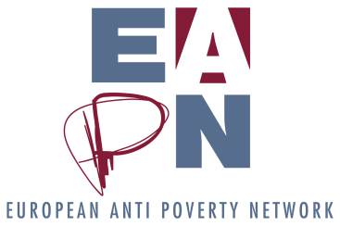

POSITION PAPER

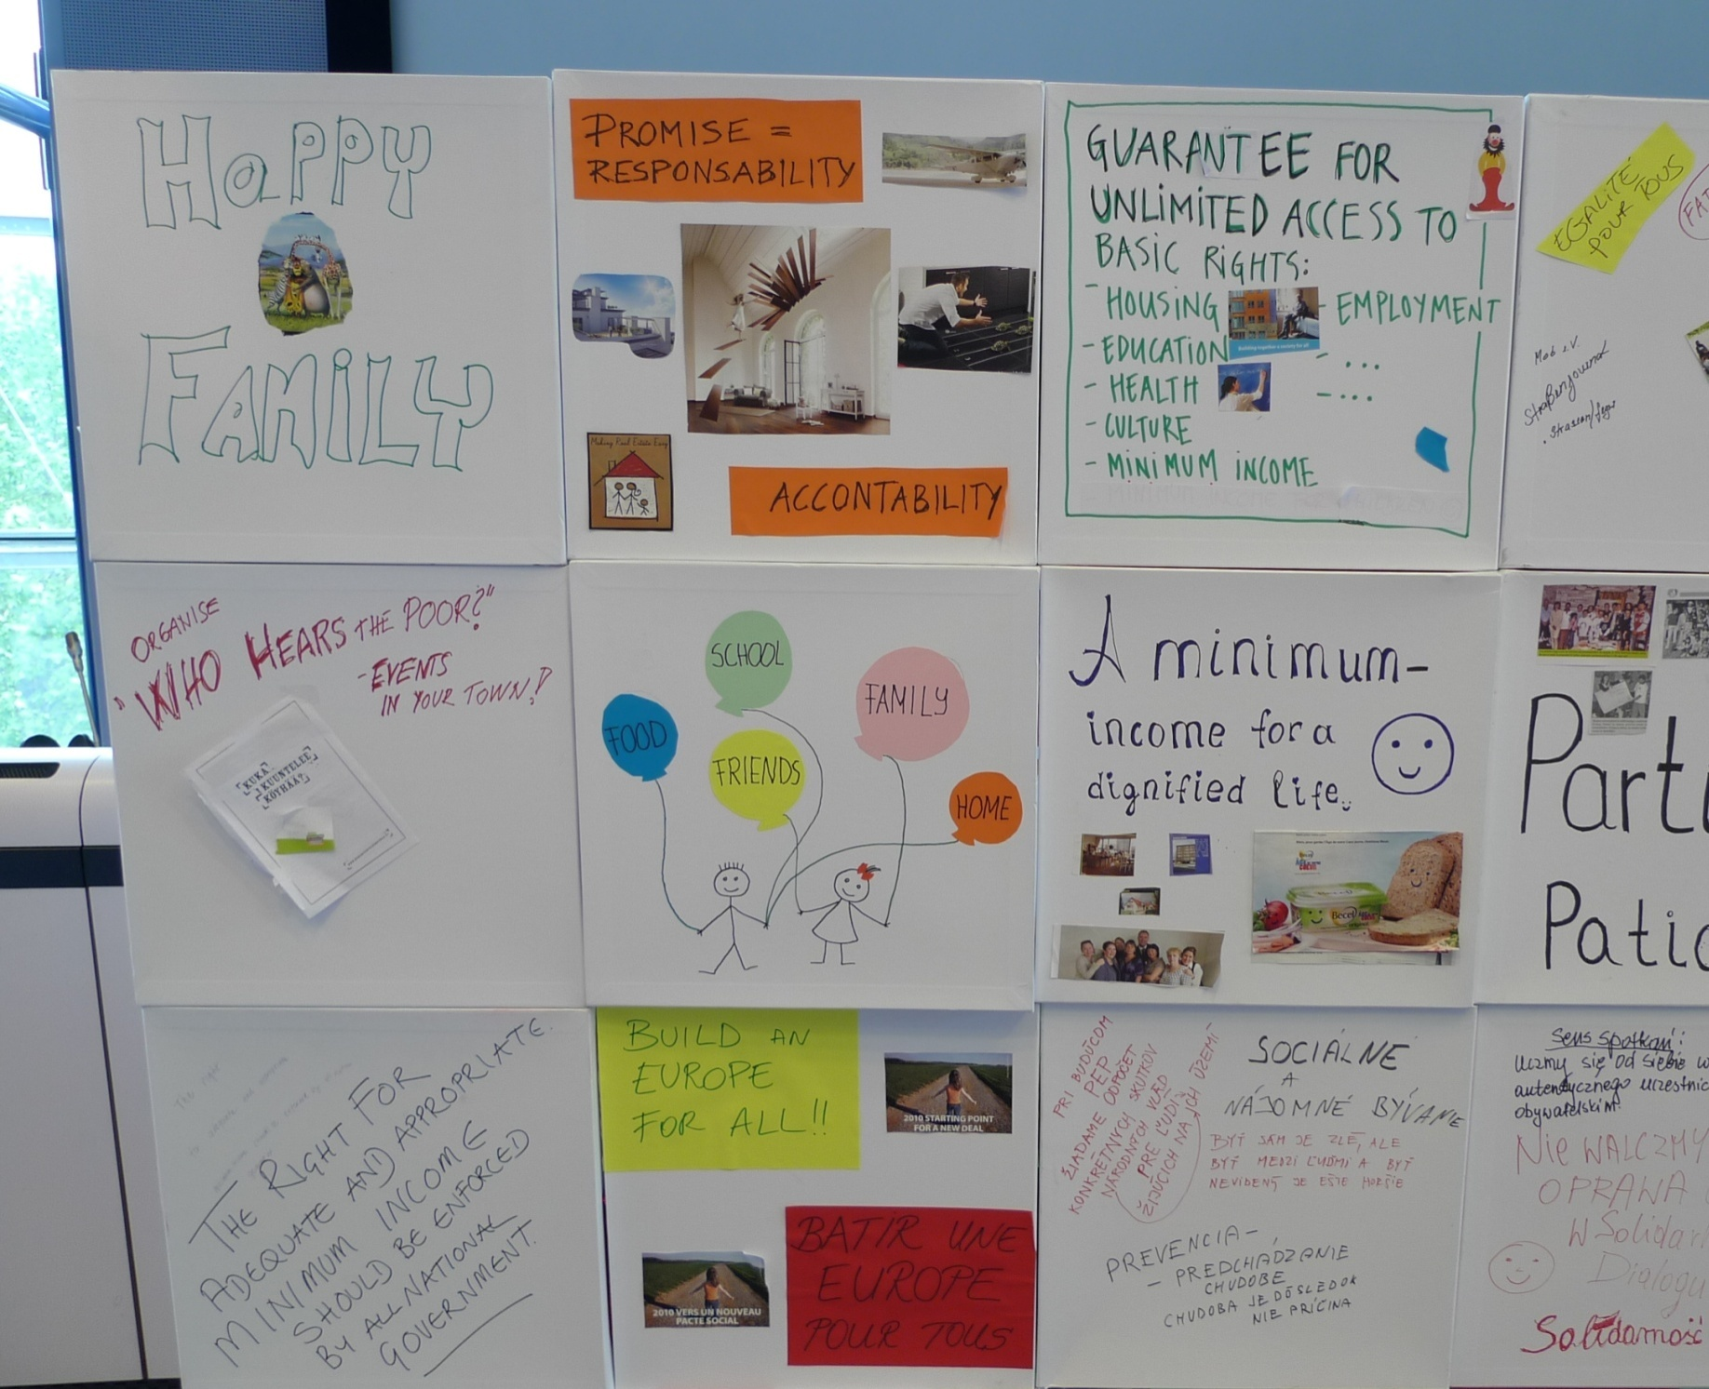

**EAPN Assessment of the 2016 CSRs**

**KEY MESSAGES**

1. **Poverty CSRs increased but lack coherence and integrated strategy**
2. **Austerity still dominant rather than social investment and redistributive tax policy**
3. **Adequacy of minimum income undermined by cuts to universal social protection**
4. **Increased access to quality health, integrated services and housing but efficiency comes first.**
5. **Employment policy continues to be a numbers’ game with emphasis on the supply side**
6. **Some progress on inclusive education, but no link to**

**Europe 2020 targets**

.

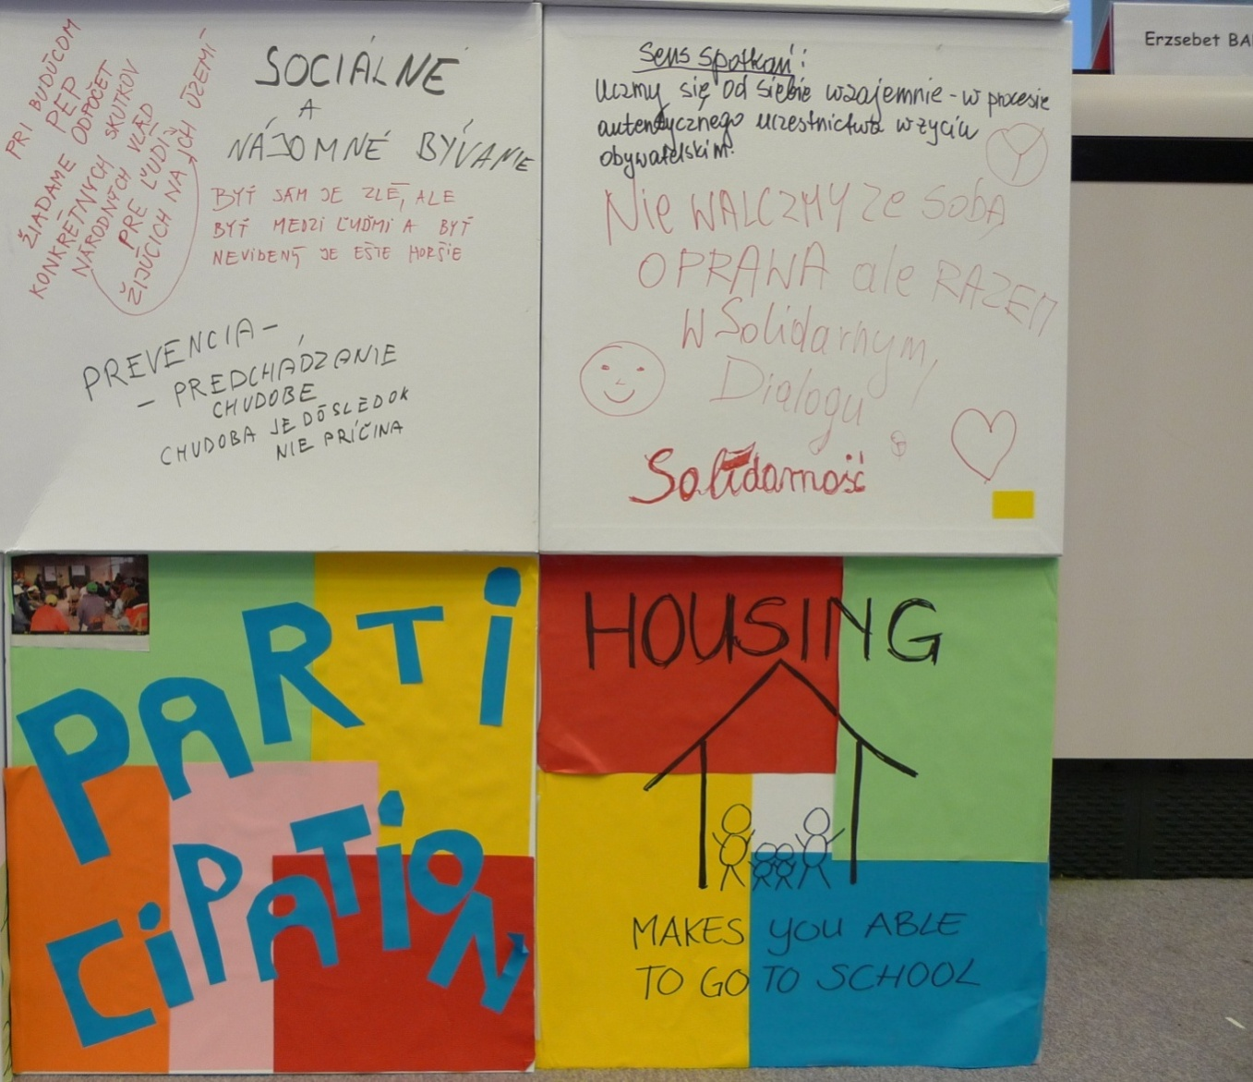



**June 2016**

**EAPN 2016 CSR ASSESSMENT**

*On May 18, the Commission adopted their proposals for the Country-Specific Recommendations 2016 (CSRs.) EAPN gave its immediate response in a* [*Press Release*](http://www.eapn.eu/eapns-initial-response-to-country-specific-recommendations-more-csrs-on-poverty-but-austerity-still-dominant/)*, “More CSRs on poverty but austerity still dominant”. This paper sets out the main messages and recommendations from a more detailed assessment of the CSRs, carried out together with our members, assessing progress on Social Europe and delivery on the Europe 2020 Strategy targets on poverty reduction, employment and education. A detailed country by country analysis is annexed.*

**Main Messages**

**‘Poverty’[1] CSRs increased, but lack coherence and rights-based integrated strategy**

The Commission highlighted 11 so-called poverty CSRs, which represents an increase from 6 to 11. However, often poverty isn’t mentioned, and piecemeal measures proposed, rather than an integrated strategy supporting social inclusion for all across the lifecycle, with integrated active inclusion for people of working age and thematic integrated strategies for key groups. With the new social pillar being launched, we would have expected a stronger focus on social rights in all countries.

**Austerity still dominant rather than social investment and redistributive tax policy**

Nearly all MS receive CSRs to reduce budget deficits with spending cuts still dominant, although often addressed obliquely. More focus on investment, but by reducing regulatory barriers to private investment in infrastructure and R+D. A positive exception is to DE, IE, where more public investment is called for in core social services. CSRs on increasing tax, including tackling evasion and collection are welcomed, but lacking inclusive tax systems which redistribute income and wealth, ie progressive taxes, property and wealth taxes.

**Adequacy of minimum income undermined by cuts to universal social protection systems**

5 MS receive CSRs on minimum income and 4 on adequacy and coverage, with some welcome detail on reducing inequalities. However, this is set against the overall approach to ‘modernizing’ ie cutting social protection systems, reducing spending, reducing universality, and raising retirement ages rather than ensuring adequate pensions for all, as part of a commitment to ensure adequate income through the life cycle.

**Increased access to quality health, integrated services and housing but efficiency comes first**

More focus is given to increasing housing supply as a boost to growth, but not to ensuring affordable access for low income households, including through social housing. Neither is tackling homelessness mentioned, nor successful housing first strategies already put in place. Whilst welcome support is given to some MS backing universal health coverage, better access, and integrated social and other services, the overall message remains sustainability, cost efficiency rather than a right’s based approach to access to quality universal services.

**Employment** **policy** **continues to be a numbers’ game** **with emphasis on the supply side**

With 20 Members States receiving a CSR on activation, this is clearly the main focus of employment policies, while job creation is not mentioned, and quality of jobs is not prioritized. Despite positive rhetoric about personalized approaches to vulnerable groups, there is still no evidence of integrated Active Inclusion approaches, that would provide pathway approaches to quality jobs alongside comprehensive access to services and adequate income support. Encouraging elements are CSRs addressed to some countries about stable and secure contracts, undermined by references in other countries to reducing wages to encourage competitiveness, and unemployment benefits to push people into work.

**Some progress on inclusive education, but no link to Europe 2020 targets**

The approach to education continues to be overwhelmingly from a labour market perspective, with as many as 10 Member States receiving specific CSRs on stepping up provision of training and upskilling, function of labour market needs. While there are encouraging proposals on raising the quality of education in some countries, as well as making it more inclusive for vulnerable groups (migrants, Roma, children from disadvantaged socio-economic backgrounds), only three countries receive CSRs related to the Europe 2020 targets: one on early school-leaving, and two on adult learning.

**Detailed Thematic Analysis**

**Macroeconomic**

* **Sustainability of public finances and austerity is still major priority.** Almost allMember States get CSRs on fiscal policy and governance, with the following highlighting explicit demands to reduce deficits (BE, BG, HR, FR, IE, SL, CY, FR, HU, ES, PL, PT, RO, SK, UK). 3 Countries are deemed to have performed well under the excessive deficit procedure (EDP), (CY, IE, SL) but are expected to continue to cut spending, whilst 6 remain under EDP (HR, FR, EL, PT, ES and UK). Portugal and Spain are issued with a threat of sanctions if action is not taken. The emphasis on deficit and debt control in all countries continues the overarching narrative of austerity with continued pressure to cut public social and health services. This continues to generate poverty and undermine poverty reduction recommendations.
* **Small shift to investment, but insufficient social and public investment.** The need to promote investment is more clearly recognized in the CSRs (BE, CZ, DE, DK, EE, HU, IE, LU, PL,) but priority is mainly given to reducing regulatory barriers for private investment, particularly in research and development and basic infrastructure rather than social and public investment (ie promoting investment in knowledge-based capital, energy and transport in Belgium; in Latvia, the call is made to provide incentives for private investment in innovation). However, positive calls are made (DE, IE, NL) for increased or diverted public spending. In Germany, the CSR calls for the government to address ‘persistent under-public investment” in infrastructure, education, research and innovation. In Ireland, underinvestment is highlighted in transport, water and housing.
* **Calls for** **investment in housing**, **but not affordable homes** **or homelessness**

3 Countries get CSRs on housing investment (LU, SE, UK).However, this is mainly through private investment in increasing supply, ie removing ‘bottlenecks’, particularly to building housing for sale or rent, but without priority to increasing access for low income families to affordable rented properties including introducing rent control. There is no call for public investment in social housing that could significantly increase the supply of decent homes at affordable rates for people experiencing poverty and social exclusion. Neither is there any prominence given to rising homelessness, and recognition of positive housing first strategies that have been put in place in some countries.

* **Positive action on tax evasion and collection/ reducing taxes on low incomes, but not inclusive growth-friendly reducing inequality.** 13 Member States receive CSRs on taxation (BE, HR, FR, DE, HU, IE, LV, LT, PL, PT, RO, SK, SE) with a focus on ‘growth-friendly’ tax, ‘reducing inefficiencies’ and ‘simplification’. Broadening the tax base (FR,) and explicitly shifting tax away from production and labour (FR, IE,) are highlighted, as well as negative cuts to corporation tax (FR, DE, PT). There are some positive recommendations, to reduce high tax wedges for low wage earners (DE, HU, LV, LT,); to increase property tax (HR, LV, SE) as well as environmental tax (LV). However, the priority given to increasing consumption taxes is inherently regressive, particularly VAT on basic goods and services, which is likely to hit the poor hardest as they spend proportionately more of their income on these services (FR, IE, LT, PL,). Continued positive focus is given to increasing tax compliance and collection (IE, LV, LT, PL, RO, SK) but this year no specific CSRS on explicitly fighting tax evasion (last year for CZ HU). There continue to be no recommendations on increasing the progressivity of taxation by tackling flat taxes in countries facing poverty and growing inequality, or increasing wealth taxes. Specific social impact assessment should be made on all tax proposals, to ensure that the people in poverty are not impacted worse, and to promote the redistributive function of tax.
* **Increasing competition and privatization, but no consideration of social impact.** 6 Member States receive CSRs requiring increased competition and privatisation in public contracts (DK, FI, FR, HU, IT, PT). However, there is no requirement to assess the social impact on jobs and services, particularly access and quality for low income groups or to support social clauses. Increasing competition in services (DK, FI, FR, IT) removing restrictive practices (HU), and restructuring plans for state-owned enterprises are still the priority. (PT).

**Poverty**

* **Increased number of so-called “Poverty” CSRs (6-11) but little coherence.** 11 Member States receive so-called CSRs on ‘poverty’ (BG, CZ, HU, IE, RO, SK) according to the Commission’s Communication, reflecting an increase from last year (6). However, it is not always easy to see how they will reduce poverty. The number is still too low, given that the poverty target has failed in almost all countries, with nearly 1 in 4 people in poverty and social exclusion, 4.2 million more than in 2008[2] when the Europe 2020 poverty target was set. Although the countries cited are in general the countries facing greatest risks of poverty and social exclusion, there are some exceptions (ie Estonia is not included and Czech Republic is, although Estonia has much greater problems and increase of poverty). Moreover, the justification ie the high levels of poverty and social exclusion in these countries is only explicitly mentioned in the preamble to the CSR in 4 MS (BG, HU, LV, RO), whilst in 3 others only partial references are made (ES, HR, IE, PT) ie in Spain, in relation to income support; in Ireland and Portugal, to children at risk of poverty and in Croatia to older people. In CZ, reference is only made to the inclusion of disadvantaged children in education. In 2 of the MS named, no mention of poverty and social exclusion is made at all. (IT, SK).
* **Some positive CSRs but too piecemeal and lacking an integrated strategy.** There are more positive examples of CSRs with proposals of social measures but many propose very partial measures aimed at specific target groups, rather than a request for an integrated strategy for all groups facing poverty and social exclusion, based an integrated active inclusion approach or supporting specific EU thematic strategies eg Investing in Children or Tackling Homelessness and housing exclusion. One of the better examples is seen in Bulgaria eg here the CSR requires the government to increase quality education access for disadvantaged groups, reinforce integrated services and active labour market policies, access to health and funding, coverage and adequacy of minimum income and minimum wage. The majority propose rather piecemeal proposals for specific groups (eg education for disadvantaged children (CZ). When this is combined with the fact that in the same countries the dominant CSR 1 is often fiscal consolidation demanding cuts in spending on services, which is likely to increase poverty, it is difficult to see the overall coherence of the proposals.

**Minimum Income and Social Protection**

* **Increased priority to adequacy of minimum income but undermined by rationalization of social protection systems.** 5 Member States (BG, HU, LV, LT, ES,) receive specific CSRs regarding minimum income. This year 4 of these (BG, HU, LV and LT) get welcome requirements on increasing adequacy and 3 on coverage (BG, HU, LT. Spain is asked to positively address gaps and disparities in Minimum Income). Strengthening social protection systems more broadly is also addressed: NL receives a CSR to increase access of self-employed to affordable social protection. However, in many cases this is undermined by priority given to budget sustainability ie in France where the CSR requires them to ‘reform unemployment benefit systems to bring back budget sustainability and incentives to work”. In Ireland, the CSR requires tapered withdrawal of unemployment benefit and other supplementary benefits to incentivize employment’. In others, eg Croatia, the focus is on increasing targeting, with the request to consolidate social protection benefits by reducing special schemes, aligning eligibility criteria and focusing support on those most in need. As almost no minimum incomes schemes in the EU actually take people out of poverty, we would continue to expect CSRs on adequacy of MI and other income support benefits for most countries, including issues of low take up, and an end to continuing austerity which attacks minimum income and social protection budgets, proposed usually in CSR 1.
* **Raising retirement ages without ensuring adequacy of pensions.** Less MS receive CSRs on pensions this year (5) (LU, NL, PL, PT, SL,). This may be due to the fact that most countries have responded to the EU demands. However, the main focus is still on sustainability of public pensions, asking for “retirement ages to be raised, limiting early retirement to life expectancy and increasing incentives to work longer” (LU), without recognition of the rising gaps in life expectancy levels and healthy life years of people struggling on low income and with social exclusion. Other CSRs reinforce the message of increased focused on 2nd pillar rather than statutory pensions eg making the 2nd pillar of pension systems more transparent (NL), reducing reliance on budgetary transfers (PT) and ambiguous proposals to ‘reform the pension system (SL) which imply cost cutting. Only in Poland is a specific mention made to the need for sustainable and **adequacy of pensions**.

**Access to Services**

* **Cost effectiveness dominant but Increased attention to increasing access to integrated social services and link to labour market**

Whilst cost effectiveness remains a constant theme in the CSRs, there is more welcome attention to reducing inequalities, ensuring access and investing in high quality public services, particularly social in some countries**.** In Croatia reference is making to ‘reducing territorial disparities’ in delivery of public services. In Estonia the CSR requires them to ‘ensure provision and accessibility of high quality public services, especially social at the local level’. There is a greater call for integrated services, particularly with the link to employment services (BG, RO, PT)

* **More emphasis on universal and quality healthcare but efficiency still dominant.** 9 Member States receive CSRs on healthcare (BG, CY, CZ, FI, LV, LT, PT, RO, SL). Several give a welcome higher priority to improving access, and funding of healthcare systems. (BG), or requiring implementation of universal health coverage (CY), improving accessibility, quality and cost effectiveness (LV). Some countries get more concrete proposals around improving performance particularly in prevention and primary care ie LT - strengthening outpatient care, disease prevention and health promotion, or as in RO, curbing informal payments and increasing availability of outpatient care. However, the overall tone within other CSRs is giving priority to sustainability with an emphasis on efficiency and cost effectiveness, rather than guaranteeing universal and affordable access to quality health and care services. For example, “better cost effectiveness, increasing competition” (FI) whilst PT and SL are required to ensure the long-term sustainability of the health sector. In CZ the focus is on strengthening fiscal framework in health system.
* **Reduced priority to childcare and quality early learning**

Only 3 MS (IE, ES and UK) receive CSRs related to childcare compared to 7 Member States last year (AT, CZ, EE, IE, RO, SK and UK). Most focus on increasing childcare as a response to a key barrier to women’s employment, linked to tackling child poverty in some cases, rather than an integrated ‘investing in children approach’ which combines access to adequate income, services and participation. However, the CSRs that exist are more concrete in calling for access to quality childcare (IE, ES, UK) and full-time ( IE,UK), only in Ireland is the important issue of affordability addressed: “improved provision of quality, affordable, full-time childcare”

**Employment**

* **Activation remains a game of stick and carrot approaches**

A number of 20 countries (AT, BE, BG, HR, CY, CZ, DE, FI, FR, IE, HU, IT, LV, NL, PL, PT, RO, SI, SK, ES) received a specific recommendation regarding their active labour market policies (ALMP). A few of them (IE, HU, LT) contained positive references to increasing the duration, adequacy, and quality of unemployment benefits, while others were told to, conversely, ‘improve incentives to work’ by discouraging generous benefits and potentially applying sanctions and restrictions (BE, FI. FR). A number of countries (AT, BG, CY, CZ, IT, FI, PT, RO, SK ) were urged to improve their jobseeking support for particular groups, such as youth, the long-term unemployed (BG, CY, PT , RO, SK), women (AT, CZ, IT, CZ), people with a migrant background (FI). For Hungary, supporting transitions from public work schemes to the open labour market is advised, while Italy received a recommendation on strengthening the capacity of its Public Employment Service. Bulgaria is encouraged to tackle undeclared work, while Netherlands to curb bogus self-employment and ensure adequate social protection for the self-employed.

* **Contradictory measures regarding quality of work: positive steps on tackling precariousness, worrying rhetoric on cutting wage levels**

Four countries (BE, FI, FR, PT) received a specific recommendation regarding their wage levels, which is considered too generous, and not conducive to competitiveness and job creation. These countries were subsequently advised to adjust their wages to lower levels, while 3 additional countries (BG, HR, RO) were told to adjust their wage setting mechanisms, without further explanations. Four countries (DE, HU, LV, LT) are urged to reduce the high tax wedge on low earners, while the adequacy of wages itself is not discussed. Estonia, the country with the highest gender pay gap in the EU, receives a recommendation on narrowing it. Encouragingly, five countries (DE, FR, NL, PL, PT) are encouraged to support open-ended / permanent contracts and actively support transition to these from more temporary forms of employment, such as, for instance, mini-jobs in Germany. However, the concept of quality of work and employment per se is not mentioned, neither is investment in quality, sustainable employment, accessible to all.

**Education**

* **Steps towards more inclusive education, but no link to the Europe 2020 targets**

Only 15 countries (AT, BE, BG, HR, CZ, FI, FR, HU, LV, LT, RO, SI, SK, ES, SE) received a Country-Specific Recommendation related to education. However, in most cases (9 out of 15 – BE, HR, FI, FR, LV, PL, SI, ES, SE, UK), these are focused on training, upskilling, and responding to labour market needs. For the others, there is some positive rhetoric about

making education systems more inclusive, particularly for vulnerable groups, highlighting links between socio-economic (AT, CZ) and migrant (AT, BE) background of pupils, and their educational attainment. The situation of Roma pupils is particularly emphasised in 5 countries (BG, CZ, HU, RO, SK). The qualitative aspect of education is only mentioned in 3 countries (BG, LT, RO). Overall, there is little connection with the education targets of Europe 2020: early school leaving is only mentioned in one (RO), while adult learning in two (MT, LT).

**INFORMATION AND CONTACT**

For more information on this publication, contact

Sian Jones – EAPN Policy Coordinator

[sian.jones@eapn.eu](mailto:sian.jones@eapn.eu) – 0032 (2) 226 58 59

See EAPN publications and activities on [www.eapn.eu](http://www.eapn.eu)

**The European Anti-Poverty Network (EAPN) is an independent network of nongovernmental organisations (NGOs) and groups involved in the fight against poverty and social exclusion in the Member States of the European Union, established in 1990.**

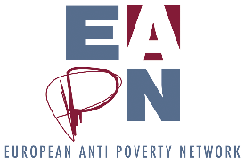

EUROPEAN ANTI-POVERTY NETWORK. Reproduction permitted, provided that appropriate reference is made to the source. April 2015.



This publication has received financial support from the European Union Programme for Employment and Social Innovation "EaSI" (2014-2020). For further information please consult: <http://ec.europa.eu/social/easi>

Neither the European Commission nor any person acting on behalf of the Commission may be held responsible for use of any information contained in this publication. For any use or reproduction of photos which are not under European Union copyright, permission must be sought directly from the copyright holder(s).

1. EC (18.05.2016) Communication: 2016 European Semester: country-specific recommendations. Table 1 indicates 11 Poverty CSRs
2. Eurostat 2014. EC European Semester Thematic Fiche: Poverty and Social Exclusion (03.05.2016)