PRACTICAL INFORMATION FOR THE EXCO/EUISG/CAPACITY BUILDING/GENERAL ASSEMBLY
Brugge/Belgium on 27/28 and 29 October 2016

All meetings will be held at the hotel where you will be staying:
Hotel De'Medici‘
Potterierei 15
B-8000 BRUGGE
Tel.: +32(0)50 33 98 33 (hotel)
Fax: +32(0)50 33 07 64
Website: www.hoteldemedici.com

How to reach the hotel from Brussels airport:
There are both direct trains from the airport to Brugge, and also trains with a stop and change of trains in Brussels.
The airport train station is located below the terminal (basement level-1).
The trains to Brugge run at 13, 30 and 59 minutes passed the hour. The last direct train from the airport to Brugge is at 22.59 h, the last train (with a change at Brussels Midi) is at 23.59h. The journey lasts for about 1.5 hours.
Brugge has only one railway station. At the exit you can take the public bus n° 4 or 14, which stops in front of the hotel at the opposite side of the canal. The bus stop to get out at is called SNAGGAARD BRUG (see map on next page).
For the bus you need to purchase a DeLijn ticket. You can either buy this from the tickets machines in the station or from the bus driver. The cost is 3 €. For the bus driver you need to have change as they won’t accept more than 10 €.
Please remember to keep your train ticket as you will need it for the reimbursement.

Registrations:
There will be a registration desk in the lobby of the hotel on Wednesday 26 October, from 18:00-19:30. Please do come and register, to avoid a rush once the meetings have started.

Thursday morning, start of meetings:
The first morning starts with the three parallel meeting (EXCO/EUISG/Capacity Building), so please go to the following rooms – which will be signposted – as from 9:00, for a 9:30 start.
EXCO: Firenze EUISG: Verona Capacity Building: Giovanni

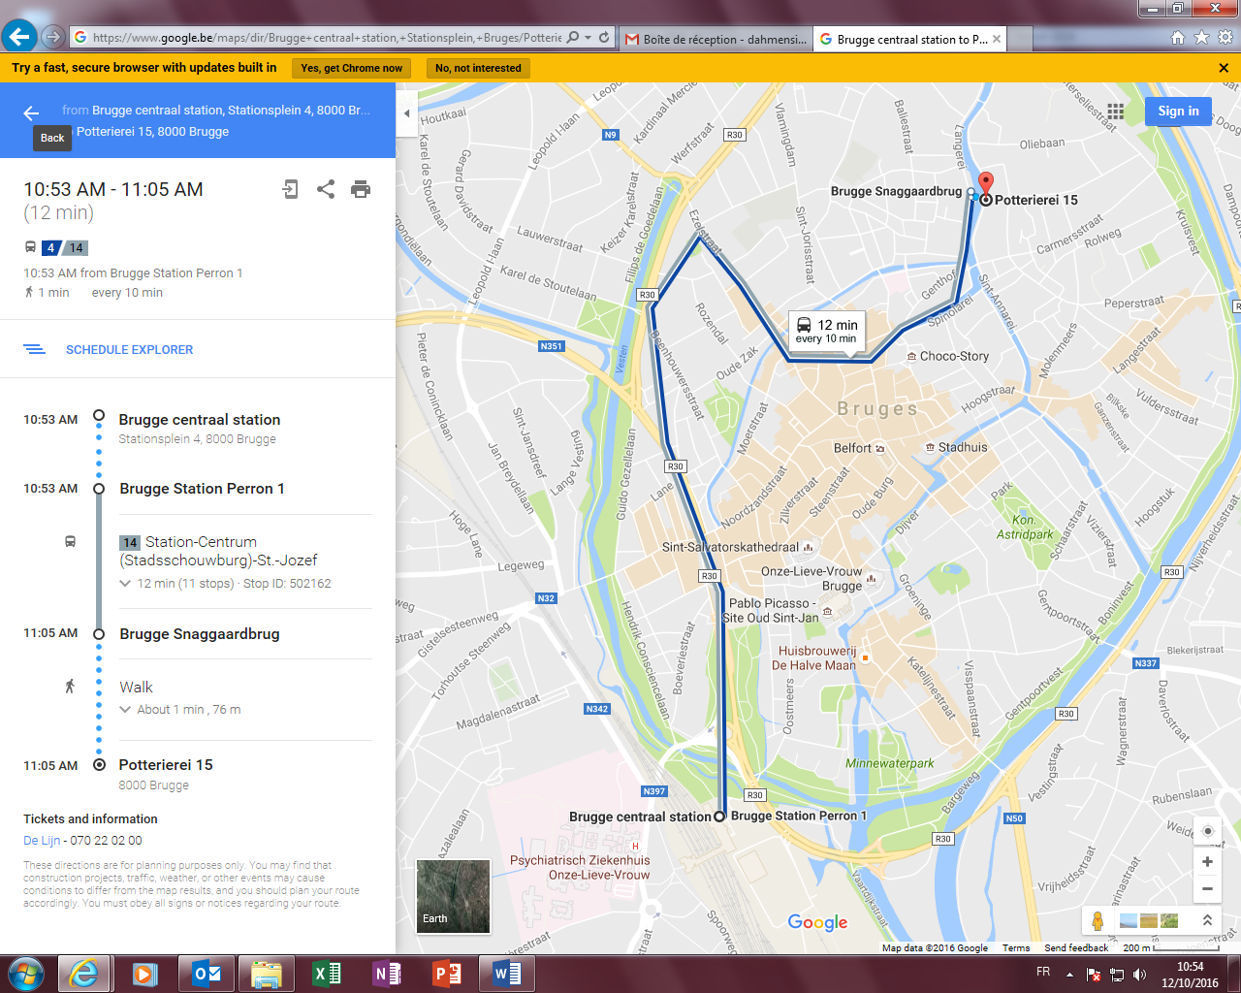

Meals:
The lunches on all three days will be served at the hotel, as well as the dinner on Thursday evening.
On Friday night dinner will be served outside the hotel, the details for that will be made available at the meeting.

You might want to know that all participants have the free use of the hotel’s Health Spa Center.

In case of questions or problems:
Sigrid Dahmen: 00 32 499 86 27 63
Rebecca Lee: 00 32 479 23 79 01

