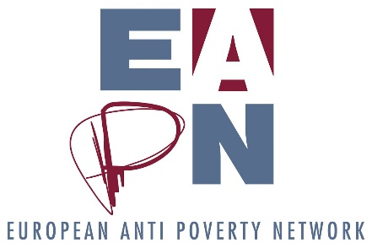
Proposal of ways of working on MFF
Background – why we are talking about this
What is the MFF?
The multiannual financial framework (MFF) lays down the maximum annual amounts ('ceilings') which the EU may spend in different political fields over a period of at least 5 years. The current MFF covers seven years: from 2014 to 2020. The next MFF is currently being discussed.
The MFF is not the budget of the EU for seven years. It provides a framework for financial programming and budgetary discipline by ensuring that EU spending is predictable and stays within the agreed limits. It also allows the EU to carry out common policies over a period that is long enough to make them effective. This long term vision is important for potential beneficiaries of EU funds, co-financing authorities as well as national treasuries.
By defining in which areas the EU should invest more or less over the seven years, the MFF is an expression of political priorities as much as a budgetary planning tool. The annual budget is adopted within this framework and usually remains below the MFF expenditure ceilings in order to retain some flexibility to cope with unforeseen needs.
Proposed by the European Commission, the regulation laying down the MFF must be adopted by the Council by unanimity after obtaining the consent of the European Parliament.
Further details can be found here
Past work on the MFF
Our past work on Structural Funds, particularly ESF and on programmes such as the EU Poverty Programmes and the EASI programme is the basis on which we can draw for our work on the MFF. The most recent work from the EUISG Task Force which developed the Barometer report (earmarking of at least 20% of the European Social Fund (ESF) to fighting poverty and social exclusion and the code of conduct on partnership) made a series of proposals which could guide our thinking on the MFF. In addition, staff have attended a number of discussions about the MFF in recent months, but we do not have dedicated members of staff to follow this. Our proposals from the Barometer report have been fed into the work with Social Platform, and have been substantially adopted. We have also tried to continue to engage with further discussions within the Social Platform, Civil Society Europe and SDG Watch, feeding in our recommendations from the Barometer report and our past work where possible.
What we have committed to do in our 2017 work programme
Outcome: Ensuring future EU funding for the fight against poverty and social exclusion
Output: Inputs to the debates and positions on the revised EU MFF
Activities: Follow these developments, cooperating with other actors on this topic. Lead reflections with the Executive Committee, who will develop the work and relevant positions. Efforts will be made to cooperate with other civil society organisations including the Social Platform and Civil Society Europe on this topic.
What methodology we propose
- An introductory discussion in plenary at the June Ex Co, followed by a cluster discussion. This discussion should focus on what output and activities the Ex Co can reasonably undertake, and how the Ex Co can deliver them.
- Assuming there is capacity, interest and motivation, a small Cluster Group - consisting of the individuals from EAPN members who have the relevant expertise and experience - could take this forward. The clusters would work principally by emails, shared documents and conference calls. No extra funds are allocated to clusters, so no extra physical meetings are envisaged.
- This cluster should be member led, recognising that the EAPN Staff Team does not have the capacity to support extra areas, and thus staff support for these areas of work from the Brussels team is minimal.
- The Brussels staff team will support by drafting clear Terms of References for these Cluster Groups and establishing effective communication channels.
A suggestion
Given the question of capacity, it may be sensible to focus on two or three key policy demands (i.e, Defend an ESF programme and the 20% (or more) ring fencing for social inclusion spending, promote a programme that would build on the EASI programme and ensure the sustainability of funds for social inclusion networks, promote a new large scale social inclusion programme building on the experience of the FEAD programme, crosscutting to these demands would be defending and promoting a stronger implementation of the code of conduct and ‘partnership principle’ and the engagement of grass-root organizations as part of civil society engagement in the design, delivery and evaluation of the use of grants) and work to ensure that these are included in the positions of alliances who are working more closely on the MFF, and support their advocacy and campaigning work.

