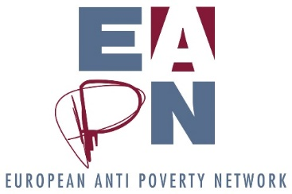
Analysis of 2017 members survey
Introduction and background
In July 2017, EAPN conducted a ‘members survey’, with the following objectives in mind:

- To better understand EAPN members
- To understand the individual and collective priorities of EAPN members for the next few years
- To understand the main capacity building needs of EAPN members
- To generate ideas about how we could improve our collective work
- To generate feedback on the way EAPN communicates with members

The results of the questionnaire will be used in the following way:
- To guide our application for the Framework Partnership Agreement with the European Commission
- To guide decisions about the content of the EAPN Capacity Building workshop in October and other capacity building initiatives
- To guide future thinking about the strategic direction and long term aims of EAPN

Overview of responses
24 responses were received from our members (17 NNs and 7 EOs). This represents 55% of our members, 55% of NNs and 54% of EOs.
National Networks | EOs
- EAPN Finland | 1. AGE Platform Europe
- Slovak Anti-Poverty Network | 2. PICUM
- Belgian APN | 3. Eurochild
- EAPN Lithuania | 4. European Federation of Food Banks (FEBA)
- Die Armutskonferenz, Anti-Poverty Network Austria | 5. The Salvation Army - Europe
- APF Malta | 6. Santé Mentale et Exclusion Sociale - SMES-Europa
- EAPN Luxembourg | 7. FEANTSA
- EAPN Germany
- Croatia APN
- EAPN Iceland
- EAPN Poland
- EAPN Ireland
- EAPN Cyprus
- EAPN Netherlands
- EAPN France
- Velferdsalliansen/EAPN Norway
- Macedonian Anti-Poverty Platform
Knowing EAPN members
A number of questions dealt with the basics of our members – how many members they have, how many staff they have, how many volunteers they have etc. A successful network needs to know its members well, and this section of the survey aimed to deepen our knowledge of our members.
Members of our members
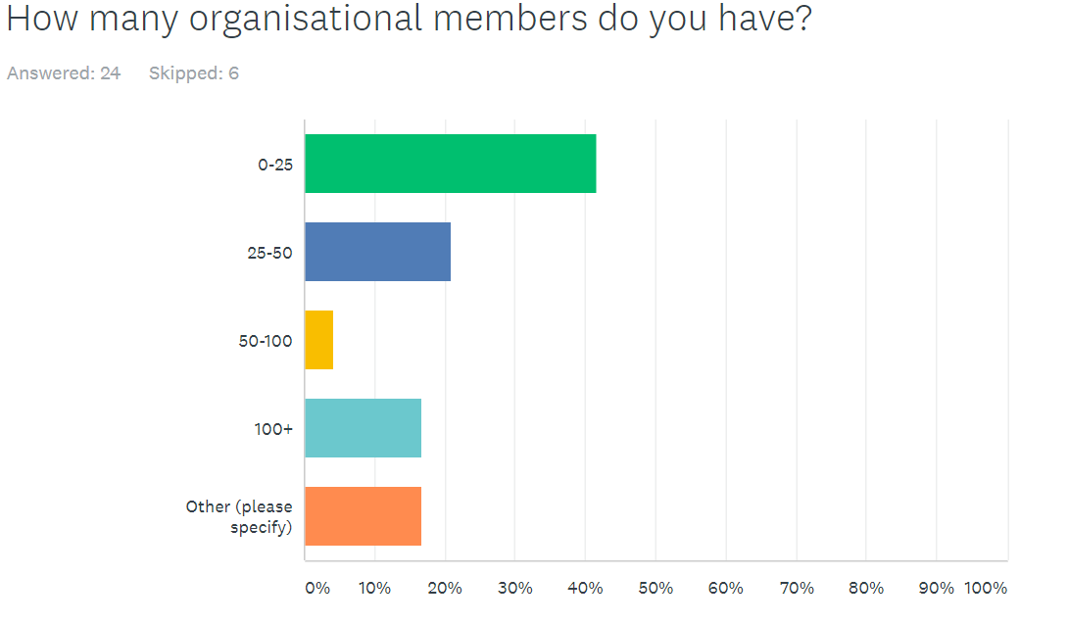
Analysis
Most EAPN members have 0 – 50 organisational members (almost 65%). Less than 20% of our members have more than 50 organisational members. This indicates that most of our members have a comparable membership structure to our own – a relatively small number of members – which could be useful when aligning our working methods, because we should be able to learn from each other.
How many individual members does your organisation have?
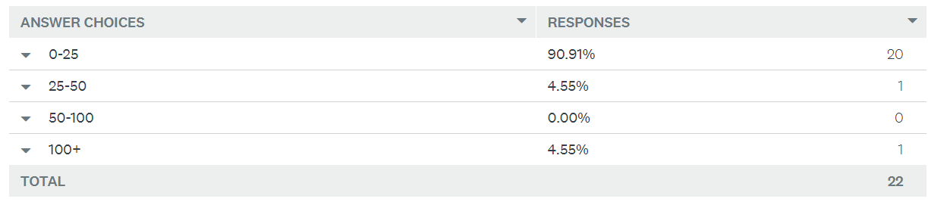
Analysis
Again, the vast majority of our members have a small (less than 25) number of individual members. It would be interesting to explore this further – do most of our members only work with organisational members? Could it be interesting to envisage opening up to individual members as a way of better engaging with people experiencing poverty, of galvanising more work and political support at the national level, of increasing our campaigning ability, or of diversifying our funding base?
Legal status
Almost all our EAPN members are legally registered in the country in which they are based – only 4 don’t have a legal presence (hosted by another organisation, usually a member).
Paid staff
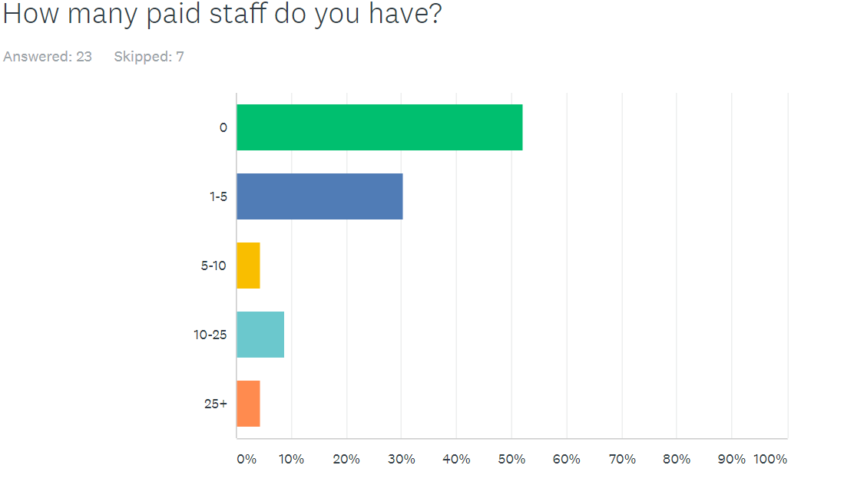
Analysis
Over half of our members have no staff, but some 10% have more than 10 staff. Of the responses, the only organisations to have more than 10 paid staff are our European organisations. No national networks who responded report having this many staff – though we know that EAPN Portugal and EAPN Spain have more than 10 staff members.
This brings up a critical issue of varying levels of capacity across our membership, and specifically the different capacities of our European members and our national members.
It may be worth exploring this issue further – have networks taken political decisions to not have paid staff, or is it because of a lack of financial resources? If it is the former, how best can we collectively work in this way? If it is the latter, how we can support national networks to increase their capacity?
How many active volunteers (someone who does at least the equivalent of one week’s voluntary work for the network per year, for example a Board member, do you have?)
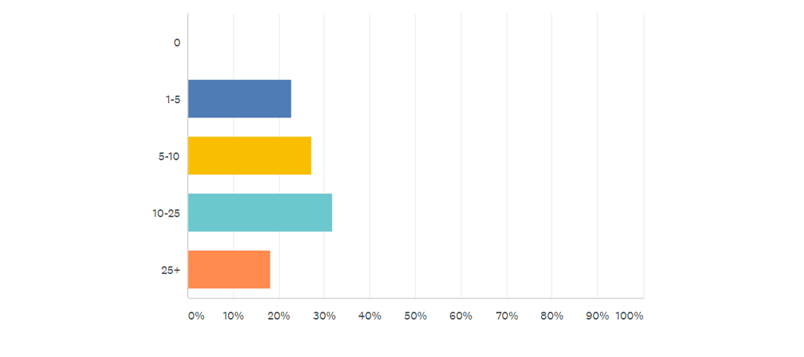

Analysis
While most members don’t have paid staff, all have volunteers. While capacity (finance and staff) is an issue, perhaps the bigger issue is making the most of the human capacity we already have, rather than insisting that we need more.
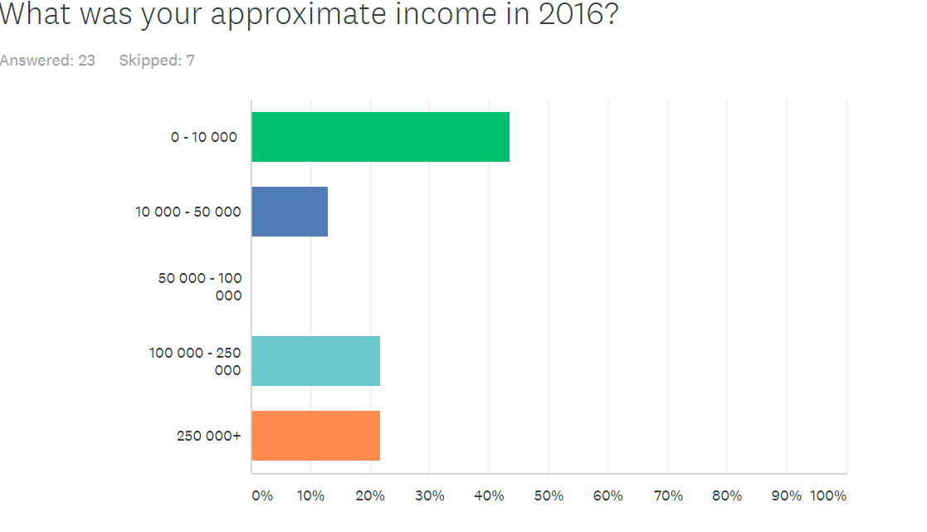
Analysis
The results are comparable to those in the question about staffing levels. Most of our national networks have annual income of less than 50000 euros, though four national networks (Belgium, Austria, Ireland, Norway) report having more than 100 000 euros annual income. We also know that EAPN Portugal and Spain have this level of income. European members make up the majority of members with larger annual income levels. This brings up the same issue of varying capacity within the network. But it also shines a spotlight on one of our values, notably:
“We believe in the possibility to achieve a better sharing of wealth, opportunities and resources”
We have this value in relation to the income of individuals and states. In order to build solidarity within the network, it may be worth considering how we can better share wealth, opportunities and resources within the network.
What is the ‘heart and soul’ of your network?
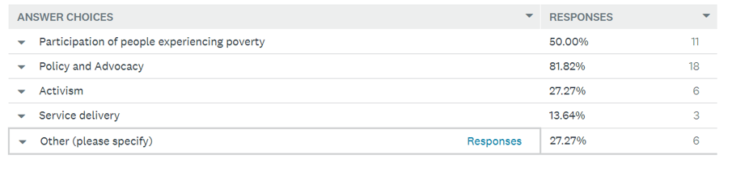
‘Other’ responses focused on membership and participation, public relations, redistributing surplus food (could be included in service delivery), journalism prizes, building a base of evidence for policy and service delivery, and the links between health and poverty.

Analysis
Policy and advocacy is the most unifying factor within EAPN, with some 80% of members recognising it as the heart and soul of their organisation. Far fewer members are motivated by activism or service delivery. Half of our members also consider the participation of people experiencing poverty as the heart and soul of their organisation. This should lead us to focus our efforts predominantly in these two areas, moving forward. That said, there is clear desire by some members to take a more campaigning and activist approach – it may be worth considering asking these members to take a lead in such a strand of work in the future, recognising their motivation and expertise. (Belgium, Salvation Army, Cyprus, Netherlands, Norway)
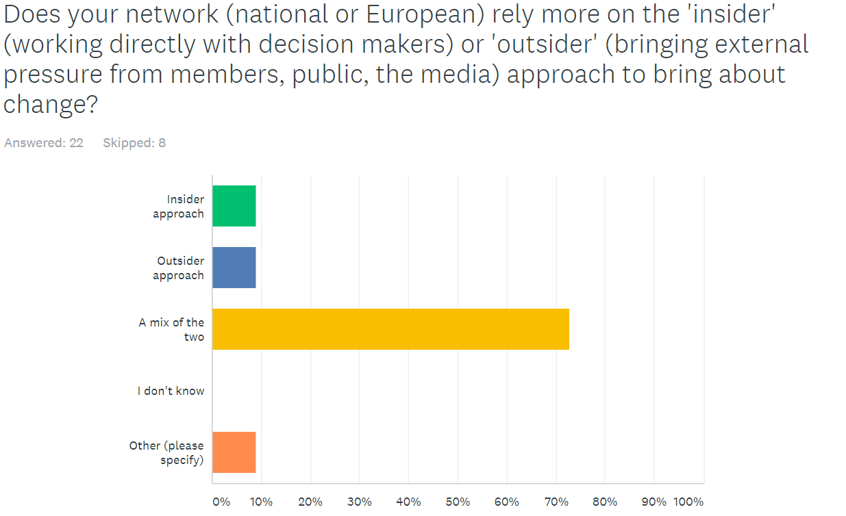
Analysis
Although most members focus on policy and advocacy, there is no clear split in the ‘approach’ favoured, with almost ¾ of the members employing a mixture of the insider and outside approach. This would suggest that EAPN should remain open to both tactics, but should perhaps occasionally recruit a campaigner, or should have one designated network (or small group) who would lead on our campaigning work.
Members were asked to highlight the three main issues they will focus on over the next few years. Responses can be divided into ‘thematic’ and ‘organisational’ and give us a good guide to where the energy in the membership may lie – thus helping us decide on what we should focus as a network over the next few years.

Analysis
Thematically, there could be value in EAPN focusing on migration, minimum income, child poverty and homelessness / housing, given the existing focus on these issues. Given that minimum income already has a project dedicated to it, we should consider focusing on migration, child poverty and homelessness / housing as themes moving forward in the next FPA.
That said – as one respondent highlighted elsewhere in the survey, in order to be successful, networks need to focus on what unites them, not what divided them. There are clear risks associated with focusing on migration – risks which we saw materialise recently.

Analysis
It is clear that EAPN members would like to focus on two main areas, notably People experiencing Poverty /participation (the two were often linked, highlighting the importance to EAPN of the participation of people experiencing poverty in our structures, as well as in European and national political processes) and network development / membership. Once again, it would make sense to build on these existing plans of our members, and to focus on these areas throughout the next FPA. (See below for further details of the capacity building needs of our members)
We asked members what we should prioritise as a European network.
We saw a similar division in answers, between a thematic and an organisation focus.

Analysis
Three thematic areas stand out here; notably:
- Labour markets (employment, jobs, wages, social protection systems)
- Migration / refugees
- SDGs / post EU2020
This is interesting, given the members’ focus (migration, minimum income, child poverty and homelessness / housing). It seems clear that our work on the labour market should clearly be continued – but it may make sense to develop a clearer focus on a small number of specific issues within this broad area. The proposed focus on the SDGs and EU2020 recognises that work has already started on this (2017 Policy Conference) and that there is scope for making meaningful change here.

Analysis
Two things clearly stand out once again, especially when we read this in conjunction with the members focus:
- PeP / participation
- Capacity building / network development
While focusing on ‘good practise to identify what actually works when lifting people out of poverty’ only received one vote, there could be value in focusing on this over the next few years, as it would give us a good opportunity to work in a positive frame, and to engage people who have experienced poverty directly. We may like to consider building this into the next FPA, and indeed the next long term plan.
QUESTIONS ON CAPACITY BUILDING NEEDS AND WHAT SHOULD BE ADDRESSED IN IRELAND
The survey included two questions on what the capacity building training in Ireland should focus on and they need to be analysed in relation to the question they are interdependent with.
- The first question about the capacity building training in Ireland was asked in relation to the thematic focus that EAPN should take on in the next years, notably 1) Labour markets (employment, jobs, wages, and social protection systems); 2) Migration / refugees and 3) SDGs / post EU2020.
Analysis
Responses highlighted the following themes:
- Migration – different aspects around it – trend beyond 2020, competition over resources between migrants and people experiencing poverty, integrating migration into the work of national EAPN networks.
- SDGs and the post 2020 EU strategy
- Strengthening the participation of people experiencing poverty in EAPN’s structures
- Miscellaneous: minimum income, campaigning and activism, gender equality, poverty and mental health

It is interesting to see that even if EAPN members would like to see EAPN focus on labour markets only one member would like capacity building on this in Ireland. This may be because members feel they have enough competences or experience to work in this area. However the recommendation made above on the need to better define and focus the interest on this thematic area should be further explored.
The immediate needs for training and capacity building on specific thematic issues are:
- Migration (most responses)
- SDGs and post 2020 EU Strategy
- Strengthening the participation of people experiencing poverty in EAPN’s structures.

- The second question related the capacity building needs of members to capacity building training in Ireland.

Analysis
The graph above shows that the four needs for capacity building identified by participants in the survey are 1) Carrying out transformative policy advocacy work (we see an overlap between three categories named by participants - national and European policy processes, advocacy strategies and challenging hostile governments. 2) How to actively engage members 3) How to work with the media; 4) Participatory methodology. Another capacity building need that stands out is fundraising.
When asked on which of these issues the capacity building training in Ireland should focus, participants in the survey highlighted the following three priorities: a) How to work with the media b) Participatory methodology and c) How to make members more active. The need to build capacity around advocacy work was mentioned as well but did not come across as strongly as in the answers to the previous question. Other capacity building needs mentioned were: addressing causes of extreme poverty, governance and internal democracy, and the need to organise initial capacity building trainings for members on the functioning of the EU, as one participant suggests below.
“I have no idea [what the focus of the capacity building training in Ireland should be]. Because things are how they are, we are dependent on external flow of money and we don't seem to be able to break this reality. This kind capacity building seems no use. A training of new individual NN members about the EU. What is the EU, what are they doing, what is the difference between council of ministers and the council of Europe, what was and is the purpose of the EU, and visiting the EU parliament... like we use to have. That will help us more.“

Recommendations based on the above findings

The findings of the survey should inform the work of the responsible team in EAPN Brussels and the Membership Development Group to make a decision about the focus that the capacity building training in Ireland should take. Bearing in mind the inevitable limitations of the survey, we make the following recommendations:
- Even if the questions on capacity building activities were specifically related to the training in Ireland, the results should also inform the overall capacity building work of EAPN
- The two questions about the focus of the capacity building training in Ireland had different intentions: one was inquiring about the thematic focus the training should have and the other one about organisational aspects on which EAPN’s national members need to have more capacity built. To establish the topic of the capacity building training in Ireland it would be useful the cross the priorities identified as a result of the analysis of answers to the two questions.
Potential topics for the training:
- Participatory methodologies for strengthening the participation of people experiencing poverty in EAPN’s structures
- SDGs, the post 2020 EU strategy and advocacy work at national and European level
- Migration and advocacy work
- Migration and how to work with the media
- As the need to build more capacity around the use of participatory methodology seems to be very important for our members, we propose to use a learning-by-doing approach and use different participative methodologies to run different sessions during regular EAPN meetings such as ExCo, EuISG and GA meetings and organise short debriefing sessions afterwards in order to support national members to better understand and apply the method in other contexts.
- As mentioned above the capacity building needs identified through this survey should not only be addressed through the training activity in Ireland but through other regular activities carried out by EAPN that have a capacity building dimension for national members such as: learning exchanges organised alongside ExCo and EUISG meetings, ExCo and EUISG meetings, and for certain topics short length webinars and online trainings could be organised.
- We also recommend that EAPN develops a more continuous and coherent approach to capacity buildings and integrates it better into its work. For example, some of the topics and issues identified as priorities by the participants in the survey easily lend themselves to webinars and online trainings – introduction about how the EU works, fundraising etc.
We asked members what a strong, effective and efficient EAPN Europe might look like three years from now.
As may be expected, there were a number of interesting and inspiring suggestions, based around the following groupings:
Advocacy
We should be an EAPN which:
- Is meaningfully involved in decisions around social policy at EU and national level, with our positions meaningfully considered by EC and national governments
- Pressures all EU governments
- Meaningfully holds the EU and member states to account on their commitment to reducing poverty
- Makes ‘offensive’ proposal on fundamental issues
- Has convincing messages on the economic case for human rights based approach to tackle poverty
- Has permanent communication channels with the Commission (with more DGs) and a ‘counselling voice’ to the European Parliament
- Is able to meaningfully advocate across all European countries, with the same messages
- Has the freedom and independence to raise issues which are not within the EU strategies
Participation / PeP
We should be an EAPN which:
- Has a convincing model on participatory practice & how user involvement improves outcomes
- Is based on more input from people living in poverty, and speaking up more for people not supported by the system
- Has the PeP meeting at the core of our network
- Uses the PeP meeting as the basis for the 'work' we should do as EAPN EU
- Is a platform for people experiencing poverty themselves (NB we should be or our national networks should be?)
- Effectively includes people experiencing poverty in its structures.
Ways of working
We should be an EAPN which:
- Creates and coordinates opportunities for members strategic engagement
- Has a well-financed secretariat, including an official, financed EAPN dedicated officer in each country/national team
- Is more horizontally connected (between members) to national different realities
- Has more active members - effective national networks campaigning against poverty, and are strong at the local, national and European level
- Communicates better, which clear messages and short, punchy presentations
- Shares good practise and results of projects
- Has developed and continuous communication channels with national networks
- Produces tools (templates, manuals) that can be of use for national networks
- Has a clear understanding of the added value of a European network
- Is member driven (understanding the national realities and assisting national networks in their work on the national level).
- Has a common sense of purpose and understanding of differences (especially richer and poorer countries)
- Sees, listens and understands & strengthens members, delivering on their priorities
- Supportive for members and as knowledge/experts/project base for NN
Activism / campaigns
We should be an EAPN which:
- Has less paper work more activism (like green peace)
- Effectively organises a campaign relevant to the national and the European level once every two years, involving as many members as possible.
- Fights until the end on our priorities
- Manages to mobilize for joint action

Analysis
- We are already working towards many of the ‘advocacy’ proposals – a big part of our success or failure will hinge on our ability to ‘meaningfully advocate across all European countries, with the same messages’. This should be a big focus of EAPN in coming years – in order to do so, we will need to focus on unifying themes, building on the priorities of members.
- There seems to be a strong sense that the participation of people experiencing poverty should be better integrated at all levels of EAPN. Again, this should be a focus moving forward – but we should recognise the challenges to doing this meaningfully, and we may need to build resources (both human and financial) in order to improve this.
- There are many strong proposals for improving our ways of working – these will be discussed within the staff team.
- A bi-annual campaign could be a very motivating action for our members – it may make sense if our members who are motivated by activism and campaigning could take a lead on this.

Members were then asked what we might need to do to build this strong and effective EAPN.
A number of strong ideas were proposed, which can again be grouped.
Get more resources
Idea: We need to secure more resources, both human and financial. We also need some independent resources, so that we are less dependent on the Commission.
Director’s proposal: This must be a priority over coming years. We will need to clarify what percentage funding we consider appropriate from the Commission, set ourselves targets and then decide how we will meet these targets. Will we prioritise foundations, governments, individuals, events? We may need to invest in a part time fundraiser / volunteer fundraiser / consultant for a short amount of time, funding permitting.
Work better with our members
- We need to create better involvement, better participation of our members
- We need to support capacity building of members to build strong social movements
- We need to better understand members and their needs
- We need to advise members, help them get resources
- We need to work better with our EOs, better integrating them into the network
Director’s proposals: Investigate the financial implications and possibilities of resourcing a full time Network Development / Membership Development Officer. Undertake an annual membership survey. Develop quick and simple ways for members to engage (representation opportunities, lobby letters, twitter campaigns, Facebook campaigns, shared actions) Ex Co to decide whether EOs are full members or associate members, and act accordingly.
Dare to be a network of and for PeP
- Focus on the active participation of PeP at all levels of EAPN, making this the heart and soul of EAPN.
- Have a working group for people experiencing poverty to exchange on how they are living their lives, focusing on trying to solve things.
Director’s proposals: Investigate what this would mean in practise, what it would look like, how much it would cost. This could be a specific piece of work done by a consultant, working with our PeP national coordinators and our networks who already have this at the heart and soul of their network. Recommendations could be put to the Ex Co in 2018.
Be a network
- Focus on what unites us, not what divides us – we are stronger together, so we should focus on the things on which we can all agree.
- Ensure we have, and we all understand, a common focus, with common aims, common advocacy positions, common projects. We are stronger when we act together.
- Motivate joint actions across the network
Director’s proposals: Over the next few years, we should move to a new model, where we agree that ALL members will contribute to the core work of EAPN – and we should clearly agree exactly what this core work will be. The majority of resources (human and financial) would go towards this core work. Other strands of work may also exist, but these would be ‘optional’, for members who have a specific interest. Fewer resources would go towards the optional strands of work.
Focus
- We should decide whether we are activists or advocates, and act accordingly.
Director’s proposal: This survey has shown that the majority of our members see the heart and soul of their organisation in policy and advocacy. A much smaller number see themselves are activists – but most of the organisations use a mix of insider (lobbying) and outsider (campaigning) approaches, so it would make sense for us to remain open to both approaches when necessary. We should decide whether it may be worth investing in a staff member to support specific campaigns, or whether we would put resources to specific members (or groups of members) to lead on certain campaigns.
Miscellaneous
- We should change our name to reflect what we stand for, not what we stand against
Director’s proposal: The Bureau should reflect on this!
We asked members to dream big – asking them for big, radical ideas on which we should work collectively over the next 5-10 years, which could make a real different to people experiencing poverty. Inspiring ideas included:
More effectively challenge regressive policies on migration
Analysis: Given comments on the need to focus on what unites us rather than what divides us, it may be wise for us as a network to agree to not focus collectively on migration, but to support specific members to work together on this issue in the future.
Focus on income redistribution and develop an alternative and inclusive economic model
Analysis: This seems feasible, although challenging – it would require significant expertise and external partnerships.
Have PeP as most visual and important part of EAPN
Analysis: This has come out clearly throughout the survey, and should clearly be a focus.
Aim to halve poverty in Europe in 10 years, eradicate it in 20.
Analysis: This would be an excellent, and highly concrete goal for us to adopt. We could link into the SDGs, and potentially build a lot of energy around this – it could be a core part of our work on SDGs / post Europe 2020. We could push states to translate SDG1 into post-EU2020, involve PeP and members in the campaign, develop positive stories about what works. A whole programme could be built around this!
Found a political party and run for offices in all parliaments
Analysis: It is not clear that this would be something which would unify our members, and would radically change the focus of the network.
Focus on universal basic income
Analysis: It is not clear that this would be something which would unify our members, given our long-term work on minimum income schemes. It may be more sensible to focus on having a position on UBI in the framework of our work on MI.
Radical pressure on the EU institutions to include as a Fifth Principle, or in the Maastricht Criteria, Social Protection as a means to a fair, just and social Europe”.
Analysis: This has the potential to mobilise members, but it risks becoming overly technical and dominated by a small number of members who can engage on this level. This should be a decision which is taken by the Executive Committee.
Focus on using human rights law and mechanisms as a way of combatting poverty and upholding rights, challenging states and / or EU institutions
Analysis: This could be very galvanising – we could have a campaign around this every couple of years, we would need to develop strong relationships with Dignity International, CESR, Amnesty and others. This is possible, but not in the context of the FPA with the Commission, which specifically states that such work cannot be financed. This would be something to consider in the longer term, if and when we have diversified our funding.
Revolution
Analysis: Our capacity for this is a little low!
We asked members about our communication tools

Analysis
15% of respondents thought that EAPN communicates too little, 45%the right amount & 40% thought that EAPN communicates too late, too much, in too much detail or with the wrong content/focus, based on the relevant feedback to the last question (below). 1 EO member thought that communications with them was too little. We should balance our communications with the various groups and all members more carefully, having clear objectives for our different communication tools. We should not be looking to communicate with our members less, we should focus on communicating better and more strategically.
How our different communication tools are rated

Analysis
Our website was rated best. Our email communication worst – 15% of members rated it poor or very poor. Members’ room, Flash & webinars fall in-between. Here again, email communication is highlighted as a priority area. We could focus on improving our email communication with members, on clarifying the objectives of our different channels to be more targeted and relevant, and building on the positive early experience of using webinars, which seems to have been welcomed by members.
We asked members how we could improve our communication activity as EAPN Europe
Over a dozen suggestions were made
- Shorter email communication with better focus on what’s important for who: e.g. summary information; split of info for EU-non-EU networks
Analysis
We could investigate better streamlining our communication channels, so that the ‘right’ information gets to the right members. The staff team could also be encouraged to write more concise and targeted emails to members.

- Send information to members further in advance
Analysis
Staff will be asked to send meeting documents two weeks in advance – this will require good forward-planning. For future campaign work, information will need to be sent much further in advance – this will require annual planning meetings of the staff team, which could take place in the context of the next FPA.
- Use shorter-format information better suited to new media, e.g. snappier, shorter
Analysis
Our policy papers need to be shorter, with clear Executive Summaries and recommendations at the start. Documents need to be laid it using more graphics. We could also look at using more infographics, videos, photos etc to complement our position papers.
- Publish a simpler-to-read version of the policy brief
Analysis
This would need policy team’s input but a good idea!
- Use the Yammer platform to share materials
Analysis
We should explore the possibility to make a part of our website available for interactive use to those with a Members Room password.
- Stop using the Reply-to-all feature on emails!
Analysis
Two options are available here:
- Emails to large groups should be sent using the bcc – this will automatically prevent the reply to all feature being overused
- Create google groups, and have the staff team moderate the flow of emails to avoid such occurrences.

- Use more plain speech instead of European Commission-speech
Analysis
For moments and places where the EU institutions are not the sole target audience, efforts should be made to avoid jargon and always explain EU processes in plain words.
- Send less draft documents, rather only final documents with useful summaries for the purposes of translation and communication nationally
Analysis
Draft documents should only be sent for comment and ideally only for 1 round of comments. Summaries of key messages together with key points from the papers can be envisaged.
Documents can be discussed on webinars – this provides an alternative route to providing feedback and can build ownership of the document, and indeed the network.
- Introduce different thematic communications to allow better flow to different workers in our European Organisations
Analysis
We could set up thematic google-groups and ask wider EO membership to join them. In the long-term we could envisage segmentation of mailings which notify only those people of work done/events coming up etc., focussed on one theme.
- Do serious study of best practice in multi-lingual networks
Analysis
In the context of the next FPA we might like to allocate some resources to help us deal with the question of translation / interpretation.
- Provide resources for members to at least input in their own language and have it translated into English
We would need to investigate what kind of resources might help the staff team deal with inputs in all of these various languages, because Google translate is a good start, but it doesn’t necessarily provide the level of accuracy required.

