N6. Evaluation of June 2017 Ex Co meeting

Logistical suggestions for the future:
Clearer, more precise information and instructions 2
More time for, and better organised group work
Send docs earlier
Shared Ex Co / EUISG session
Be clearer about expected results
Organise entertaining moments to build the network
Improve timekeeping
Accommodation needs to be less noisy
Not enough food at lunch, and was of low quality food at dinner
There were accessibility issues at the restaurants – this should be taken into consideration in the future.

Evaluation on post its - 2 questions
Q1: What was the most useful session at this ExCo Meeting?
Members were invited to put post-its on a flip chart. The word cloud below is a visual representation of the discussions members found most useful – the most prominent words are those which were highlighted the most often by members. Open Space discussions were highlighted as the most useful discussions by 8 networks, Financing for Social Protection by 3, and MFF by 2.
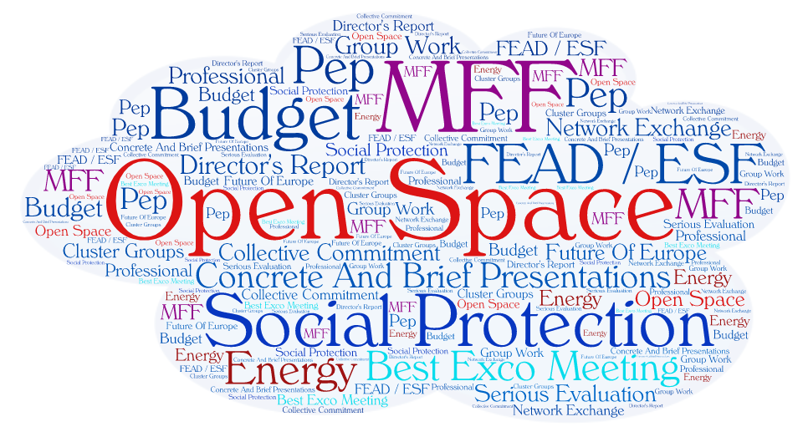

Q2: What topics would you like to discuss in the ExCo in the future?

Again, members were invited to highlight topics on post-its. Topics have been grouped into two main areas. There was much less agreement on where we should focus in the future – three networks want to see more national exchanges at the Ex Co, two want to spend more time looking at projects, and two want to focus more on social policy issues.

Internal functioning of EAPN | Issues
National exchanges and cooperation between networks 3 | Social policy issues 2
EAPN projects / joint projects 2 | Mental health and well being
EAPN principles, objectives and values | EU anti-poverty strategy
EOs role in EAPN | MFF
Streamlining EAPN governance | FEAD
More details of the Bureau and Bxl office | Energy poverty and sustainability
 | Inequality
 | Grassroots messages on poverty
 | Impact of poverty post-2020

