PRACTICAL INFORMATION
EAPN Conference and General Assembly, Dublin 19 to 21 October 2017

Accommodation
Rooms have been booked for you at the IBIS Hotel, Red Cow Roundabout, off Naas Road, Clondalkin, Dublin 22, Tel: + 353 (0) 1464 1480, , Dublin.

How to get to IBIS Hotel:
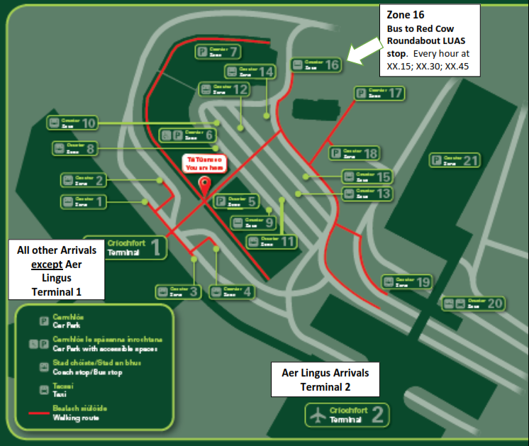
Take the Dublin Coach from Bus Zone 16 at Dublin Airport to Red Cow Roundabout Luas (tram) stop, beside the hotel.
If you cannot find it from this map, you can ask a Dublin Airport Customer Service assistant (pink T-shirts) or any other Dublin Airport staff how to get the Coach area. If all else fails, there is a 24 hour Dublin Airport information desk in Terminal 1 or ring EAPN Ireland staff.
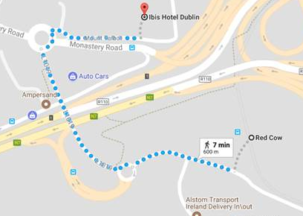
A Dublin Airport Customer Service staff member (pink shirt)
Take the Dublin Coach, direction Dundrum at 15 minutes or 45 minutes past each hour (€4 each way or direction ‘Portlaoise’ (€5) at 30 minutes past each hour
The Red Cow Roundabout Luas Stop is always the first stop after the airport. The bus journey takes 20 minutes. You can pay the driver €4 or €5 as above (or twice this for return).
The LUAS is the Dublin Tram system. The stop near the hotel, known as the Red Cow Luas stop, is also where the Dublin Coach bus from Dublin Airport stops The IBIS Hotel is about 7 minutes’ walk from the Red Cow Luas Stop. Walk up the hill from the bus stop and over the motorway bridge, where you will see the hotel on your left. There will be EAPN Ireland volunteers at the roundabout at most times..
Getting to the Conference Centre and the other venues
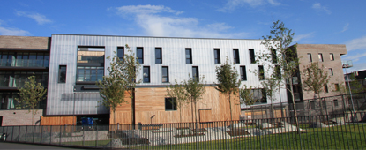
The meetings will take place in the F2 Centre, Reuben Plaza, Rialto, Dublin, Tel: 353 (0) 14716700
Walk from IBIS Hotel to the Red Cow Luas (tram) Stop (map on the page before)above).
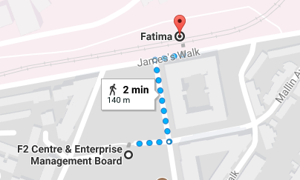
Take the Luas/tram from Red Cow Luas Stop to the Fatima Luas Stop (8 stops/16 minutes). Walk (2-5 mins) from the Fatima Luas Stop to the F2 Centre via Reuben Street. Please see map below for direction to F2 Centre from Fatima Luas Stop.
There will be EAPN Ireland volunteers to lead you.

Field Visits on Thursday afternoon, 19th October, 2017
You will be led to all of the field visits by staff and volunteers leaving from the Conference centre. The visits will be:
- Community participation in urban regeneration, hosted by Fatima Groups United
- Rights based approach to housing standards and community building, hosted by Community Action Network and Rialto Rights
- Travellers and Roma community development and rights, hosted by Pavee Point
- Peer research, housing and rights hosted by Focus Ireland
All are connected by the ‘Red Line’ Luas/tram system.
After the field visits there will be a short turnaround time in case you wish to return to the hotel before the social, particularly with visit C. You may prefer to stay in the City Centre. Volunteers will help you either way.
Social Events
- Thursday, Department of Employment and Social Protection, Busarus, Store Street, Dublin 1, 7pm
- Friday, Jury’s Inn, Parnell Street, Dublin 1, 7pm
Volunteers will guide you from your hotel.
Returning to Dublin Airport on Saturday
You can either leave your luggage at the hotel in the morning and return the same way as you came or take your luggage to the conference centre. From the conference centre, you can return the way you came (Luas t5ram to Red Cow Roundabout and Dublin Coach to the Airport) or take the Luas to Heuston station and change to the 747 bus to Dublin airport. The latter route is slower but the busses are much more frequent. More detailed information will be available at the conference centre.
Getting Around
LUAS (Dublin Tram) Red line

Tram direction Tallaght or Saggart
 | Red Cow | Hotel | IBIS Red Cow Hotel | 3 minutes walk from Luas
 | Kylemore
 | Bluebell
 | Blackhorse
 | Drimnagh
 | Goldenbridge
 | Suir Road
 | Rialto
 | Fatima | GA. Field Visits A & B | F2 Centre | Beside Luas stop
 | James's
 | Heuston
 | Museum
 | Smithfield | Field visit D | Focus Ireland Housing, Stanhope Green | 15 minutes walk from Luas
 | Four Courts
 | Jervis
 | Abbey Street | Dinner Friday | Jury’s Inn, Parnell Square | 10 minutes from Luas
 | Busáras | Dinner Thursday | Busarus | Beside Luas stop
 | Connolly | Field visit C | Pavee Point | 10 minutes walk from Luas
Tram direction Connolly or Point

Dublin Airport *  City Centre  F2 Conference centre *  * Red Cow IBIS Hotel | 