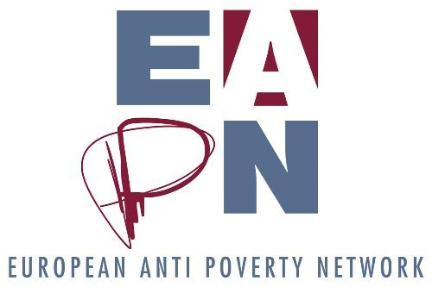

EAPN position on the MFF - March 2018
Executive Summary

EAPN’s key messages on the MFF include:

- The level of spending under the MFF must not decrease
- The MFF must support the implementation of the European Pillar of Social Rights and the Sustainable Development Goals
- The MFF must prioritise combating poverty and social exclusion
- The EU must maintain an ambitious target to combat poverty, supported by a large-scale poverty and social inclusion programme
- At least 30% of this programme must be ring fenced for combating poverty and social exclusion
- These funds must be allocated, as a priority, to active inclusion for those most affected by poverty and social exclusion
- Europe must recognise civil society as full partners in EU funding processes
- Grassroots anti-poverty projects developed by civil society organisations must be able to access EU funds under the MFF

- Background

The Multiannual Financial Framework (MFF) is the tool through which the rules for the formation of the European Union budget are defined, and which has been used to address the challenges that have confronted the Union over the years; the MFF review tool should also serve to anticipate the issues that will have to be addressed in the years to come including on the basis the choices that will be made by the European Council on the scenarios for the future of Europe.

The current debate on the MFF takes place at a time when, following the long depression due to the financial and "social" crisis of the last 10 years, a recovery is expected to be able to improve the conditions of Europeans, but has yet to do so for many. It also comes in the context of Agenda 2030 and the Sustainable Development Goals (SDGs), the EU2020 strategy and the debate on its successor (particularly the target on reducing poverty) and the recent adoption of the European Pillar of Social Rights.

Data tells us that the situation of citizens, particularly in relation to poverty, has deteriorated. Today the situation is worse than in 2008. The Europe 2020 strategy has nine targets to be reached by 2020. The only target which is not seeing any progress, unfortunately, is the target related to people at risk of poverty or social exclusion.
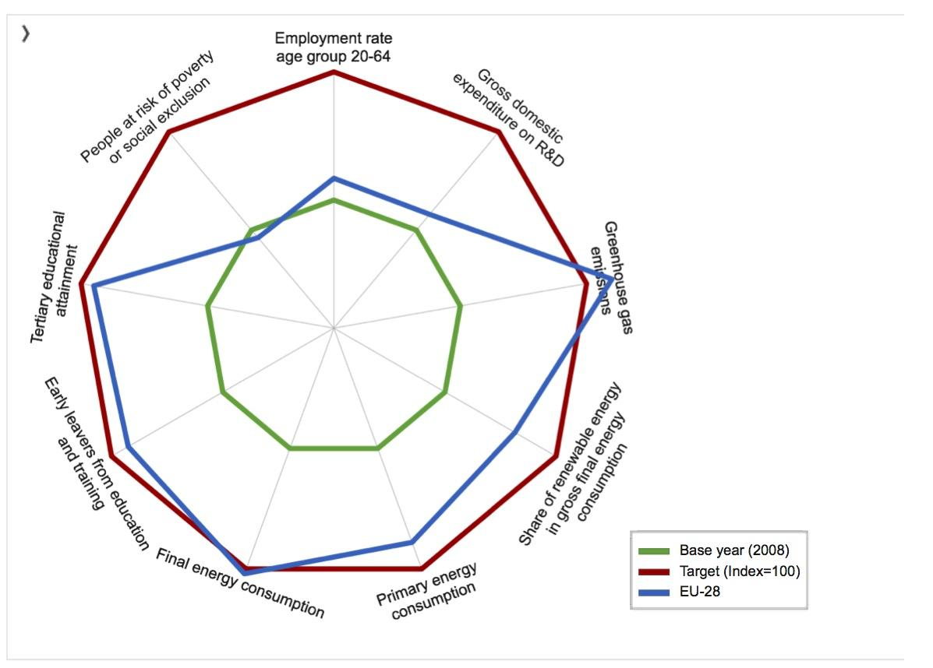
Ref: http://ec.europa.eu/eurostat/web/europe-2020-indicators/europe-2020-strategy
This diagram presents the current situation of the EU for the nine indicators by showing the progress made since 2008 and the distance still to cover towards the Europe 2020 key targets.

EAPN hopes that this data will strengthen the resolve of the European Commission and Member States to fight, with every possible effort, poverty and exclusion, making every possible effort (including increasing funding) - to make up for lost time and to reach the EU2020 objectives.

During the years EAPN has focused on European Structural Funds, particularly the European Social Fund (ESF) and the Fund for European Aid to the Most Deprived (FEAD), and on programmes such the EaSI programme and Horizon 2020 (the EU research programme). The EAPN Barometer Report was developed in 2015, looking at the impact of earmarking of least 20% of the ESF to fighting poverty and social exclusion, and the code of conduct on partnership.

2. Objectives as defined in the Treaty on the European Union

The MFF must help deliver on the EU's objectives as specified in the treaty : “It shall combat social exclusion and discrimination, and shall promote social justice and protection, equality between women and men, solidarity between generations and protection of the rights of the child. It shall promote economic, social and territorial cohesion, and solidarity among Member States”

3. Financing

- While Brexit will have a number of financial implications for the European project as a whole, it is important that the level of spending under the MFF does not decrease. As we hear regularly, Europe is facing new and multiple challenges - it is thus unrealistic to expect to be able to meet these challenges with less money. We know that much more progress needs to be made in tackling poverty and social exclusion - and this requires financial investment. As such, innovative ways should be found to increase investments for social inclusion and social cohesion, or to at least maintain the current levels of spending.
- As extra financial resources are needed to tackle poverty and social inclusion, new forms of financing must be found. A Europe wide financial transaction tax, and meaningfully tackling tax avoidance and evasion would be good places to start.
- Leaders must recognise the legitimate anger from European citizens at a political system which tacitly accepts 120 million people living in or at risk of poverty and social exclusion, while simultaneously permitting the elite to avoid paying billions of euros of tax, which should be used to finance public services. A coordinated European action against tax avoidance and evasion is necessary so that multinationals pay the taxes they owe in the relevant jurisdictions.
- At least 50% of any additional funds should be dedicated to the fight against poverty and social exclusion in Europe, via the implementation of the European Pillar of Social Rights and the Sustainable Development Goals. Funds must be allocated, as a priority, to guarantee active inclusion for those affected by poverty and social exclusion.

4. Key propositions

Combating poverty and social exclusion is one of the specific goals of the EU and its Member States in the field of social policy, but in accordance with Article 153 TFEU, social inclusion is to be achieved solely on the basis of non-legal cooperation — the open method of coordination (OMC).

At this time of risk of a lack of solidarity, and increasing divisions between peoples and within states, there is a need for the Heads of State and Government to have long-term political courage in choosing to finally embark on a path of greater union, where politics prevails over the rules and where European citizenship and social protection is the primary focus of the European Union.

We call on the European Commission and Member States to assume their responsibility to ensure that the fight against poverty is central to the European Union's policies and priorities, and for this to be recognised in the next MFF. Our key asks include:
- Prioritising the fight against poverty and social exclusion
- Launching a new large scale social inclusion program
- Better including civil society organisations as full partners in EU funding processes

4.1. Prioritising the fight against poverty and social exclusion
With the current instruments it will not be possible to achieve the goal of poverty reduction as established in Europe 2020. We believe that it is necessary to:

- Multiply efforts and economic resources to make up for lost time for effective delivery on the Europe 2020 target to reduce poverty by at least 20 million by 2020
- Maintain an ambitious target to move towards the eradication of poverty for the 2030 strategy, built on the Europe 2020 strategy, and supporting the implementation of the European Pillar of Social Rights and the Sustainable Development Goals
- Combating poverty and social exclusion is one of the specific goals of the EU and its Member States in the field of social policy, in accordance with Article 153 TFEU and the European Parliament Resolution of 24 October 2017 on minimum income policies as a tool for fighting poverty. The next MFF should support an ambitious follow up of this article, including using the Open Method of Coordination (OMC) to its full potential and introducing a directive on Minimum Income Schemes
- Allocate sufficient resources for the meaningful implementation of the European Pillar of Social Rights, including for the implementation of principle 14 (introduction of a European Minimum Income scheme)
- Support the implementation of the Sustainable Development Goals
- Increase significantly the level of expenditure of the EU Programme for Employment and Social Innovation (EaSI), recognising its capacity to make a meaningful impact on levels of poverty and social exclusion and ensuring increased opportunities for anti-poverty organisations and other actors to engage in transnational exchange and learning

4.2. Launching a new large-scale poverty and social inclusion programme
EAPN highlights the need for a new large-scale poverty and social inclusion program, within the ESF+ which integrates the European Social Fund (ESF) and the Fund for European Aid to the most Deprived (FEAD) (the so-called ESF+ programme) to improve combating poverty and social exclusion. We would like to make the following remarks on the proposal of an ESF+:

- Ensure that, as a minimum, 30% of this fund (but not less in absolute terms then in the current MFF) is ring fenced for combating poverty and social exclusion, and that funds are allocated, as a priority, to active inclusion for those most affected by poverty and social exclusion
- Ensure that funds dedicated to poverty reduction and social inclusion in the proposed ESF+ are effectively spent, by developing clear criteria to track and monitor this expenditure.
- Ensure that the content of the ESF+ is based on the European Pillar of Social Rights in order to support the implementation of the Pillar across Member States
- Ensure more robust implementation of the ex-ante conditionality of the anti-poverty programs and actions based on integrated active inclusion – which must be an active part of the delivery of the programme
- Recognise that civil society organisations, including anti-poverty NGOs, are a crucial part of the European democratic project, and a way to rebuild the trust which is currently lacking between European citizens and their institutions, by ensuring the sustainability of funds for social inclusion networks and supporting transnational exchanges on the fight against poverty and exclusion
- Build an independent monitoring system with the active involvement of stakeholders including civil society and experts with experience of poverty
- Meaningfully include experts with experience of poverty and their organisations in the design, delivery and evaluation of the programme
- Facilitate social innovation and the exchange of best practices between NGOs of the Member States
- Recognise the difficulties small NGOs have in making large financial contributions to such projects, and provide grants which don’t insist on such contributions
- The ESF+ should address geographical communities and communities of interest (i.e Roma/Travellers, People with Disabilities, Single Parents) who experience high levels of poverty and social exclusion
- The enlarged fund should be done with due respect to the nature, objectives and regulations of each funding line and the resulting ESF+ fund should keep autonomous budgets for the current ESF, FEAD, recognising the need to give FEAD the change to develop

4.3. Better including civil society organisations as full partners in EU funding processes

The level of trust that European citizens have in the European Union is low. Civil society organisations have a particular focus on the most marginalised citizens, and as such are best-placed to ensure that their voices are heard. This makes civil society a key part of the solution. By specifically recognising the role of civil society organisations in delivering on some of the founding values of the European Union, the MFF can meaningfully contribute to tackling this problem of legitimacy and trust. Concretely this means that the MFF must recognise the space of civil society by:

- Promoting a stronger implementation of the Code of Conduct via the introduction of an ex ante conditionality on the partnership principle to ensure it is correctly applied, and transposing the key elements of the Code of Conduct into ex ante conditionality applicable to all major funding streams
- Ensuring adequate support for: a) building the independent monitoring of delivery through the monitoring committees, b) activation of survey of civil society stakeholders, c) specific engagement with beneficiaries, i.e. people with direct experience of poverty
- Ensuring engagement of grassroots organizations as part of civil society engagement in design, delivery and evaluation of the use of grants. Diverse funding modalities and mechanisms – especially grants – should be made available to civil society under all instruments/programmes (both thematic and geographic). The requirements for project proposals should be proportional to the size of the grant awarded, and simplification should consider not only the management phase but also the selection phase
- Ensuring access of grass-root anti-poverty projects developed by NGOs, with dedicated support made available to smaller projects, with and grants particularly offering 100 percent up-front funding, to overcome technical and financial obstacles
- Simplifying programme requirements and evaluation
- Providing more support and technical assistance be given to support the implementation of bottom-up, innovative approaches by NGO’s and grass-root organizations working alongside key target groups at the project level
- Providing grants offering 100% or high % upfront funding - an important way to overcome financial obstacles for engagement

Active Inclusion is an integrated strategy, built on three interconnected, but independent, strands: adequate income support (adequate minimum income), access to quality services and support into quality jobs through inclusive labour markets. This integrated, comprehensive strategy is rooted in fundamental rights and offers an integrated pathway approach that could make a real difference in developing effective means to counter the persistence of poverty, exclusion and long-term unemployment

