

REFLECTION PAPER

EAPN Financing Social Protection

Reflection Paper

mARCH 2018

Executive summary

Social Protection, and how to finance it, have long been key issues for EAPN. We believe that quality welfare schemes are essential to promote more equal social and sustainable development, to reduce inequalities, and to prevent and tackle poverty and social exclusion.

The financial crisis, the subsequent austerity measures, the "retrenchment of welfare state" and the anticipated impact of technological changes on the labour market attract growing attention. The European Pillar of Social Rights has led to a renewed EU level focus on rights of access to social protection.

However, while the social, economic and political implications of social protection systems and the need of their improvement are widely recognized, the usual arguments for the financial inability to provide adequate social protection continue to dominate the debates. EAPN is sometimes accused of having utopian and unrealistic ideas when it comes to social protection financing.

The aim of this paper is to contribute to the economic arguments for how to finance high quality social protection schemes. The paper is based on EAPN’s vision of quality social protection systems, and presents important paths which could provide funds to support such systems. These paths are organised around four main axes, which are further developed in proposals for concrete actions:



**Improve public budgets:** Revisit and improve the financial regulative frameworks; Reallocate public expenditures; Re-shape tax systems; Enhance independent social audits;



**Address quality of jobs and insurance systems:** Focus on quality of jobs; Consider policies toward primary distribution; Expand social security coverage; Reconsider the design of insurance systems;



**Normalize the responsibilities of national and international institutions:** Improve financial control; Manage debts in socially useful way; Increase transparency and responsibilities for policies undertaken;



**Consider the EU wide prospect:** Harmonize the social protection systems in EU; Clearly target the EU funds at social indicators and make their usage conditional on progress made; Introduce a global tax on wealth across EU; Learn lessons from EU member states and EU history;

There are grounds to believe that combining these paths would contribute not only to well-designed social protection systems but to a sound and good society as well. It is important to underline: there is clear evidence that options to finance high-quality social protection schemes in all EU Member States do exist and their implementation depends primarily on political will.

Introduction

Social protection enhances the well-being of individuals, families, communities and societies by shaping better distribution of and access to goods and resources and by playing an important role in response to different risks (such as poverty, social exclusion, insecurity, unemployment, disability, etc.).[1] The Treaty on the Functioning of the European Union (TFEU, Art. 9)[2] explicitly includes the guarantee of adequate social protection as a requirement of the Union when defining and implementing policies.

Social protection is an indispensable element of the European social model**[3]** and of the"good society" – a society that stimulates peace, social solidarity and harmony, a society in which people are happy to live. After World War II the recognition that high quality social protection systems are needed for society, and policies implemented in this regard, have led to the so called Golden Age of Western democracies.[4]

However the economic and social trends, including the rise of inequalities, the concentration of wealth, opportunities, prospects and power, austerity measures, poorly understood fiscal consolidation, effectiveness and efficiency, etc., have produced questionable attention to social protection, mainly as a means to reduce public deficit and debts. These developments subordinate social protection to ‘emploization’, activation and myths about “the undeserving poor, benefit cheats, scroungers, etc.” result in limiting access and widening inadequacy[5] and the failure to provide essential services to people at times of crisis[6]. This constitutes a false economy as it results in avoidable suffering and almost inevitably gives rise to greater costs in the long term. In fact such trends result into deep fundamental challenges for the EU: retrenchment of welfare states, weakening of the EU mission, breakdown of its founding values, the EU’s alienation from the citizen’s interests, the separatists’ trends, etc.

Recent developments, like the European Pillar of Social Rights and the Sustainable Development Goals provide new windows of opportunities to adequately re-focus on the rights of access to social protection on European and global levels. Still, these initiatives need to be further developed from abstract principles and opportunities to well-thought-out mechanisms to guarantee a move in the desired direction. Such mechanisms should **clearly identify what is and what is not acceptable in terms of adequacy, coverage and universality, minimum thresholds, levels of inequality, quality jobs, etc.** Otherwise, these recent developments could just be again submerged in the vagueness of bureaucratic reports and "unexpected" consequences as many others before them.

The social protection system EAPN would like to see

EAPN argues that quality welfare schemes are essential to promote more equal social and sustainable development[7]. In this respect, several basic principles should be at the heart of the social protection system:

**A. No one is left behind**: Adequate access (eligibility) to social benefits for all who need social protection; Adequate range of covered social risks (risk groups); Reliable tools for identifying those who should have access.

**B**. **Real, meaningful and adequate support for individuals and families**: The whole social protection system should be based on socially acceptable and constantly updated amounts of the different benefits defined by adequate benchmarking methods (for example, reference budgets); The financing should be governed by quality of life considerations instead of the current dominating employment & financial considerations; This will build the real capacity of the social protection to significantly reduce poverty, social exclusion and inequalities;

**C**. **Non-regression rule**: Any proposal for reducing the level of coverage or access needs to be subjected to a prior assessment of the social impact; Thus fluctuation of the financing of the system depending on the economic situation should be avoided; The system needs to be constantly monitored through an adequate system of indicators which will lead to updating its basic parameters (coverage, eligibility and amounts of benefits);

**D**. **Preventive functions**: The social protection system should not only aim to eliminate the negative consequences of social risks but also to seek to develop prevention. This should include empowering and resourcing social, community and advocacy workers and other statutory service providers to incur expenditure in order to prevent family breakdown, homelessness and other crises resulting in substitute care arrangements for children and dependent adults.

**E.** **Democratic Governance:** Development and implementation of adequate social technologies to effectively involve target groups and those working with marginalised individuals & communities in the system management, in particular participation in the creation of reference budgets, in social impacts assessments and evaluations, in the proposals for updating and changes.

In order to enforce these principles it is important to:

* **Clearly recognize social protection and wellbeing of all as political priority,** giving priority to a Social Investment Pact that balances the Fiscal Compact;
* **Provide the necessary funding** by earmarked EU funds based on established threshold or benchmark below which spending on social protection should not fall.
* **Block policies contributing to opposite directions:** If fiscal consolidation and austerity measures continue to undermine social protection systems, poverty will be even further increased[8].

Aims of social protection

Social protection is a human right, legally binding on Member States, as per many EU and international documents. It should guarantee that social rights are upheld, providing social security, life in dignity and real chances for human development.

If adequately designed, social protection system positively contributes both to individuals and societies. The social protection system that EAPN believes in should aim to:

1. Alleviate the impacts of insecurity, poor health, economic and social vulnerability by bettering the quality of life of vulnerable people living in difficult situations;
2. Provide socially acceptable living standards capable to ensure a dignified life for all;
3. Enhance welfare, including supporting people to live independently rather than invest in profit motivated services that promote dependency;
4. Generate preventive and sustainable effects by strengthening the resilience of individuals, families and communities and enhancing the ability to respond to risks
5. Reduce individual and national poverty rates;
6. Strengthen the cohesion of societies by reducing inequality, building social justice and effectively eliminating social exclusion and isolation
7. Promote of sustainable and inclusive economic growth, productivity and employability, quality jobs and consumer demand;
8. Maintain political stability.
9. Address the root causes and dynamics that undermine people's safety, security and wellbeing[9]

How quality social protection could be financed?

While **social, economic and political implications** of social protection systems are widely recognized[10], the usual arguments for the financial inability to provide adequate social protection continue to dominate the debates. However, in the face of the concentration of wealth, the misuse of public funds and the increasing riches of the EU and Member States, these arguments seem questionable at best, aIs it political **inability**, **incapacity** or **unwillingness** to finance such systems?.

The World Social Protection Report 2017-2019 proposes a variety of options to expand fiscal space and generate resources for social protection, even in the poorest countries[11].

Here EAPN presents important paths which, together, could quality social protection systems throughout the EU. It is important to underline that combining these paths would contribute not only to well-designed social protection systems but to a sound and good society as well.

These paths could be systematised into 4 basic axes:

1. **Improve public budgets**
2. **Address quality of jobs and insurance systems (with contributory schemes) thus decreasing the pressure for social assistance (non-contributory ones);**
3. **Normalize the responsibilities of financial ministries, national governments, international institutions and the EU;**
4. **Consider the EU wide prospect.**

Multiple and interlinked options are connected with these four important axes to finance well-designed social protection systems.

1. ***Improve public budgets***

**A1 Revisit and improve the financial regulative frameworks and stop the financialization process within the EU member states.** There is need for better financial norms and rules to protect the public interests in reference to corporate taxation, concessions, public procurements, privatizations, loans taking & financial balances that currently often privatize profits while socializing the losses. B**uilding sound financial normative frameworks based on social commitments will contribute to increasing public budgets.**

**A2. Reallocate public expenditures** to social protection systems, recognising social concerns. **EAPN proposes a Golden Rule on Social Protection spending – i.e. Social Protection expenditure should not fall under 35% of GDP. Recognising the discrepancies between European countries, a Silver Rule could indicate that Social Protection expenditure should not fall under 30% of GDP.** Fiscal savings and other state revenues stored in special funds as well as discounts in the calculations of public deficit and debt when necessary could be used in this regard.

**A3. Re-shape tax systems by better balancing between the interests of different groups in a society.** The EU member states have different tax systems and not all of them are clearly oriented to cope with income inequalities, poverty and social exclusion. The taxation systems’ trends in the last decades need to be reconsidered. **EAPN considers necessary clear recommendations for progressive taxation and tax wedges, higher direct taxes and lower indirect taxation. – such changes to national tax systems could provide meaningful funds for social protection systems. In additions, a European wide financial transaction tax, and meaningful efforts against tax avoidance and evasion would complement such tax policies and could provide additional funds for social protection systems.**

**A4. Independent social audits** on social protection systems could track and propose ways for eliminating spending inefficiencies and thus increase and better target public budgets.

1. ***Address quality of jobs and insurance systems (with contributory schemes) thus decreasing the pressure for social assistance (non-contributory ones);***

**B1. Focus on quality of jobs**. Sound labour incomes are effective way to simultaneously increase public budgets (due to their link with insurance and taxation systems), and decrease the need for non-contributory social assistance (due to their link with many contributory benefits: pensions, unemployment benefits, sickness benefits, motherhood benefits, etc.). However, the share of salaries in GDP keeps decreasing, especially in some member-states. Clear guidance on labour share in GDPs, quality of jobs, link of minimum wages to costs of living, decrease of working poor rates, etc. could turn jobs into a basic pillar of living standards and social protection systems. **No doubt a society with well-paid employees and a low unemployment rate has lower needs for social assistance and can focus on generous and adequate support for those who need them.**

**B2.** **Monitor and control** wage/salaries disparities.[12]. Different ways to address this problem exist and are well known (by taxation, salary caps, etc.) and they all could contribute to public budgets. As stated, **EAPN favours clearly designed progressive taxation in this regard[13]**

**B3. Expanding social security coverage** is often linked to the need to include informal economy in the official economy. This will undoubtedly increase the inflow in the insurance and taxation systems. Arguments against often include statements linked to the role of informal economy as poverty alleviator. However a sound and quality social protection system could prevent such dangers. Additionally enforcing untaxed adequate minimum income could contribute as well. There is an obvious need to differentiate the ways addressing different wage categories of employees in this regard. Especially necessary is to **review the insurance systems considering exemptions for well-paid staff, including government and other employees.**

**B4. Reconsider the design of insurance systems** – data on pension incomes are important to provide evidence on the available pension systems and their adequacy. The recent trend in Hungary and Poland to return to PAYG public system instead of staying in the ill performing private pension funds suggests a need of social impact assessment of pensions’ reforms during the last decades. Additionally there is need for a clear guidance on non-adequate insurance ceilings – especially for healthcare (which means that high salaries do not pay the same rate of health insurance and the system is designed to produce regressive tax wedges). Healthcare systems in EU are supposed to be solidarity and ceilings on health insurance could hardly be explained, especially in countries with bad health indicators. Abolishing health insurance ceilings (upper limit on health insurance contributions) will increase the budgets for the healthcare, which is an important part of the social protection system. What is more there are EU member-states without ceilings for health insurance and they could be used as good practices. **Improving insurance systems through a fairer distribution of costs between different income groups will strengthen the contributory schemes and reduce the pressure on the non-contributory ones.**

1. ***Normalize the responsibilities of financial ministries, national governments, international institutions and the EU***

**C1. Improve financial control and its transparency.** Corruptive practices and illicit financial flows deprive public budgets of revenues needed for social protection[14]. Researchers of offshore cash flows and financial havens, link them to the lack of regulations, information (bank secrecy) and knowledge[15]. Vague normative financial frameworks and ‘legal’ corruption need decisive actions and higher responsibilities of financial ministries and tax authorities.

**C2. Managing debts**: many countries in South and East Europe need to restrict their social protection systems due to the combined effects of debts borrowed at high costs and austerity measures. The options for debt restructuring have to be seriously considered with the democratic involvement of people concerned and adopting rules for transparent and personal responsibilities of executives who have made the debts. In this regard the experience of Iceland could be very informative.

**C3. Increasing transparency and responsibilities for policies undertaken:** Many reforms linked to social protection (pension, healthcare, taxation, deinstitutionalisation, austerity, ‘retrenchment of welfare state’) have been suggested by international organizations. Now it is clear that many of these ideas have produced negative effects – accumulating social problems and higher price for societies. Increasing the transparency and responsibilities for policies undertaken will provide societies with opportunities to take part in the decision making and to decrease the price of social protection reforms.

1. ***Consider the EU wide prospect:***

**D1. Address the need to harmonise the social protection systems:** While there are powerful trends in harmonization of economic and financial policies, liberalizations, de-regulations, privatizations, retirement age increase, enforcing conditionality in active labour market programs, transferring energy production to renewables, ecological standards, size of cucumbers, standards for happy chicken and many others, the refrain of the uniqueness of each country is unconvincingly but persistently repeated with regard to basic for citizens social indicators. It has to be clear: no economic and monetary union is possible without social union. And the social dumping is only one very small detail in all these. There is a growing need of harmonization trend, including incomes and living standards against the currently increasing divergence among EU member-states. In this regard there are plenty of actions to be undertaken:

**D2.** The EU funds to be clearly targeted at social indicators and conditioned on clear reports how cohesion is achieved within and among the member-states;

**D3.** The availability of EU funds to be conditional on the question how they deliver on social rights;

**D4.** Usage of EU labour market initiatives, for example ‘Youth guarantee’ to enforce really quality jobs and inclusive growth, based on clear indicators instead on propaganda clichés;

**D5.** Using the European Semester process to insist on social indicators’ progress and not allowing macroeconomic and financial recommendations to lead into the opposite directions;

**D6.** Requiring countries with low values on key social indicators to elaborate and implement clear roadmaps for how they will work toward reaching EU averages and how they will finance their social protection systems. These roadmaps have to be elaborated together with social stakeholders. Access to special EU funds should be conditional on progress made.

**D7.** A tax on wealth across EU, with proceeds used to finance social protection

**D8. Learn lessons from EU member states and EU history.** As Stiglitz points out “The nature of growth now is radically different from that after the World War II…Then the welfare was shared”[16]. As a consequence in the most developed countries the GDPs in post-war EU were lower than now while the quality of social protection systems was higher. Combining practices from the Nordic countries and from the period 1950-1973 of Western democracies provide enough lessons how sound social protection systems could be financed.

Conclusion

There is clear evidence that plenty of different options to finance high quality social protection schemes in all EU member states do exist. **It depends not on money but on political will.**

EAPN is ready to work actively for adequate social protection systems to be established in EU and encourages it members to incorporate the reflections in this paper in their thinking and positioning.

**Annex 1. The status of this document**

**This paper is issued on behalf of the Financing for Social Protection Committee,** a sub-group of the Executive Committee. The original draft was produced by Maria Jeliazkova of EAPN Bulgaria, based on desk research (predominantly on existing EAPN positions) and the results of discussions at the Executive Committee meeting of June 2017. This draft was then shared with the Financing for Social Protection Committee, and detailed comments were received by the International Federation of Social Workers, as well as EAPN Europe. The redrafting was coordinated by Maria Jeliazkova of EAPN Bulgaria, and it was possible to incorporate most the inputs received.

The second draft was shared with all EAPN members, and detailed comments were received from EAPN Ireland. EAPN Bulgaria coordinated the redrafting process, with the support of EAPN Europe. In accordance with the EAPN protocol on forming policy positions, the final version was signed off unanimously / by an ordinary majority (delete as appropriate) of the **Financing for Social Protection Committee**

**Diversity of opinion within civil society**

Whilst EAPN members have a range of views on certain topics, all members are united in working to bring about a social Europe, free of poverty and social exclusion, with access to economic, social and cultural rights for all.

During the process of writing this paper, different opinions emerged within EAPN on the level of Social Protection spending EAPN should recommend Member States commit to. No members opted out of this reflection paper.

**ANNEX 2**

**Current levels of expenditure on Social Protection Systems[17]**

Levels of expenditure on Social Protection currently vary greatly from one state to another, from 14.5% of GDP in 2014 (Latvia) to 34.3% of GDP (France)

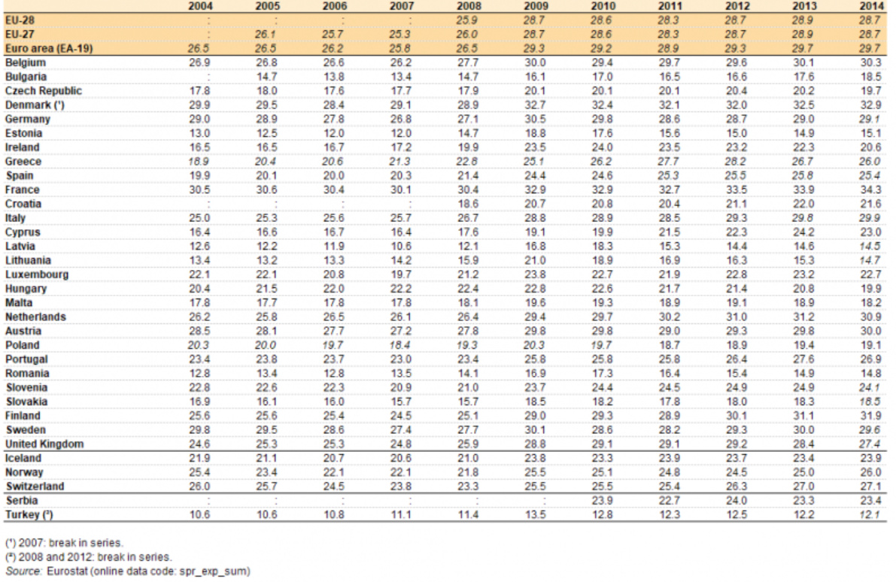

**People at risk of poverty or social exclusion**

|  |  |  |  |  |  |  |  |  |  |  |  |  |  |  |  |  |  |  |  |  |  |  |  |
| --- | --- | --- | --- | --- | --- | --- | --- | --- | --- | --- | --- | --- | --- | --- | --- | --- | --- | --- | --- | --- | --- | --- | --- |
|  | | ***2006*** | | ***2007*** | | ***2008*** | | ***2009*** | | ***2010*** | | ***2011*** | | ***2012*** | | ***2013*** | | ***2014*** | | ***2015*** | | ***2016*** | |
| Belgium | | 21.5 | | 21.6 | | 20.8 | | 20.2 | | 20.8 | | 21 | | 21.6 | | 20.8 | | 21.2 | | 21.1 | | 20.7 | |
| Bulgaria | | 61.3 | | 60.7 | | 44.8 | | 46.2 | | 49.2 | | 49.1 | | 49.3 | | 48 | | 40.1 | | 41.3 | | 40.4 | |
| Czech Republic | | 18 | | 15.8 | | 15.3 | | 14 | | 14.4 | | 15.3 | | 15.4 | | 14.6 | | 14.8 | | 14 | | 13.3 | |
| Denmark | | 16.7 | | 16.8 | | 16.3 | | 17.6 | | 18.3 | | 17.6 | | 17.5 | | 18.3 | | 17.9 | | 17.7 | | 16.7 | |
| Germany | | 20.2 | | 20.6 | | 20.1 | | 20 | | 19.7 | | 19.9 | | 19.6 | | 20.3 | | 20.6 | | 20 | | 19.7 | |
| Estonia | | 22 | | 22 | | 21.8 | | 23.4 | | 21.7 | | 23.1 | | 23.4 | | 23.5 | | 26 | | 24.2 | | 24.4 | |
| Ireland | | 23.3 | | 23.1 | | 23.7 | | 25.7 | | 27.3 | | 29.4 | | 30.3 | | 29.9 | | 27.7 | | 26 | | 24.2 | |
| Greece | | 29.3 | | 28.3 | | 28.1 | | 27.6 | | 27.7 | | 31 | | 34.6 | | 35.7 | | 36 | | 35.7 | | 35.6 | |
| Spain | | 24 | | 23.3 | | 23.8 | | 24.7 | | 26.1 | | 26.7 | | 27.2 | | 27.3 | | 29.2 | | 28.6 | | 27.9 | |
| France | | 18.8 | | 19 | | 18.5 | | 18.5 | | 19.2 | | 19.3 | | 19.1 | | 18.1 | | 18.5 | | 17.7 | | 18.2 | |
| Croatia | | : | | : | | : | | : | | 31.1 | | 32.6 | | 32.6 | | 29.9 | | 29.3 | | 29.1 | | 27.9 | |
| Italy | | 25.9 | | 26 | | 25.5 | | 24.9 | | 25 | | 28.1 | | 29.9 | | 28.5 | | 28.3 | | 28.7 | | 30 | |
| Cyprus | | 25.4 | | 25.2 | | 23.3 | | 23.5 | | 24.6 | | 24.6 | | 27.1 | | 27.8 | | 27.4 | | 28.9 | | 27.7 | |
| Latvia | | 42.2 | | 35.1 | | 34.2 | | 37.9 | | 38.2 | | 40.1 | | 36.2 | | 35.1 | | 32.7 | | 30.9 | | 28.5 | |
| Lithuania | | 35.9 | | 28.7 | | 28.3 | | 29.6 | | 34 | | 33.1 | | 32.5 | | 30.8 | | 27.3 | | 29.3 | | 30.1 | |
| Luxembourg | | 16.5 | | 15.9 | | 15.5 | | 17.8 | | 17.1 | | 16.8 | | 18.4 | | 19 | | 19 | | 18.5 | | 19.8 | |
| Hungary | | 31.4 | | 29.4 | | 28.2 | | 29.6 | | 29.9 | | 31.5 | | 33.5 | | 34.8 | | 31.8 | | 28.2 | | 26.3 | |
| Malta | | 19.5 | | 19.7 | | 20.1 | | 20.3 | | 21.2 | | 22.1 | | 23.1 | | 24 | | 23.8 | | 22.4 | | 20.1 | |
| Netherlands | | 16 | | 15.7 | | 14.9 | | 15.1 | | 15.1 | | 15.7 | | 15 | | 15.9 | | 16.5 | | 16.4 | | 16.7 | |
| Austria | | 17.8 | | 16.7 | | 20.6 | | 19.1 | | 18.9 | | 19.2 | | 18.5 | | 18.8 | | 19.2 | | 18.3 | | 18 | |
| Poland | | 39.5 | | 34.4 | | 30.5 | | 27.8 | | 27.8 | | 27.2 | | 26.7 | | 25.8 | | 24.7 | | 23.4 | | 21.9 | |
| Portugal | | 25 | | 25 | | 26 | | 24.9 | | 25.3 | | 24.4 | | 25.3 | | 27.5 | | 27.5 | | 26.6 | | 25.1 | |
| Romania | | : | | 47 | | 44.2 | | 43 | | 41.5 | | 40.9 | | 43.2 | | 41.9 | | 40.3 | | 37.4 | | 38.8 | |
| Slovenia | | 17.1 | | 17.1 | | 18.5 | | 17.1 | | 18.3 | | 19.3 | | 19.6 | | 20.4 | | 20.4 | | 19.2 | | 18.4 | |
| Slovakia | | 26.7 | | 21.4 | | 20.6 | | 19.6 | | 20.6 | | 20.6 | | 20.5 | | 19.8 | | 18.4 | | 18.4 | | 18.1 | |
| Finland | | 17.1 | | 17.4 | | 17.4 | | 16.9 | | 16.9 | | 17.9 | | 17.2 | | 16 | | 17.3 | | 16.8 | | 16.6 | |
| Sweden | | 16.3 | | 13.9 | | 16.7 | | 17.8 | | 17.7 | | 18.5 | | 17.7 | | 18.3 | | 18.2 | | 18.6 | | 18.3 | |
| United Kingdom | | 23.7 | | 22.6 | | 23.2 | | 22 | | 23.2 | | 22.7 | | 24.1 | | 24.8 | | 24.1 | | 23.5 | | 22.2 | |
| Iceland | | 12.5 | | 13 | | 11.8 | | 11.6 | | 13.7 | | 13.7 | | 12.7 | | 13 | | 11.2 | | 12.5 | | : | |
| Norway | | 16.8 | | 16.5 | | 15 | | 15.2 | | 14.9 | | 14.5 | | 13.7 | | 14.1 | | 13.5 | | 15 | | 15.3 | |
|  | |  | |  | |  | |  | |  | |  | |  | |  | |  | |  | |  | |
| Source of Data: | | Eurostat | |  | |  | |  | |  | |  | |  | |  | |  | |  | |
| Last update: | | 08.03.2018 | | | |  | |  | |  | |  | |  | |  | |  | |  | |
| Date of extraction: | | 11 Mar 2018 17:41:01 CET | | | | | |  | |  | |  | |  | |  | |  | |  | |
| Hyperlink to the table: | | http://ec.europa.eu/eurostat/tgm/table.do?tab=table&init=1&plugin=1&language=en&pcode=t2020_50 | | | | | | | | | | | | | | | | | | | |

**Japan and EU: Share of Salaries in GDP**

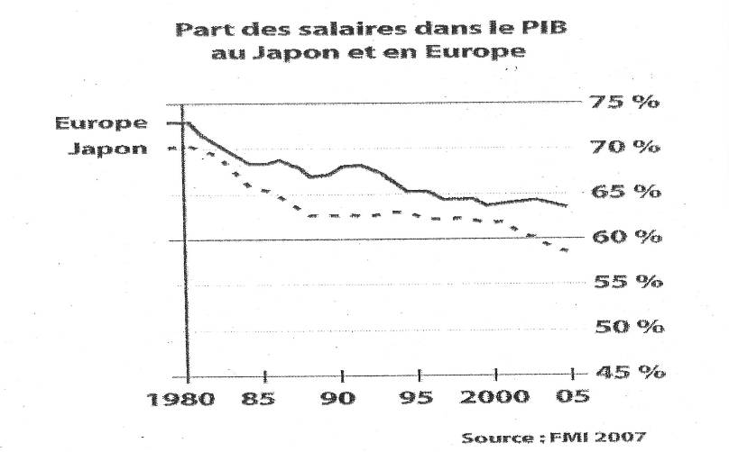

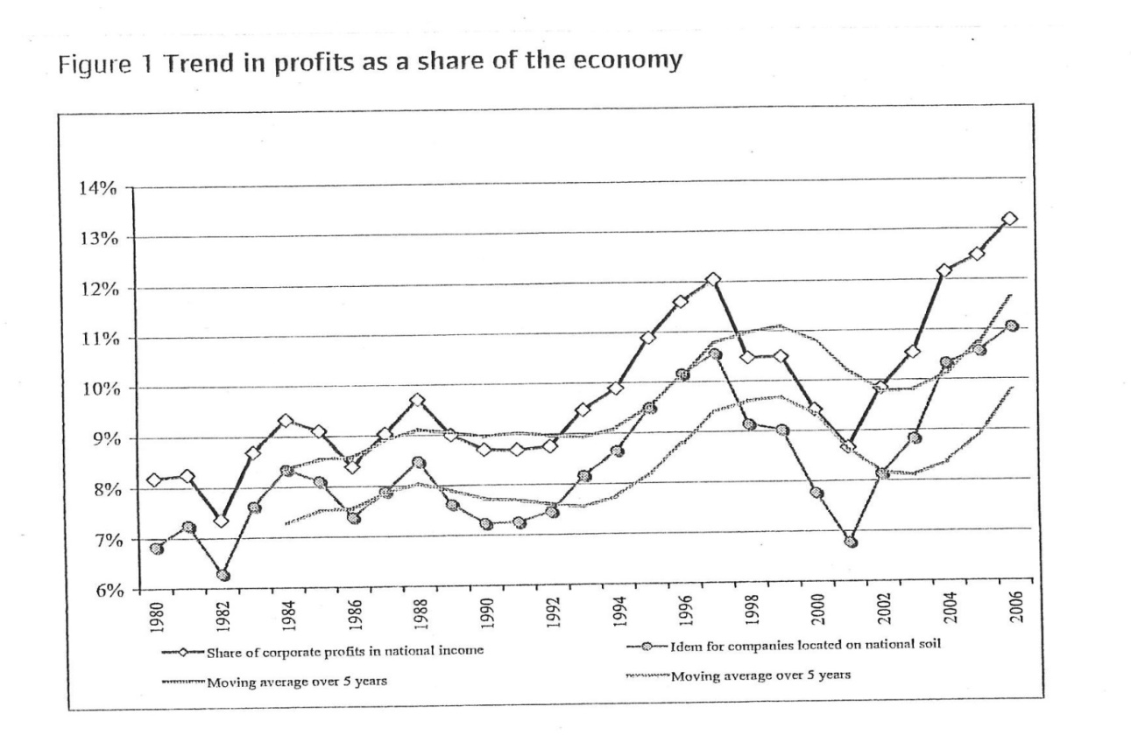

**Reduction of corporate tax in the EU (average)**

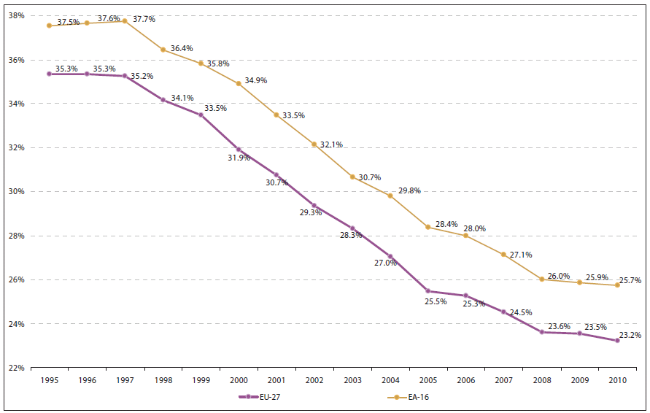

Source: European Commission (2010a). Note: adjusted statutory tax rate on corporate income for EU-27 and euro area averages, in percentage, 1995-2010; цит. по D. Rinaldi, Public Resources, Redistribution and Fiscality in the Fight Against Poverty, Council of Europe, p. 11



Annex 5:

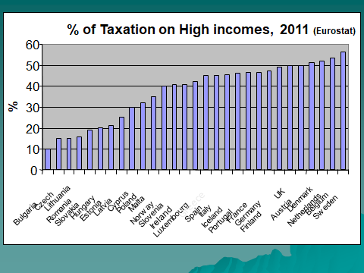

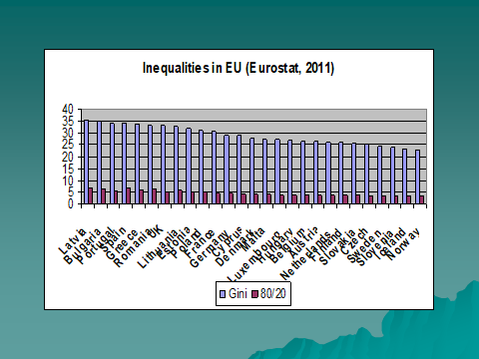



1. European Commission, Employment, Social Affairs and Inclusion, <http://ec.europa.eu/social/main.jsp?langId=en&catId=1063>
2. „In defining and implementing its policies and activities, the Union shall take into account requirements linked to the promotion of a high level of employment, the guarantee of adequate social protection, the fight against social exclusion, and a high level of education, training and protection of human health.”
3. ETUC, Social Protection Policy/Social Inclusion, <https://www.etuc.org/issue/social-protection>, downloaded on 15.12.2017
4. Data and analyses proofs that the period 1950-1973 represents the “golden age” for the developed countries could be found in A. Maddison, A. Samwick “Four eras of income inequality”, etc.
5. [Social Protection Committee annual report 2017](http://ec.europa.eu/social/main.jsp?catId=738&langId=en&pubId=8048&furtherPubs=yes)
6. See for example the film “I Daniel Blake”, directed by Ken Loach
7. See for example: Final declaration EAPN General Assembly 2016; Last Chance for Social Europe? EAPN Position Paper on the European Pillar of Social Rights, 2016; EAPN Proposals on New Commission Integrated Guidelines: Economic and Employment, 2015; Presenting the European Minimum Income Network (EMIN), September 2013; “EU needs a new Social Vision, Process, and Strategy to Fight Poverty based on strong social protection systems and services, as well as quality jobs and financed by fair tax!” A letter to: Ministers of Social Affairs, EPSCO, Meeting on the 21-22 June, 2012, EAPN.
8. “EU needs a new Social Vision, Process, and Strategy to Fight Poverty based on strong social protection systems and services, as well as quality jobs and financed by fair tax!” A letter to: Ministers of Social Affairs, EPSCO, Meeting on the 21-22 June, 2012, EAPN
9. IFSW’s global statement “The Role of Social Work in Social Protection Systems: The Universal Right to Social Protection”<http://ifsw.org/policies/the-role-of-social-work-in-social-protection-systems-the-universal-right-to-social-protection/#.WeeximEJ7MM.gmail>
10. ETUC considers social protection as a crucial driver for universal social rights, economic development and quality job creation. According to the Shared Mission for Universal Social Protection, adopted by ILO and World Bank Group in 2015: “There is considerable rigorous scientific evidence that well-designed and implemented social protection systems can be the foundation for sustained social and economic development – for individuals, communities, nations and societies.”
11. World Social Protection Report 2017-2019, ILO, Geneva, 2017, p.184. The 8th financing options proposed are: 1. Reallocating public expenditures; 2. Increasing tax revenues; 3. Expanding social security coverage and contributory revenues; 4. Lobbying for aid and transfers; 5. Eliminating illicit financial flows; 6. Using fiscal and central bank foreign exchange reserves; 7. Managing debt: borrowing or restructuring existing debt; 8. Adopting a more accommodating macroeconomic framework.
12. “Poverty and Inequality in Societies of Human Rights - The Paradox of Democracies: Living in dignity in the 21 century”, ed. A. Scruiba, Council of Europe, 2013
13. Additionally a maximum income threshold could be a stimulus for increasing the low incomes.
14. See for example, the Global Financial Integrity database: <http://www.gfintegrity.org/>
15. Thierry Godefroy, Pierre Lascoumes, Le capitalisme clandestine. L’illusoire regulation des places offshore. Paris, La decouverte, 2004.
16. J. Stiglitz, The Price of Inequality: How Today’s Divided Society Endangers our Future, 2012

   
17. The graphs in this section are available via <http://ec.europa.eu/eurostat/statistics-explained/index.php/Social_protection_statistics>