EAPN
CONTRIBUTION TO THE DISCUSSION ON THE WHITE BOOK ON THE FUTURE OF EUROPE
EXCO members of the Future of Europe working group, led by EAPN Spain, wrote this draft, with contributions from several EAPN National Networks
CONTENTS

I. WHY MUST EAPN GET INVOLVED IN THE DISCUSSION OF THE FUTURE OF EUROPE? 2
II. INTRODUCTION 3
III. THE PILLAR OF SOCIAL RIGHTS… IS IT AN ACTUAL CHANGE? 3
IV. LISTENING TO THE EUROPEAN CITIZENS 4
A. SOMETHING IMPORTANT IS MISSING IN THIS REASONING… 5
B. WHAT IS THE EU POPULATION THINKING ABOUT THE EU? 5
1. TRUST 8
2. GLOBALISATION 12
3. SOLIDARITY 13
C. RECOMMENDATIONS 14
V. THE SCENARIOS FOR EUROPE 16
A. IS THERE ROOM FOR A “SOCIAL” SCENARIO 6? 16
VI. PROPOSALS FOR A SOCIAL EUROPE 17

WHY MUST EAPN GET INVOLVED IN THE DISCUSSION OF THE FUTURE OF EUROPE?

EAPN must be involved in the discussion on the Future of Europe because there is much at stake.

Firstly, the fact that a quarter of the European population has been at risk of poverty and exclusion for more than a decade indicates a high level of malaise, which could fairly be called a "major social crisis". While one of the five goals of the Europe 2020 strategy aspired to reducing by at least 20 million the number of people in or at risk of poverty and social exclusion (from 115.9 million in 2008 to 95.9 million in 2020), in 2015 these citizens already accounted for 117.6 million in the EU-28. Moreover, 32.2 million disabled people were at risk of poverty and social exclusion in 2010, as well as 26.5 million children, taking the overall percentage to unacceptably high levels (23.7%). The rise in inequality since the economic crisis has especially impacted women, single parent families, the young, non-EU residents, the unemployed, the in-work poor, among others, exacerbating poverty among them and excluding them even more from the labour market.

Secondly, because austerity policies have involved cuts in social spending, and even the countries with the more developed Welfare States maintain AROPE rates above 10% of the population.

Thirdly, despite stark statistical data, there are still strong doubts about the need for social convergence and harmonization at European level within the Council, who supports subsidiarity as an iron corset for preventing a stronger Social Europe.

Fourth, because citizens maintain a level of detachment and / or mistrust of the European Union's role in their lives, basically because they do not feel protected in their economic and social rights in a clear and effective way. Increasing inequality is one of the biggest challenges, as it undermines social confidence and reduces support for democratic institutions. It lurks behind the new toxic relationship that western societies have established with their future and explains much of recent resentment-driven electoral phenomena and the surge of identity politics with its disruptive backlash.

Fifth, because the Pillar of Social Rights does not contemplate any dialogue or governance process with civil society and, worst of all, does not establish mechanisms to promote poverty eradication, as it relies on Member States’ commitment to the Pillar.

The different scenarios have large social consequences. The scenario involving a setback to the past contemplates the free movement of citizens as the only social policy. The approach of a Europe split in “different speeds” can bring poverty alleviation to some member states, but it will generate more inequalities than those existing today. The fifth scenario, to do more together, does not end up committing itself to a social Europe, as we believe it is necessary. That is why a sixth scenario, committed to a new and strong Social Europe, is fundamental.

EAPN needs to be fully involved in this crucial debate because we are a channel for the demands of people living in poverty, as well as for our mission to promote the democratic participation of civil society.

INTRODUCTION

This document wants to bring fresh views about what EAPN already analysed regarding the 5 Scenarios proposed by President Juncker.

In the first part, we present key findings of the recently published Eurobarometer 461, where EU citizens were questioned about very significant matters for the purpose of our debate:

- Their trust in the EU, national governments, justice, and the media;
- The impact of globalization in increasing inequalities, and the role of the EU in protecting people from its negative consequences;
- Solidarity as a key value for the EU.

Next, we draw some recommendations on how these figures and trends could help EAPN prepare a more accurate and efficient strategy towards a more social and fair EU.

In the second part, we take into account the Italian document to consider the possible scenarios, and we pay specific attention to the civil society proposal, named as Scenario 6.

In the third part, we outline 10 proposals which could be included in a better, stronger and fairer Pillar of Social Rights.

THE PILLAR OF SOCIAL RIGHTS… IS IT AN ACTUAL CHANGE?

EAPN welcomes the adoption of the Communication and the Social Pillar package as an important demonstration of a will to deliver on President Juncker’s promise of the “Social Triple A”, at a time when Europe faces the consequences of long standing mistakes and a real threat of disintegration. However, we are concerned about the concrete impact on the lives of the 1 in 4 Europeans living in poverty. Will it help to guarantee or reinforce their social rights? Will it help to rebalance the EU priorities to ensure economy policies deliver for people, not just for business? These in the end will be the key tests if people are to renew their faith in Social Europe.

Initial key positive elements include a clear rights-based approach aiming at upward convergence on rights as well as improving take up of rights. Some important improvements are seen in the key principles – for example the recognition that children have a right to protection from poverty, the new provision of a right to social protection to apply to all types of workers; the recognition of the right to adequate unemployment benefits for reasonable duration, and very importantly for EAPN, the explicit stating of the right to a minimum income that ensures a life in dignity. The legislative proposals on work-life balance and access to social protection also appear a positive step forward, as do the extension of a social scoreboard and the mainstreaming of monitoring through the European Semester.

However, the Pillar remains a framework of principles rather than binding obligations that can guarantee rights, particularly for the most vulnerable, and initially it is only focused on the Euro area, and this is one of the major concerns. The lack of focus on poverty and social exclusion (beyond children), or link to Europe 2020 targets raises high concerns. We would need to see more concrete benchmarks particularly in key areas of social protection and social inclusion, linked to active inclusion, and explore in detail how the package will be implemented on the ground with the involvement of Member States and stakeholders. The lack of concrete legal and non-legal initiatives and proposals for EU frameworks on minimum income, minimum wage and funding levels for social protection raises worries of how the package will benefit those people who are not working, or only in poor quality jobs. Finally, whilst civil society is identified as an actor to aid implementation, civil dialogue is not considered on a par with social dialogue, which is a very difficult to understand – and accept – missed opportunity.

LISTENING TO THE EUROPEAN CITIZENS

On 1 March 2017, the European Commission presented a White paper on the Future of Europe, setting out challenges and opportunities for Europe in the coming decade. A Special Eurobarometer survey focused on EU citizens’ opinions about different topics linked to the White Paper.

The Survey clearly states that the burning issues are related to the European Union staying behind other world economies, considering its shrinking share in the global GDP. Accordingly, persistent high unemployment, “the migration crisis” and “terrorist threats” are causing “instabilities”, which in turn provoke this delay.

“The European Union is the world’s largest single market, the largest trade power, and the largest development and humanitarian aid donor. The euro is the second most used currency in the world. However, the EU share of the global GDP is shrinking and unemployment remains too high, despite a significant improvement in the last four years. The migration crises and terrorist threats and attacks add to a sense of instability and transition, which is reinforced by geopolitical uncertainties”.

SOMETHING IMPORTANT IS MISSING IN THIS REASONING…

As in the 5 possible scenarios drawn by the EC, increasing inequality and high poverty rates are neither a major cause of concern, nor are they considered as key explanatory issues. The facts that a quarter of the EU population living in AROPE is not able to take full part in the markets, that nearly 10% of those who are employed are living in poverty as well, or that 43% of lone-parent families are in poverty, do not get into the EU reasoning. But it should.

EAPN’s mission should also be to remind the EC that social cohesion adds to economic competitiveness, and that it is an added value to the European economy.

WHAT IS THE EU POPULATION THINKING ABOUT THE EU?

Eurobarometer 88 on Public opinion (fieldwork done in November 2017) showed the main concerns at European level. Immigration and terrorism are clearly leading: at 39% (+1 percentage point since spring 2017) and 38% (-6) respectively, both items are mentioned more than twice as often as any other issues. Though the increase is limited (+1), immigration has gained ground for the first time since autumn 2015, after a 20-percentage point decline between autumn 2015 and spring 2017. After a steep rise between autumn 2016 and spring 2017 (+12), which took terrorism to the top of the ranking for the first time, this concern has now lost some ground, falling to second place. However, it is still far ahead of economic issues: the economic situation is in third place (17%, -1), the state of Member States’ public finances in fourth (16%, -1) and unemployment in fifth (13%, -2). In sixth place, climate change is now mentioned by 12% of Europeans after a 4- point increase, achieving a double-digit score for the first time since autumn 2010. Other items are mentioned by no more than 10% of respondents: crime (10%, unchanged), the EU’s influence in the world (9%, unchanged), the environment (8%, +2), rising prices/inflation/cost of living (7%, unchanged), pensions (4%, +1), energy supply (3%, unchanged) and taxation (3%, unchanged).

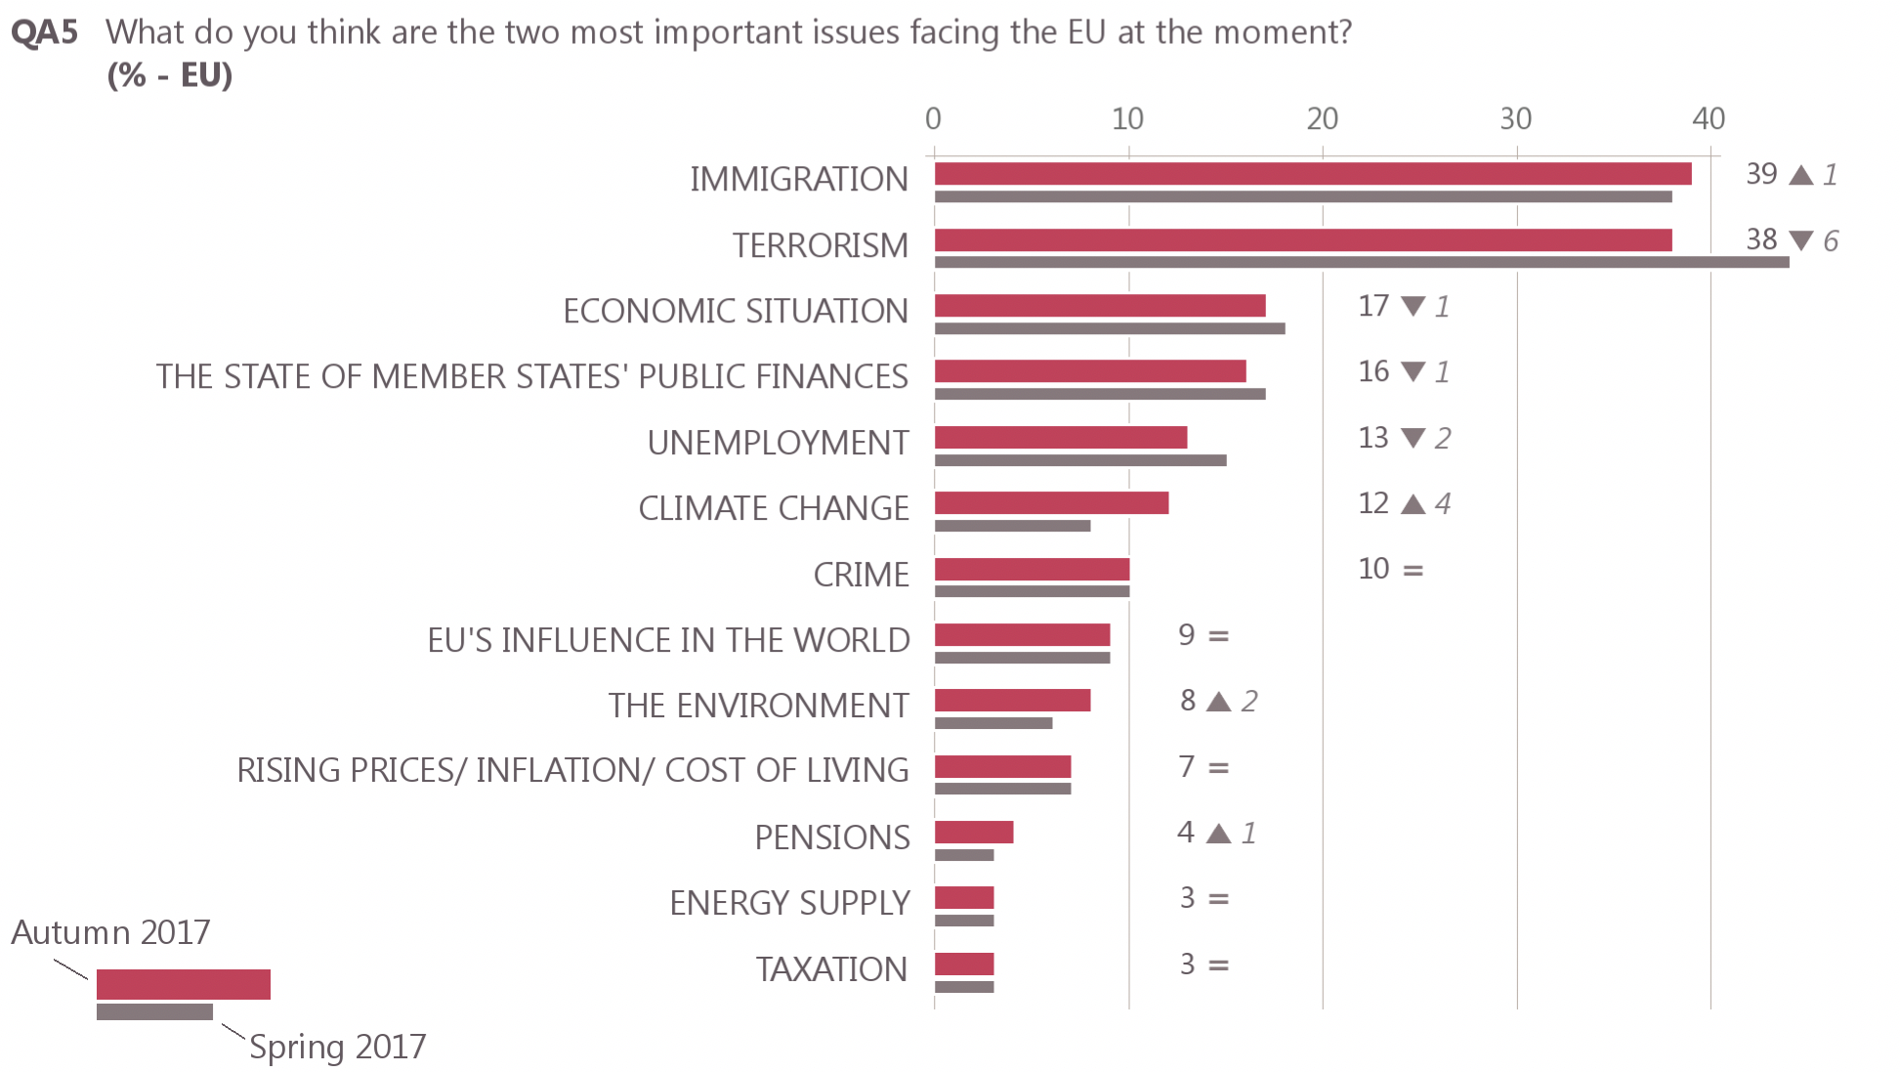

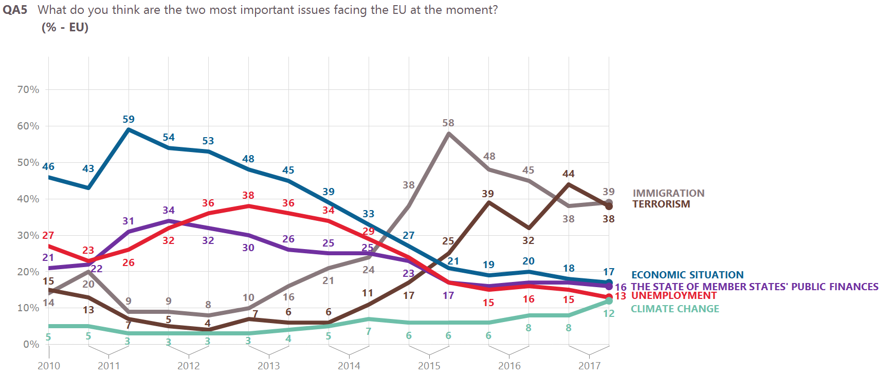

The obvious conclusion is that - despite the statistics showing steady AROPE and Inequality rates- economic problems are being pushed to secondary positions among the public opinion on the EU. The following figure shows that the variables “Economic situation” or “Unemployment” were not chosen as the first concern in any Member State. An accurate interpretation of this contradictory situation could be difficult to make, but it could be important to take this scenario into account for future analysis.

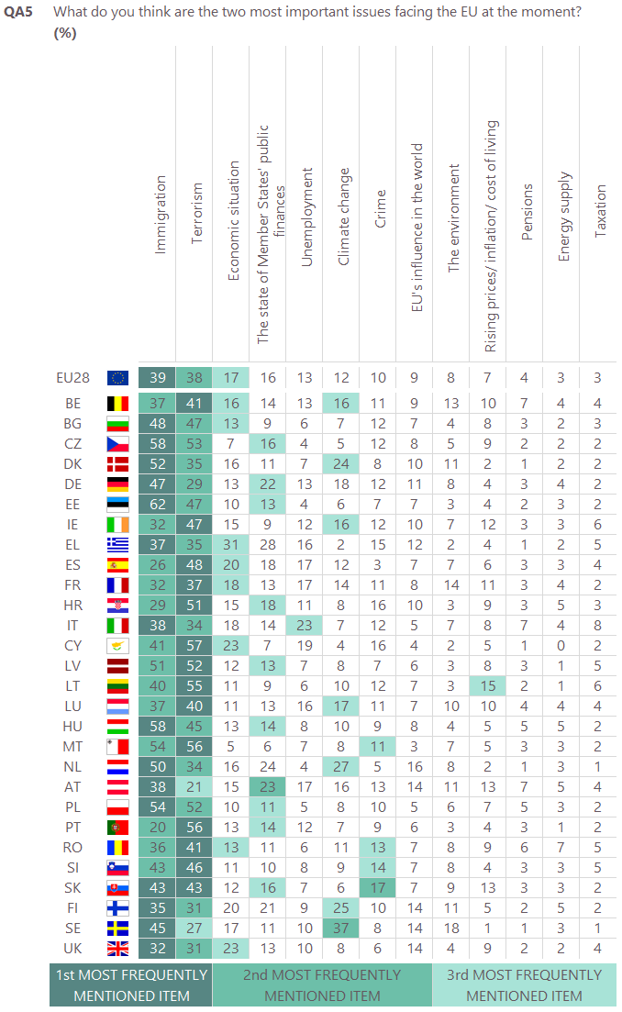

However, the conclusions of the main concerns regarding the national level differ. In this case, Unemployment remains at first place, followed by Immigration. Health and social security is mentioned by 20% of respondents, in third position. In fourth place, rising prices/inflation/cost of living is mentioned by 17% of respondents. In equal fifth position, we find terrorism and the economic situation (16% respectively). Pensions is a variable cited by 14% of respondents (+1), ahead of crime (12%, unchanged) and the education system (11%, -1). Four other items are mentioned by 10% or less of the population: housing (10%, +2), the environment, climate and energy issues (10%, +3), government debt (9%, -1) and taxation (7%, unchanged).

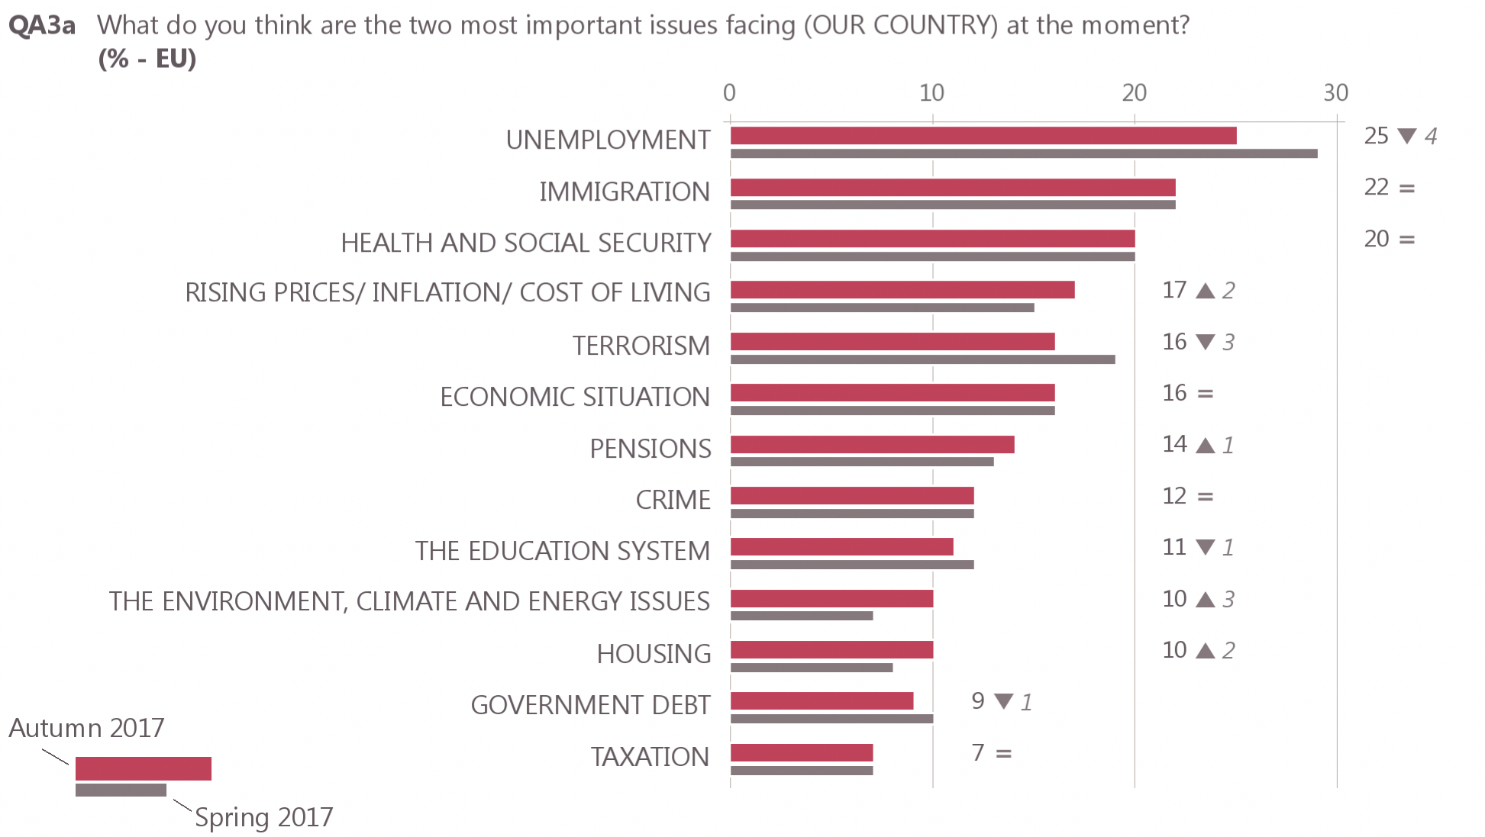

TRUST
Although trust in national Governments and in the EU is increasing, most people do not trust neither the EU, nor their national governments.

Next, key Survey’s findings are explained, with the intention of pointing out the most significant ones for EAPN positioning regarding the future of the EU.

47% of all respondents tend to trust the European Union - up 11 percentage points since autumn 2016. 46% DO NOT TRUST THE EU, and 7% DON’T KNOW.

- The majority of those aged 55+ tend not to trust the EU (51%), while the majority of those aged 15-24 tend to trust it.
- Gender does not make big differences. A slight majority of men tend to trust the EU (48% vs. 46% who to tend not to trust it), while opinion is divided amongst women (both 46%).
- The longer a respondent remained in education, the more likely they are to tend to trust the EU: 56% with the highest levels do so, compared to 33% of those with the lowest education levels.
- Students (64%) and managers (59%) are the most likely to tend to trust the EU, particularly compared to the unemployed (39%).
- The more difficulties a respondent has in paying bills, the less likely they are to trust: 30% with the most difficulties do so, compared to 50% of those who experience the least difficulties.
- The higher a respondent places themselves on the social class scale, the more likely they are to trust: 70% of those who place themselves in the upper class do so, compared to 38% who place themselves in the working class.
- Finally, respondents who place themselves on the left (52%) or centre (51%) of the political scale are more likely to trust the EU (vs. 43% of respondents on the right).
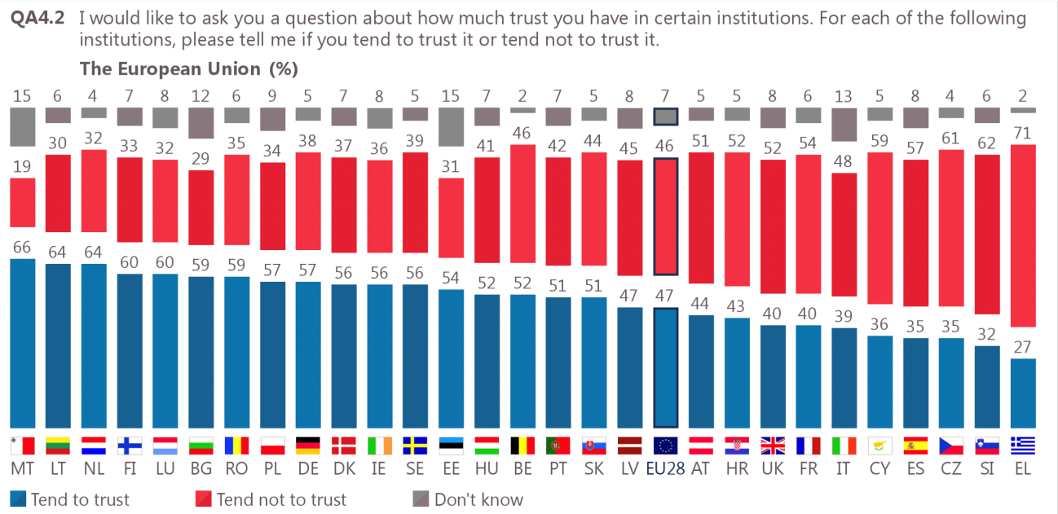

40% tend to trust their national Government – an increase of nine points since autumn 2016. 56% DO NOT TRUST THEIR NATIONAL GOVERNMENT, and 45 DON’T KNOW

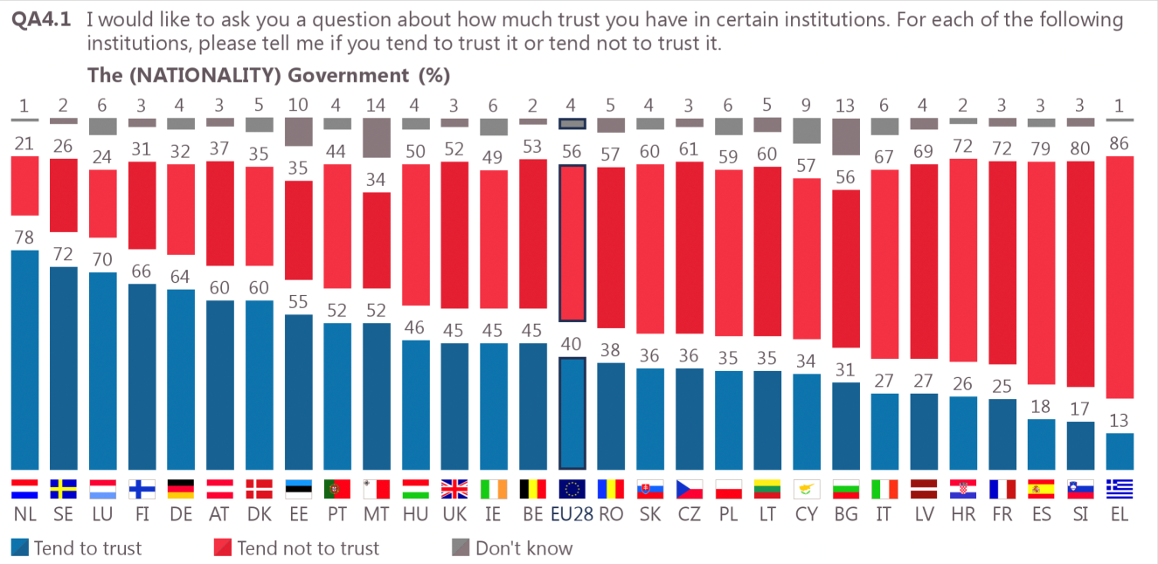

52% say they tend to trust justice and their national legal system (+1 pp since autumn 2016). 44% DO NOT TRUST JUSTICE AT THEIR COUNTRIES and 4% DON´T KNOW.

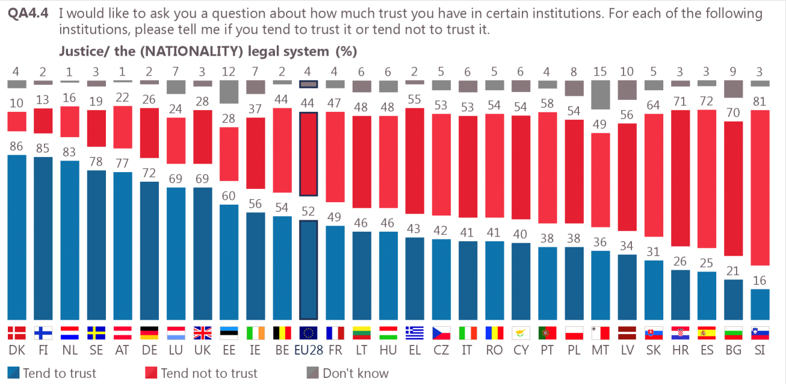

61% of respondents tend not to trust the media, only 34% trust and 5% don´t know. This is particularly true in the case of the low-income and poor respondents.

- Respondents who completed their education aged 20 or over are the most likely to trust the media (37% vs. 32%-33% of those with lower education levels).
- Managers and other white collars are the most likely to trust the media, particularly compared to manual workers and the unemployed (37% vs. 31%).
- The less difficulty a respondent has in paying households bills, the more likely they are to trust the media: 36% of those with the least difficulties do so, compared to 29% with the most difficulties.
- Respondents who consider they belong to the upper middle class (49%) are the most likely to trust the media particularly compared to those who place themselves in the lower middle (30%) or working class (31%).

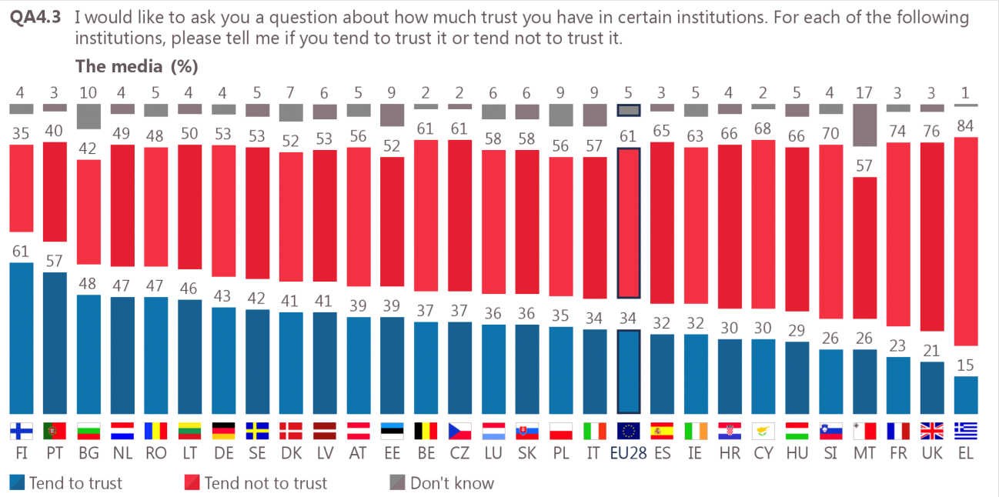

GLOBALISATION

54% of respondents see globalisation as positive and important for economic growth

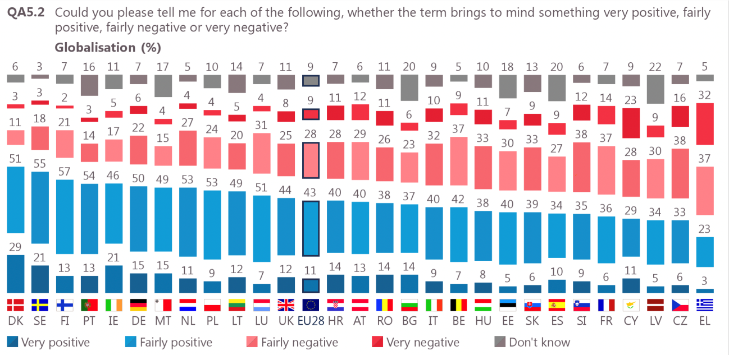

Although 63% also think it increases social inequalities.

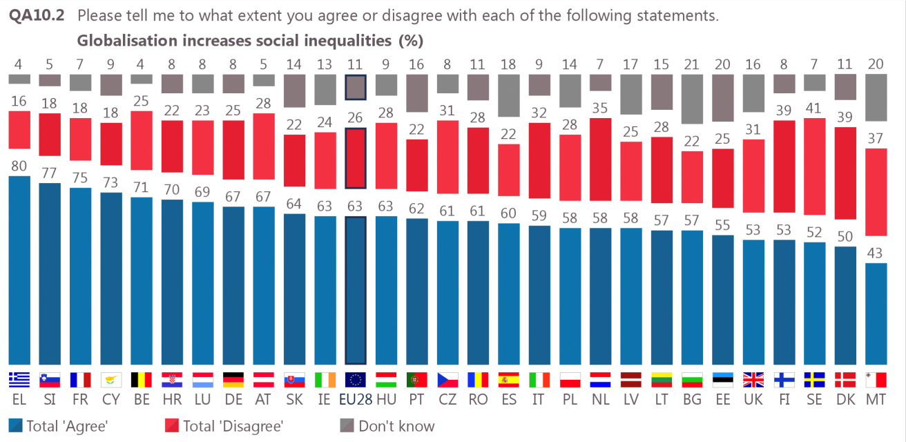

- Men are more likely to agree globalisation increases social inequalities (65% vs. 60% of women).
- Respondents who finished their education aged 16 or older are the most likely to agree (64% vs.58%).
- Manual workers are the most likely to agree, particularly compared to house persons (67% vs. 56% of those who stopped school at the age of 15 or before).
- 60% of the unemployed agree, only 26% disagree and 14% don’t know.
- In addition, respondents with a negative view of the EU are more likely to agree globalisation increases social inequalities (69% vs. 60% of those who are positive), as are those who do not tend to trust the EU (66% vs. 61% of respondents who tend to trust the EU). Finally, respondents who see globalisation as an opportunity are less likely to agree than those who do not (61% vs. 77%).

45% agree that the European Union helps to protect European citizens from the negative effects of globalisation, 43% THINK THAT EU IS NOT HELPING THEM AGAINST GLOBALISATION’S NEGATIVE IMPACT and 12% DON’T KNOW.

The youngest respondents are the most likely to be positive, and agree European Union helps to protect European citizens from the negative effects of globalisation:

- 51% of the youngest respondents do so, compared to 41% of respondents aged 55+.
- Those who remained in education the longest, and current students, are also the most likely to agree.
- The fewer difficulties a respondent has in paying bills, and the higher they place themselves on the social scale, the more likely they are to agree.
- Finally, as has been the case for past questions about globalisation, respondents with a positive view of the EU, those who tend to trust it, and those who see globalisation as an opportunity are more likely to be positive. For instance, 61% with a positive view of the EU agree, compared to 21% who have a negative view.

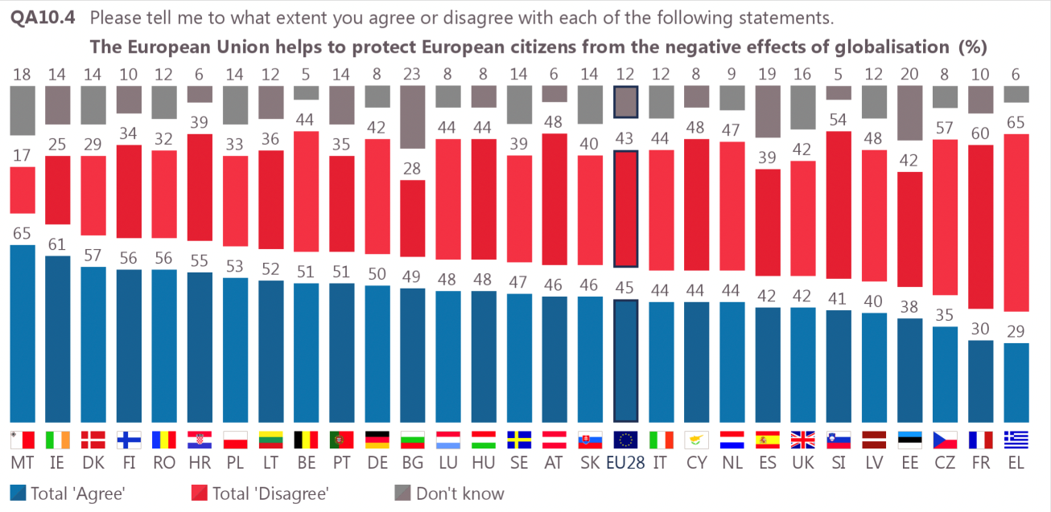

SOLIDARITY

79% consider solidarity to be positive, with 34% saying it is “very positive” and 45% that it is “fairly positive”. Only 18% consider solidarity to be negative, although only 4% see something very negative in solidarity.
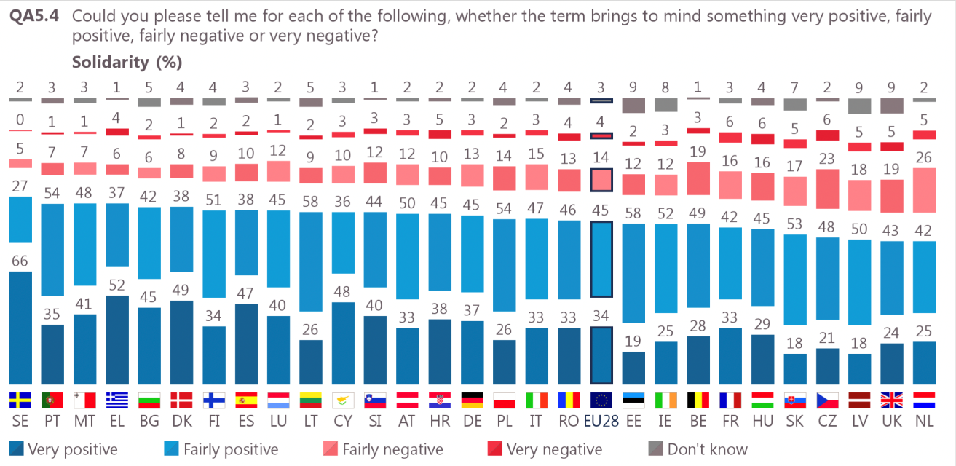

This result further emphasises the importance of the social dimension of the EU for Europeans that has been identified in previous surveys. For example, in a Special Eurobarometer survey conducted in September-October 2016, social equality and solidarity was the most mentioned area that EU society needs to emphasize to face major global challenges. In addition, social inequalities were the second most mentioned challenge for the EU (after unemployment), and comparable living and education standards were the two factors considered most helpful for the future of Europe.

Very important: we note that –since 2009- there is a steady and stark public attitude in supporting “solidarity” as a key EU value.

RECOMMENDATIONS

- The EC is blind regarding the social and economic impact of inequalities. We can use the EU rationale to bring arguments in favour of social cohesion. Poverty and social marginalization translate into the exclusion of nearly 118 million people from the domestic markets, and add increasing budgetary burden into trying to solve economic, social, educational, health, political, and security issues derived from inequality.
- 46% tend to not trust the EU, but there are big differences in this share among member states. It would be important to EAPN’s national networks to analyse what is going on in each of them, to focus in a proper communication and political advocacy about the EU matters.
- 67% of the people with lowest education levels, 61% of the unemployed, 70% of those who suffer most economic difficulties and 62% of the working class don’t trust the EU. They are EAPN’s target-groups! Regarding this generalized and targeted lack of support to the EU, these figures could turn into powerful tools for EAPN to communicate that the EU is mistaking its way, and that there is a clear need to resort to social values.
- 43% do not think that the EU is helping them against the negative impact of globalization. EAPN can use this big audience to prepare a powerful message towards more social economy, a more concrete Pillar of Social Rights, with directives about social standards (minimum income, minimum wage, child benefits…), vocational training, social investment and more transparency/accountability/democracy.
- 61% of citizens don’t trust the media. As shown by the report, low-income and poor people do not trust the media. This means that they may be (or could be) informed through alternative sources, as the social networks. In this sense, the field is open for EAPN to develop more updated activities, and wiser communication strategies in the main social networks! Therefore, we need updated and powerful audio-visual instruments, like a video, which can bring a new trust and more involvement of civil society in the chance of developing a strong Social Europe.
- The enormous public commitment to the idea of solidarity (79% or similar, since 2009) reinforces the social dimension of Europe, and confirms that EAPN must insist on this line of argument, but using all the data that support it, in a constant and consistent way.

THE SCENARIOS FOR EUROPE

From the Survey’s findings, we can clearly conclude that there is a stark commitment to a Social EU, based on solidarity and the protection of the people living in vulnerable conditions. It is also crystal clear that most of the citizens don’t trust the EU, which means that they disapprove the road taken by the Commission and the EU in general.

The Italian document provides with a very good analysis of the current situation of the EU, and the need to develop MORE POLICIES, and talk less about “the scenarios”.

The new scenario could be based in the development of the Social Pillar, but we agree with the Italian position that it would be adamant to reform the Treaty, to ensure that all levels of government have clear competences and responsibilities in terms of protection and social promotion. It is necessary to reconsider giving more competences to the EU, because the biggest challenges are shared and common.

Moreover, we need to get away from individual, member-state-based “solutions”, as they may drive us into dumping procedures, which could furtherly translate into more inequality and less rights for everyone.

IS THERE ROOM FOR A “SOCIAL” SCENARIO 6?

EAPN has already signed for an unofficial Scenario 6, drafted by an alliance of civil society organizations, the SDG Watch, which considers the commitments of Agenda 2030, the environmental objectives, social rights and gender equality. A more inclusive and social scenario that would allow us to move forward together, in which the European Pillar of Social Rights and the SDGs are central elements of the political Agenda.

EAPN must continue supporting this approach, making comprehensive inputs on poverty and social exclusion. We need, on the one hand, to be able to make acts of influence to build a more participatory, more democratic and more social Europe. On the other hand, we need to have a clear instrument to defend our proposal to fight poverty, as part of the EU policy hardcore.

Consequently, EAPN will be committed to an annual update of this Scenario 6, taking into account the new needs, and the unmet needs, of all EU citizens and especially those at risk of poverty and social exclusion.

PROPOSALS FOR A SOCIAL EUROPE

The Charter of Fundamental Rights must govern in the Member States not only for European legislation, but also for national legislation. The European Social Charter should be fully enforced. Poverty and exclusion rates that are scandalously high should not be accepted any longer. The distribution of wealth is increasingly unequal and employment is no longer the way to social inclusion for several million Europeans, who have a job and, despite this, live in poverty. For these reason, EAPN makes several proposals towards a truly Social Europe.

- Inclusive employment, including a strong fight against all sorts of discrimination, which may lead to improvements in labour income, and the disappearance of in-work poverty;
- Decent, fair and stable work for all and especially for young people. That allows to have a clear vision of the future.
- Decent pensions, which provide a good standard of living, with universal healthcare and long-term care. This implies the elimination of the current gender gap;
- Effective and adequate guaranteed income standard that serves all households that are currently without resources (implementing the 2008 Active Inclusion Recommendation, mentioned in the EC document about the Pillar);
- Economic benefits for children, in addition to direct support resources for single parents and big families who are in greater difficulty, in order to tackle child poverty (implementing the 2013 Recommendation Investment in Children);
- Extensive and quality educational investment, especially in early childhood, at the end of compulsory schooling and throughout life (to comply with the EU 2020 headline targets and to fight the trade-offs of globalization);
- Attention to the most vulnerable groups, including a vigorous fight against all kinds of discrimination, and recovering (and revamping) the 2005 EU Integration Agenda);
- A broad offer of social housing to ensure this fundamental right, and to eradicate homelessness (as recommended in the 2013 Social Investment Package);
- A set of comprehensive affirmative actions, in all areas, to eradicate gender inequality (as established in different EU Directives on Equal Rights between men and women and, of course, the 2009 Lisbon Treaty);
- An effective tax reform at European level, with social equity, that fights against corruption and evasion (to reform the current fiscal convergence in order to make it more progressive and to raise funds for financing the redefined Social Model): fair taxes for all.
- Effective social services and a comprehensive and quality social support, implemented by the social NGOs and the social economy organizations (previous recognition of their role as true social actors, which may lead to their incorporation to a reformed Social Dialogue framework).

Finally, to achieve the objectives we indicate, it seems to us that the time has come for the Heads of State and Government, in the light of the difficulties that the Union is facing and the lack of trust that citizens have in the European Union, make a leap in quality and have the courage to work intensively and quickly to realize what was prefigured in the "Ventotene Manifesto" which prefigures the need for the establishment of a European federation with a European Parliament elected by universal suffrage and a democratic government with real powers in some fundamental sectors.
Only a political Union can be effective to achieve the objectives of the Social Europe and making sure that the European Pillar of Social Rights and the SDGs are effective on the ground of the Union, without excluding any citizen.

A former document was drafted by EAPN Ireland, in October 2017: www.eapn.ie/eapn/wp-content/uploads/2017/10/eapn-ireland-submission-on-the-future-of-europe.pdf
The report “Combating inequalities as a lever to create jobs and economic growth” was adopted by the European Parliament in 2017. The European Parliament establishes combating inequalities as a political priority of the EU, and proposes a roadmap with norms, tools and resources to achieve this. It establishes the need to balance the European Semester by introducing genuine monitoring of the Union’s social dimension and feeding this data and any conclusions into the country-specific recommendations. It focuses on the need to reinforce European labor legislation in order to strengthen working rights and incomes, and to introduce new EU-wide solidarity mechanisms to combat child poverty, the gender gap and social exclusion. Finally, the report emphasizes the need to improve our fiscal coordination and harmonization in the fight against tax fraud, evasion and disloyal unethical fiscal engineering that happen in this field.
Special Eurobarometer 461, “Designing Europe’s future: Trust in institutions Globalisation Support for the euro, opinions about free trade and solidarity”, Survey requested by the European Commission, Directorate-General for Communication and coordinated by the Directorate- General for Communication, fieldwork April, publication in June 2017.
http://ec.europa.eu/commfrontoffice/publicopinion/index.cfm/Survey/getSurveyDetail/instruments/STANDARD/surveyKy/2143
Eurobarometer 88, November 2017, confirms the same situation; therefore the following analysis is still valid.
An explanation given to this unusual rise: “Trust in the EU has been gradually increasing since autumn 2015. The trend since autumn 2016, however, is somewhat dramatic: an 11 percentage point increase in the proportion that tend to trust the European Union, and an eight-point decrease in the proportion of respondents who tend not to trust. Some of this large change may be explained by a difference in the sequence of questions in the current survey compared to the previous Standard Eurobarometer. This may have put respondents in a more positive frame of mind when answering this question”. Survey, page 21.
The European Semester has not prioritized the evaluation of the performance and outcomes of economic policy coordination, not have taken into account the evolution of social progress and social justice in the EU, or the reduction of inequalities. The Commission did not improve the process of policy coordination in order to better monitor, prevent and correct negative trends that could increase inequalities and weaken social progress or negatively affect social justice, putting in place preventive and corrective measures when necessary. According to the abovementioned Parliament Report, “this should be considered and included, where appropriate, in the European Semester”. Paragraph: “Establishing European policy coordination for combating inequality”, particularly point 5.
At the beginning of the 2017’s state of the union address, the president of the European Commission, Jean-Claude Juncker, spoke of a "window of opportunity … to build a more united, stronger and more democratic Europe for 2025." Revisiting the debate he started in March with the "Five scenarios for Europe by 2025", he set out his own "scenario six" for the future of Europe, combining elements of each of the original scenarios. https://euobserver.com/opinion/139006
https://www.eapn.eu/over-250-non-governmental-organisations-launch-alternative-vision-for-europe/

