PRACTICAL INFORMATION - FROM BILBAO AIRPORT to OVIEDO
EAPN EXCO – Oviedo 23 to 24 March 2018

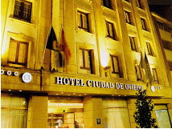
Accommodation
Rooms have been booked for you at the Hotel SERCOTEL CIUDAD DE OVIEDO, Calle Gascona, 21, 33001 Oviedo, Tel: + 34 985222224.
The Hotel has a privileged location right in the centre of Oviedo. It's found a stone's throw from the old town, the cathedral, and several bars and restaurants.

How to get to Sercotel Ciudad de Oviedo FROM BILBAO AIRPORT

From Bilbao Loiu Airport to Bilbao Termibus – Google Maps Link HERE
By taxi: 15 minutes. 30 € approx.
By public transport. Bus line A3247 (final stop): 25 minutes. 1,45€
On the arrivals floor there is a customer services desk and ticket office. From the airport, buses leave every 30 minutes from 06:15 to 23:15.

From Bilbao Termibus (bus station) to Oviedo Bus Station – Google Maps Link HERE
Alsa Bus offers service between Bilbao and the city of Oviedo. Daily departures from the Termibus at 01:45, 06:00, 08:30, 10:30, 12:05, 13:30, 14:30, 16:30, 18:00, 18:45.
In bold quickest options (Premium or Supra buses). Duration: 3:30 hrs approx. Price: between 30€ and 40€ depending on buses.
Duration with normal buses: 4hrs or 5hrs. Price: 19,12€

From Oviedo Bus Station to the Hotel Sercotel (Calle Gascona, 21) - Google Maps Link HERE
Leaving the station take Calle Jeronimo Ibrán, reach the square, Plaza Primo Rivera, and turn into calle General Elorza. Continue straight 300 meters and turn right into Calle Foncalada. Continue straight 150 meters and turn left into Calle Gascona.
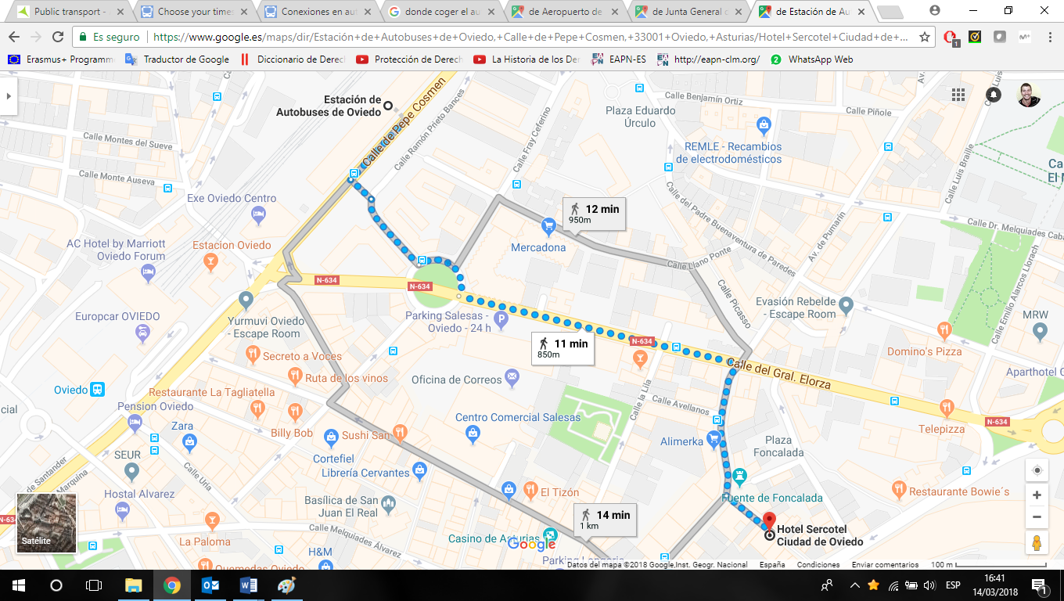

Getting to the Conference Centre

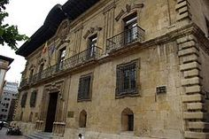
The meetings will take place in the PALACIO DE LOS CONDES TORENO, Plaza Porlier, 9, Oviedo. (Google maps Link HERE)
Turn right leaving the Hotel and walk until the first corner, turn right into Calle Manuel García Conde. Then turn left into the first street Calle Carlos Bousoño. At the end of Calle Carlos Bousoño turn right into Calle Arguelles and then turn left into Calle Mendizabal. The PALACIO will appear on your left.
There will be EAPN Spain colleagues to lead you.
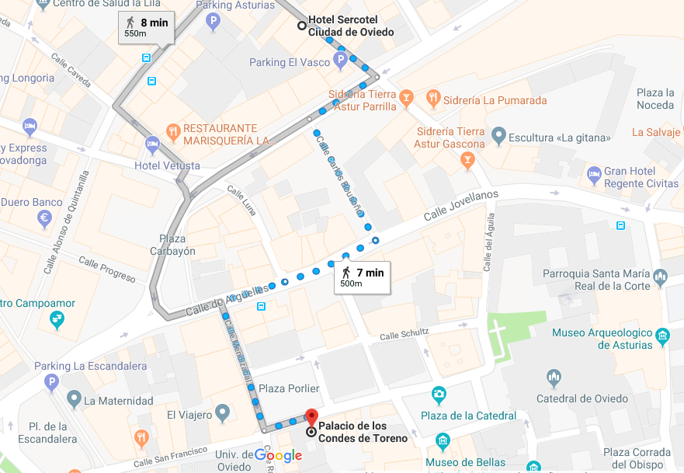

Contact details:
- Sigrid Dahmen (EAPN) – Tel.
- Marcello Ronchi (EAPN-ES) – Tel. 0034 673569330

