PRACTICAL INFORMATION
EAPN EXCO – Oviedo 23 to 24 March 2018

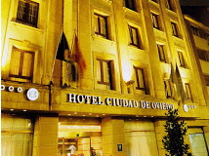
Accommodation
Rooms have been booked for you at the Hotel SERCOTEL CIUDAD DE OVIEDO, Calle Gascona, 21, 33001 Oviedo, Tel: + 34 985222224.
The Hotel has a privileged location right in the centre of Oviedo. It's found a stone's throw from the old town, the cathedral, and several bars and restaurants.

How to get to Sercotel Ciudad de Oviedo
From Asturias Airport to Oviedo City Centre – Google Maps Link HERE
By Alsa Intercity buses: 45 minutes. 8€
Airport Bus stop location: Opposite the arrivals terminal
Oviedo bus stop: Bus Station (Calle Pepe Cosmen)
Alsa Bus offers service between the airport and the cities of Oviedo. Daily departures from the airport at 07:00, 08:00, 09:00, 10:00, 11:00, 12:00, 13:00, 14:00, 15:00, 16:00, 17:00, 18:00, 19:00, 20:30, 22:00 and 23:20. These times may be delayed by up to 15 minutes if information about an arriving flight appears on the information panel when it is due to leave.

From Oviedo Bus Station to the Hotel Sercotel (Calle Gascona, 21) - Google Maps Link HERE
Leaving the station take Calle Jeronimo Ibrán, reach the square, Plaza Primo Rivera, and turn into calle General Elorza. Continue straight 300 meters and turn right into Calle Foncalada. Continue straight 150 meters and turn left into Calle Gascona.
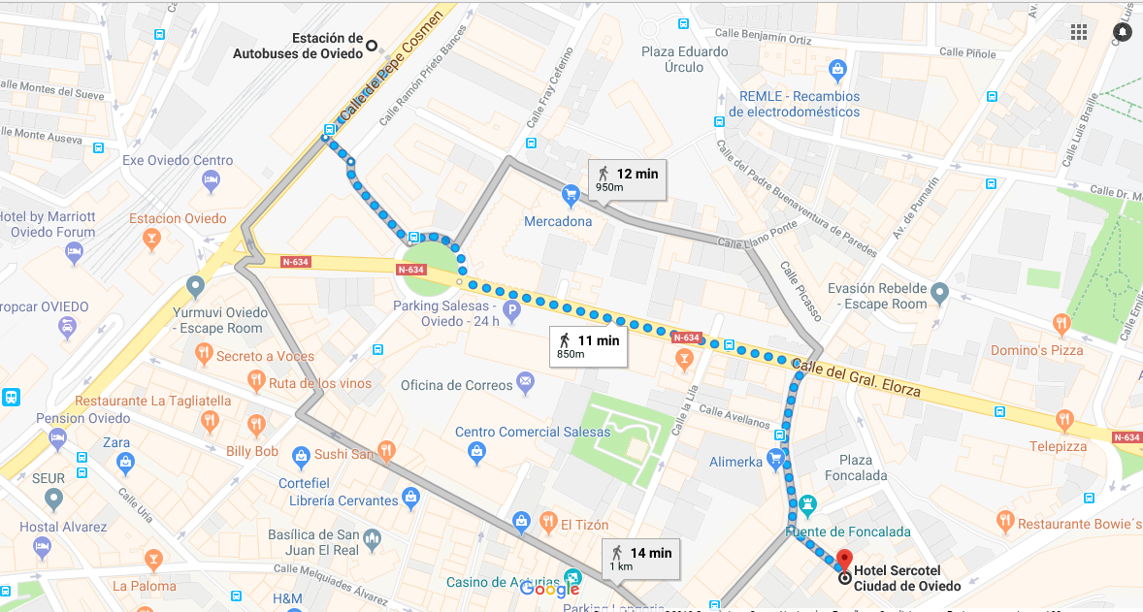

Getting to the Conference Centre and the other venues
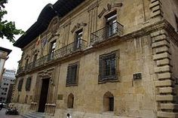
The meetings will take place in the PALACIO DE LOS CONDES TORENO, Plaza Porlier, 9, Oviedo. (Google maps Link HERE)
Turn right leaving the Hotel and walk until the first corner, turn right into Calle Manuel García Conde. Then turn left into the first street Calle Carlos Bousoño. At the end of Calle Carlos Bousoño turn right into Calle Arguelles and then turn left into Calle Mendizabal. The PALACIO will appear on your left.
There will be EAPN Spain colleagues to lead you.
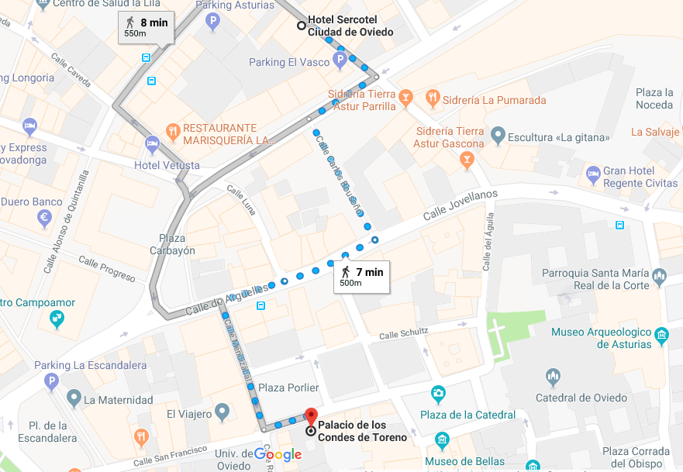

Social Events
- Friday 23 March, 18:00h – Official reception to the Regional Government (Junta General Principado de Asturias) C/ Fruela, 13.
5 minutes walking from the PALACIO DE LOS CONDES TORENO.
EAPN Spain colleagues will guide you from the meeting venue to the Regional Government.

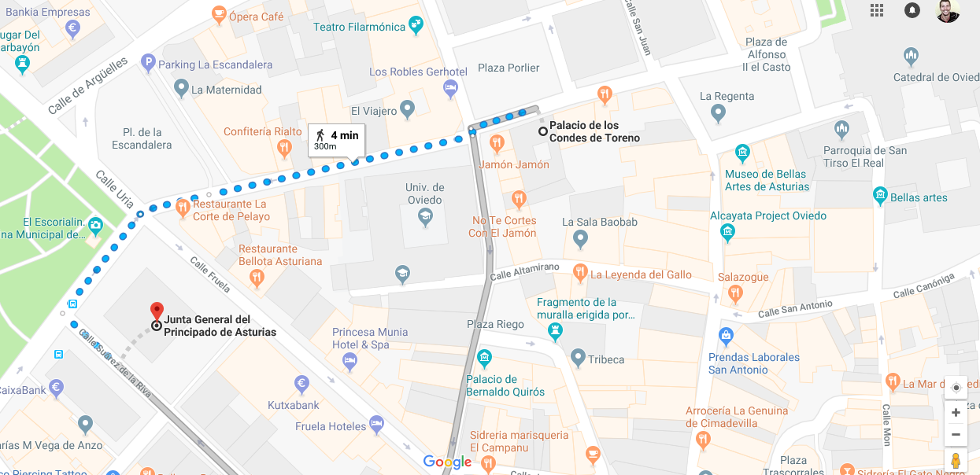

- Friday, 23 March, 20:00h Dinner at Restaurante-Sidrería Tierra Astur Parrilla (C/ Gascona, 9). 2 Minutes walking from the Hotel, same Street.
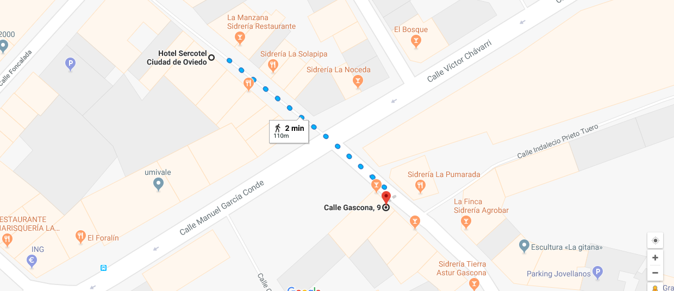

- Saturday, 24 March, 13:30h Lunch at Restaurante LA GRAN TABERNA (Calle del Águila, 5. 3 Minutes walking from the meeting venue.
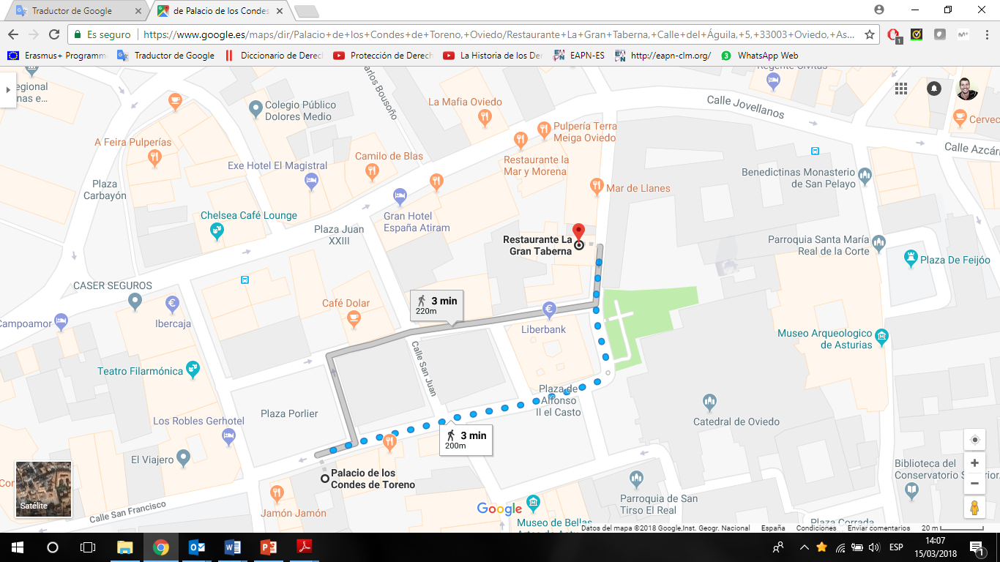

Contact details:
- Sigrid Dahmen (EAPN) – Tel. 0032 499 862763
- Marcello Ronchi (EAPN-ES) – Tel. 0034 673569330

