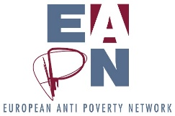
Risk Assessment update, May 2018
Background
Part of the EAPN Director’s role is to ‘identify and evaluate the risks to the organisation (internal and external) and ensure with the Bureau / Ex Co that proper risk management strategies are in place’. An ongoing risk assessment system has been developed, whereby the Director makes an initial assessment of the risks every two months.
The assessment provides a framework to analyse both the level of risk (how likely is X to occur) and the potential impact. Based on this analysis, further action would be taken at different levels – see the table below/
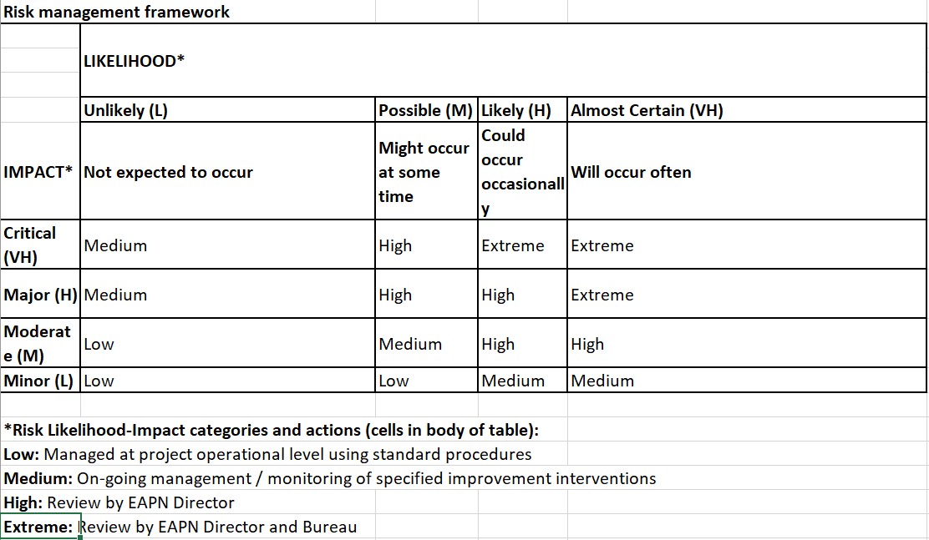
In simple terms, this means that risks which are identified as low or medium will be managed within the office. High risks will be looked at more closely by the Director, and extreme risks by the Bureau, with the Director. Once a year, the Bureau will report back to the Executive Committee on the level of risk, and mitigating actions taken / recommended.
‘Extreme’ risks identified in May 2018
Seven risks have been identified as ‘extreme’ in May 2018, and are thus presented to the Bureau, notably:
Risk | Comments
1.4 Inability to attract and retain high quality staff with relevant skills | Linked to 1.5, details below.
1.5 Staff team unable to deliver on work programme | The work programme would be deliverable if we had all staff members. Ideally I suggest we need 1.5 more staff to deliver work programme comfortably, but it could be delivered with the team as it stands, if no-one was off on sick leave and we were better able to recruit interns etc.
1.6 Members fail to deliver on their commitments | Linked to 1.8 – manifests by extremely low engagement in Working Groups (MFF, Future of Europe). Also delivering on commitments in contracts.
1.8 Limited ownership and participation from members | Linked to 1.6 – crucial to select topics to work on which are truly of interest to members, which build on the work they are already focusing on.
2.4 Excessively costly governance processes | An ongoing issue, accounting for some 10% of our core costs.
2.6 Poor communication with our members and stakeholders | See below
3.4 Over-reliance of one source of funding | Recognised by the Ex Co, and we are working hard to address this.

Two of these risks are worth specifically highlighting to the Executive Committee as they have become more acute since the last analysis:
1.4 Inability to attract and retain high quality staff with relevant skills
While we have an attractive remuneration policy (which we are still in the process of trying to renegotiate), we have to recognise than in recent years, three members have needed time off for burnout issues, and others are not far from reaching breaking point.
Actions taken
- Discussions on burnout at the staff level
- Discussion at the March Ex Co
- Formation of ‘Burnout Task Team’ (IFSW and EAPN Netherlands) which is looking at developing organisational policies and procedures to promote well-being and prevent burnout
- Cancelled working lunches at staff level
- Establishing monthly social lunches for staff members
- Investigating staff and management training on preventing and dealing with burnout
- Recruiting support staff and interns to replace staff off on burnout
1.6 Members fail to deliver on their commitments / 1.8 Limited ownership and participation from members
We have seen these risks manifest throughout our work on the Multiannual Financial Framework and the Future of Europe – there is limited engagement of members when we try to coordinate work on such issues. More recently, we have seen low levels of member participation when trying to bring together a funding proposal for a project on poverty reduction and social inclusion across borders in Europe – which one would think should be precisely the kind of projects all EAPN networks would want to apply for.
Actions taken
- Ongoing efforts to try to involve members in different areas of collective work – MFF, Future of Europe, Barometer report etc.
- Securing participation of European Organisations in the PeP meeting
- Attempting to find EAPN collective priorities through membership surveys and the strategic thinking process
- Encouraging members to represent EAPN on the Economic Policy Working Group of ESCR Net (EAPN Greece and IFSW are representing us in this space)
- Breakfast roundtable on the MFF organised in collaboration with 3 members (Eurochild, Eurodiaconia and FEANTSA)

