Promising practices on In-work Poverty

Contents
Promising practices on In-work Poverty 1
Introduction 5
CHECKLIST 8
Criteria for identifying promising in-work poverty practices 8
Promising practices from the EAPN membership 11
Spain 12
Finland 18
Latvia 24
Denmark 30
Ireland 36
Scotland 42
England 48

Introduction

EAPN is a network dedicated to the fight against poverty. Our aim is to work together to achieve a reduction of poverty, through improvements in antipoverty policy and practice at national and EU level. While poverty and social issues in general have been gaining more and more visibility at the EU level, with the adoption of the Pillar of Social Rights and the Social Fairness Package, we still believe that the focus is still too much on employment as the main way out of poverty. While it might be true in some cases, our members often witness the spreading of in-work poverty, that is, people experiencing poverty despite having a job. In fact, in 2016, 9,6% of the people in employment were living under the poverty threshold, corresponding to over 32 million workers at risk of poverty; in-work poverty increased by 1.3% at the EU-28 level between 2010 and 2016 (Eurostat, 2018). This issue is particularly crucial in the work of EAPN: in fact, it was the thematic focus of last year’s annual Meeting of People experiencing Poverty, which produced relevant key messages on the topic and its links to other crucial subjects such as youth, gender, homelessness, older people, etc. Given the importance our members attribute to this topic, our Executive Committee decided in October that this topic would be the thematic focus for the EU Inclusion Strategies Group throughout the year 2018. Nonetheless, EAPN’s advocacy on the topic dates back to many years ago, culminating in the adoption of a shared position paper on the issue (“Working and Poor”, 2013), that served as a basis for subsequent policy and advocacy actions on this topic.
In order to further develop our analysis and advocacy activities around in-work poverty, and building on the position paper and the key messages of the 16th European Meeting of People Experiencing Poverty, a project of collection of promising practices was envisaged among this year’s work priorities. This proposal has been made to share knowledge and give visibility to good practices that have been able to address positively the crucial issue of in-work poverty. This will go alongside our analytical work through the Semester and the Poverty Watch which highlight the reality of current trends and main challenges.

What is this project?
This is a handbook collecting promising practices around tackling in-work poverty, whether they are policy, projects or campaigns. The rationale behind this work is to draw from experience of people directly involved in these processes to offer an overview of what seems to be working in the fight against in-work poverty. In this regard, this collection was also inspired by a similar work done in 2016 around social innovation, that culminated in the publication of the EAPN Booklet on Social Innovation. The collection of promising practices around in-work poverty followed the usual procedure EAPN adopts for its documents: the EU Inclusion Strategies Group discussed the approach underpinning this work in the March 2018 meeting in Belgrade; following the discussion, the scoping note and the checklist were drafted, and members were asked to submit promising practices in May/June 2018; a first draft collection was presented to the EU ISG in the July 2018 meeting in Brussels, and members provided some additional practices and details over summer 2018; the final draft was then presented to and approved by the EU ISG in the September 2018 in Vienna and finalised in October 2018. This collection of practices, put together by Chiara Fratalia in the EAPN Europe office, will be disseminated among EAPN members, as well as EU decision-makers and the general public.

CHECKLIST

Criteria for identifying promising in-work poverty practices

EAPN proposes a list of criteria to be checked to assess whether a given practice is a promising practice. To be regarded as such, practices should generally fulfil some, and not necessarily all, of these criteria. These criteria include, in EAPN’s view:
- Effectively reducing in-work poverty and improving people’s wellbeing. The practice contributes directly or indirectly to in-work poverty reduction, improvement of wellbeing, exercise of human rights and life in dignity. The impact can be on the individual level, or at the level of the group, community or society.
- Empowering users. A promising practice should support and stimulate empowerment while responding to users’ needs, rather than providing only passive support. In this sense, it should possess a bottom-up approach and be participatory or at least responsive to users’ needs, while also generally coming from ideas of CSOs or citizens; if the initiative comes “from above” (meaning from institutions, authorities), it needs to gather bottom up ownership and support from the participants, while adjusting to the needs and context of the community.
- Sustainability. Promising practices should be sustainable, not one-off interventions with no follow-up, or actions with no permanent/long-term changes. Punctual actions might constitute good practices if they represent a blueprint that could reproduced to address the same issue in a different – but still similar – context. Sustainability also means enduring organisation, which is capable of generating the necessary resources in order to maintain the action over time.
- Transferability / adaptability. Promising in-work practices should be able to impact beyond the single case where they were generated, by offering chances to be transferred, adjusted to other groups or contexts, and to create greater impact.
- Accountability. A promising practice should be transparent, with a high level of visibility in the community, with appropriate internal and external evaluation, end users’ feedback mechanisms, and impact assessment before and after the implementation.
- Types and relativity of novelty. Promising practices should introduce some novelty in one or more of the following aspects:
  - Identification of a new need that was not previously met through services or products.
  - Provision of a new product or service that satisfies real needs (individual, collective, community, new or old ones).
  - New methods of doing things (producing, delivering services), which can include new technologies, or new forms of organisation, or new relations.
  - New actors are involved in innovation initiative, which were previously not engaged.
- Complements, but does not replace, universal public services. Promising practices in in-work poverty need not to substitute themselves to comprehensive and universal State service provision.
- Needs to contribute to positive changes in attitudes, mindsets, and values. Promising practices increase awareness on social problems, on opportunities to improve inclusion and wellbeing, on benefits from increased wellbeing of vulnerable groups. They bring changes in values, norms, perceptions of others, decreasing the social distance between groups, while fostering solidarity and cohesion.

Promising practices from the EAPN membership

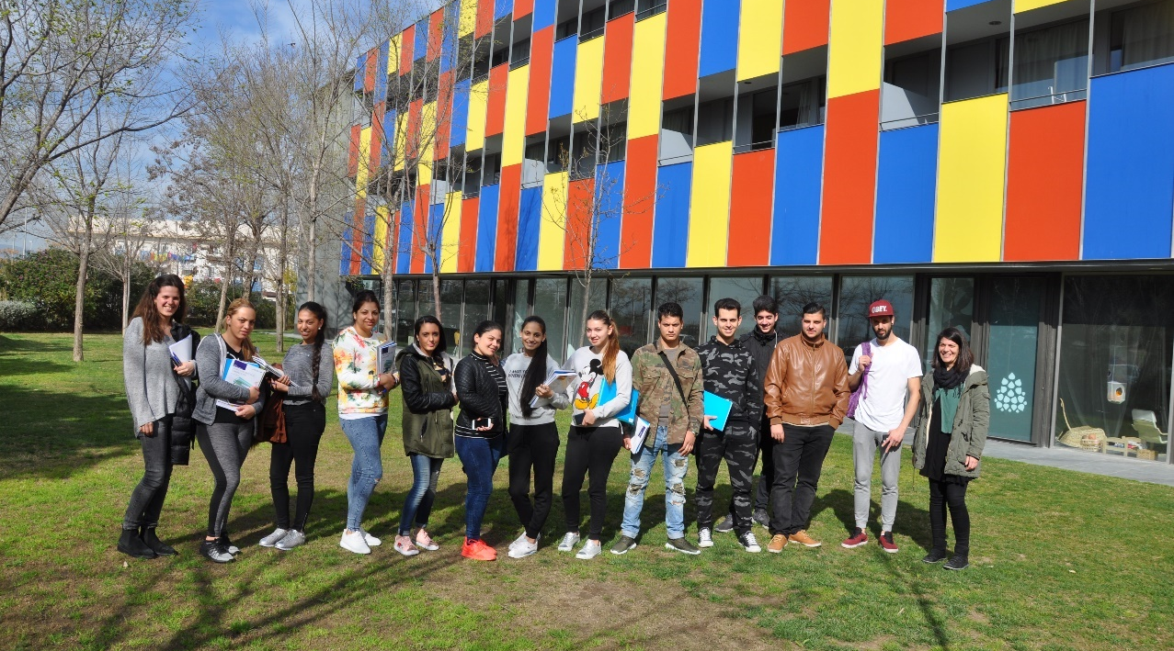

Spain

Fundación Esplai – Young Value project
© Fundación Esplai
Identification information
Territorial Network: Fundación Esplai, Ciudadanía comprometida
Contact information: Isabel Santero (isantero@fundesplai.org)

Context
In Spain, 37.4% of young people are unemployed and 22.7% are NEETS (“Not in Education, Employment, or Training"). Spain heads the European ranking of youth unemployment in the Eurozone. The lack of opportunities and experiences, negative future perspectives, and weakened sense of purpose are their frequent arguments for explaining their loss of faith in entering the labour market or continuing with their training.
The Young Value Project, in its pilot phase, has been carried out in the neighbourhood of Sant Cosme del Prat de Llobregat and in the city of Cornellà de Llobregat. Both territories belong to the province of Barcelona, in the Autonomous Community of Catalonia, Spain.
Promising practice in detail
The Young Value Project is developed by the Esplai Foundation; it provides a “second chance” to young people, aged between 18 and 25 years old, who are at social risk. This project allows them to discover and improve their talent based on the empowerment and strengthening of their skills and capacities.
The Young Value Project offers boys and girls a one-year paid contract, which combines a process of training in a “welcoming company”, where they learn how to develop in an organizational culture, with stronger work habits and a learning environment. In past times, this NGO has focused their efforts on getting them jobs. But they have realized that, once these youngsters began working, they did not know their rights and duties as workers. The purpose of this project is to provide information on the rights and duties deriving from the employment relationship, as well.
The Young Value project trains young people and informs them about the current legislation, as well as about the rights and duties that they have as workers; this contributes to the improvement of well-being, to the exercise of human rights and to life with dignity of the project participants. It is a project transferable to other municipalities and autonomous communities of the Spanish state. We consider it an innovative project, because from the beginning we involve the collaborating companies in the development of the project and the training in labour aspects.
The project prepares young people to enter the labour market: In the case of El Prat de Llobregat, a municipality of Barcelona, especially among the Roma girls, they did not expect to be able to work on anything other than street vending or house cleaning jobs, sporadically. It helps breaking the vicious circle of lack of studies, opportunities and job access: for some participants the project has been an opportunity to break inefficient and unproductive dynamics to be more likely to find a job and feel more fulfilled or autonomous. Additionally, it promotes positive habits and attitudes towards access to the labour market: for some of the participants, the project has served to break a monotonous routine that did not favour insertion in the labour market for new actions more productive. These actions or routines will make them more able to find a job, with decent conditions, once the project is finished.

For more information:
http://fundacionesplai.org/area-formacion/joven-valor/
"I lived with my parents, we went out to sell scrap... But of course it's not the same to go to sell than to have a job. And even more when you get married, you have a child ... And no, I don't like the sale, I was going to sell and that, but I prefer a job where I can have more stability." (Participant 3, El Prat).
"[The project] motivated me to start studying, especially doing something, to feel useful because I was at home watching TV or I spent all day walking. And I said: the years go by, you're the same and you have nothing! I say: well, I start to study, I learn, I meet people, I get back into the field, I work. And it helps you financially, even with a little pinch, but it's a good thing." (Participant 5, El Prat).
"I do see myself more prepared now than before; Of course, now I have skills that before, for example, I did not have." (Participant 5, El Prat).
"[The project] has changed me a lot, because I was standing, doing nothing, walking around the house, doing some errands, and that's it. And now, why not? You have something to do, you get up, go to your job, to your company; in the afternoon you come here, and it's great." (Participant 2, El Prat).
"For me, this project has been the best, because it has raised my spirits and ... I don't know, you dedicate yourself to something else, that is, you have a routine, you get up, you come here, you are doing something, that you did not do before, I do not know how to explain myself." (Participant 7, El Prat)
"[I have changed a lot] on a personal level. [The project] motivates you very much... But above all, because you feel fulfilled, you feel that you are worthy, that you are useful." (Participant 3, El Prat).
"I had considered working. But maybe, in my mind, I thought, "Well, if I get a cleaning job or I get a job like that ..." These were things that I more or less know how to do, but of course ... administrative!!! I don't know, I never imagined that I was going to get here. [...] because being a secretary, administrative, all that I've always liked, but of course I've always thought: "that's very difficult". And once I am here I see that I am capable; I am trained for that, to work, to do many more things.” (Participant 4, El Prat).

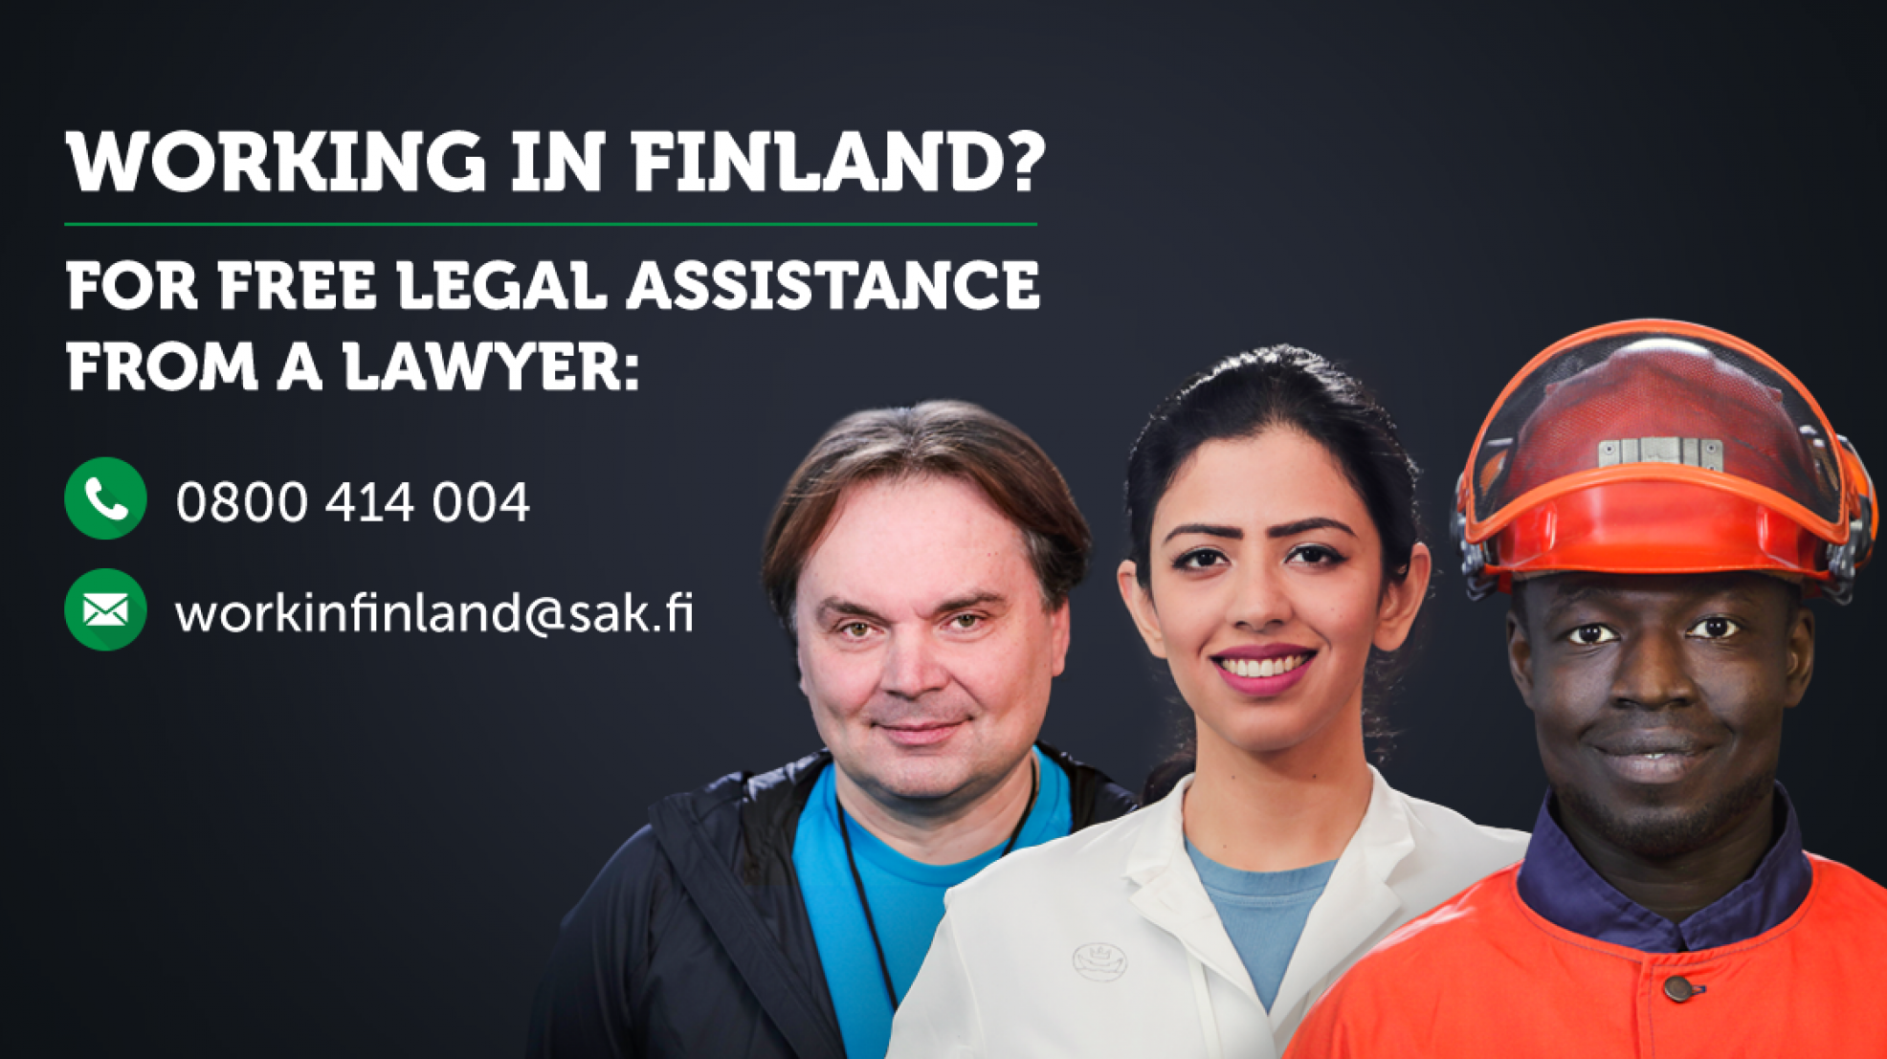

Finland

© SAK
SAK – At Work in Finland

Identification information

National Network: EAPN-Finland

Contact information: Jiri Sironen (jiri.sironen@ehyt.fi)

Context

In-work poverty in Finland is lower than in any other country in the European Union. Still there are problems, particularly among the unskilled workforce and in precarious jobs. This is especially the problem of women workers and with immigrant background, because they are working in precarious jobs, where trade unions have not so much power.

The wages are commonly negotiated by the trade unions and are relatively good, but since there is no minimum wage in Finland, there are pockets of very low-paid-jobs and/or are not following the legislation and thus not paying the employees what they should have.

Promising practice in detail

The SAK Central Trade Union has set up an employee rights advisory service for immigrants addressing questions or problems they might face concerning their employment. This free service is open to all and does not require trade union membership and is provided in Finnish and English.

As one can read on their website, their lawyer can offer advice if:

You don’t understand your employment-contract, or you would like a specialist to check it before you sign.

You suspect that you are not getting the correct pay, shift work bonus or holiday bonus.

You would like to know the normal wage levels in your industry.

You would like to check some detail concerning your holiday entitlement or working hours.

You are suffering harassment or discrimination at work and you need advice on how to deal with it.

As made clear on their website, the service is not there to find jobs for people or to provide advice on seeking work, neither to contact employers on employees’ behalf. The advisory service also aims to inform immigrants about the rights and duties of employees in Finland.

This SAK initiative is part of the At Work in Finland project subsidized by the European Social Fund (ESF) and is also backed by Service Union United (PAM) and the Trade Union for the Public and Welfare Sectors (JHL).
At Work in Finland was developed by SAK according to feedback received from their users, and was contacted 800 times in the last two years – mostly regarding salary issues. This service is particularly useful, since immigrants are often not familiar with Finnish work rules and therefore get often too easily exploited; moreover, they generally tend to be less engaged with trade unions. SAK, together with other national labour confederations (Akava, STTK) also offer a summer job information service, specifically tailored for offering advice on summer jobs.

The service offered by SAK could help preventing and combating in-work poverty, by allowing people to check whether they’re offered an appropriate salary and pushing for more sustainable contracts. Such initiative can also contribute to the empowerment of workers, by offering them tools to shield themselves from unfair working conditions and also by feeling supported from trade unions and civil society. While it helps people reaching other public services through it, this service also provides trade unions with useful information on the reality of the different workplaces, while also providing workers with direct evidence of the importance of trade union support.

Your rights and duties are part of the ground rules of the working world. You should insist on your rights, but also remember your duties. Understanding the ground rules can help you avoid many problems. The details of employment can often be quite complicated, but you do not have to tackle these problems alone. If something is not clear to you, then don’t be afraid to ask your supervisor, shop steward or trade union. They can also help if you have problems at work. (SAK, Fair Play at Work publication)

If you’re a foreigner working in Finland, you should educate yourself on labour rights. They’re designed to protect all workers and employees have the same rights and responsibilities regardless of nationality. But sometimes problems may occur and that’s why it’s important to know your rights. If you have questions about your employment, wages or holiday compensation, or if you are suffering harassment or discrimination at work, you can call or email the employee rights advisory services.
(SAK promotional video for the service, here)

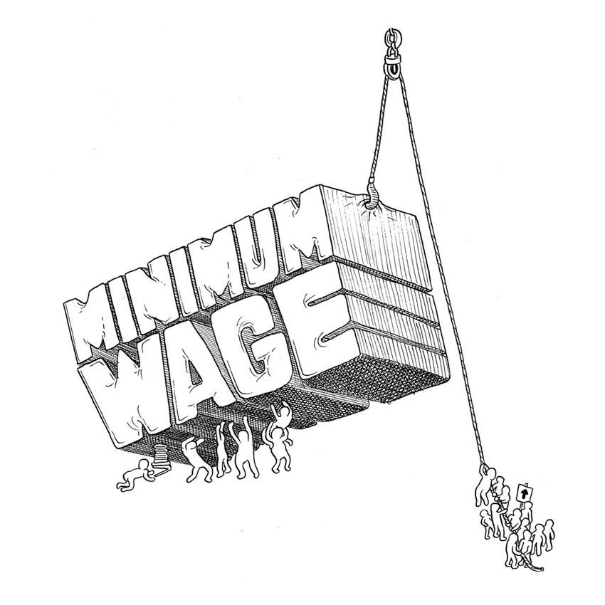

Latvia

© Sam Wallman
Policy actions around minimum wage
Identification information
National Network: EAPN-Latvia
Contact information: Elīna Ālere-Fogele (elina.alere.fogele@eapn.lv)

Context
In Latvia, in-work poverty is highly crucial. Statistics show that 22.1% of total Latvian population are at risk of poverty, the poverty threshold is calculated as 330 EUR per month for an individual person. In 2016, 9% percent of employed persons (8.4% male, 9.6% female) were under risk of poverty, which is close to EU average rate. Though, must be mentioned, that a general problem in Latvia persists as generally income of Latvian people stay comparatively low, while living costs and prices are close to European level. In 2018, minimum wage set by the Regulations of Cabinet is 430 EUR per month before taxes; workers who receive minimum salary get 314 EUR after taxes. This means that in any case those who receive minimum wages certainly are at risk of poverty. Though there is a slight improvement during past years as the Cabinet raises level of minimum wage on a regular basis (it was 320 EUR in 2014, 360 EUR in 2015, 370 EUR in 2016, 380 EUR in 2017), Latvia remains having 4th lowest minimum wage in the EU, and the second lowest, 536.9 EUR, if expressed in Purchasing Power Standards (first semester of 2017) .
In 2017, proportion of workers receiving minimum wage or less was 20% of total number of employed persons, and it is suspicious that in public sector this figure is 11%, while in private sector it reaches high 24%. This proves the generally common practice of underreported income (so called “envelope salaries”) in private sector, resulting in lack of social protection, and undermines the right to proper health care, as well and social benefits. The high rate of those earning less than minimum salary indicates on the high rate of atypical contracts and bogus self-employment, which is a common problem as well.
And again, Latvia has signed the Revised European Social Charter with a reservation to Article 4 Paragraph 1, thus in a political level refusing to recognise the right of workers to a remuneration such as will give them and their families a decent standard of living, and indirectly stating that working people may not be able to earn enough not to live in poverty.

Promising practice in detail
Case 1. The Tri-lateral Cooperation Council, which is an advisory body for the Cabinet, in April 2018 has supported amendments to the Labour Law, providing introduction of General Agreements in different economic sectors regarding minimum wage in the specific sector. First such initiative comes from the Partnership of Latvian Construction Entrepreneurs (NGO), which is collecting the necessary support from the whole construction sector. To come into force by January 1, 2018, the General Agreement has to be signed by Construction Entrepreneurs who represent 50% of total number of the employed in the industry or 50% of the industry’s total turnover, and if so, it will be legally binding also for those construction companies which have not signed it. The agreement provides that minimum wage for those working in the construction sector, including unqualified workers, shall be 780 EUR / month. Such an initiative is very welcomed, especially as construction sector is the one with the highest level of shadow economy including underreported wages.
Case 2. In January 2018 amendments to the Law “On Taxes and Duties” came into force, providing that the Government (the State Revenue Service) shall ensure that information / list of employers where average monthly remuneration for workers is minimum wage or beneath it. This initiative aims at fostering safety of commercial environment, fair competition and avoid tax evasion. Though the aims are clearly “business-focussed”, users can benefit from this before entering a job checking whether their potential employer is an honest one and socially responsible. The list is available for public on the website of State Revenue Service and the information is updated every month.
Both offered cases hopefully will be sustainable, especially the practice initiated by the Partnership of Construction Entrepreneurs. If this will develop it could be expected that other economic sectors and industries will follow the example. As mentioned before, construction sector is the one with the commonly paid low salaries to unqualified works and with black economy. As for Case 2, it should be an interest of employers not to be on the list of ones paying minimum or even less in wages.
Both cases were reflected as a big step forward on TV news broadcasts, newspapers and internet portals, and hopefully (as for Case 1), other industries will follow, thus pushing the Government to increase the minimum wage to a decent level.

“It is a little step, though it’s welcomed. Definitely it will be useful for those looking for a job. Just they could post the list directly on the Revenue Service’s website, not as an excel file which needs to be downloaded and opened separately. Users might face difficulties to find information about employers which pay minimum salaries in the net in such a format.” (Anonymous user, case 1)

“I was looking for a job as a janitor, and I needed to choose between two potential employers. An acquaintance of mine helped me find the list on the net, and one of them was mentioned there. That helped me to make the choice. I am over 60, close to pension age, and not at a very good health, so for me it is important that taxes are paid for me from the whole salary I receive.” (Andrejs, user, case 1)

“Employees work for wages, not for overtime. The main issue is wages in general, starting with the minimum wage in the industry. Besides, overtime should not be a regular practice for companies, but only an extra situation. General agreement is a systemic and intelligent tool for raising wages in Latvia, and according to calculations made by the Latvian Construction Industry Trade Union - it would positively affect the salaries of about 10,000 employees.”(Irēna Lapiņa, Vice-Chairperson of the Free Trade Union Confederation of Latvia, here, case 2)
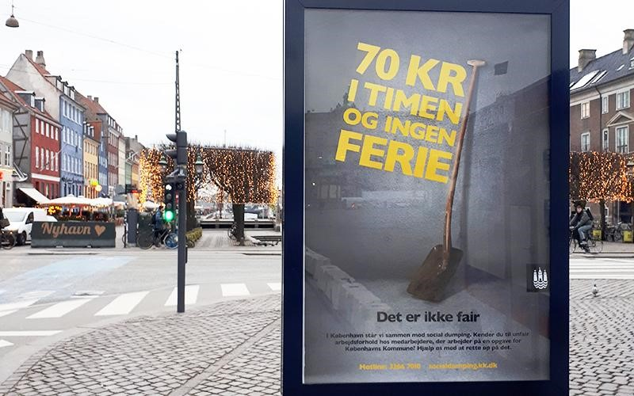

Denmark

© Københavns Kommune
Copenhagen against social dumping
Identification information
National Network: EAPN DK
Contact information: Ole Meldgaard (olemeldgaard1@gmail.com)
Picture says: “70 kroner per hour and no holidays. That is not fair.”

Context
Denmark is among the European countries with the lowest level of in-work poverty due to generations of negotiated labour market conditions and wages well above the poverty line. According to the latest statistic from Eurostat, 5.3 per cent are in risk of in-work poverty in Denmark (4 per cent in 2010) against 9.6 per cent in EU. However, since 2004 and the enlargement of the European Union and liberalization of the labour markets, social dumping has been on the agenda as a cause of in-work poverty. This reflects a strongly increased concern among employees and some employers, in trade unions and political parties, that Danish wage and working conditions can be undermined by unfair competition, if no action is taken.
Vulnerable groups face a greater risk of becoming working poor: part-time workers, young people, single parents, non-nationals and people working on temporary contracts. Sectors with most working poor are hotels, restaurants, cleaning, forestry, agriculture, construction and transport, and sectors where the organization of workers is weakest in unskilled industries.
The attitude of the Danish trade unions is clear: we welcome foreigners to the Danish labour market but we do not accept exploitation of foreign workers and undermining of the Danish labour market and welfare model. The definition of social dumping is also clear. It is wage and working conditions below usual Danish standards according to the agreement for the various sectors.

Promising practice in detail
“Copenhagen against social dumping” is an action taken against social dumping to ensure fair working conditions and fair competition for everyone, who works on behalf of the City of Copenhagen. The project is supported by companies, which actively work to ensure good working conditions for employees. The cooperation emphasizes that the efforts also benefit companies, which have to compete on equal terms when they offer tasks for the municipality.
The demand for fair pay and working conditions is a part of the contract with the City by way of a labour clause covering the entire supplier chain. Additionally, some suppliers are also covered by education and employment clauses, where it is possible to educate trainees and apprentices or employ unemployed persons for an assignment. A supplier to the City has to ensure:
- The employees’ wages, working hours and working conditions must (as a minimum) be on the same level as the existing collective agreements for the same type of work. The City of Copenhagen uses national collective agreements – made between the most representative trade unions and employers’ associations in Denmark – to determine the minimum requirements for wage and working conditions.
- The employees must be informed about their wage and working conditions within four weeks after the work has commenced.
- All employees must have valid residence and work permits.
An action team controls the conditions to ensure that the clauses are followed. Among other tasks, the action team makes control visits to the suppliers and partners to ensure that they have proper conditions. The supplier and sub-suppliers must be able to refer to the collective agreement they have used to determine wage and working conditions for their employees. The action team must have access to minutes of meetings and log books when they perform inspection visits. The team collaborates with the Danish Working Environment Authority and the Danish Customs and Tax Administration and the Police. What happens if the action team discovers breaches? At first, it will point out the breach and give the supplier the possibility of rectifying the matter. If this does not take place, he risks having to pay a penalty. Ultimately, the City of Copenhagen may terminate the contract – or demand that the supplier terminates the contract with his sub-supplier if the sup-supplier does not comply with the requirements.
A contract may also contain an education or traineeship clause. In the training plan, the supplier must describe how he intends to ensure that he employs the number of trainees stipulated in the contract. The employees must be able to document their identity by producing picture identification.
Information about the clauses is distributed in more languages. The project also mobilises the citizens in the fight against social dumping. Posters and banners in the city and social media inform Copenhageners about typical signs of social dumping - unfair wages, lack of job security and unacceptable working hours - and encourage contact with a hotline if they see signs of social dumping. The hotline is always open, and the action team can deploy on short notice.
Many foreign workers come from countries with poor experiences with trade unions, but more and more foreign workers join the trade unions when they see they benefit from their services. More foreign companies have been sentenced to re-pay millions of Euros they systematically have underpaid their workers. At the same time, the trade unions have won the trust of many foreign workers. (Ole Meldgaard)

As a supplier to the City of Copenhagen, it is therefore your responsibility that your employees – and the employees of your suppliers – have fair pay and working conditions. At the same time, you must contribute by educating trainees and apprentices on the City’s projects when possible. (City of Copenhagen, fliers to suppliers, here)

Pull up your sleeves under fair conditions. Thank you for working on an assignment for the City of Copenhagen – you contribute to keeping the wheels turning in our city. When you put on your work clothes and perform a task for the City of Copenhagen, you are entitled to fair pay and working conditions. (City of Copenhagen, fliers to vendors, here)

Ireland

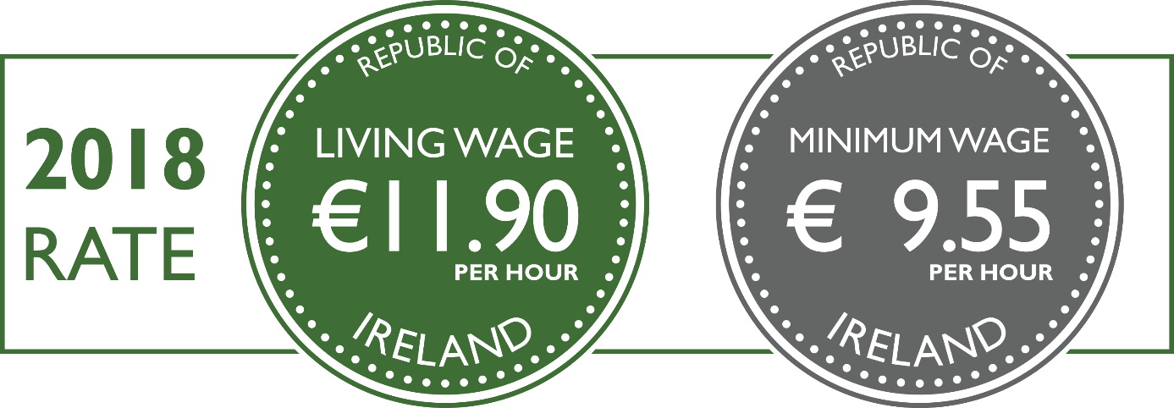

© 2018 Living Wage Technical Group
Living Wage Campaign

Identification information
National Network: EAPN Ireland
Contact information: Paul Ginnell (www.eapn.ie)

Context
In 2016 approximately 1 in 8 of those at risk of poverty in Ireland, or 100,000 people, are in work. This equates to 5.6% of those in work. As overall disposable incomes have begun to rise in the past few years the levels of in work who are those at risk of poverty for those in work has not fallen. Material deprivation among those in-work poverty increased from 1 in 15 before it crashed to 1 in 5 by 2014. This fell to 1 in 8 in 2016. In 2015 Ireland had the third highest proportion of low paid jobs in the OECD with 24% of workers estimated to be on low pay. There are also issues regarding precarious work in the Irish economy which have been characterised as ‘if and when’ work arrangements. In terms of the National Minimum Wage in Ireland just over 10% of worker in Ireland were reported as earning the National Minimum Wage in 2016. About two thirds of those on the NMW were women.
In 2015 the Low Pay Commission was established under the National Minimum Wage (Low Pay Commission) Act, 2015. The principle role of the Commission is to make such recommendations to the Minister that are designed to set a minimum wage that is fair and sustainable, and when appropriate, is adjusted incrementally, and that, over time, is progressively increased to assist as many low-paid workers as is reasonably practicable without creating significant adverse consequences for employment or competitiveness. It has also looked at a number of other related matters. The Low Pay Commission is appointed by the Minister and includes an independent Chairperson and representatives from across different sectors

Promising practice in detail
In 2014 a number of organisations in the community and Voluntary Sector and Trade Unions came together to form the Living Wage Technical Group. Among them was the Vincentian Partnership for Justice which develops the Minimum Essential Standard of Living (minimum essential budget standard) for Ireland.
Using the MESL data the Technical Group developed an hourly Living Wage for Ireland. In 2014 This was calculated at €11.45 per hour. This is the hourly rate necessary for a single person, with no dependents, working full time (39 hours per week). The National Minimum Wage at the time was €8.65 The group provided background data on how the rate was calculated. They also calculated the annual living wage needed for a number of different family types.
The Living Wage Technical Group update the living wage on an annual basis. The Living Wage for 2018 is €11.90 per hour, while the National Minimum Wage for 2018 is €9.55 in 2018, a gap of €2.35 per hour. The Government has committed to raising the Minimum Wage to €10.50 by 2021.
The publication of a living wage calculation helps to highlight to Government, and wider society, the level of pay necessary to provide for a decent income for workers and their families.
To date the Living Wage is not being used by Government to inform the NMW. However, it provides a benchmark for against which the national Minimum Wage can be judged and has been used on a consistent basis by many organisations, including EAPN Ireland, in lobbying for decent pay.
More information on www.livingwage.ie

© Clean Clothes Campaign Ireland

“What is a Living Wage? It is a wage which makes possible a minimum acceptable standard of living. It is evidence based and grounded in social consensus.” (Living Wage campaign website)

The idea of a living wage was “initially dismissed as impossible” but developed to become recognised “as a compelling cause which offers benefits to workers, employers and to wider society”. (Hirsch and Moore, 2011)

“You can’t bargain for a higher wage, even if you are very experienced,” says Chowdhury, who has been working in the restaurant trade since he moved here from Bangladesh, 12 years ago. “All you hear is that there are many others who are willing to work for lower. So you just need to take what you can get.” (The Irish Times, 2014, here)

Scotland

Living Wage Accreditation Scheme

© Scottish Living Wage Accreditation
Identification information
National Network: EAPN UK
Contact information: Peter Kelly (peter.kelly@povertyalliance.org)

Context
The problem of in-work poverty in the UK has been growing for many years. The statutory National Minimum Wage was introduced in 1999 and has helped ensure that low paid workers received higher percentage pay rises than most other groups of workers, particularly in the last 10 years. However, in part because of cuts to benefits such as Tax Credits and Child Benefit, workers in low paid employment have still had far from adequate incomes. In 2017, the Joseph Rowntree Foundation estimated that around 3.7 million workers in the UK were in poverty and that 8 million of the 12 million working age families in poverty contained someone who was in paid employment. Combined with rising numbers of workers on zero hours contracts and the growth of other flexible forms of employment, the UK Government introduced a new higher rate of minimum wage for over 25 years in 2016 – the so called ‘National Living Wage’, although this too falls below what is seen as a real adequate Living Wage.
Promising practice in detail
In response to the salience of in-work poverty as a problem, the campaign for a real Living Wage has developed in the UK over the last 16 years. Starting in London, emerging from a grassroots community organising process, the campaign for a Living Wage has involved trade unions, grassroots activists, voluntary and community organisations, faith groups and ultimately employers. The goal of the campaign was to encourage employers to pay a higher, voluntary Living Wage – effectively to change the practice of employers across the UK. This Living Wage has been calculated by using the Minimum Income Standard, and is therefore not a figure that is simply picked by campaigners but has its basis on an independently calculated assessment of what workers need to get by.
The campaign developed from one that is traditionally ‘oppositional’ to one that has sought to engage with employers directly, particularly those in the private sector. A key element of this engagement has been the development of a system of accreditation that employers apply for when they can verify that they are paying the Living Wage to all of their employees, including subcontracted employees. There are now more than 4,000 employers accredited as paying the real Living Wage. Employers pay an accreditation fee, a sliding scale depending on the sector and number of employees. This fee is a sustainability tool built in the campaign model, and it allowed the movement to grow and engage many more employers, ultimately benefiting more employees and promoting sustainability.
This initiative began as a result of community campaigning and the campaigns, organised by the Poverty Alliance in Scotland and Citizens UK elsewhere continue to develop grassroots support for the real Living Wage. People with direct experience of in-work poverty have been at the forefront of the campaign and remain so. The campaign significantly impacts on in work poverty: It is estimated that since 2001 more than £600m has gone into the pockets of low paid workers above what they would have been paid if they were paid at the level of the statutory minimum wage. Around 150,000 workers in accredited companies and organisations received a pay rise in 2017 when the real Living Wage increased.
The approach taken with accreditation, a positive engagement with employers, has led to the opening of new discussions with the private sector around the need for it to play a role in addressing poverty. Engaging with the corporate social responsibility agenda in this way has the potential to radically change business practice.

“Great businesses know that, even during these tough times, not only is fair pay the right thing to do but paying the real Living Wage brings big benefits. Nine out of ten accredited Living Wage employers report real benefits including improved retention, reputation, recruitment and staff motivation.” (Katherine Chapman, Living Wage Foundation Director)

“It makes life a lot easier, you’re getting paid more and you feel appreciated because you get paid more. Last year when I worked here I was being paid the minimum wage, and then I had to quit when I went back to university because it wasn’t worthwhile to keep the job on. But then I came back last April, and that’s when they moved up to the Living Wage, and I’m going to stay working here while I’m at university because when you go to part-time, the hours still work up to get some wage” (Sophie, Scottish Living Wage campaign video here)

"Before being paid a Living Wage, life was difficult, financially for me. I am a single parent, and was working to try and have enough money to pay my bills, and provide for myself and my son. I had no social life, and constantly had to tell family and friends that I was unable to meet them for a meal, drinks. Earning the Living Wage means I'm not so tired, I can give up some extra part time work and there's a little left at the end of the month." (Lynne, Living Wage UK here)

"Being paid the real Living Wage means we can have more of a social life and go out dinner or buy a treat for our partners instead of worrying about bills." (Mel, Living Wage UK here)

“Heathrow’s status as a world-class airport is down to the quality and expertise of our colleagues. We firmly believe that paying the Living Wage is the right thing to do as a responsible employer. (John Holland-Kaye, Heathrow CEO)

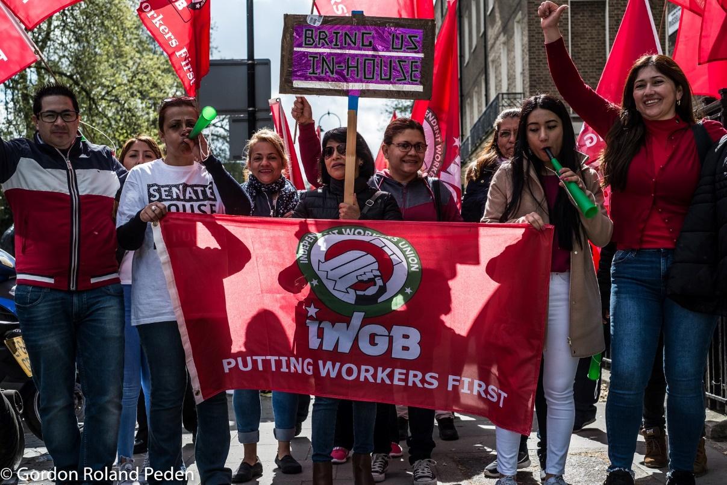

EnglandScotland

Living Wage Accreditation Scheme

Identification information
National Network: Independent Workers Union of Great Britain (IWGB), through EAPN UK
Contact information: Sebastien Flais (sebastienflais@iwgb.org.uk)

Context
The biggest concern our members face is precarious work as a result of companies’ denial of basic employment rights in the UK, spurred on by very poor enforcement from the government. The issue is stereotypically associated with the rise of so called “gig economy” but can be found in traditional employment too. Despite being employees, workers at the University of London are denied genuine access to trade union rights. The IWGB cannot bargain with the outsourcing company because there is already a recognition agreement in place. We are the most active union, but the agreement means that the company complies with Article 11 of the ECHR, regarding freedom of association, and cannot be forced to recognise another union. The University ultimately controls the terms and conditions of the workers, by setting the budget and choosing the outsourcing company, but also denies workers the opportunity to bargain with them, as the company is the legal employer.
Across our branches we are also dealing with misclassification loopholes, commonly associated with app-based employers like Uber and Deliveroo. Companies are increasingly denying workers’ rights they are entitled to in law by claiming they are independent contractors who are running their own businesses. In reality, the workers are subject to many conditions by the company – sometimes having to wear a uniform, always subject to the companies’ rates and usually supervised. They are usually “limb (b) workers”, a category of self-employed that entitles individuals to minimum wage, holiday pay, trade union rights and protections against discrimination. Unabated, these practices spread like wildfire across an industry and stretch beyond the so called “gig economy”. In the courier, foster care work and private hire industries, misclassification is standard practice.

Promising practice in detail
Ideally, the companies will follow good practices of their own accord by providing the union that represents the workforce the ability to negotiate and follow the law. This is unlikely, so unions have to think creatively to organise precarious workers and act as vehicles for political change. We have often used combative campaign tactics, usually the way forward without recognition – we secured the London Living Wage and won four pay rise campaigns for couriers through strikes and protests. Another option is by going through the courts. We have won misclassification cases with couriers from CitySprint, Excel (now a part of CitySprint), Addison Lee and The Doctor’s Laboratory (TDL). As a result of further legal action, we also have a collective bargaining agreement with TDL, the first in the UK’s “gig economy”. We also have an ongoing case against the University to entitle the outsourced workers to negotiate directly with the University.
The government can make the most meaningful difference by enforcing the law. There is little incentive for employers to comply – CitySprint had to pay two days holiday pay as a result of breaking the law. As a result, once misclassification is in place, most companies will follow and cut corners for a profit. As a solution, we have recommended to the government stricter sanctions, enforced by an independent and well-resourced body.
Our campaigns concentrate on improving terms and conditions at work. Our pay rise and London Living Wage campaigns immediately improved members’ conditions at work. Cases can be slow to provide results – the Uber worker rights claims were made in 2015 – but they are useful to expose bad practices.
We make sure that the workers’ voice is the strongest in the union. 14 of the 19 positions available on our Executive Committee are occupied by branch officials, who are all workers in their respective branches (e.g. all officials in the couriers’ branch are former or current couriers). If members ever experience an issue, there is a weak bureaucratic barrier for them to raise it with the highest officials. We also provide the branches with a lot of autonomy.
By fighting issues like misclassification, we are putting the worth of workers at the forefront of the discussion. Fighting for basic rights when workers are exploited, either through de jure or de facto means, exposes employers’ never-ending desire to cut costs at the expense of their workforce.

More information on IWGB and the work they do:
- Introduction video to the union featuring several members
- Video including our members on limb (b) worker status
- Video of outsourced workers on why they support the IWGB campaign to end outsourcing
- Guardian’s article on IWGB work in the so-called “gig economy”
- Guardian’s article on Sarah Anderson, chair of the IWGB Foster Care Workers Branch

“The branch had only 20 outsourced workers. We spoke Spanish. We recruited, and membership rose to 100,” Moyer-Lee (general secretary of the IWGB) says. “It’s about working from the bottom up.” […] At the Back in House strike is Liliana from Colombia, who became a cleaner at the University of London five years ago. Then, she was earning a little over £6 an hour, and says she was bullied by her supervisor. Now, she is paid the London living wage (£10.20 an hour). “I am not alone,” she says. “We have solidarity. They cannot make injustices against us because we stand together.” (The Guardian, 2018, here)

“There are so many misconceptions around what we foster carers do: I am supposedly self-employed, but I can only work for my one employer; I have signed a document which sets out what I have to do and how much I will get paid, but I am told it is not a contract; I have regular supervision – a series of boxes are ticked to make sure I am following the strict rules; I have a chain of command set in stone; I have to follow the child’s care plan whether I like it or not, or whether or not I think it is good for the child; I can’t have another job, yet I can be dismissed on a whim with no notice by employers who act as judge, jury and executioner.” (The Guardian, 2017, here)

All data coming from the Joint Employment Report 2018, based on data collection from the EU-SILC survey.
http://www.lboro.ac.uk/research/crsp/mis/thelivingwage/

