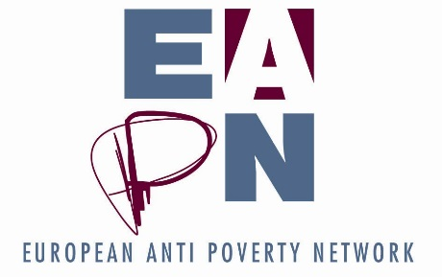

HANDBOOK

For the EAPN Bureau 2018 – 2021

- EAPN BACKGROUND and history

Timeline
Origin and development of EAPN

- EAPN Structure
Organigram
Terms of Reference of different structures
EAPN membership

- Legal documents

Statutes
Standing Orders

- Financial issues
Income sources
Budget
EAPN Fund
Reimbursements

- Risk analysis
- Strategic Thinking process
Phase 1 report
Phase 2 report
Next steps

- Best practise governance

EAPN BACKGROUND and history
Visual timeline

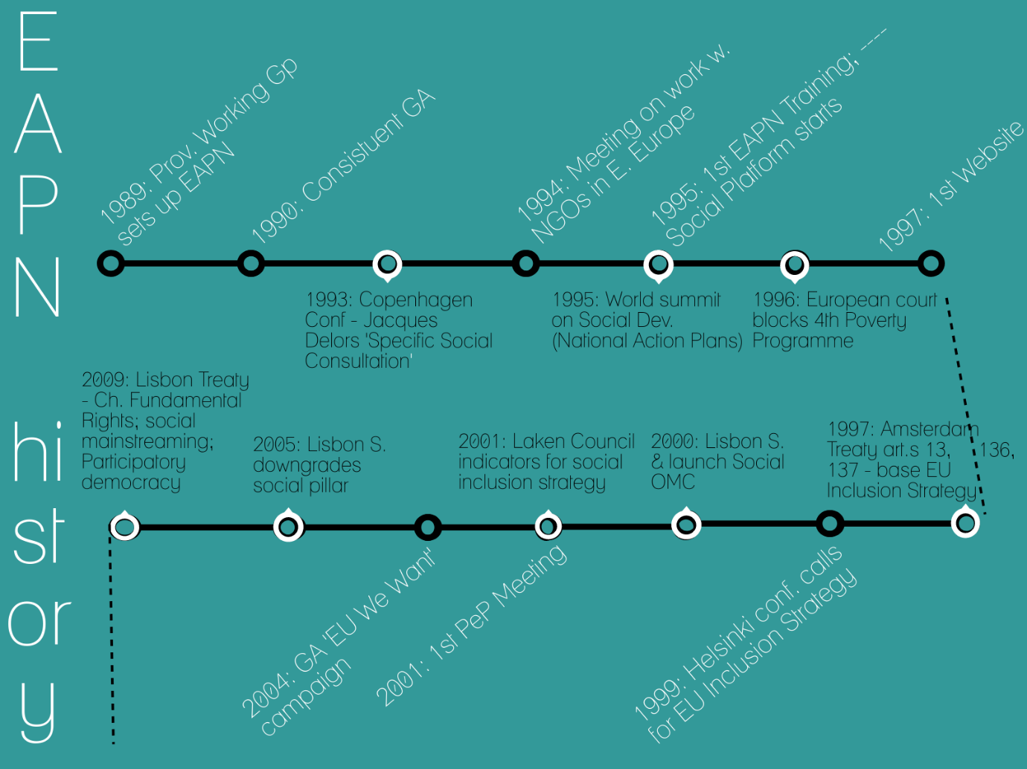

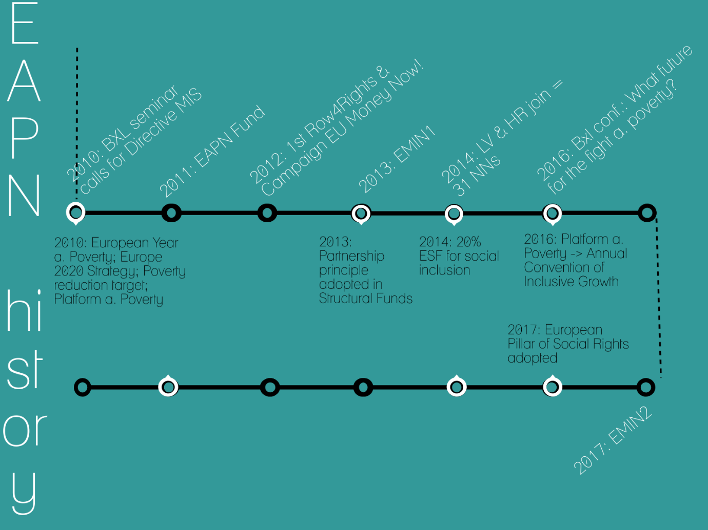

- Origin

The creation of the anti-poverty network is the result of a convergence of interests on the part of the NGOs themselves and on the part of the European Commission.

On the part of NGOs, there was an increased awareness in the nineteen eighties of the European dimensions of the fight against poverty, and the influence that Community policies could have on national policies. They realised that countless special-interest groups were already well represented in Brussels both in the commercial and non-profit sector, while people living in poverty and the organisations which work with them simply were not. That is the gap which the European anti-poverty network has been aiming to fill since its founding General Assembly held in Brussels in December 1990.

Contacts and links between the Commission and NGOs involved in fighting poverty were stepped up during the eighties, particularly, but not exclusively, through the existence of the first two poverty programmes (1975-1980 and 1985-1989). At the same time the Commission became increasingly aware of the role of NGOs in the fight against poverty and on the need for all actors to work together. It felt the need for a body which would be broadly representative at European level of the many groups involved on the ground.

- The June 1989 colloquium and the creation of the Provisional Working Group (1989-1990)

More than two hundred persons involved in anti-poverty action throughout the member states were brought together in June 1989 in Brussels with financial support from the Commission, organised by ESCAP.

The gathering came to the conclusion that there was a need for a liaison structure between the many anti-poverty initiatives in the member states and the Community institutions in order to highlight and address the problems and realities of poverty within the development of Europe.

To this end a provisional working group of eight persons, chaired by Hughes Feltesse (France) was appointed whose task was:

- to disseminate information on and promote the project of an “anti-poverty liaison” as widely as possible within each member state with particular attention to reaching to the most marginalised

- to promote the constitution of national, regional and local anti-poverty networks

- to draft the terms of reference and the statutes of a European liaison committee of voluntary anti-poverty initiatives

- to prepare and organise a General Assembly of the “Liaison” which would reflect the diversity of voluntary initiatives involved in empowering the most disadvantaged.

- Creation of EAPN and main developments and achievements To date:

- Constituent General Assembly December 1990

EAPN was formally created then, with eleven national networks (the German national network joined in November 1992) and several European organisations. Its statutes contain the following objectives:

- to put the fight against poverty and social exclusion on the political agenda of the European Union

- to lobby for and with people and groups facing poverty and social exclusion

- to promote and enhance the effectiveness of actions against poverty and social exclusion through transnational partnerships and exchanges of experience.

- Structuring and strengthening of the network

At European level:

EAPN was created in 1990 with eleven national networks. The German network was formed in 1991 and joined EAPN at the 1991 General Assembly. The Finnish and Austrian networks joined at the 1995 General Assembly. The Swedish network joined during the 1998 General Assembly.

In recent years the enlargement of the EU has poised an additional challenge to EAPN and considerable work has been addressed to developing contacts with appropriate NGOs in the countries concerned in order to establish National Anti-Poverty Networks that would become members of EAPN. An important first step in this direction was taken at our 2003 General Assembly when EAPN Bulgaria became a member of EAPN. At the 2004 General Assembly Networks from Hungary, Malta and the Czech Republic joined EAPN. Networks from Norway and Cyprus were welcomed into EAPN at the 2005 General Assembly. At the General Assembly of 2006 the Lithuanian Network joined EAPN. Poland and Slovakia joined the Network in 2007, Romania in 2008 and Slovenia in 2009.

Ten European organisations were members or observers at the constituting General Assembly of December 1990; as of December 2018 this number has grown to 13. There have been as many as 30.

EAPN set up a secretariat in Brussels in January 1992, first, with a director and a development officer, then an administrator and an executive secretary and, since August 1996, an information officer. Since then, the secretarial team has been reinforced by the hiring of additional personnel. A complete list of the present members of the secretariat and their key areas of responsibilities is to be found elsewhere in this induction pack.

A training programme for EAPN members was set up in 1995 with one, then two training sessions per year. Several hundred members have benefited from it.

At a national level, progress continues to be made in structuring and strengthening the national networks and, in some cases, accessing the financial resources necessary to operate (see section 4).

- Policy development

Over the years EAPN has set up various working groups and task forces to help formulate policies as well as to serve as an exchange of experience between members.

EAPN has published and circulated a large number of documents (position papers, working group reports, seminar reports, annual reports, declarations etc.)

The main issues tackled have been:

Minimum income, social protection, the reform of the structural funds, poverty and social exclusion in southern and peripheral countries, women and poverty, racism and poverty, economic exclusion and the right to work, the need for a European Anti-Poverty strategy, the Lisbon Agenda and the EU Inclusion strategy (OMC on Social Protection and Social Inclusion), the revision of the European Treaties, and the implications of EU enlargement.

- Lobbying/representation

With the institutions

Right from the start EAPN was closely involved in consultation over Commission policy on social exclusion (with the Commission’s communication on social exclusion of December 1992 and with the “specific social consultation” promoted by J. Delors at the Copenhagen conference in 1993).

Relationships with the European Parliament: EAPN has taken part in several public hearings, has influenced a large number of resolutions and has obtained a high visibility in the European Parliament.

Relationships with other institutions and in particular, the Council of Ministers, have been slower to get established; however increasingly strong links have been developed with the Presidencies, in particular through the European Meetings of People Experiencing Poverty (organised by the Presidency of the first half of the year) and the Round Table on Social Inclusion (organised by the Presidency of the second half of the year). The contact in relation to these meetings has often led to a strengthening of the engagement of EAPN in other actions under the Presidency programmes.

In recent times EAPN has developed a strong inter action with the Social Protection Committee and to a lesser extent with the Employment Committee.

EAPN has made a start in widening its institutional contacts beyond the EU Community institutions: the Council of Europe, (EAPN collaborated with the Council of Europe on their “Human Dignity and Social Exclusion” project and obtained Consultative Status in January 1998), the U.N (participation in the World Summit on Social Development in 1995 and the follow-up in June 2000 and January 2005)

Co-operation with other organisations:

Following the organisation of the social policy NGO Forum in 1994 organised by EAPN, the network was instrumental in the creation and development of the Platform of European Social NGOs (Social Platform) from 1995 onwards. The Social Platform in turn has also developed contact with other NGO Families (Environmental, Human Rights and Development) through the Civil Society Contact Group. EAPN has been active on behalf of the Social Platform in this group.

Other partners: In addition EAPN has sought to strengthen our contacts with the European Trade Union Congress (ETUC) with some success and with UNICE (European Employers Organisation) with little real success. We currently prioritise our participation in the ESCR-Net (International Network for Economic, Social and Cultural Rights connects over 280 NGOs, social movements and advocates) where IFSW and EAPN Greece represent us. Within this alliance we focus on the Economic Policy Working Group. Time permitting it could be interesting to focus on their Social Movements Working Group as well, but we have not been able to prioritise this. We are also members of various alliances (formal and informal), but in reality struggle to find the time to manage these alliances effectively.

- Communication

Network News/EAPN Magazine: since April 1992 Network News has been regularly published and distributed by EAPN. Printed versions of this Newsletter are available in English and French. Funding is available to National Networks to translate the Network News in their own language and where Networks take up this opportunity, electronic versions of the Newsletter in these languages are available. Network News is now produced four times a year. In 2009 EAPN has experimented with the production of an EAPN magazine which replaces the Network News.

Since December 1997, the secretariat has published brief up to date news in ‘EAPN Flash’ twice a month for distribution by electronic mail. It is also available on the Internet.

EAPN has had its own Internet site since May 1997. A new web site was created in 2005 which aimed at being a portal web site on poverty and social exclusion. In 2007 there was a revision of the web site aimed at making the key work areas of EAPN more visible and allowing greater exchange between EAPN members. In recent years the website has been redeveloped and a Members Room added. Social media has also been developed, with 7000 followers on facebook and 2000 followers on twitter. There is much room for growth of our social media, though many members are not so active on twitter, for example.

Since 2005 EAPN has produced an internal document ‘EAPN Policy Brief’ for people active in the European or National Administrations or working groups of EAPN. This document aims to provide hey information about development and actions in the key policy areas impacting on the work of EAPN.

Directory of members: a database with details about EAPN members was established in 1993 and has been revised once, in 1996. Two paper editions have been published and a version was available on Internet in June 1998. This information is now available on the EAPN website.

- The European institutional environment in which EAPN has developed

At first, thanks mainly to the impetus given by President Delors, EAPN grew in a climate favourable to developing action against poverty at European level.

Several major conferences on social exclusion were organised by the Commission where EAPN’s whole Executive Committee was invited.

A major political document was adopted by the Commission in December 1992 (Towards a Europe of solidarity - COM (92)542) about which EAPN was thoroughly consulted.

Two important recommendations were adopted by Council in June 1992 (on minimum income and on the convergence of social policy objectives)

A “specific social consultation” involving EAPN, COFACE, ETUC and UNICE was introduced after a major speech by Delors at the Copenhagen conference (May 1993). This constituted the culmination of this favourable climate, which had however, already started to decline, particularly following the Danish and French Maastricht referendum.

Difficulties arose over the fourth poverty programme put forward by Commission in October 1993, never adopted by Council due to the opposition of Germany and the UK.

The legitimacy of Community action against poverty and social exclusion began to be questioned. The observatory of national policies to combat exclusion was disbanded; the Interservice Group on exclusion within the Commission ceased to meet; the planned interinstitutional declaration on exclusion was abandoned.

Things went from bad to worse with the legal action of the UK supported by Germany against the Commission over allegedly spending money illegally for anti-poverty projects in 1995 and 1996 and the European Court of Justice ruling of May 1998.

The situation started to change following the signature of the Amsterdam Treaty in 1997, which provides in Article 136 for the Community’s social policy to include amongst its objectives the fight against exclusion, and provides in Article 137 for co-operation measures in the fight against poverty and social exclusion which can be adopted by qualified majority. It must be stressed that during the Intergovernmental conference which led to the Amsterdam Treaty, EAPN had conducted a long and vigorous campaign for the inclusion of the fight against poverty and social exclusion into the Treaty.

Following the signing of the Amsterdam Treaty EAPN has campaigned for the implementation of article 137 with a European strategy against poverty and social exclusion .The conference organised by the Commission in May 1999 and the conference organised by EAPN in Helsinki in November 1999, ‘Social Exclusion in Europe – Time for Action’, were occasions to launch such a call. Significant steps in this direction were announced under the Portuguese Presidency part of the Lisbon Strategy and have been further advanced under the French Presidency with the adoption of objectives for the fight against poverty and social exclusion at the Nice European Council. This EU Inclusion Strategy base on National Action Plans on Social Inclusion has now become a main focus of the work of EAPN. At European level there is a community action programme to support the strategy. EAPN at European level and to varying degrees at member state level is actively engaged in the institutional arrangements to implement this strategy.

During 2005 and 2006 there was a major revision of this strategy under the banner of ‘streamlining’ which led to the creation of the Open Method of Coordination on Social Protection and Social Inclusion of which the National Action Plans on Inclusion remain a part. This change and the general climate under the revised Lisbon Strategy (2005-2010) with its focus on jobs and growth has not been favourable to the fight against poverty but despite this EAPN has sought to maintain the issue of poverty and social exclusion on the EU Agenda. Considerable process are still working at EU level, Peer Reviews, Thematic Years against poverty, Active Inclusion Recommendations, follow up on Minimum Income, Services. For EAPN one of the main difficulties is that the centrality of the National Action Plans for Inclusion has been lost in the process and as a result it has become harder to maintain dynamic for the EU process at National level.

Conclusion

The challenge still remains to make sure that the Inclusion Policies are reflected in the broader objectives of the European Union and in particular in relation to the post Lisbon agenda, the Spring Council and the Broad Economic Policy Guidelines. It is hoped that the 2010 EU Year against Poverty and Social Exclusion can restore momentum to the EU Inclusion Strategy and ensure a stronger focus on actions to fight poverty and social exclusion and to create a more dynamic process for the engagement in particular of National NGOs in the process. It is also essential that the end result of the dialogue about the future of the EU Constitutional Treaty strikes the right balance between its, social, employment, environmental and economic, policies.

EAPN Structure
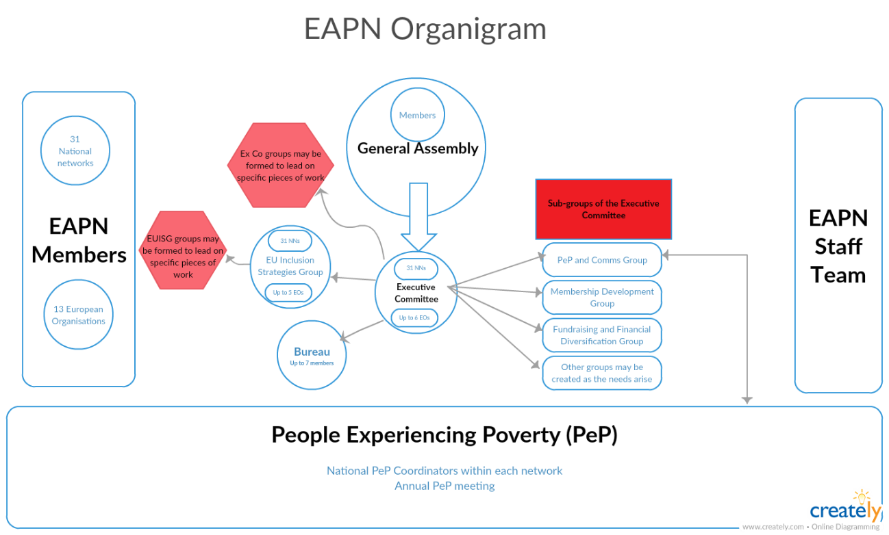

Structures not captured on here fully include:
- Burnout / Wellbeing Task Team

Terms of Reference of different structures

Governance bodies
General Assembly
Ex Co
Bureau

EAPN membership
What does it mean to be a member of EAPN?
National network or European Organisation

Other bodies
EAPN EU Inclusion Strategies Group (EUIS Group)

Introduction
This document sets out the terms of reference for the new EAPN EU Inclusion Strategies group (EUIS Group). It implements the EXCO decision (23-25 November) for the Work Programme 2012.

Description
The EU Inclusion Strategies Group (EU/ISG Group) is the new, decision-making EAPN working group which will drive EAPN policy and lobbying work on EU Inclusion Strategies, at national and EU level. It replaces the existing Social Inclusion, Employment and Structural Funds Working Groups and is given delegated powers by the EXCO to develop and decide on EAPN main policy work. It will meet three times a year (2 days) and be formed by 1 member from each national network (backed by a permanent substitute) and 5 representatives from the European Organisations. The Group will be supported by the Secretariat.

The EU/ISG is the permanent working group established to deliver on Goal 1, Objective 1.1 and 1.2 of new Strategic Plan through Strategy 1.

Goal 1: A social and sustainable development model that tackles poverty, social exclusion and inequalities is at the heart of decision making in Europe.
Objective 1.1: EAPN will work to ensure that the Europe 2020 strategy, the Platform against Poverty and the Social Inclusion strategy (Social OMC), the Employment Policy (European Employment Strategy and Cohesion Policy (Structural Funds) delivers progress to: effectively mainstream social concerns, reduce poverty and inequality and ensure that public policies, programmes and intervention reach people living in poverty, including the most disadvantaged.
Objective 1.2: EAPN will work to support its members to effectively engage in public debates and national and European policy making, on poverty, social exclusion and inequality.

Strategy 1 proposed in the Strategic Plan:
- Being an innovative and active partner and to be a relevant reference point, shaping and influencing EU inclusion policies and strategies.

Activities
The group will develop together an effective way of working to deliver on the objectives. Information and experience will be mutually exchanged between the members of the group and the secretariat, and there will be a focus on capacity building to enable members to engage actively at national and EU level in promoting effective anti-poverty policies. The main activities that will be carried out by the group are likely to include:
- Information and exchange on EU developments related to Europe 2020, Flagship Platforms, Social OMC, Employment, Structural Fund future framework agendas, national policy developments and EAPN actions.
- Mutual learning and capacity building:
  - on EU processes and policy proposals,
  - how to engage in stakeholder processes at national and EU level (NRP/Social Report/Platform Against Poverty, European Employment Strategy and Structural Funds future Framework)
  - how to develop own national anti-poverty strategy proposals in the context of structured dialogue with national decision-makers.
3) Members developing effective anti-poverty inputs through structured dialogue with institutional partners at national level to feed into EU Inclusion Strategies, feeding back developments, and contributing to a joint analysis of all inputs.
4) Building common policy positions and other instruments, proposing Task Forces on specific topics to EXCO and participating in them.
5) Developing lobbying campaigns and alliances to deliver on the objectives of the group.
6) Organizing one EU policy conference a year in cooperation with the EXCO and smaller lobbying events.

The information/capacity building activities are primarily tools to enable members to take action to influence anti-poverty strategies at national and EU level, which is the main goal of the group.

Methodology/Way of Working
As it is a large group (35), an effective way of working will need to be developed. The sessions will be organized in dynamic, interactive workshop/ seminar format. There will be the potential for smaller fixed thematic working groups within the meeting programme (for example: on Structural Funds Future Framework, Macro-economic input to NRP, Employment and Social Inclusion, Active Inclusion, Educational inequality…). The group will also propose and participate in Task Forces, developing a concrete product or outcome over a fixed period, in liaison with the group, projects, and participation in useful alliances at national and EU level. Formal decisions will be taken in a more formal, structured format ie with votes if necessary. The group will report to the EXCO once a year, preferably with a joint session involving at least the Steering Group. A representative of the Bureau will participate in the group to ensure coherent working.

Role of the Steering Group
The group will elect a Steering Group of 3 members for the next 3 years to facilitate/organize the EUIS group with secretariat support. The role of the Steering Group will be to:
- Support the work of the Group to reach the objectives
- Work together with the Secretariat on establishing agendas and following up on priorities, (during as well as between meetings)and
- Facilitate Group discussions during meetings.
The 3 representatives in the Steering Group will be elected by the EUIS group at the beginning of each 3 year period. The group should aim to involve 2 national members and 1 EO, to maintain the balance reflected in the Strategic Plan.

Participants Profile and Role
Each National Network will select two representatives for the group: a permanent representative and a substitute, who can replace the fixed representative when necessary and help to link to work at national level. The representatives should be different from the EXCO member, to ensure checks and balances in the organisation, and to ensure better division of tasks and responsibilities, avoiding overload. The EO’s selected (5 representatives) should also nominate a substitute. Members choose their own representatives, but participants should preferably have:
- Knowledge/experience of EU Inclusion Processes and engagement at national level with EAPN (NRP, NAP Inclusion, Employment or Structural Funds) (EU level for Eos)
- Experience of at least 2 years in EAPN at national level or in EO.
- Knowledge/experience of the reality of poverty and national inclusion policy
- Commitment to active participation in group, including regular inputs (written and oral) in consultation with their networks and organisations, developing joint pieces of work, and regularly and effectively linking work from the group to the national level.
- Good spoken and written English or French. ENG/FR translation will be available.

The primary role of members in the group will be to:
- Participate actively in the EU group, contributing information on national developments and realities, EAPN actions
- Inform and support their network/EO to engage/lobby in the national processes, preparing quality inputs to EU Inclusion Strategies (Europe 2020, Employment, Structural Funds and the new programme to replace Progress).
- Organize regular information distribution, meetings and capacity building with national members, ideally through a fixed group.
- Work together with EU group members to develop common assessments/reports/ policy positions and lobbying campaigns at national and EU level.
Membership Development Group needs updating)

Objective: to relaunch a pro-active Exco-led membership development process with focus on implementing MASS, Training and Capacity Building Agenda and Supporting Networks based on their request:

Action at the November Exco meeting:

- Set up the Member Development Group, made of 6 Exco members. The Group would meet separately and carry out qa substantial amount of work related to membership development and support in EAPN.
  - Decide on the composition of the Group
  - Decide on the Mandate of the Group based on the proposals below
  - Decide on Methods of Work based on the proposals below

Background Exco decision: Based on a thorough analysis of the situation of National Networks and upon the agreed Bureau proposal (June 2014 Exco voted in favour), Membership Development will be pro-actively driven by two groups:
- Bureau – taking statutory and politically sensitive issues related to member development.
- Member Development Group – responsible for implementation of the member development strategy, training and capacity building work, Membership Assessment and Support System and other tools that EAPN members have developed until now.

The 2015 Work Programme highlights the Bureau vision for a more proactive membership development approach with Exco members actively planning and implementing actions with support from the secretariat. The Bureau retains the responsibility for politically sensitive issues (conflict management, ad-hoc support etc. and statutory requirements – annual reports, change of statutes etc.).

Composition of the Group including criteria

: 6 Exco members with experience in building National Networks, interested and able to meet separate from the Exco meetings and to actively plan and carry out the development work throughout the year. The Exco should strive to uphold its statutory requirements and have a geographic representation in the Group as well as other balance criteria usually applied in EAPN.

Mandate of the Group

The group should have a mandate of the same duration as the Exco – 3 years and it should report regularly to the Exco. The Group should implement the following:

- Membership Assessment and Support System (2 Networks per year undergoing the process).
- Training and Capacity Building Strategy, including planning and carrying out the activities budgeted as part of annual work programmes (2 seminars are planned for 2015).
- Offer support visits to networks that struggle to engage with national or European agenda of EAPN (upon request from members).
- Provide induction to new members of EAPN.
- Act as a liaison group for members, maintaining active communication with them.
- Follow the implementation of the goal 3 of the Strategic Plan on direct participation of people experiencing poverty and social exclusion in EAPN work.

Methods of work: The Group will base its work on the Membership Assessment and Support System, as well as on the renewed Training Agenda of EAPN, both approved by the Exco in 2013-2014. The work should aim to reinvigorate National Networks through various approaches:
- Peer support
- Direct contact and communication
- Training and capacity building
- EAPN seminars and meetings.

The Membership Development Group should meet at least 2 separate from Exco meetings and develop its own agenda of work, based on the needs identified in EAPN. The group will be supported by the Development Officer, and where necessary, by other Secretariat members.

In short, this Group has very demanding tasks ahead that will be divided among its members. It is a plus to have experience of setting up or running national networks and knowledge of EAPN development.

PeP / Comms Working Group

Background
EAPN Mission
• To promote and enhance the effectiveness of actions to eradicate poverty and prevent social exclusion
• To raise awareness around poverty and social exclusion
• To empower the people living in poverty and social exclusion
• To lobby for and with people and groups facing poverty and social exclusion.

EAPN Communication work
The objectives of our Communications work include increasing the visibility of the voices, faces and experiences of people with direct experience of poverty and breaking stereotypes about (people experiencing) poverty. We are convinced that meaningful participation of people experiencing poverty should be at the core of EAPN. We don’t want to talk ‘about’ people experiencing poverty, without giving them a voice, but we want to amplify their voice.

EAPN Communications Working Group
The EAPN Communications Working Group will be giving guidance to EAPN Communications work, with a specific focus on how people experiencing poverty can participate in this work, how their voices and faces can be made more visible. This group will be working on a long term structured basis, providing guidance for both EAPN staff and the members. Respecting our own principles, this means that this working group should also include people with direct experience of poverty.

Composition
This Group will be composed by 8-10 individuals, from 3-4 National Networks and 1 European Organisation. Each member should delegate 2 persons: 1 person with direct experience of poverty, and 1 person who is working on communications in the network or is member of one of the other EAPN bodies/groups (ExCO, EUISG, PeP National Coordinators…). The 2 persons from each member will have complementary expertise, and will be working in tandems (pairs, duos), supporting each other.
Selection
We intend to create a diverse working group, in terms of age, gender, ethnicity, different experiences in terms of poverty and in terms of working with EAPN.
All members should have a specific interest in participation of people experiencing poverty and in communications work.
Staff (Communications Officer) and Bureau member(s) will select the participants based on an objective ranking system, taking into account relevant experience and motivation.

Ways of working
• 1 face to face meeting of this group (in Brussels or in the country of one of the tandems) per year
• Ongoing discussions using tools agreed by all participants, for example online meetings
• The meeting will always be organised in an active participative way

Legal documents

Statutes (link to Members Room)
Standing Orders (link to Members Room)

Key issues in 2018 - 2021
Following the decision taken at the 2018 General Assembly about the voting rights of members, we will need to make changes to the Standing Orders in 2019 to reflect these changes, notably in the article about Membership Fees.

The Dutch Resolution of 2017 may also have repercussions for the Statutes and the Standing Orders. Our Dutch member is working with the Director to make concrete proposals on this, which will be ready for consideration by the Bureau in Q1 2019. These proposals will focus on issues like individual members, the role of people experiencing poverty in governance bodies etc.

Other big discussions in the context of the Strqtegic Thinking process may well lead to necessary changes to the Statutes and Standing Orders. Obviously any restructuring of our governance bodies would led to such a change. The 2018-2021 Bureau will need to pay close attention to this, and it should become one of the major priorities of this Bureau.

- Financial issues
Income sources
Budget

EAPN Fund

The objective of the fund (from the official statutes of the Fund)
- To support the fight for a social Europe free of poverty through:
  - Ensuring the development of EAPN and its National Networks as a strong alliance of anti-poverty NGOs contributing to the participation of people experiencing poverty.
  - Supporting the anti-poverty work of EAPN and its National Networks and to increase the impact of participation of people experiencing poverty in all matters and policies that affect them and the communities in which they live.
  - Sponsoring a biennial Prize for Innovation from Transnational Learning in the Fight against Poverty and Social Exclusion in Europe.

Management of the Fund
- I person appointed by KBF (Stefan Scheffers)
- 4 people appointed by EAPN: President, Treasurer, Director and one from the Exco (currently there is a vacancy for the treasurer and the person from the Exco)
These five people agree:
- 2 independent people for the fund Management (currently the representative of HRH Princess Astrid of Belgium – the representative does not attend but should be periodically kept informed of developments with the Fund. We need now to meet to report and to check that it is still ok to name HRH as a supporter of the Fund) and Jerome Vignon former Director Social Inclusion EU Commission
- An independent Chairperson (Hugh Frazer)
Staff support for the fund
- KBF provide some staff support for the fund, to call and host meetings, record decisions taken, manage the funds available, follow up grants from the fund. For this the charge an annual fee of 5% of the funds allocated in that Year.
- EAPN appoints staff to support the work of the fund (at the moment Fintan two days per Year.
- There are no other costs associated to the running of the fund. We organise meetings to coincide with Bureau meetings to ensure no extra costs and members of the fund management committee work in a voluntary capacity and are not reimbursed for out of pocket expenses for attending meetings.
Decision Making
- Informally, items for decision are prepared in advance of the meetings of the Fund Management Committee. The members of the Fund Management Committee and the appropriate group/s in EAPN (Bureau, previously Exco subgroup on finance and funding and for broader decisions Exco) are circulated with information and exchanges are had to feed into the formal decision making.
- Formally, all decisions are taken at the Fund Management Committee
Where does the money come from?
- Donations to the EAPN Fund can be made to the account of the King Baudouin Foundation, Rue Brederodestraat 21 , 1000 Bruxelles, Belgium Account no: 000-0000004-04, Iban BE10 0000 0000 0404 – BIC : BPTOTBEB1 (Banque de La Poste Rue des Colonies (P28), 1000 Bruxelles) with the reference “S20750- EAPN Fund "
- Donors will have the possibility to use the Transnational Giving Europe (TGE) network or the King Baudouin Foundation United States (www.kbfus.org) for cross-border donations to support the Fund, if they are resident in one of the TGE countries or taxpayers in the USA.
- In reality the biggest donations have come from uncommitted funds available in EAPN.
Grants from the Fund
- The donations received in any particular year are available to be used for grants in the following Year.
- There is an agreement in principle (this could be reviewed) that the total amount available to be spent for grants each year would be broken down in the following manner:
- 10% for building capital (can be spent in Years when little is available from the fund or can be used for Loans to EAPN NN led transnational exchange projects)
- 40% National Networks solidarity Grants (there is an agreed process and procedure for applying for these grants that should be reviewed each time there is a call)
- 10% for European Organisations Solidarity Grant (we have no agreed procedure for this at the moment and as the amounts available is so small, little purpose to agree a procedure)
- 5% EU alliance building (can link to an item in our core work programme and thus become matching funds for EAPN)
- 5% International Alliance Building (again could support work of core work programme and become matching funds)
- 10% for direct support for participation of people experiencing poverty (is needed for uncovered costs associated to the annual PeP meeting)
- 5% EAPN Prize
- 10% X Factor (to cover some unexpected opportunity EAPN may receive which can’t use other funds for)
- 5% administration

- There has been an effort to match spending from the funds to this principled agreement but in Years where small amounts are available overall, not all the areas have had funds allocated and the amounts not used have been allocated mainly to National Networks Solidarity Grant and to the PeP

- Grants which have been allocated
Year | Grant | Amount
2012 | EAPN Netherlands | 10000.00
 | Support for organising Ekta Parishad Peoples March | 1000.00
 | Support for EAPN Activists to take part Ekta Parishad Peoples March | 3000.00
2013 | Support for EAPN Learning Forum | 3500.00
 | Support for the PeP 2014 | 7000.00
 | Support for SMES Conference | 4500.00
 | EAPN Award | 7000.00
 | Florence 10 + 10 Mobilisation | 1500.00
 | Loan EAPN Hungary | 10000.00
2014 | EAPN Estonia | 10800.00
 | EAPN Greece | 5780.00
2015 | EAPN Serbia | 5850.00
 | EAPN Macedonia | 5930.00
 | EAPN Hungary | 6000.00
 | PeP 2015 | 9000.00
 | EAPN Policy Conference 2015 | 3600.00
2016
2017
2018
 | Total of Grants made | 95180.00

Reimbursements

- Risk analysis

The Director aims to undertake a risk assessment every two months. The results of this risk assessment will be presented to the Bureau every three months. The Bureau will present recommendations, based on the Risk Assessment, once a year to the Executive Committee.

INSERT LINK TO A GOOGLE DOC?

Major current risks include:
  - Inability to attract and retain high quality staff with relevant skills
  - Staff team unable to deliver on work programme
  - Members fail to deliver on their commitments
  - Limited ownership and participation from members
2.4 Excessively costly governance processes
2.6 Poor communication with our members and stakeholders
3.4 Over-reliance of one source of funding

Strategic Thinking process

Since early 2018, EAPN has been heavily engaging in a Strategic Thinking process, looking to define our direction for the next 25 years. Finalising this process by September 2019 must be a key objective of this Bureau.

The process has been divided into three phases. Reports of the first two phases are available on Members Room, in a specific section which captures all information about the process:

Report of Phase 1 here
Report of Phase 2 here (Our Theory of Change) (PESTLE analysis here)

The 2018 Membership Survey has been a key input into this process as well, and is also available on Members Room. Bureau members are encouraged to familiarise themselves with these documents.

Key steps in early 2019 include:
- Compilation of input received from people experiencing poverty directly
- Working through the implications of the Dutch Resolution. (EAPN Netherlands leading on this)
- Cost benefit analysis of our current governance structures (need to appoint a consultant to support)
- Preparing key decisions for the General Assembly in September 2019

Next key points – Staff review in Q2 2019 to see what changes we might need to make. June 2019 where final resolutions etc need to be submitted. September 2019 in Finland where we need to take decisions.

Strategic Communication
One major issue to work through is building ownership of the strategy, and working through how members might translate the strategy to their levels. We have already planned monthly strategic communications with the whole network on this, and we should reflect, as a Bureau, whether there are other ways we can ensure that our members will truly integrate the strategic direction (Theory of Change, implications of Dutch resolution, governance review, PeP input etc) into their work.

- Best practise governance

