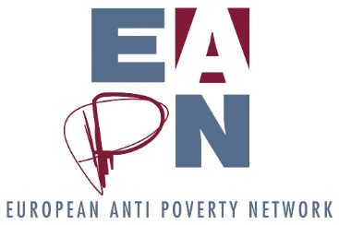

Notes of EAPN Bureau meeting
18 – 19 December
Vienna

Participants: (members): Vera (Austria), Eleni (Cyprus), Richard (France), Biljana (Macedonia), Honoratte (Norway), Ian (IFSW) (dial in)
Participants (staff): Leo
Apologies: Saviour (Malta), Carlos (Spain)

Analysis of progress against objectives of the meeting

Objective | Analysis of progress
Team building | 😊
Setting priorities | 😊 3 clear priorities set for the mandate of this Bureau
Agreeing roles | 😊 Clear division of labour agreed between Bureau
Building understanding of EAPN |  Good start made, good identification of further topics where we need to go deeper.
Insights and foresights | 😊 Very useful discussions around implications of potential decisions which may be taken during Strategic Thinking process.
Politics | 😊 Strong discussions, with clear actions agreed, on EAPN’s position re. recent protests in Europe and our parliamentary elections campaign.

Session 1 – Bureau Building
This session kicked off with a ‘River of Life’ exercise, to build understanding of how everyone has arrived at this point in their professional life. Individual ‘rivers of life’ can be found below! These images were created by Bureau members to highlight significant events which have changed the course of their lives, contributed to past achievements and led them us to where they are today. This exercise is designed to help new members of a group understand how they have all arrived in this group, and thus to know each other better.
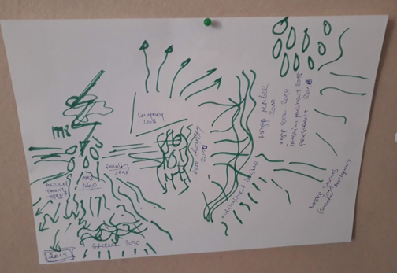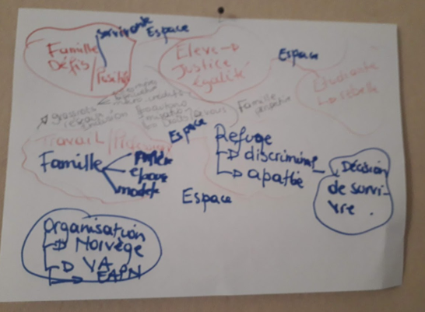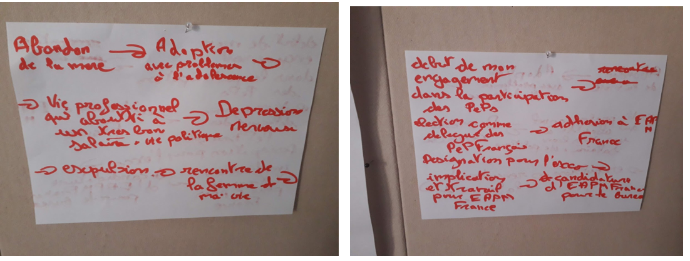

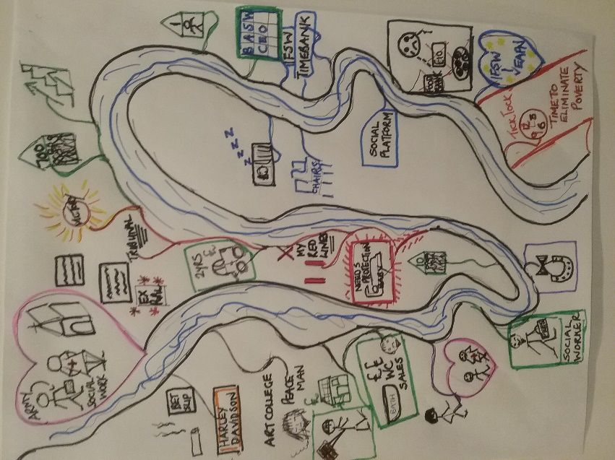
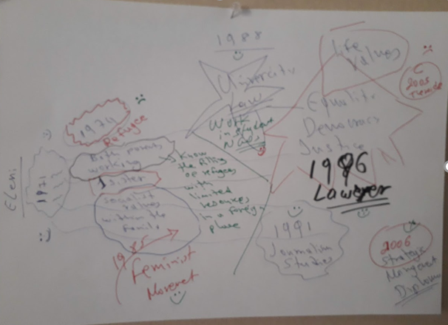
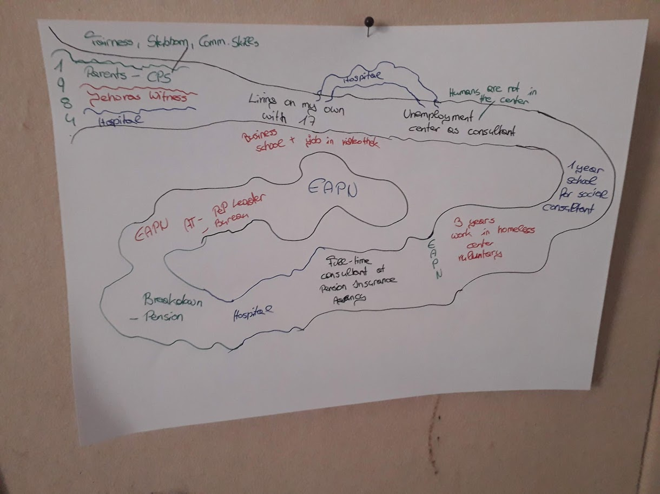
Session 2 – Objective Setting
Key discussion points
The online vote clearly indicated the top 3 priorities of this Bureau for 2018-2021 – see results below.
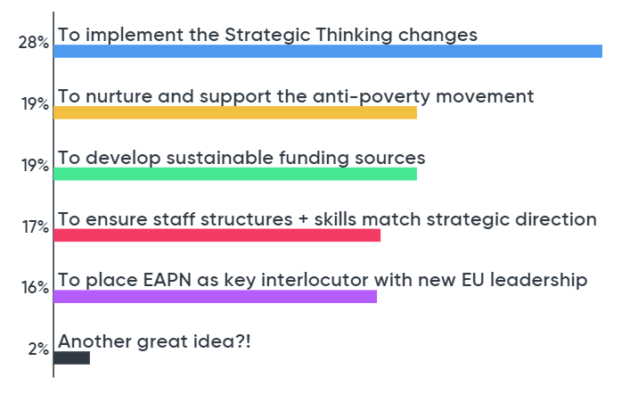
- It was agreed that most of the priorities actually come under the top priority, i.e implementing the Strategic Thinking changes.
- We must stop focusing on the lack of money we have, and focus more on our goals and objectives. It is clear that we need to access more unrestricted funds, and this must be a priority.
- The Bureau must be strategic and visionary
- The Bureau is clear that we must act as one unified EAPN, with our structures acting coherently and together. We will need to ensure that the Ex Co and EUISG work better and more coherently.
- The Bureau will have 2 roles to play – providing political leadership throughout the process and building ownership within the rest of the network.
Decision
D1. The Bureau sets itself the 3 following priorities for its mandate:
Priority 1: To implement the outcomes of the Strategic Thinking process.
Priority 2: To nurture and support the anti-poverty movement
Priority 3: To develop sustainable funding sources for EAPN

Roles and Responsibilities of Bureau members
Key discussion points
- The roles need to have a clear ToR to guide the actions. These ToRs should include how the staff supports this role.
- Each role should have a clear lead, with a support / substitute.
- The Bureau needs to work closely with the Director, to ensure s/he is spending his/her time effectively.
- Bureau members should propose a vision they have for their roles, which can then be discussed at the next meeting / webinar.
- Personal engagement of Bureau members is crucial – each member should develop individual work plans so that other members are aware of different areas of work.
- Bureau members should report to the whole Bureau on progress within their roles on a regular basis.
- We need to have a written agreement between the President and the Director about how they will work together.
- We don’t need a specific role of ‘Support to the President’, given than all VPs will support the President!
- Bureau roles were agreed – see attached document.
- Bureau members also shared their areas of expertise, so everyone can have a sense of how they can best support EAPN.

Bureau member | Thematic Expertise
Eleni | Gender equality, feminism. NGO legislation. Advocacy and lobbying strategies. Reviewing legislations. Bi-communal work.
Biljana | Economist for Development. Intersectoral connector – economy and green policies. Networking. Environment and sustainability.
Vera | Organiser. Meeting and group facilitator. Synthesising laws for analysis. Statistics. Musician. Financial planning. Reference budgets. Data and statistics.
Honoratte | Project evaluation. Network building. Staff management. Gender. Scandinavian Group. Global links, specifically Africa.
Richard | Political activism. Evaluation of public policies. Integration of migrants, and non-accompanied minors. Social work. Access to housing.
Ian | Social Work. Social policies. Managing people and budgets. Membership.
Carlos
Saviour

Key discussion points
Decision
D2. Bureau will have monthly webinars, on the first Wednesday of each month at 15 30 CET, for a trial period of 3 months. These calls will be spaces for each member to share updates on their specific roles, and for the Director to discuss key priorities with the Bureau. Wed 6 Feb, 6-7 March (face to face), Wed 3 April

Action | Responsible | Deadline
A1. Share template for Bureau members to report, finalise. | Eleni and Leo | 22 Jan
A2. Develop agreement on ways of working together | Director and President | End Jan
A3. Check which specific roles Saviour and Carlos will take on, as well as their key experiences | Director | End Jan
A4. Prepare 1 page Terms of Reference for each role undertaken, including a ‘vision’ or ‘goal’ for that role. Based on document B7. | Each Bureau member | - Jan
A5. Report progress against each role, using template | Each Bureau member | 30 Jan

Session 4 Induction
Key discussion points
- Bureau members reported a varied understanding of EAPN, ranging from 5 to 8.5 / 10. Key points which members hope to understand better include (in no order):

- PeP
- The EUISG
- EAPN finances
- EAPN Fund
- Connection between different bodies in EAPN
- EAPN’s role in the European Semester

- The EAPN organigramme was discussed. While there are some issues with it, it was agreed that we should not spend time revising it as it may change as a result of the Strategic Thinking process. It was agreed that all groups of EAPN should have Terms of References explaining their role – this specifically applies to PeP National Coordinators, and PeP themselves.
- It was noted that our 30th anniversary is coming up, and discussed the possibility of recognising specific contributions of certain members and staff.
- The link between the EUISG and the Bureau was discussed – see the decisions below. It was agreed that the Ex Co needs to take a decision around the EUISG, its role and its powers, ensuring that EAPN acts as one network, with the different bodies supporting each other together, not acting unilaterally. The Bureau is clear that the Ex Co sets the overall political direction of the network, and the EUISG was created to form policy to support the overall direction of the network.
Decisions
D3. We will take an induction topic at each Bureau meeting / webinar, starting with the financial situation in February 2019.
D4. There should be a joint meeting between Ex Co and EUISG each year, to update on work/thinking as well as to do common work on new concerns.
D5. A representative from the EUISG Steering Group will be invited to participate in political / policy discussions of the Bureau meetings, to ensure that proposals/discussions build on EAPN policy work, and that the EUISG is kept up to speed with Bureau discussions and thinking.
D6. The Bureau will not send a representative to EUISG meetings, as the time commitment would be too heavy for Bureau members.

Action | Responsible | Deadline
A6. Prepare induction documents on our financial situation | Richard and Philippe | 30 Jan
A7. Feed back to Sian the decisions about the EUISG | Leo | - Jan
A8. Ensure Terms of References are developed for all constituent groups | Leo | End 2019

Session 5: Strategic Thinking
Key discussion points
This session invited Bureau members to simulate 3 key decisions which may or may not be taken during the Strategic Thinking process, and to reflect on the potential implications of these decisions. The session started with a vote on the ‘Impact vs effort’ of these decisions, to give a sense how beneficial the decisions could be against how difficult the decisions may be to implement. Results of this vote are below:
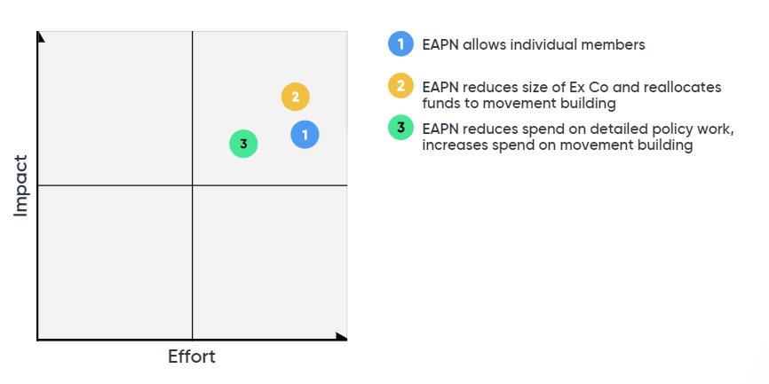
Discussion on Simulated decision 1 – allowing individual members
There would be several complications, notably:
- Changing the voting system
- Participation of individual members in General Assembly
- Whether individual members would be restricted to PeP, or whether anyone could join.
- Our current structure couldn’t easily accommodate individuals, so we would need to change our structures somewhat.
- Would members be prepared to change as well?
- Are we ready to change our mindsets and ways of working to enable this?
- Would ‘big organisations’ withdraw from EAPN if we have too many individual members?

Potential solutions discussed include:
- Calling the individuals ‘supporters’ rather than members.
- Changing the statutes
- Testing, experimenting over a set period
- Linking this issue to that of movement building and being more of a network of people experiencing poverty
- Asking certain networks to share their experience, the pros and the cons – EAPN Austria, Macedonia and UK have this experience already, as did EAPN Spain. (The Membership Development Group could take this on, for example)

Discussion Simulated decision 2 – reducing size of Ex Co and increasing spend on movement building
- Some Bureau members feel that the size of the Ex Co shouldn’t be reduced, others feel it should. The Bureau reflects the division within the overall Ex Co on this issue.
- There was more consensus on the idea that the Ex Co, and other structures, should have fewer meetings, and funds saved should be reallocated to movement building and other areas where we could have more impact on poverty levels. Webinars could be used more regularly to ensure work is done outside of meetings.
- It was agreed that any changes of this nature should be introduced over a couple of years – for example, physical meetings reduced by X in Y1 and Y in Y2. A document / calendar to guide this change would need to be very clear, outlining how and when the change could happen, and what spaces would be created to enable participation in other spaces.
- There are risks that some members may react strongly if the Ex Co is reduced. We would need to ensure that members still feel ownership of EAPN, and that there are still relevant spaces for participation and leadership available to all.
- Even if this is difficult, some felt it makes sense in order to have a more effective governance body for the long term.
- IF there is a smaller Ex Co, then there is realistically no need for a Bureau. This would be a big decision and would need to be worked through.
- It is important that the Bureau sees the financial implications of this potential decision.
- The Governance Review, to be undertaken as part of the Strategic Thinking process, should make clear recommendations on this. This review should look briefly at the governance structures of other networks, to help guide discussions.
- The Bureau, and the Ex Co, will need to speak about this in more detail in 2019, aiming to take a decision at the General Assembly in September.

Decision
N/A – no decisions were taken during this session.

Action | Responsible | Deadline
A9. Ask the Membership Development Group to look into the issue of Individual Membership, capturing the experience of networks who already allow individual membership. | Magda, Leo | 20 Feb TBC
A10. Consider the report on the implementation of the Dutch resolution | Bureau, led by Vera | 6-7 March
A11. Ensure Governance Review makes clear recommendations on Ex Co, consider recommendations at next Bureau and Ex Co | Ian, Leo | 6-7 March, early April

Session 6: Politics
This session largely focused on current protest movements, and documents behind EAPN’s campaign around the European Parliamentary Elections.

Key discussion points on protests
- Austria protests are weekly, but numbering in the hundreds. Not linked to yellow vests.
- Agreement that EAPN should say something about the yellow vest protests, focusing on expressing concern about what has led to this movement. We shouldn’t only focus on this movement, but on the causes behind the movement (austerity, persistence of poverty, inequality) – we should be using this as a hook to make our positions better known. EAPN should be visible in these moments, drawing the similarities between the various protests.
- Anything we say should be in accordance with our ‘Media Statements protocol’. Given that we can based on statements of existing positions, we can treat it as ‘Type a’ from the protocol.
- We should set the ground with an end of year message, and then say something more public in January / February, trying to target Euronews.

Key discussion points on EAPN campaign on European Parliamentary Elections

- It would be useful if members are able to use the campaign website
- When the campaign is ready, we should take key messages to the heads of the political groupings
- Ideally, members would also focus on getting people to vote – we could take the European Parliament’s campaign and promote it to our members as well, as this could help increase the vote.
- Video messages should also focus on getting people to vote.

Key discussion points
Decision
D7. An end of year message will include our thinking on the current protests we are seeing throughout Europe. A press release will be prepared in January / February on the same topic.
D8. The messages for the parliamentary campaign are strong enough.

Action | Responsible | Deadline
A12. Share end of year message. | Leo, with Vera and Richard | 20 December
A13. Prepare press release on protests | Elke, Leo, Vera TBC | - Feb
A14. Ensure members are able to use the campaign website | Elke | TBC
A15. Organise meetings with head of political groupings on the campaign | Leo, with staff | TBC
A16. Investigate joining up with the ‘This Time I’m Voting’ Campaign of the Parliament | Leo, Elke, Biljana | End Jan
A17. Share the manifesto of EAPN France | Richard | End Dec

Any Other Business
Inequality project

We are aware there are some electronic discussions about the Inequality Project, with a number of members expressing reservations, even talking about leaving EAPN over this issue if they are not able to ‘op out’ of the project. This issue was discussed at length. Key points include:

- We had a vote on this project, the vote should be respected
- We should be discussing to build positive energy around this project
- The Bureau and staff team should act together on this, focusing on communicating clearly with members.

Decision
D9. Members should not be allowed to publicly opt out of such actions, nor should they be working against established positions of the network.
D10. Ian will lead on liaising with European Organisations about his project, as he is responsible for relationships with European Organisations

Action | Responsible | Deadline
A18. Write back to FEANTSA, explaining position | Ian | End 2018

