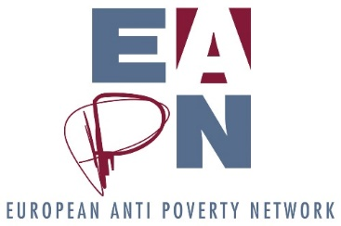
EAPN 2 pagers
Background
The final report of the first phase of the Strategic Thinking process highlights the need for a clear and shared political analysis (5.2), and one recommended change is for EAPN to “translate its Values statements into accessible analysis documents”, as part of developing a clear and shared political analysis. Discussions indicated the need for the documents to be clear and accessible to public, politicians, national networks and PeP. This means that the language should be simple, that the papers should be no more than 2 pages long, and that we should include a visual element (picture, infographic, boxes) to make the document more attractive and readable. If we cannot explain our key positions / demands in 2 pages, then we are going to find it very difficult to convince others to implement our demands.
Phase 2 has gone some way to clarify our political analysis via the PESTLE analysis and the Theory of Change. The President will lead a process, with other colleagues from the Ex Co, to develop a short document clarifying our political ideology. The 2019 work programme has identified 5 areas, stemming from our values, where we would like to develop clear, accessible analysis documents. These documents will complement the political ideology developed by the President.
Objectives of these 2-page analysis documents
- To clarify to everyone engaged in EAPN, in understandable language, EAPN’s understanding, analysis and demands on these key areas.
- To enable members to use these positions at the national level, both in translations but also in advocacy work.
Primary target audience
- EAPN staff
- EAPN members
- EAPN partners
- People experiencing poverty
Secondary target audience
- National governments
- EU institutions
- Other advocacy targets

Expected dissemination
- EAPN website – we’d expect a clear section of the site which captures our key positions
- Circulated to all members
- Translated by members
- Used by EAPN staff and members as basis for interventions, responses to consultations, press releases, media interviews…
Examples to consider
https://issuu.com/oa-padare/docs/rb1338_oxfamfactsheet2014
https://skepticalscience.com/docs/debunking_one_pager.pdf
Potential Structure
- Introduction – what is EAPN
- Brief explanation of the issue, the problem
- EAPN understanding of key themes (i.e our definition of poverty, our definition of participation)
- EAPN key messages on the issue
- EAPN key demands of those who have the power to influence the issue. (For example, the paper on poverty and education may have key demands for Ministries of Education and DG EAC. The paper on participation may have key demands for EAPN members, for national governments, and for European Institutions. The paper on gender may have key demands for EAPN, for companies, for national governments, for European Institutions)

Ensuring accessibility of language
In order to ensure the language is simple, there are a couple of online tools we can use, notably
- https://datayze.com/readability-analyzer.php
- https://www.webfx.com/tools/read-able/check.php

