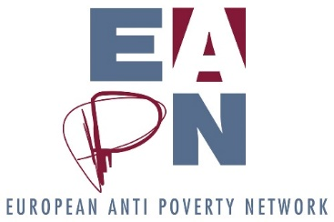
Strategic Thinking session agenda
Ex Co / EUISG
13 June, 2pm – 6pm
Objectives
- To ensure we all understand the process to date, and the different ‘outputs’ which have come from the Strategic Thinking process
- To reflect on the Theory of Change together, on what it could mean for different levels of EAPN.
- To create an “impact analysis” of different scenarios for EAPN structures to implement the Theory of Change, as an input to further discussions within Ex Co
Draft agenda
- Setting the Scene, 30 minutes
We will have a big image on the wall, which is an overview of the different phases of the process. We’ll be gathered around this, and will walk ‘through’ the image together, highlight the different deliverables. The idea is to build a collective picture of the process and the deliverables, so we all understand what has happened and what may yet happen.
- Theory of Change, 60 mins
- Introduction
- Self-managed table discussions

What is the greatest opportunity you can see here for your country? For EAPN Europe?
What are the risks?
What would you like to see happen and why?
Is this the most effective way of getting where we need to go?

- Feedback on the Theory of Change, with specific focus on the issue of EAPN supporting and nurturing the anti-poverty movement
- Response, next steps
- Coffee break

- World Café on Structures (4 tables)
- Intro (5 mins)
- Explanations, reading, understanding what we are doing (10 mins)
- Impact Assessment for the 4 scenarios. (45 mins for first table discussions, 30 minutes for second.)
- Plenary feedback, next steps

