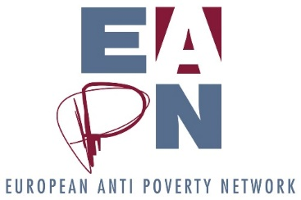

Systemic Konsensing / Points of Resistance

As a next step in our Strategic Thinking Process we need to find out which direction we will take, as a group. This form of decision-making “Systemic Konsensing” is not asking stakeholders to agree to a proposal, but asks the extent of the resistance – and so allows a result that comes closest to consensus.

The group develops as many suggestions as possible and then selects those which come closest to the consensus by identifying the proposal that has the least rejection in the group, and therefore the least potential for conflict. At the same time, it is from the existing proposals that we aim to achieve the best balance of interests among the participants.

For each individual proposal / scenario, the extent of the total resistance of the group gets determined.

Why use this methodology?
- to make a decision that is as consensual as possible
- to expand the focus on possible solutions
- to allow even reserved or silent group members the chance of equal consideration of their voice
- to minimize the conflict potential in controversial decisions

Each proposed solution is evaluated by each group member with so-called resistance points. You evaluate each scenario for itself, by giving 10 – 0 points for each.
Zero points means "no resistance" or "I can support this solution". The highest score to be awarded is 10 and means "strong resistance" or "I strongly disagree with this proposal".

Finally, the points awarded by the participants are added together for each proposed solution. The lowest score solution has the least resistance in the group and is therefore closest to consensus.

For EAPN Strategic Thinking

The Strategic Thinking session on 13 June will undertake an impact assessment of the different scenarios. On the 14th, the Ex Co will build on this work, and will be invited to use this methodology to select the scenario which has the least resistance, and which can then form the basis of our revised structures.
Request to EAPN members
The Bureau asks all networks to come to the Ex Co having discussed the scenarios internally and ready to participate in this methodology. It will help progress discussions in advance of the General Assembly, and allow the Ex Co to select a scenario to work further develop.

