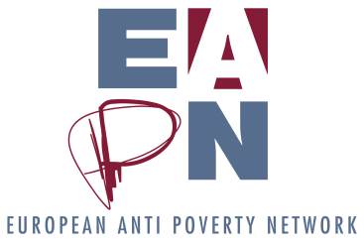
DRAFT POSITION PAPER

Delivering Agenda 2030 – for People and Planet
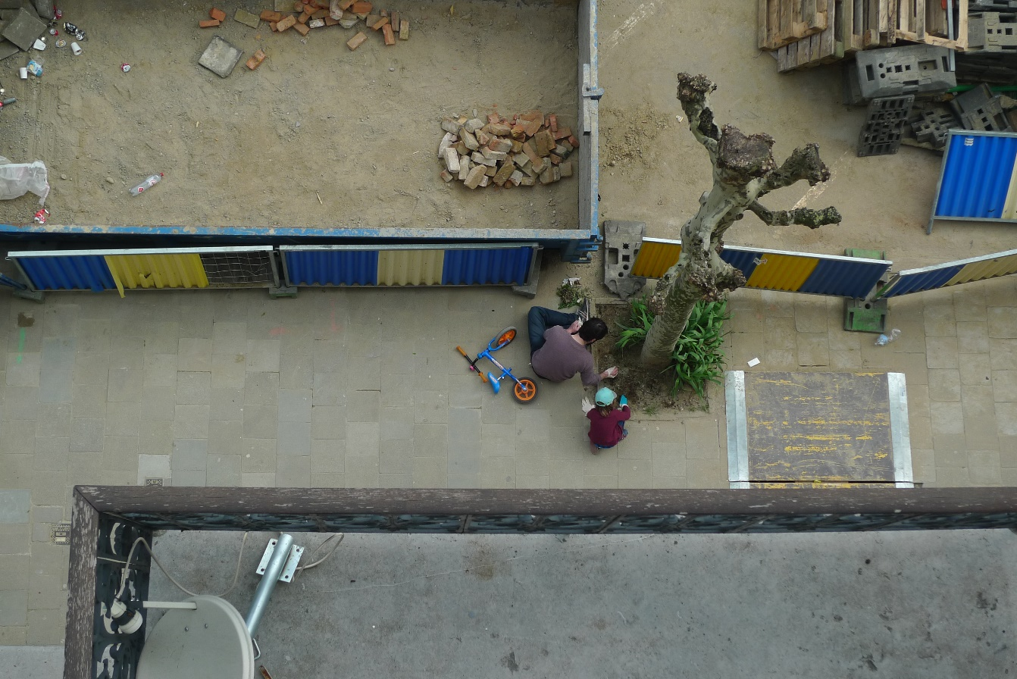
EAPN proposals for a post Europe 2020 strategy

JUNE 2019
EUROPEAN ANTI-POVERTY NETWORK
BOULEVARD BISCHOFFSHEIM, 11 – 1000 BRUSSELS
www.eapn.eu

CONTENT

1. WHY THE EU NEEDS A RIGHTS-BASED, SOCIAL AND SUSTAINABLE STRATEGY? 4
2. MAKING AGENDA 2030 AND THE SDGs THE OVERARCHING FRAMEWORK, UNDERPINNED BY THE SOCIAL PILLAR? 5
3. LINKS BETWEEN THE SDGs AND THE SOCIAL PILLAR 5
4. POTENTIAL OVERARCHING VISION AND GOALS OF A NEW STRATEGY 6
5. FOUR KEY PRIORITIES OF A NEW STRATEGY 7
5.1 Achieving poverty eradication and increasing well-being 7
An ambitious EU poverty target with mid-term review 7
Effective poverty indicators and social scoreboard 7
A rights-based integrated anti-poverty strategy, beyond employment 8
Urgent action to guarantee minimum income and social protection 9
Concrete results on all social rights 9
5.2 Political pre-requisites to achieve results 10
High-level political commitment 10
Making well-being the goal: rebalancing the economic/social/environment 11
5.3 Embedding participation and transforming EU coordination instruments 11
A participative, social and sustainable European Semester 11
Make civil society equal partners 12
5.4 Mobilising EU Funds to support the strategy 13
Increase effectiveness of EU funds spending on poverty reduction 13

Delivering Agenda 2030 – for People and Planet
EAPN proposals for a post Europe 2020 strategy

WHY THE EU NEEDS A RIGHTS-BASED, SOCIAL AND SUSTAINABLE STRATEGY?

- The Europe 2020 strategy set out to achieve “smart, sustainable and inclusive growth”, but failed to deliver concrete results that improved people’s lives. The new post 2020 strategy offers a key opportunity to make a real difference to people and planet.
- The poverty target failed to deliver on its promises of a reduction of at least 20 million people, indeed increasing to 123 million during the crisis, exacerbated by austerity measures. Today, 113 million people still face a risk of poverty, over a 1/3 in some Member States, whilst many groups face worse challenges. However, the target did ensure a political focus on poverty in the EU agenda, supported by EU funds.
- Europe 2020 prioritised Stability and Growth, justifying devastating cuts to welfare states. This generated more poverty and inequality, whilst wealth increased for the top 1%. The EU is seen as defending the interests of the market/businesses rather than the people it aims to serve.
- Whilst the European Pillar of Social Rights is an important social initiative, it remains a framework of principles not obligatory rights, without an implementation plan. The risk is that it remains on the side-lines rather than at the heart of the new strategy.
- Our planet is in crisis, but governments have failed to act on their promises! Whilst a ‘green transition’ is vital, including tackling the social impact for poorer regions and people, social goals must not be secondary but joint, equal and mutually reinforcing priorities.
- ”Smart, sustainable and inclusive growth” cannot deliver for people and planet! The current market-led growth model, with an overarching reliance on GDP, is simply unsustainable. Europe must learn lessons from Europe 2020, the financial crisis, and from New Zealand’s ‘beyond GDP’ approach, and put social and environmental justice at the heart of policy and spending decisions, making well-being the overarching aim.
- Participation has to be central: engaging people who face poverty and the NGOs that support them, at all stages to deliver real results. This should start with a participative process to develop the new strategy, following the example set by the SDGs and Agenda 2030.
- The EU must launch a participative consultation process to build a social and sustainable development strategy that increases well-being, puts people and planet before growth, and makes poverty eradication a pre-requisite.

MAKING AGENDA 2030 AND THE SDGs THE OVERARCHING FRAMEWORK, UNDERPINNED BY THE SOCIAL PILLAR?

- AGENDA 2030 is an inspirational plan to prioritize people, planet and shared prosperity signed up to by all Heads of State of the UN in 2015, and delivered through 17 Sustainable Development Goals (SDGs) and 169 Targets.
- It provides a new universal social and sustainable global agenda, which is integrated and indivisible, highlighting the need to “balance the three dimensions of sustainable development: the economic, social and environmental”.
- It puts poverty eradication at the heart: “eradicating poverty in all its forms and dimensions, including extreme poverty, is the greatest global challenge and an indispensable requirement for sustainable development” and pledges that “no one will be left behind’’.
- It is framed by respect for human rights, grounded in the Universal Declaration of Human Rights, and other Treaties. It defends above all human dignity, pledging that no one will be left behind. “Recognizing that the dignity of the human person is fundamental”.
- High-level monitoring is carried out yearly by the UN, which the EU monitoring mechanisms (e.g. European semester) should better feed into, connecting national reports.
- NGOs and people facing poverty are recognized as key actors in the partnership for design, monitoring and delivery and were directly involved in the design and adoption of the plan. “All countries and all stakeholders, acting in collaborative partnership, will implement this plan”… “underlining the key voices of the poor and most vulnerable’’.
- Delivering for people is paramount! There are at least 9 Key SDGs essential to the fight against poverty and inequality. The European Pillar of Social Rights overlaps in many principles, but not all, nor does it establish a clear goal to eradicate poverty or to reduce inequality, unlike the SDGs.
- The EU has already committed to implement the SDGs both in its internal and external policies. See here.

3. LINKS BETWEEN THE SDGs AND THE SOCIAL PILLAR

SDGs | European Pillar of Social Pillar
1. End Poverty | No explicit principle, but scoreboard indicator (AROPE). Most principles can contribute. Poverty explicit only in 11: childcare and support to children – right to protection from poverty.
2. End Hunger | No explicit principle. 6, 12, 14, 20 could ensure adequate income.
3. Ensure Healthy lives and promote well being for all ages | 10, 15, 16 and 18 covering healthy, safe and well adapted work environment, data protection and right to timely access to affordable, preventive and curative health care of good quality.
4. Ensure inclusive and equitable quality education and promote lifelong learning opportunities for all | 1. Right to quality and inclusive education, training and lifelong learning
5. Achieve gender equality and empower all women and girls | 2. Gender Equality
6. Ensure availability and sustainable management of water and sanitation for all | 20. Access to essential services – water is mentioned
8. Promote sustained, inclusive and sustainable economic growth, full and productive employment and decent work for all | 2 chapters of the EPSR are dedicated to employment both access (1) and fair working conditions (2). Key principles include 4, 5, 6, 7, 8, 9, 10, 13 and 15
10. Reduce inequality within and among countries | No explicit principles. 3. Equal Opportunities for all groups, 17. Inclusion of people with disabilities, 19. Housing and assistance for the homeless

POTENTIAL OVERARCHING VISION AND GOALS OF A NEW STRATEGY

- The post 2020 strategy’s aim should be: to promote social and sustainable development that eradicates poverty and social exclusion, creates well-being and reduces inequalities.
- This needs a paradigm shift away from the current economic model of austerity, towards social investment in public social protection and services and quality jobs, stepping up efforts on tackle tax evasion and avoidance, and promoting progressive taxation.
- Ending poverty in all its forms must be a pre-requisite for effective social and sustainable development, putting poverty eradication at the heart of all policies. There should be no complacency about the high levels of poverty and inequality in the EU.
- It must explicitly promote human rights and promote participation – underpinned by UN frameworks, the Charter of Fundamental Rights and the European Pillar of Social Rights.
- People and Planet first! Environmental, social and economic goals should be equal and coherent: the economy must serve people and planet, not the other way around.
- The 17 SDGs should form the main goals of the post 2020 strategy, ensuring continuity with the targets of the existing Europe 2020 strategy, linked to the Social Pillar.

5. FOUR KEY PRIORITIES OF A NEW STRATEGY

5.1 Achieving poverty eradication and increasing well-being

An ambitious EU poverty target with mid-term review
- The Europe 2020 Strategy set a high-level EU poverty reduction target: to reduce poverty by at least 20 million people by 2020. The poverty target gave visibility and kept poverty high on the EU agenda. It also brought EU funding, with the 20% earmarking of ESF. However, it clearly failed, with only a 5 million reduction towards the EU target, after large increases.
- The target design was flawed: all others referred to a percentage. Member States were also allowed to set their own targets, with national indicators, avoiding the EU common set. There were also failings in the implementation and monitoring.
- Agenda 2030/SDGs give a strong priority to ending poverty with 5 targets. Whilst the Social Pillar has no specific principles or targets on poverty, most principles are expected to contribute to poverty reduction.

What Solutions?
- Give a strong priority to the AGENDA 2030 goal to End Poverty in all its forms (SDG 1), and adopt an EU target for all MS of 50% reduction of at-risk of poverty and social exclusion (AROPE)
- Include a commitment to end extreme poverty by 2030 as stipulated under SDG 1. Extreme poverty in an EU context should be measured as the number of people experiencing homelessness (on any given day this number is at least 700.000)
- All Member States should use the EU aggregate indicators (AROPE) rather than individual national ones. Monitor the delivery on the combined indicators as well as separately.
- Aim for progressive realisation, agreeing interim 5-year targets and an action plan – i.e. recognize the challenges particularly for poorer countries facing higher rates.
- Support Member States in the delivery but ensure transparent and detailed yearly monitoring with a mid-term assessment, involving NGOs.

Effective poverty indicators and social scoreboard
- The development of the AROPE indicator (at risk of poverty and/or exclusion), whilst controversial and imperfect, allowed a robust, comparable, high-level monitoring of relative poverty as well as more extreme poverty.
- The current Severe Material Deprivation indicator is recognized as weak, as it is insufficiently comparable across countries with very different living standards.
- The Social Scoreboard in the Social Pillar is not sufficiently connected to the full set of EPSR principles, and less to the SDGs.
- As the scoreboard focuses on EU averages, it does not encourage ‘upward convergence’, rather complacency around achieving the ‘norm’. The indicators need to be combined with ambitious targets to achieve more than this.

What Solutions?
- All Member States to use the same multiple EU AROPE indicators, as with other goals/targets
- Replace the Severe Material Deprivation indicator with the new Material and Social Deprivation indicator
- Increase the coherence of the Scoreboard to the European Pillar of Social Rights, including clearer indicators for all 20 principle areas
- Connect the Scoreboard (averages) to the post 2020 poverty target monitoring (ambition), to support more effective upward convergence.

A rights-based integrated anti-poverty strategy, beyond employment
- Individual rights or principles alone, cannot deliver on poverty. This requires a rights-based integrated strategy focused on the needs of the individual and ensuring access to quality jobs, services and social protection.
- Despite positive EU integrated strategies to reduce poverty (Active Inclusion Strategy, Investing in Children etc), a job alone is still pushed as the silver bullet to combat poverty and ensure social rights, whilst in-work poverty increases rapidly (9.6%).
- This approach prioritises ‘making work pay’ by ‘increasing incentives to work, hardening conditionality with increased sanctions and hardship’, regardless of growing precariousness of jobs, low wages, growing in-work poverty and lack of quality jobs.
- Not everybody can work, nor achieve quality jobs. It does not meet the needs of children or older people. The EU’s first priority must be to ensure a right to a dignified life for all with good living standards.

What Solutions?
- Political affirmation of the right to a dignified life for all, throughout their lives.
- Agree and Implement an EU integrated, rights-based, person-centred strategy building on Active Inclusion – the right to adequate minimum income/ social protection, access to quality services (education, housing, health, energy etc) and quality jobs, underpinned by EPSR and SDG principles.
- Implement agreed EU thematic strategies for key groups e.g. Investing in Children and support implementation of the Child Guarantee.
- Deliver on the pledge to ‘leave nobody behind’ that underpins the SDGs. Acknowledge that extreme poverty is an urgent and growing reality needing specific measures, particularly to tackle homelessness, based on SWP Tackling homelessness and housing exclusion.
- The strategy should be actively monitored and promoted through the European Semester, and supported by EU funds.

Urgent action to guarantee minimum income and social protection
- All the SDGs and Social Rights are important. However, Ending Poverty is a pre-requisite and depends on guaranteeing access for all to a quality minimum income. Nobody should be left without sufficient income to live a decent life.
- EPSR Principles 12 and 14 are essential to ensure support for an EU that protects, particularly in the context of regressive business models exploiting new forms of precarious work.
- The EU has a clear role to play to enforce these social rights, through soft instruments, but should take more urgent action through EU legal frameworks.
- Financing adequate minimum income and social protection requires public investment as a public good. This requires coherent action on tax and effective funding of public systems.

What Solutions?
- EU must guarantee the right for all to adequate income support/social protection, throughout the lifecycle and beyond employment.
- Minimum income must be adequate, accessible and enabling: empowering people’s social participation as well as a foundation to access quality, sustainable jobs.
- Soft Instruments like the Semester and benchmarking should be made more effective, requiring progressive achievement with the support of EU funds and establishing clear indicators for adequacy.
- An EU Framework Directive guaranteeing adequate minimum income is essential to take people above the poverty threshold (60% median income) underpinned by reference budgets. This is feasible under current EU Treaties and would not require EU funds.
- Require increased funding/adequacy of social protection system through tackling tax evasion/avoidance and promoting more progressive tax.

Concrete results on all social rights
- The implementation of all 20 principles of the EPSR are essential for the fight against poverty.
- EAPN prioritizes 5 Social Rights that are essential to delivering a person-centred integrated active inclusion strategy to reduce poverty: Minimum Income (14) and Social Protection (12), Wages (6) (and quality work), Access to Education, training and lifelong learning (1) and Access to essential services (20). Housing (19) and Healthcare (16) are also key. These can be linked to SDGs (see table in Section 3).
- The main instrument for implementation will be through the European Semester and EU funds. But hard law is vital if rights are to be guaranteed, ensuring upward convergence for the EU social model.
What solutions?
- Agree an Action plan: ensure timed implementation of all principles through soft coordination mechanisms (i.e. the European Semester combined with EU funds) and progress on EU hard law.
- Fair Wages: develop an EU framework together with social partners and civil society organisations to guarantee adequate minimum wages/living wages which take people out of poverty and provide a positive incentive/hierarchy above decent minimum income. A benchmark for adequacy could be 60% of the average wage.
- Access to Education, Training and Lifelong Learning: prioritize investment in universal free public education, including early learning and care and through the life course; promote right to education beyond skills for employment, supporting life skills and participation in the Community, working in partnership with families, community organisations and students themselves.
- Access to Essential Services: Guarantee rights to public services - Invest in affordable quality services, particularly housing and health. In housing, require expansion of social housing and regulation of market to ensure affordable rents. In health: invest in universal free health systems by increasing funding through progressive tax/tax collection including prevention and primary care.

5.2 Political pre-requisites to achieve results

High-level political commitment
The Europe 2020 strategy suffered from the changeover to a new Commission who adopted a new set of priorities (President Juncker’s 10 Political Guidelines). The European Pillar of Social Rights is an important social initiative, backed by the inter-institutional proclamation, however it lacks ownership and concrete plans for implementation.
What Solutions?
- A high-level commitment from Presidents of all EU institutions to adopt Agenda 2030, the 17 SDGs and 169 goals as the overarching frame, underpinned by the EPSR, driven directly by the European Commission President, with each Commissioner responsible for an SDG.
- A commitment to coherent, effective action – with a roadmap and action plan to deliver all 17 SDG goals, implementing the 20 principles of the European Pillar of Social Rights.
- Visible recognition of the role of stakeholders particularly people with direct experience of poverty and Civil Society Organisations in the design, monitoring and implementation - to provide citizen accountability.

Making well-being the goal: rebalancing the economic/social/environment
- Although there has been an improvement in Social Recommendations with the Social Pillar, fiscal/economic coordination remains dominant, with stability and growth as the goal, and social rights undermined by austerity.
- Scenario 1 from the Reflection Paper on the Future of Europe offers hope but currently gives priority to transition to ‘green growth’, with low profile given to social rights and poverty.

What Solutions?
- Rebalance macroeconomic priorities to support social rights/environmental protection.
- Adopt Scenario 1 of the Future of Europe reflection paper but ensure strategy benefits ‘People as well as Planet’, making ending Poverty a pre-requisite, embedding synergies between environmental and social standards, making the economy an instrument for well-being.
- Replace Stability and Growth Pact with a Well-being Pact.
- Rebalance resources in the European Commission/EU institutions to provide equal staff/resources for social with economic departments (e.g. DGs), and Secretariat General.
- Create a transparent checklist and mechanism to ensure ex-ante social, environmental and distributional impact analysis prevent negative macroeconomic measures.
- Ensure greater, transparent accountability – pro-actively share, involve and listen to reactions of people and NGOs on the ground, to ensure the EU is on the right track.

5.3 Embedding participation and transforming EU coordination instruments

A participative, social and sustainable European Semester
- The European Semester is likely to remain the main EU coordination instrument for the new strategy. Although progress has been made on recognizing its role in social as well as economic coordination, the dominant focus continues to be on promoting the stability of the Euro and macroeconomic growth, prioritizing austerity and privatisation.
- The reduced number of CSRs only confirms this domination, squeezing out a consistent focus on poverty and social rights, without an appreciable increase in implementation.
- The Semester would need to be transformed to ensure Agenda 2030 and SDG objectives are promoted through a balanced approach putting social and environmental goals on a par with economic and ensuring equal participation of civil society as key stakeholders in policy decision-making process.
- The Semester should connect more effectively to the UN’s “Voluntary National Review process”, which effectively monitors the implementation of the SDGs at the national level.
What Solutions?
- Transform the European Semester into a Social and Sustainable Development Semester, delivering on the environmental and social goals of Agenda 2030 and SDGs, with the eradication of poverty as pre-requisite.
- Establish an explicit Road Map setting out objectives, key actions, the role of key institutions and stakeholders, with detailed timelines and guidelines, detailing how all the EPSR principles and SDGs following up on Europe 2020 targets are to be monitored and delivered through the mechanisms.
- Replace the Annual Growth Survey with the Annual Social and Sustainable Development Survey giving equal priorities to economic, environmental and social goals, published together with a Joint Employment and Social Development Report. Reflect priorities in equal chapters (e.g. 1 explicit chapter on social goals – end poverty etc in the Country Reports, National Reform Programmes).
- Expand number of CSRs to at least 2 per area (i.e. economic, social and environmental), underpinned by a full analysis of all SDGs/Social Rights in the Country Reports.
- Establish a clearer connection between the EU coordination process and the Voluntary National Reviews feeding into the UN High Level Political Forum.
- Ensure accountability and participation embedding equal treatment for civil society organisations in design, implementation and monitoring, particularly in the Semester.

Make civil society equal partners
- European Civil Society Organisations have been the poor sister in Europe 2020 through its main instrument: the European Semester. They have been neglected until recently in the main driving documents (AGS) compared to social partners.
- Some improvements have taken place recently at EU level – including the new Recital 11 in the Employment Guidelines and a new commitment by the Commission to stakeholder dialogue (DG EMPL – 2018).
- At national level, the engagement is inconsistent across Member States, with some promising examples and many poor ones, but with very little evidence of consistent impact. The expanding role of the European Semester Officers is promising.
- The systematic involvement of people directly facing poverty and social exclusion is currently a missed opportunity to learn from the ground and ensure sustainable solutions.

What Solutions?
- Adopt a full protocol around civil society engagement on a par with social partners.
- Agree guidelines, systematic good practice, mutual learning/peer reviews.
- Establish a funding line to support permanent dialogue processes with people experiencing poverty and NGOs at national level and promote the development of cross-sectoral alliances and input.
- Appoint a specific Commissioner and officers in each DG responsible for civil society engagement for each SDG, particularly through the Semester.
- Agree explicit guidelines and monitoring of European Semester Officers to ensure equal treatment working with CSOs and people in poverty as with other stakeholders.
- Embed a yearly Round Table conference, which national and EU civil society organisations to directly prepare to raise concerns directly with EU institutions.
- Agree direct dialogue of ‘experience experts’ with decision-makers in EU institutions through the yearly meeting, but also as ‘experts’ in on-going policy development.

5.4 Mobilising EU Funds to support the strategy

Increase effectiveness of EU funds spending on poverty reduction
- The Europe 2020 poverty target/priority also brought EU funds with it – e.g. 20% earmarking on poverty reduction in the European Social Fund, and important EU research and other funding lines. The ex-ante conditionalities have been crucial to requiring action on anti-poverty strategies based on active inclusion.
- Whilst the 20% has been well monitored by the European Commission, it is difficult to get accurate information about the project level and to ensure that funding is being used to effectively support poverty reduction and social inclusion. The main success criteria remain getting people into any job rather than social inclusion.
- Priority for funds is increasingly given to large-scale national public or private projects rather than supporting grassroots innovation, with NGOs struggling to get an equal role in monitoring committees or to get support to access or manage funds.
What Solutions?
- Increase the earmarking on social inclusion to 30%, including FEAD, and better enforce the ‘enabling’ ex-ante conditionalities with clear outcome indicators that monitor the quality of the integrated active inclusion strategies and ensure a real impact on poverty and social exclusion.
- Strengthen the partnership principle, implement the code of conduct on partnership through an ex-ante condition, and make more meaningful participation of NGO / beneficiary engagement in monitoring committees obligatory.
- Avoid the instrumentalization of ESF by national governments to finance mainstream public programmes.
- Support innovative, longer term projects developed by grassroots community organisations and NGOs, with upfront funding, with global grants, avoiding the 20% co-financing requirement.
- Improve monitoring with soft social indicators i.e. distance travelled to social inclusion and out of poverty, with quality of outcomes including mental health, confidence, social integration, life skills as well as quality sustainable jobs.

INFORMATION AND CONTACT

For more information on this publication, contact
Sian Jones – EAPN Policy Coordinator
sian.jones@eapn.eu – 0032 (2) 226 58 59
See EAPN publications and activities on www.eapn.eu

The European Anti-Poverty Network (EAPN) is an independent network of nongovernmental organisations (NGOs) and groups involved in the fight against poverty and social exclusion in the Member States of the European Union, established in 1990.

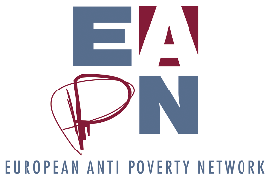
EUROPEAN ANTI-POVERTY NETWORK. Reproduction permitted, provided that appropriate reference is made to the source. June 2019.
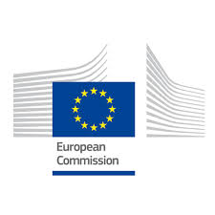
This publication has received financial support from the European Union Programme for Employment and Social Innovation "EaSI" (2014-2020). For further information please consult: http://ec.europa.eu/social/easi
Neither the European Commission nor any person acting on behalf of the Commission may be held responsible for use of any information contained in this publication. For any use or reproduction of photos which are not under European Union copyright, permission must be sought directly from the copyright holder(s).

For example Germany and Sweden adopting long-term unemployment indicators.
New indicator of Material and Social Deprivation (2017) see here:://publications.europa.eu/en/publication-detail/-/publication/05e37b96-ae3a-11e7-837e-01aa75ed71a1/language-en
Bea Cantillon: 10 Arguments for prioritizing minimum income as a follow up to the social pillar. (Jan 2019)
See EESC recent opinion.
See EMIN Final Report and Recommendations here.
Country-specific Recommendations (CSRs)
EC. Future of Europe Reflection Paper: Towards a sustainable Europe by 2030. (28.01.2019)

