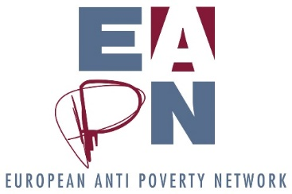
EAPN and ‘Working Yet Poor’
Background
EAPN is part of a project consortium ‘Working Yet Poor’, led by the University of Luxembourg.
Project partners
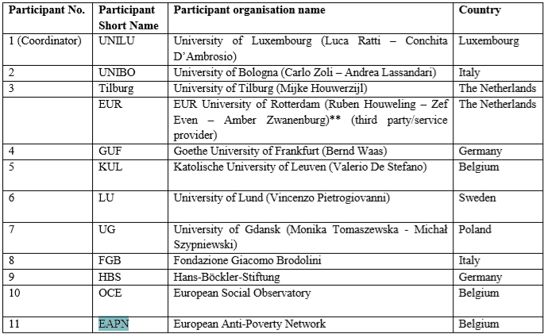
Target countries
Seven representative countries have been selected based on their geographical area and their different industrial relations systems and legal orders.
- Luxembourg
- The Netherlands
- Belgium
- Germany
- Italy
- Sweden
- Poland
Overarching goal
Contribute to the enhancement of social rights and to the advancement of the state of art and normative content of EU citizenships by elaborating recommendations on the exercise of EU social rights as an integral part of EU citizenship

Specific Objectives
- Develop sound conceptualization of EU citizenship and strategies fostering the social dimension thereof
- Initiate and develop an EU-scale discourse on in-work poverty, the reasons of its spread, its societal impact and the feasible policy actions that MSs and the EU should undertake.
- Foster the enhancement of social rights for the categories of persons investigated, particularly the right to get “fair and adequate wages” enshrined in the EPSR through best practices
- Establish the theoretical justification to make social rights functional to the enjoyment of EU
Main activities
- Developing concepts and definitions of in-work poverty and assessing the social indicators to measure the working poor phenomenon in the EU and to investigate the societal impact thereof. Particular attention will be given to the gender dimension of in-work poverty.
- Analysing in-work poverty phenomenon to assess how Working Poor have been exercising social rights, particularly concerning the right to get fair and adequate wages
- Focusing on four sensitive areas of labour markets in which vulnerability impedes the full enjoyment of citizenship. These areas, comprised of Vulnerable and Underrepresented Persons (VUPs), cover low-skilled standard employment, flexible employment, self-employment, and casual/“zero-hours” employment.
- Investigating the legal framework of seven selected countries and how the financial-economic crisis has impacted on them, focusing on measures supporting households’ incomes and improving working conditions.
- Developing a comparative analysis, aimed at establishing the relationship between social policy instruments in MSs and outcomes in terms of social inclusion and fairness
- Providing a comprehensive analysis of EU approaches and actions supporting citizens’ access to social rights, considering the division of competences, the level of social policy harmonization and the potential of the EPSR
- Develop a common EU legal concept of “fair and adequate wages” as a step in the implementation of EPSR
- Design feasible actions (policies and/or best practises) to guarantee a minimum set of social rights also to vulnerable and underrepresented persons among different systems and within the EU.
- Elaborating recommendations to give substantive content to the EU citizenship and developing policy proposal based on the study of EU and MSs legal framework and of the measurement and assessment of in-work indicators
- Bringing together various stakeholders from all over society with their respective expertise/experience (e.g. policy makers, social partners, academics, students, citizens, NGOs to ensure an open dialogue on in-work poverty, social rights and EU social citizenship and its continuation even after the expiring of project’s activities
- Promoting the co-creation of knowledge around the investigated topic through the organization of participatory workshops and/or conferences
- Developing targeted communication and dissemination activities to stimulate the debate at national and supranational level
Specific outcomes
- Assessment of how the investigated legal systems have tackled in-work poverty of selected VUP groups, with the aim of identifying policy priorities
- Elaboration of policy toolkits on best practices, addressed to the EU and national legislators to tackle in-work poverty and substantiate EU citizenship
- Creation of a network of stakeholders (mainly MDUs and SRIs) to foster continuous knowledge exchange, bridging policy makers, academics, governments, social partners, civil society, and private entities to develop multi-level strategies to promote better social rights for all VUPs groups
- Creation of reports, paper, policy briefs, books, conferences, workshops, and further communication activities to disseminate findings, knowledge, and results of the WorkYP project.
Overview of EAPN engagement in different Work Packages
Work package 1 – Management
EAPN – 2 person months
Months 1 – 36
Contribute to management of project, participate in project meetings (5 meetings foreseen over course of project), maintain good communication flow with coordinator and other partners, contribute to the deliverables and report preparation

All partners: members of the PMC, participate in project meetings, maintain good communication flow with coordinator and other partners, contribute to the deliverables and report preparation

Work package 2 – Measurement and Societal Impact
EAPN – 2 person months
Months 1 – 34
D2.1 Measuring in-work poverty in the EU: Definitions and Assessment of Social Indicators
D2.3 Assessment of policy proposals report
EAPN national members would ensure the participation of Vulnerable and Underrepresented Person (VUPs) in the ‘Multi-Disciplinary Units’ (MDUs) involved in these tasks. ‘The MDUs will consider what it means to be in work and poor in many ways: in terms of well-being, social situation, and social exclusion of people experiencing in-work poverty, both from a societal and economic angle’ EAPN officer would coordinate the engagement of EAPN national members.

All partners: members of the PMC, participate in project meetings, maintain good communication flow with coordinator and other partners, contribute to the deliverables and report preparation

Work package 5 – EU and MSs Targeted Policies
EAPN – 5 person months
Months 18 - 36
OSE leads this work package, but EAPN will lead on D5.1 “Direct and Indirect Measures for MSs”. On the basis of results of the comparative analysis of WP3, we will identigy policy priorities and feasible actions that MS can take to alleviate in-work poverty (eg minimum wages, living wage, taxes and social contributions, family benefits and social assistance, and in work-benefits). It will also point out proposals for indirect measures (eg. Skills development and education, provisions of affordable childcare, measures that help improve living standards of low income workers)” We will need to cross check carefully with existing policy positions, outcomes of PeP meeting etc, and to integrate these findings into our ongoing advocacy and campaigning.
It will be interesting for EAPN to contribute to D5.4 (Policy Proposals on the implementation of the Pillar of Social Rights)
“EAPN will substantively support OSE in the elaboration of policy proposals, on the basis of their ‘Compendium of Promising Practises – Combatting In-Work Poverty”

All partners: members of the PMC, participate in project meetings, maintain good communication flow with coordinator and other partners, contribute to the deliverables and report preparation

Work package 4 – Reconceptualising EU Citizenship
EAPN – 1 person months
Months 6 – 32
No major engagement is envisaged here, though it will be in our interest to contribute to the design of the ‘legal concept of “fair and adequate wages” and “decent standard of living” (Deliverable 4.3). Strong links will be needed with the Policy Team here. We may also integrate the findings around social policy harmonisation and measures to fill social protection coverage gaps and ensure benefits rights for VUP groups.

All partners: members of the PMC, participate in project meetings, maintain good communication flow with coordinator and other partners, contribute to the deliverables and report preparation

Work package 3 – Domestic Initiatives and Comparative Best Practices
EAPN – 3 person months
Months 1 – 24
Each MDU will study its own national legal systems, and will organise a mid-term national workshop (Month 12), where they will present a first draft of a national report. Stakeholders will be invited. Conferences will be held in month 18 to present the final national reports, and in month 36 to present the results of the full project. EAPN will ensure the direct participation of Vulnerable and Underrepresented Person (VUPs) to the national workshops, bringing real-life experience of working people.

All partners: members of the PMC, participate in project meetings, maintain good communication flow with coordinator and other partners, contribute to the deliverables and report preparation

Work package 6 – Dissemination and Communication
EAPN – 8 person months
Months 1 - 36
EAPN will contribute to the dissemination of the results of Work YP project, both by producing outputs (articles, reports, blogs) and promoting outputs through existing channels. Of particular interest to EAPN will be the projects social media strategy (focus on twitter and facebook), the VUP YouTube channel (summarise key facts on in-work poverty, share videos of VUP stories), and the national and international dissemination events.
EAPN will have a specific role to play in securing engagement of VUPs at the national level, and to support each MDU in initiating national dissemination workshops addressing target groups. Our role should be to help access the target groups, rather than the actual workshop organisation. EAPN will also be involved in anti-poverty events organised by Work YP members at the national level, ideally participating as main partners. There will be opportunities to organise events on, for example, October 17.
Mid-term and final conferences provide engagement and advocacy opportunities for EAPN.

All partners: members of the PMC, participate in project meetings, maintain good communication flow with coordinator and other partners, contribute to the deliverables and report preparation

We have a total of 21 person months over the 36 months of the project.
Funds
The maximum EU contribution to EAPN will be 160 800 euros.
Personnel costs | 114,400
Other direct costs | 14,240
Indirect costs (25%) | 32,160
Total | 160,800
The breakdown of our ‘personnel costs’ can be as follows:
Project Manager | 50% - 6 months a year for 3 year | 34,800 per year, total of 104,400
EAPN members |  | Total of 10 000 euros for members over the course of the project, split between EAPN Netherlands, EAPN Italy, EAPN Poland and EAPN Luxembourg.

