EAPN GENERAL ASSEMBLY
HELSINKI, FINLAND 2019

Timetable

Friday 13.9.2019
Arrival to Helsinki
14:00-18:00 Bureau Meeting at the Soste offices (address: Yliopistonkatu 5, 00100 Helsinki, 7th floor, meeting room Ruori)
18:30 Welcome reception hosted by the Mayor of Helsinki

Saturday 14.9.2019
9:00-13:00 Meeting
13:00 Lunch
14:00-17:30 Meeting
19:00 Dinner

Sunday 15.9.2019
9:00-13:00 Meeting
13:00 Lunch
14:00-17:30 Meeting
18:30 Dinner

Monday 16.9.2019
9.00-12:30 Seminar
12:30 Lunch
Departure from Helsinki

********************************************************************************

Getting to the hotel from Airport

By train: Every train from the airport goes to the city center. (About 45 min)
By bus: Busses 615 and 415 go to the city center. (About 60 min)

From the airport you need to buy ABC -ticket, which cost 4,60 euros from the machine and 6,50 euros from the bus driver.

Tickets:
- ABC -ticket is required for journeys from Helsinki to the airport and vice versa.
- You can purchase your ticket from an HSL ticket machine. There are HSL ticket machines at the train station entrance in the corridor between the T1 and T2 terminals, in the baggage claim hall in T2 and at bus stops. In addition, you can buy tickets from the Alepa grocery store, WH Smith kiosks (T1 and T2 Departures hall), R-kiosks (Arrivals hall 2A in T2) or the Tourist Info (Arrivals hall 2A in T2).
- You can also purchase your ticket from the bus driver. Tickets are not sold on trains. You can buy your ticket from a ticket machine, via HSL Mobile ticket app or from a R-kiosk.
- Make sure to save the ticket so that you can use it also at the tram. ABC -ticket is valid for 90 minutes.

More information www.hsl.fi/en/timetables-and-routes/terminals/transport-links-helsinki-airport

From the city center take tram 3, 6T or 7 to the hotel (14 to 19 minutes) from the railway station (0301, platform 41). Get out at stop 0259 Urheilutalo. Walk 80 meters to the hotel.

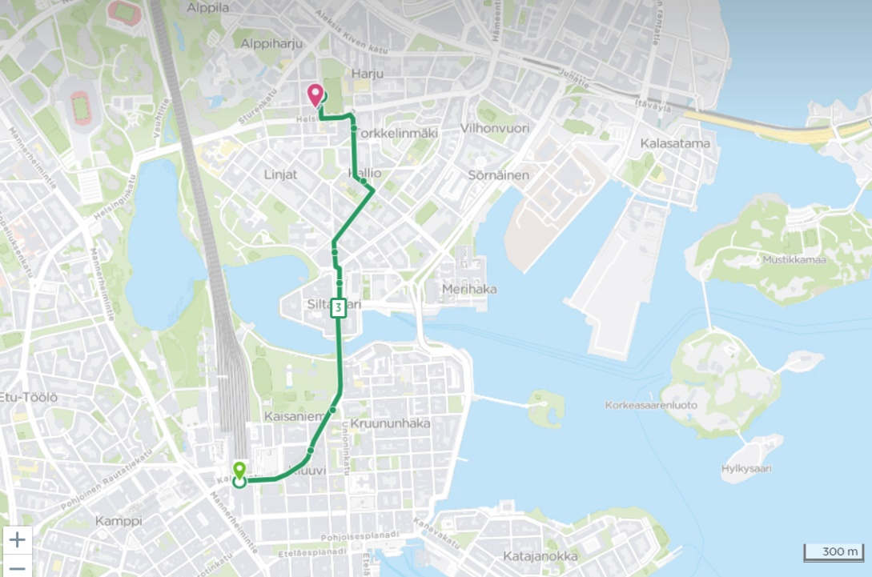

Getting to the hotel from Harbours

More information www.hel.fi/helsinki/en/maps-and-transport/sea-air/harbours/

Taxi

If you need to use taxi please make sure to use either Taksi Helsinki, Lähitaksi or Fixu Taxi. The drive to railway station for 1-4 persons with Fixu Taxi costs 35 €, with Lähitaksi 39 € and with Taksi Helsinki 41 €.
Please note that the use of taxes is under your own responsibility as EAPN will not reimburse taxis.

********************************************************************************

Hotel Scandic Kallio

Läntinen Brahenkatu 2,
00510 Helsinki
+358 9 68999036

Breakfast included.

https://www.scandichotels.com/hotels/finland/helsinki/scandic-kallio?_ga=2.35046369.1948656374.1560160741-983097149.1554363652

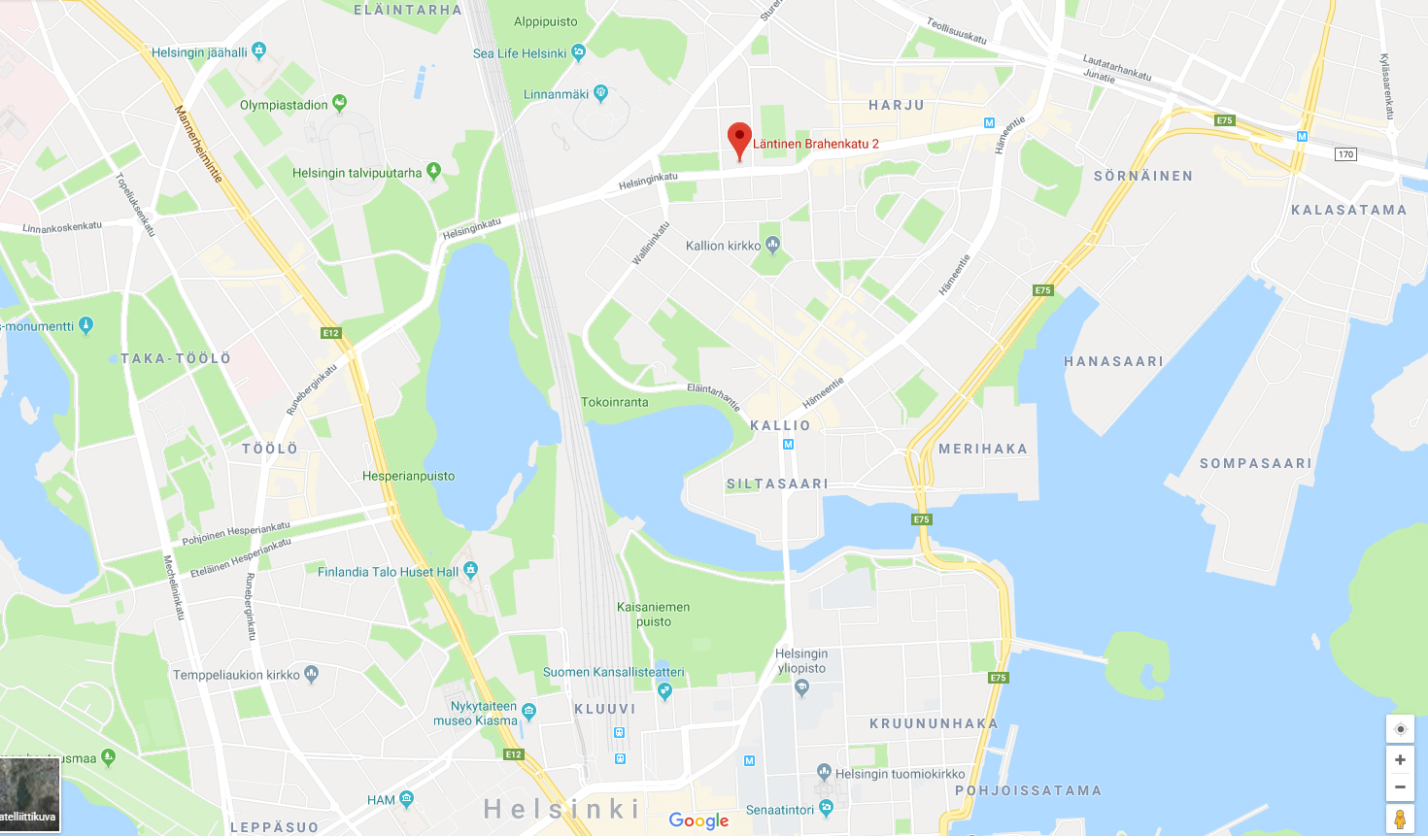

********************************************************************************

Welcome reception

Old Court House
Aleksanterinkatu 20,
00170 Helsinki

Old Court House was built in 1763 and is located in the empire center of Helsinki, in so called Lion block.

Getting from the hotel to Old Court House

Tram – 14 minutes

Take tram 7 from Urheilutalo (stop 0278). Get out at stop 0450 Hallituskatu and walk 150 meters.

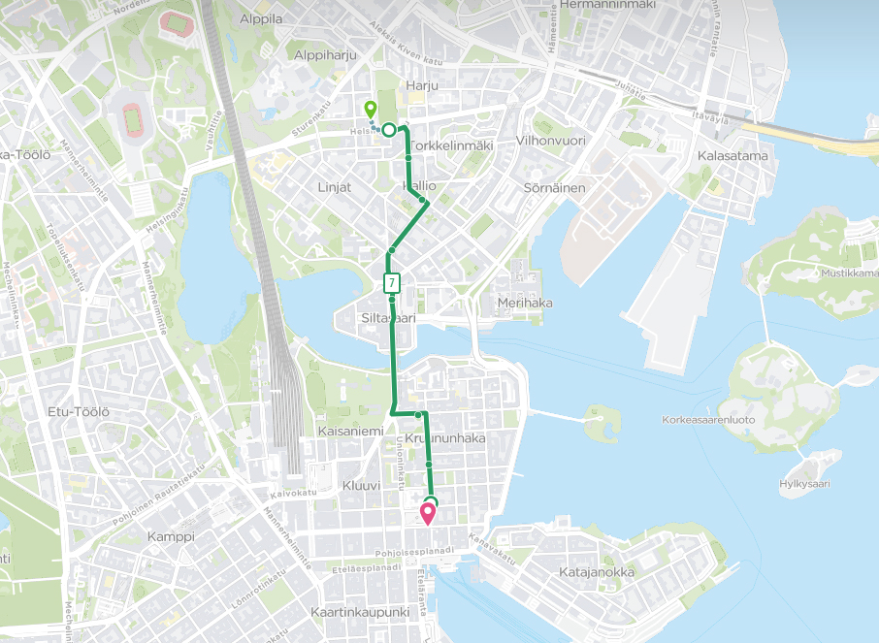

********************************************************************************
Meeting venue

Kalliola Settlement

Sturenkatu 11,

00510 Helsinki

The venue is located in Alppiharju. Kalliola Settlement is a multi-function association founded in 1919 and as the name suggests, its activities rest on community values. Kalliola produces social services, provides adult education and supports civic and voluntary activities in the metropolitan area.

More info about Kalliola Settlement www.kalliola.fi/in-english/

Getting from the hotel to Kalliola Settlement

Walking - 5 minutes

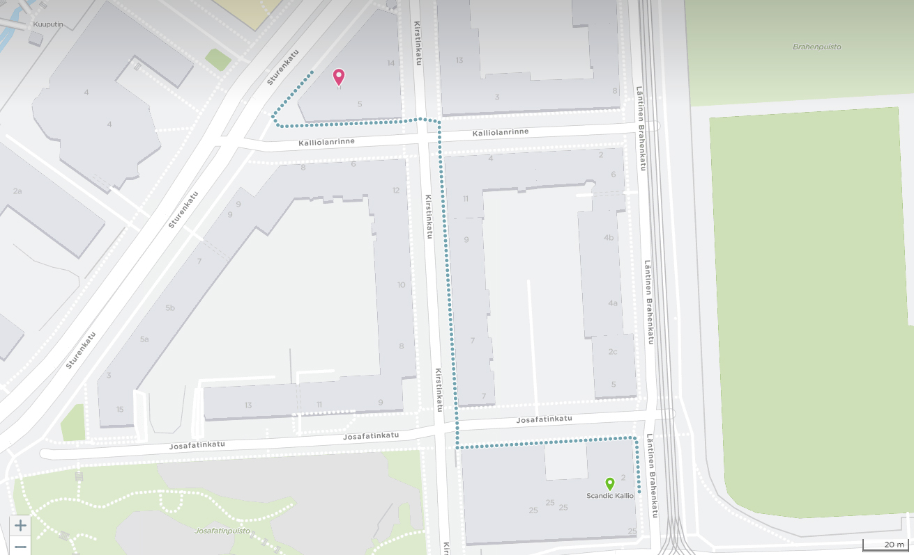

********************************************************************************

Seminar venue 16.9.
Helsinki Central Library Oodi
Töölönlahdenkatu 4,
00100 Helsinki

Helsinki Central Library Oodi is a living meeting place at Kansalaistori square, right at the heart of Helsinki. It is one of 37 branches of Helsinki City Library. It was opened in December 2018.

More info about Oodi www.oodihelsinki.fi/en/

Getting from the hotel to Oodi

Tram – 20 minutes

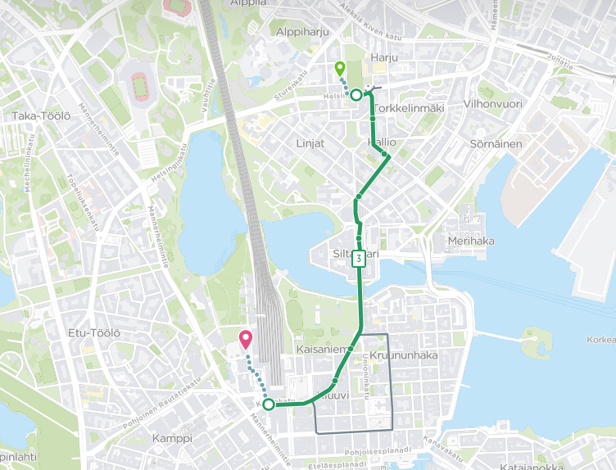

Walk 150 meters to stop 0278 Urheilutalo. Take tram 3, 7 or 6T. Get out at stop 0302 Rautatieasema. Walk 350 meters to Oodi.

********************************************************************************
Lunches

14.9. Sture 4
Sturenkatu 4 / Kulttuuritalo, across the road of the meeting venue

15.9. Café Damascus
At the same building as the meeting

16.9. Fazer
At the same building as the seminar

********************************************************************************

Dinners
14.9. Presto
Eteläesplanadi 14

Getting from the hotel to the restaurant

Tram – 23 minutes

Walk 150 meters to stop 0278 Urheilutalo. Take tram 3 or 6T. Get out at stop 0702 Ylioppilastalo. Walk 400 meters to the restaurant.

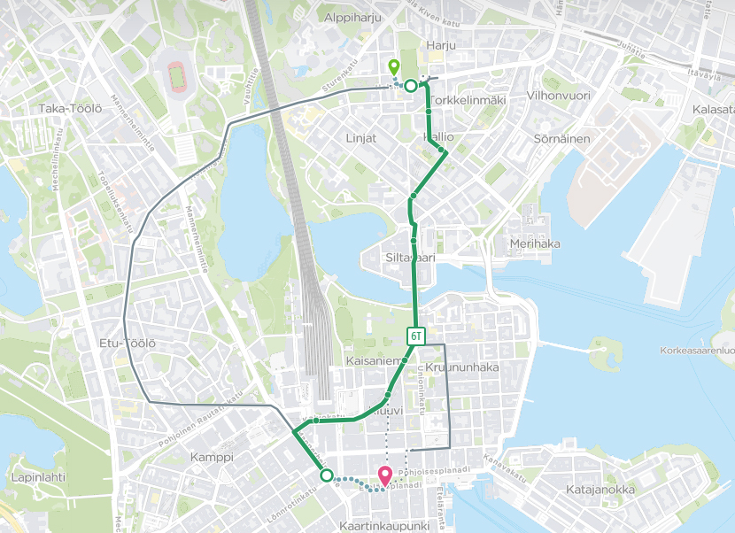

15.9. Sture 4
Sturenkatu 4 / Kulttuuritalo, across the road of the meeting venue

********************************************************************************

Helsinki

Helsinki is a modern, pocket-sized European city known for design and high technology. Helsinki’s attractive and unique character comes from its proximity to the sea, as well as its location between the East and the West.

Visit Helsinki / My Helsinki www.myhelsinki.fi/en and https://twitter.com/VisitHelsinki
City of Helsinki www.hel.fi/helsinki/en
Helsinki Times www.helsinkitimes.fi
Finland www.visitfinland.com and https://finland.fi
Finnish Government www.valtioneuvosto.fi/en/frontpage
The Ministry of Social Affairs and Health http://stm.fi/en/frontpage
Finland Politics https://finlandpolitics.org

Kallio

The hotel and meeting venue are located in Kallio which is in the eastern end of Helsinki´s heart. Formerly a working-class neighbourhood, the laid-back, idiosyncratic and spirited area has a noteworthy array of boutiques, cafes, restaurants, bars and more.

www.visitfinland.com/article/vibrant-helsinki-district-kallio/

Sights and shopping

Kotiharjun sauna – legendary Kotiharju sauna was built in 1928
Levykauppa Äx - record shop
Frida Marina - secondhand shop
IPI Kulmakuppila - café that employs employees with disabilities
Meripaviljonki Terrace – unique floating terrace

********************************************************************************

Basic Finnish Words

Hei = Hello
Kiitos = Thank you
Kyllä = Yes
Ei = No
Minun nimeni on… = My name is…
Hyvää yötä = Good night
Huomiseen = See you tomorrow

********************************************************************************

More information

We will keep you posted at the Facebook event.

Marjo Rinne
campaign coordinator, EHYT ry
marjo.rinne@ehyt.fi
+358 50 301 5210

Erja Saarinen
secretary, EAPN-Fin
erja.saarinen@soste.fi
+ 358 50 433 4202

Anna Järvinen

board member, EAPN-Fin
anna.jarvinen@soste.fi
+358 50 586 5677

