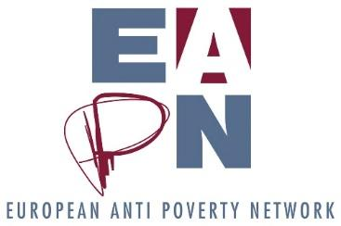

EAPN’s Theory of Change

v5, 29 August 2019
For adoption

Context
EAPN members engaged in the Theory of Change exercise as part of our 2018 – 2019 strategic thinking process. The need for such an exercise was recommended by Phase 1: Reaching a Shared Understanding, and a strong mandate to deliver this exercise was given to the EAPN Director and Bureau.

To inform the process a PESTLE analysis was undertaken by the staff team, and the results of the final membership survey were also analysed. A Draft Theory of Change was presented to the Bureau in early September 2018. The paper was updated following these discussions, and the updated paper was debated by the Ex Co in late September, and then during the General Assembly, with representatives of the Ex Co, EUISG and participants in the Capacity Building Workshop. Discussions continued throughout 2019 within the members, staff team, Bureau, Ex Co and EUISG, and the Theory of Change was adopted by the General Assembly in Helsinki, September 2019.

This paper represents the outcome of many discussions, which raised some key questions and challenges, including (but not limited to):

- How should EAPN build the public support and pressure which are needed to eradicate poverty?
- Are people experiencing poverty given enough importance in our Theory of Change?
- How should EAPN enable the participation of people experiencing poverty in our structures?
- How should EAPN Europe best support its members?
- How should we best coordinate between the European and the national level to bring about the biggest political impact?
- How will we change our ways of working in order to embody the Theory of Change?
- How will we ‘land’ these Strategic Changes at the national level?

Our Theory of Change is not meant to provide all the answers to these questions – further discussions and decisions will be needed when we start implementing the Theory of Change in 2020 and beyond.

What do we mean by a Theory of Change?
Theory of Change is a methodology for planning that is commonly used among NGOs. At its simplest a Theory of Change defines the overall change we want and then identifies the major changes which are needed in order to achieve this overall change. Once these major changes are identified, organisational strategies to bring about those major changes can be agreed and evaluated.
A Theory of Change allows us to be clear and explicit about the changes we believe are necessary to eradicate poverty and social exclusion.
Our Theory of Change isn’t premised on who we are right now, but on who we need to be and what we need to do in order to achieve our Vision. We are striving to take the most pragmatic steps to strengthen and grow both our network and our impact. The activities that will arise from the Theory of Change represent the most significant changes we need to make to how we work in order to achieve our vision.

Strengthening Public Support in Europe for the Eradication of Poverty
We recognise that we need public opinion more firmly on our side if we are to create the political will to eradicate poverty. More people and organisations need to be brought into the ‘fight’ against poverty, the fight for access to social and economic rights. Whilst EAPN has traditionally been strong and successful in political circles, we recognise that we have had less success in convincing ordinary people, and wider civil society, of the need to eradicate poverty in Europe, and that our arguments are the right ones. We recognise that we need to make progress here. To do so, we do not need to fundamentally change who we are, but we do need to rebalance the focus of our activities, spending more time, energy and resources on public facing campaigning to complement our high-level policy and political advocacy. This rebalancing will be a key challenge for EAPN moving forward.

Our Theory of Change
The overall change EAPN wants to see is:
“A sustainable Europe free of poverty and social exclusion, with high levels of equality, where political, economic, social and cultural rights are respected”.

We collectively mapped the changes that are necessary to achieve that vision, identifying six. These are signified in the graphic by items with a green border (and explained in detail on p3-4). Three of these changes, (C, D and E), i.e. changes in policy, law and politics can only be achieved if the other three changes are achieved.
We then collectively mapped where EAPN could have most impact, and agreed four priorities (p5-6), all supported by policy expertise in specific key areas - signified by items with a red border. All of this is underpinned by a strong EAPN network, strong members, and strong public support throughout Europe for the eradication of poverty and social exclusion.

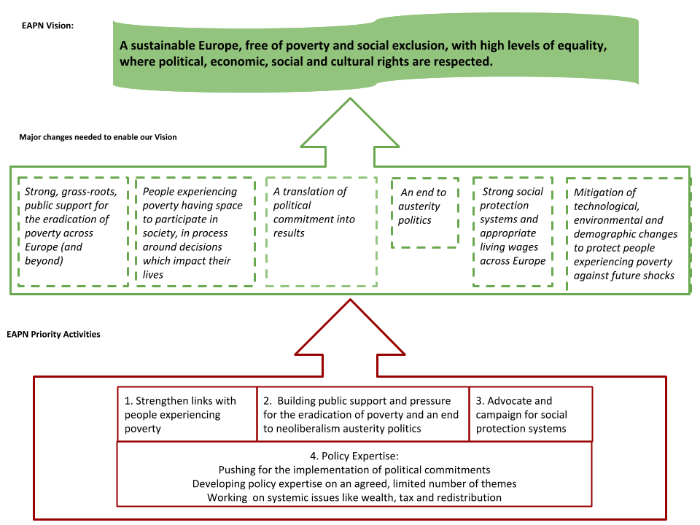
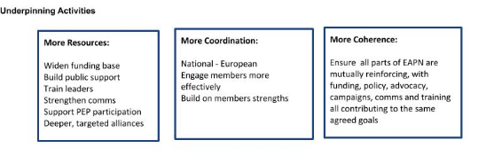

Major Changes needed to achieve our Vision
A. Strong, grass-roots, public support for the eradication of poverty across Europe (and beyond)
While we have some political commitment to poverty eradication, public attitudes to poverty (and excluded groups) are still problematic. When Europeans understand poverty eradication and social inclusion as public goods, as matters of social justice and human rights, then we will be able to make a stronger impact on poverty.
This means EAPN needs to have strong members, strong engagement and participation in our workspaces, strong campaigns and political advocacy across our network and beyond. It means an anti-poverty network which really belongs to people experiencing poverty. It means a well-resourced network, with members being able to access EU funds, national funds, philanthropic funds, CSR funds, public donations. EAPN, and the wider ecosystem of anti-poverty organisations and activists must be able to bring meaningful pressure on governments and corporations at key moments. Meaningful links with anti-poverty structures across the world would help strengthen the European movement.
B. People experiencing poverty having space to participate in society, in process around decisions which impact their lives
Participatory democracy is a key way to make progress on poverty, as people closest to the problems have a strong sense of the potential solutions. People experiencing poverty need to have a meaningful space within existing organizations as well as opening new spaces. We need to explore what this means both for EAPN and for society at large.

C. A translation of political commitment into results
Member States have committed to tackling poverty and social exclusion at a high level, via the SDGs and the Social Pillar. We need to ensure that this commitment is translated into action and results, with meaningful strategies, backed up by funding, to ‘land’ these frameworks at the national and local level.
D. An end to austerity politics
While the high-level political commitments are in place, we are coming out of a decade of austerity following the financial crisis of 2008. To meaningfully tackle poverty and social exclusion in the long term, austerity politics need to end, social spending needs to be prioritized, and resources need to be more fairly distributed throughout society - this means that richest members of our societies, including multinationals, need to pay more tax to ensure that public finances are healthier, and governments are better able to fund social policies. Tax justice is thus a crucial element in the fight against poverty.
E. Strong social protection systems (specifically Minimum Income schemes) and appropriate living wages across Europe
These systems are vital to protect the poorest members of our society. The European Minimum Income Network has shown us that Minimum Income schemes vary greatly across European countries and even within countries, and many are too bureaucratic to achieve high levels of take up. The rise of the gig economy provides a real challenge to living wages, which need to be protected and promoted.
F. Mitigation of technological, environmental and demographic changes to protect people experiencing poverty against future shocks
Policies will be needed to protect poor people against extreme weather events (recent heat wave across Europe) and technological advances (retraining workers in sectors which may be lost in the transition to the non-carbon economy) as well as changes in demographics, including ageing populations and the emergence of new groups of people at high risk of poverty.

Where could EAPN have the most impact?

EAPN does not need to focus everywhere – this would be neither strategic nor feasible, given our resources. We have analysed where we are best placed to contribute to the change we want to see, recognising our history, our strengths and successes, our weaknesses and failures – and we recognise the key role that both governments and the EU has in creating these changes. We have identified and agreed on four priorities, all underpinned by strengthening our network and our members, and strengthening public support for the eradication of poverty.
Underpinning activity:
Strengthening our network, our members, strengthening public support for the eradication of poverty in all countries across Europe, and building links with anti-poverty structures across the world. This will mean allocating resources to widening our funding base, to building public support, to training our leaders, to strengthening our communications, to supporting participation of people experiencing poverty, and to building stronger alliances with other likeminded organisations and structures. It will mean focusing on coordination between the European and national levels, helping national members be involved in EU processes, building on the strength of the national level, and strengthening the coherency of EAPN, ensuring that our policy work is fully connected to our projects, funding, campaigns, communications and training work.

Four Priorities:
- Strengthen links with people experiencing poverty and ensure that they are meaningfully involved in, and leading, grassroots anti-poverty advocacy work and campaigns around poverty, inequality, precarious work, digitalisation, social protection (with a focus on minimum income), living wages, at national and European levels. We will amplify the voice of individuals and groups living in poverty so that their authentic experience is heard, understood and used by the media, policy makers and the public. Work coming out of the 2017 Dutch Resolution and the Comm’On group will be the basis for this priority.
- Building public support and pressure for the eradication of poverty and an end to neoliberalism austerity politics by developing challenging frames and narratives, and alternative social and economic political options. We will develop a compelling narrative about the reality of poverty in Europe, increasing our capacity to translate facts, figures and policies into meaningful and accessible stories that inspire action and aid understanding.
- Advocate and campaign for social protection systems (with a focus on minimum income schemes), and living wages throughout Europe, directly towards governments but with an increased focus on the public as well. As part of our advocacy we will continue to push for meaningful civil society space in national and European political processes with the most potential impact on the eradication of poverty and social exclusion.

The content of these three activities come from our other priority:

4. Policy expertise, which has three strands:
- Pushing for the implementation of political commitments like the Social Pillar and the SDGs, via policy work at the national and European level
- Developing policy expertise on an agreed, limited number of themes within key areas, notably: a) A multidimensional approach to poverty, social exclusion and inequality b) Access to social and economic rights, c) Access to quality services d) Cross-cutting priorities, notably Environmental, technological and demographic challenges, and gender. (Recognising the need to prioritise issues where there as value add for European level work, and which can mobilise our members)
- Working on systemic issues like wealth, tax and redistribution, by developing expertise and working in alliances.

This Theory of Change will be our compass, guiding our work and decisions for the future. We recognise the need for further detailed discussions throughout the network, in order to define and agree the full implications. We recognise the need to tread carefully, reforming at a pace which does not undermine the core strengths of EAPN – national networks, and the engagement of people experiencing poverty.

Through the changes we will make as a result of this strategic thinking process, we will have the opportunity to grow as a network, to invigorate new, more effective ways of working nationally and to inspire others to act, and to be part of the fight against poverty in Europe and beyond. We can be more relevant and take a stronger, more strategic approach to issues like harnessing the human rights framework and working more creatively with young people – the next generation of anti-poverty activists. We have energy, hope and vision - and we have worked hard together to get to this point.

This strategy will require every one of us, individually and collectively to change how we work together. That change will be challenging, but our future is very bright.
We will revisit this Theory of Change every three years, to ensure that our thinking is up to date and reflects EAPN’s analysis of the current political and social climate.
ENDS

