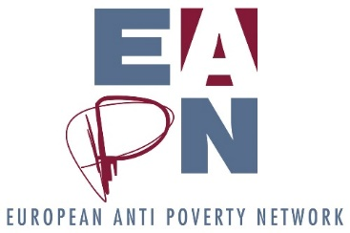

Notes of EAPN Bureau meeting
4-5 December
Brussels

Participants: (members): Vera (Austria), Eleni (Cyprus), Richard (France), Biljana (North Macedonia), Honoratte (Norway), Carlos (Spain), Ian (IFSW)
Participants (staff): Leo, Philippe, Elke, Sandy, Rebecca, Mathias (At different times)
Apologies: Sigrid, Magda, Florence

Session 1 - Setting the Scene
Minutes of last Bureau meeting approved
Agenda approved
Action points discussed during the course of the meeting
Session 2 - Politics
Key discussion points
- Review of the PeP meeting
Coherency between our policy work and the PeP meeting can be an issue – with the meeting this year focusing on areas where we already have existing positions. While the meeting is clearly a space for PeP to discuss and bring forward their experiences, there is a need to ensure coherence and a good use of everyone’s time!
It’s also important to be accountable to participants in the meeting, telling them how we are using the results of the meeting. This will involve all groups of EAPN considering the key messages / recommendations of the meeting and discussing how they will use them. This doesn’t mean that all groups will start working on these areas of concern – it could simply be that key messages will be integrated into ongoing work, for example. At a minimum, all groups should be considering the key messages from the meeting, and reporting back to the next National Coordinators meeting.
- Future of Europe
Decision
D1. We should push for the results of the PeP meeting of 2019 and 2020 to be taken into consideration by the team pulling together the results of the various citizen consultations.

- Post-2020
SJ attended an ECFIN conference recently – she reports that they are clear that a post-2020 strategy will be put in place. She suggests that Commissioner Gentiloni’s role will be Important in this process.
- Action Plan for Social Pillar
A recent meeting with Commissioner Schmit suggests that there will be a consultation in early 2020, with a plan by the end of 2020.
Decision
D2. Members will be encouraged to participate in these discussions, by asking their Semester Officers about the plans at an early stage and asking to be included.

- Green New Deal
We know that this is going to be ‘the’ main proposal coming out of the Commission in the first part of their mandate. An early leaked draft can be seen here. We should aim to be making a response – and agreeing our position should start on our webinar on 16 December.
Decision
D3. Draft a response to the first Green New Deal proposal, based on existing positions and discussions on 9 Dec at Parliamentary event and 16 December (webinar). The focus should clearly be on protecting PeP; with points like the price of food etc.

- Minimum Income
D4. Following the invitation to apply for a side event at the German Presidency’s high-level event focusing on Minimum Income (Sep 16 2020) we will put together a concept note / proposal.

- Semester
Not all members, and certainly not all members of members, recognise the importance of the Semester process. This is a concern for EAPN, given the progress we have made here in recent years, and given how all the major political initiatives will be run through the Semester process in the coming years. The recent webinar and Semester toolkit are crucial tools here for EAPN and our members, and should be the focus on such capacity building work.
- MFF
Apparently, the last proposal coming out of the Parliament is ‘problematic’, though it has not yet been meaningfully analysed. Given that most EAPN members don’t work on the MFF, we do not prioritise it – but we should see if we can add our voices to allies who are working on it in more detail (Social Platform). EAPN Spain may also be able to help develop some key points.
Action | Responsible | Deadline
A1. Draw up a ‘one-pager’ of how we will consider PeP priorities in the different structures of EAPN | Magda, Vera, Leo | March 2020
A2. Finalise and send letter to Institutions with the key messages of the PeP and circulate, asking for what they plan to do with these priorities | Magda, Leo | End of year

Session 3 – Operationalising the 4 priorities and underpinning activities of the Strategic Review
Key discussion points
The Director presented the initial findings from the Membership Survey – available here on Members Room – and the sense of the recent staff discussion of the strategic review.
Bureau members were then asked to reflect on the question: How would we know we have made progress against our 4 priorities and underpinning activities after 2, 5 and 10 years, as a way to complement the questionnaire and the discussions.
The results of this exercise formed the basis of the discussions with the staff team on 5 Dec, and will be triangulated with the results of the Members questionnaire in February 2020. At the end of March 2020, the aim is for the Ex Co to approve an implementation plan, and then to spend April – June discussing financing and staffing behind the plan.
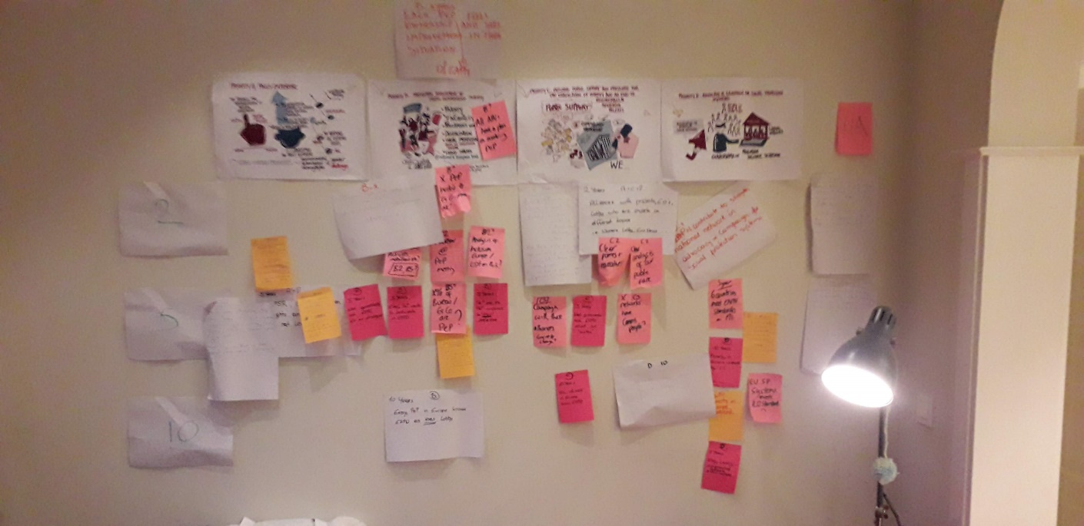
No specific decisions or action points arose from this session.
Session 4: Staffing Review in the framework of the Strategic Review
Key discussion points
Philippe, as the Trade Union representative, outlined the various issues the staff team have with the proposals of the staffing review, notably:
Timing – they prefer it to be done once the plan is operationalised.
Timing – they feel Trade Union reps should have been informed as soon as the proposal of having a staffing review was being discussed by the Bureau
Process – they would like the full process to be established before engaging in the staffing review
Process – they would have liked to have been better informed about the review in advance, and to have better understood what it would involve
Power – they are worried the consultant will have too much power in this process, and that whatever s/he recommends will simply happen
Fear – they are worried about giving ‘wrong’ answers to questions and potentially losing their jobs
The Bureau tried to address various issues, notably:
Process – it will never be 100% clear. This is the first time a staffing review has been done in EAPN, and we are building the process.
Power – the consultant holds no power. They make recommendations, EAPN does with them what we like. The Bureau and Ex Co will take the recommendations – some will probably be accepted, some rejected, some amended etc. The Bureau chooses to work with a consultant to avoid bias, and to ensure an independent viewpoint.
Fear – the bureau is looking to understand the current situation, to know exactly what we have in place in relation to the strategic review. They are looking to understand whether we may need more staff and what this might cost, rather than looking to make redundancies.
Timing – the Bureau wants to finalise all of this by June 2020, to be able to report back to members, as requested by the General Assembly. There is flexibility to start the Staffing Review at the start of April 2020, when the Ex Co has finalised the implementation plan.
The Bureau was also very clear on a few issues, notably:
Leadership – the Director is mandated to lead on such staffing reviews.
Strategic Review – this does reflect a new reality, a new direction within EAPN, and the Bureau expects the staff to be willing to adapt to these new realities.
Consultant – we will be bringing in a consultant to do this review.
Decision
D5. From now until the Ex Co meeting (30-31 March), we will focus on the implementation plan for the priorities and the underpinning activities. From 1 April to Ex Co meeting in June, we will focus on the financing and the staffing needs to support this implementation.

Action | Responsible | Deadline
A3. Check this in principle agreement with the staff team | PL | 20 December
A4. Contact Local Knowledge to set up dates | LW | Early Jan

Session 5: 30th celebrations of EAPN
Key discussion points
- The Journalism Prize is probably the most important element of the celebrations, in terms of visibility. It can only be actioned if we are able to find funds – we should be focusing on Euronews, who we should ask for a partnership on the Prize, but also offer them the opportunity to cover activities throughout the year, and access to our members and our people.
- We agreed on the importance of organising all of our activities around the key theme and the key branding. This would mean that all EAPN events will be held under the same ‘banner’, the same theme and the same branding. EAPN members would be encouraged to do the same.
- The core programme of the 30th celebration must be what we can already build into the existing work programme, with extra pieces actioned should funding be secured. This would mean that celebrations should clearly be built into the GA and the PeP meeting.
- A document which highlights what we have done in the last 30 years, which highlights our successes, our achievements, and how we have engaged PeP, would be very useful.
- If we do focus on the homeless world cup, we should reach out to FEANTSA at an early stage to check (the main idea around either the Homeless World Cup or Euro 2020 would be to have a logo or the branding on shirts, adverts etc)
Decision
D6. Journalism Prize is the priority for EAPN in the framework of the 30th celebrations. Time should be spent here.
D7. The theme will be ‘The Time is Now to Make Poverty History - 30 years should have been enough’. Latte Creative will be asked to develop branding.
D8. We’ll focus on a photo competition rather than a short story competition, aiming to help deliver on our ‘public support’ priority and contribute to an increased social media presence

Action | Responsible | Deadline
A5. Update the members with plans, invite to contribute to any committee which seems weak | Leo | Early Jan
A6. Check the 2019 and 2020 budget to check what we can already allocate towards the celebrations | Leo / Philippe | End of year
A7. Finalise the history / timeline with Sergio | Leo, Sergio, Elke | Early Jan
A8. Members working on Journalism Prize to feedback their ideas | Vera | Early Jan
A9. Make a 30 second video to launch the 30th celebrations | Carlos, Elke | Early Jan
A10. Prepare letter for members to use with governments in January 2020 | Leo, Eleni | Early Jan
A11. Support members in securing press / social media coverage in January | Elke | Dec / Jan

Session 6: Statutory Review and Membership Fees

Key discussion points on the Statutory Review
The process proposed by Eleni was slightly amended, it now reads:
• Bureau to finalise proposed amendments by 15/01/2020
• All members to receive the proposal by 01/02/2020
• All members to send comments and suggestions by 01/03/2020
• Bureau to reflect and incorporate members written views in one document for the ExCo meeting by 15/03/2020
• All members to receive final document with all proposals and suggestions by 20/03/2020
• ExCo to discuss and finalize in the ExCo Meeting on the 30-31/03/2020
• All members to receive the Ex Co proposal by 1/07/2020
• General Assembly vote 2/10/2020 TBC
Proposed amendments were discussed, and the following points arose:
- Revising statutes required a two thirds majority within the General Assembly, so this needs to be handled carefully. Key issues will involve membership fees and tenure limits.
Key discussion points on Membership Fees
- It was noted that some members may end up leaving EAPN if membership fees of 2800 euros are introduced, and they do not meet the criteria for exceptions
- While some European members are not able to use the EaSI funding to pay these fees, they could choose to use other sources of funding to do so
- If we have equal voting rights, we should have equal responsibilities towards the network
- For members who are not able to pay, we should aim to support them to develop a coherent fundraising plan which goes much further than just being able to pay the membership fee
- Perhaps there should be an option of ‘Pay What You Can’ (and pay the remaining amount at a later date?)
- We need to be careful about the consequences of not paying membership fees – however, it is clear that the Ex Co took a clear decision on the need to have mandatory fees, and the implication of this is that there are some consequences – otherwise the fees are simply not mandatory. Consequences could include losing a vote at the GA, or losing the financed participation in the GA, or having your status reduced to that of observer for that GA.
- The revised fees should apply from 2020, with the criteria coming into place in 2021.
- If members cannot pay fees in 2020, they should be offered support immediately.
- We will need to be clear by when the fees should be paid, and what happens if you have not paid fees by this date.
- It is far from clear that members would vote for this at the General Assembly, despite the Ex Co voting in favour – as such, we’ll need to be careful when making proposals to the Executive Committee – remembering that we will need a majority of two thirds to make such changes.
- No perfect solutions exist which will please everyone – but we will need a clear process for decisions, clear consequences and clear exceptions.
Decision
D9. The process to be followed for the Statutory Review is above.

Action | Responsible | Deadline
A12. Send revised statutes to Bureau | Eleni | 20 December
A13. Share final comments with Eleni | Bureau members | 15 Jan
A14. Revise the statutes and send to members | Eleni and Leo | 01 Feb
A15. Discuss key questions with Dentons | Eleni and Leo | End Feb
A16. Send further comments on the Membership Fees paper / proposal on criteria to Leo, Philippe, Carlos, Richard | Bureau members | 06 Jan
A17. Revise paper and submit to Ex Co for discussion / decision | Treasurer, with support of PL and LW | 13 March

Session 7: Staff and Bureau on Strategic Review
Staff and Bureau had a session to look at the potential short medium- and long-term objectives under each of the Priority Areas and the Underpinning Activities which the Bureau had come up with yesterday, following the overview of the early responses to the Members Questionnaire.
Results of this discussion have led to a first draft of an ‘Action Plan to Implement the Strategic Review’ which will be revised in February, following the deadline for the questionnaire and the analysis. This second version will be considered by other groups and put to the Executive Committee meeting of March 2020 for consideration.
Session 8: 2020 Calendar
- January – we should aim for a video message from Carlos announcing the 30th celebrations, what the year is about etc.
- February – we will aim for a Bureau meeting in Cyprus on 17-18 Feb
- March – the EUISG is in the Canary Islands. SG of EUISG to be invited to a session of the Bureau (webex)
- March – Ex Co should hopefully be in Luxembourg. Bureau to arrive a day early for a pre-meeting, and leave late to enable a debrief.
- June – any week outside 8-14 June should be feasible for the Ex Co / EUISG / Policy Conference
- October – General Assembly should be 1-3 October in Berlin if possible. If no co-financing is possible then we should organise it in Brussels.
AOB
- We agree that Biljana will reach out to Magda asap to get the MDG up and running
- We should request the model of participation from organisations like EDF, ATD and Inclusion Europe.
- It may be better to focus on PeP participation at the national level before the European level
- Developing ToR for the PeP NC will be a good start for this
- All Bureau members will fill in the Contact Book asap and confirm with Sigrid
- We should explore the possibility of applying for UN Democracy Fund opportunity in December, for the Journalism Prize
- German Government was talking recently about ‘Minimum Protection’ rather than ‘Minimum Income’ which is a worry, as it may indicate a move towards providing more goods / services and less money. If this is the case, we will need to mobilise to fight against it.

