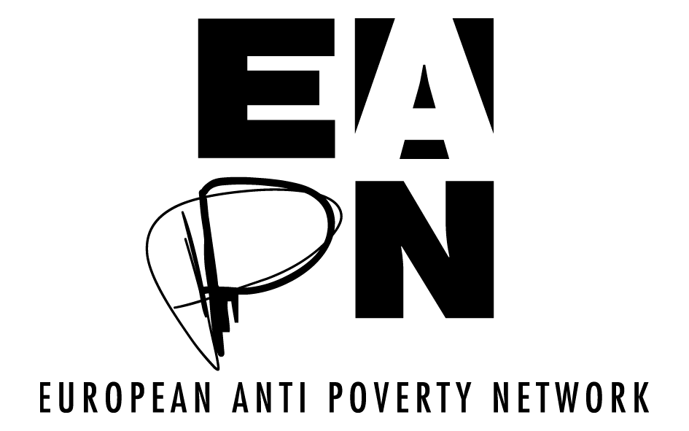

Terms of Reference for: EAPN’s Assessment Report on Europe 2020 and European Semester’s delivery on Poverty/social exclusion and participation

Scope of the Assessment Report

The objectives of the Assessment Report:

1) to evaluate progress made towards the poverty and other key social targets (employment and education) and the effectiveness of national policy from the perspective of EAPN members/PeP.
2) to assess the impact of the European Semester instruments in achieving the required results and engaging people experiencing poverty and civil society organizations
3) to highlight key upcoming challenges and make recommendations for the future period, linked to the EAPN post 2020 position paper.

- The paper will assess the current state of play and trends on poverty and social exclusion data, specifically the poverty, employment and education targets, during the period 2000-2010, drawing on EU secondary sources: Eurostat, the Joint Employment Report, ESDE, as well as EAPN publications and members national evidence.
- It will more qualitatively assess national policy developments and their impact, and the role that the European Semester has played, particularly the Country Reports and the CSRs drawing on national experience and examples. This should include testimonials/case studies from people experiencing poverty as well as examples from EAPN publications as well as the SPC/EMCO evaluation and other assessments.
- It will summarize key learnings, messages and recommendations, in the current context of the New EU leadership and Drivers, linked to the EAPN Position Paper and other work.
- The style of the report should be non-academic, accessibly and clearly written with examples and voice of PEP where possible, as well as concrete examples from EAPN members evidence but also technically sound citing sources of statistical evidence. It should aim to communicate beyond decision-makers to broader stakeholders.
- The consultant will work with and report to the EAPN Policy Coordinator regarding the structure and content of the report, the methodology, the questionnaire, the draft texts and the finalizing of the report. The Policy Coordinator will be responsible for liaising with the Comms team on publication/dissemination.
Responsibilities and Timeline

- An initial workshop exchange will be carried out as part of the EAPN ES conference, highlighting key areas of concern and collecting specific evidence on the 19 March 2020 to be referenced in the report.
- The consultant will collect initial secondary source material and draft an on-line questionnaire in consultation with the Policy Coordinator to collect main primary data through a quantitative scoreboard and qualitative questions to capture main policy impact including examples/testimonies including participation assessing the role of the European Semester, to be sent out at the end of May to be completed by members by the end of June. This may include a session in the June EUISG.
- The consultant will analyse the findings and draft the report by the 15th July, checking the copy with the Policy Coordinator before it is sent for final comments to the EUISG by the end of August.
- The consultant will include comments/amendments from members and finalize the text of the report by the 7th September.
- The Policy Coordinator will liaise with the Communication Team to ensure that the final report is laid out and printed for the EAPN conference on the 24/5/6 September.

