THE T IME I S

M E E T I N G S H O R T R E P O R T

P E P
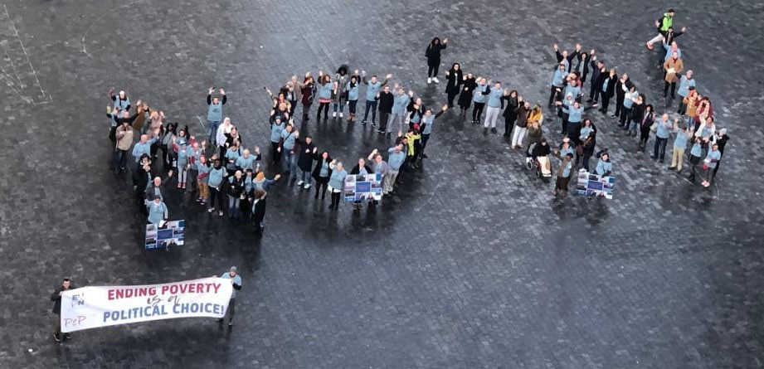

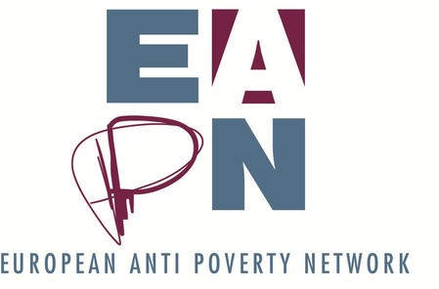
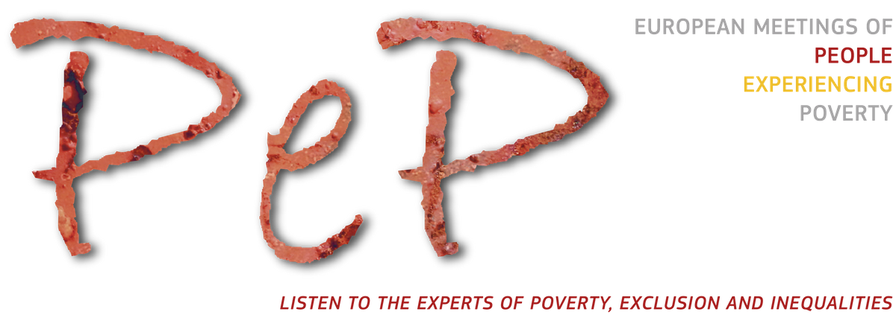

1 8 T H E U R O P E A N M E E T I N G O F
P E O P L E E X P E R I E N C I N G P O V E R T Y

INTRODUCTION

The theme for the 18th European Meeting of People Experiencing Poverty (PEP Meeting) was The Time is Now. The event took place at the Crown Plaza Hotel in Brussels, on 18-19 November, and was organised by the European Anti-Poverty Network (EAPN) with financial support from the European Commission, the Finnish Presidency of the European Council, and the EAPN Fund.

The conference brought together almost 150 participants, including national delegations of people experiencing poverty (PEP) from 32 countries, policy makers and representatives of European non-governmental organizations working towards eliminating poverty.

Taking place right at the beginning of a new term of the European Commission (EC) and Parliament, the meeting came at an important moment and gave an excellent opportunity for people experiencing poverty to speak up and present their political priorities in five key areas:
Access to housing;
Participation in societies;
Access to adequate minimum income; Access to good quality health care services;
Access to decent jobs and employment opportunities.

"[ The] PEP Meeting i s NOT a business meeting!
This i s about people’ s l ives and they deserve to be heard".
Participant from EAPN Spain

PEP meetings have been organized yearly since 2000, therefore the history of these meetings was also presented. There are still 110 million people in poverty across the EU, therefore it is important to raise awareness about the persistent challenges that PEP face and outline the priorities they want to see on the agenda of the new EC.

This short report aims to highlight the key demands developed by PEP and presented to policy makers at the meeting. The expectation is that the political leaders present at the meeting will include these key demands in their priorities and will act on them!

T H E T I M E I S N O W

1 - P E P 2 0 1 9

main moments of the meeting

THE OPENING PLENARY

The opening plenary featured 3 powerful testimonies made by PEP from Ireland - Alice Kelly, Greece - Samba Diallo, and Finland - Linnéa Partanen.

The policy makers present - Dragos Pislaru, Member of the European Parliament, Renew Europe Group and Josefine Hederström, Acting Head of the Disability and Inclusion Unit, DG Employment Social Affairs and Inclusion, European Commission - responded to the 3 stories shared by PEP and outlined how they see the role of the newly elected Parliament and the EC in dealing with the challenges faced by Alice, Samba and Linnéa.

This debate was co-facilitated by Vera Hinterdorfer, EAPN Austria and EAPN Vice-President and Leo Williams, EAPN Director.

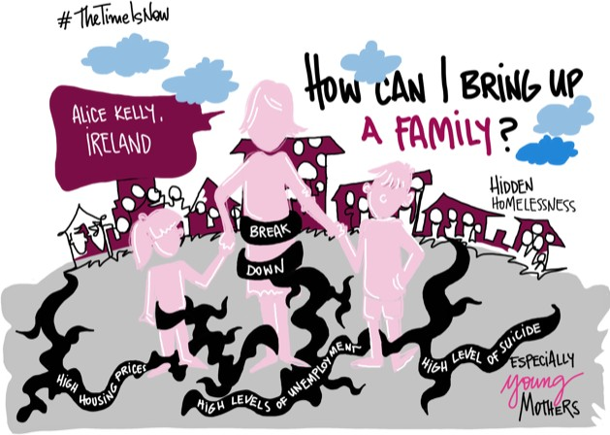
Andreaa Buzec

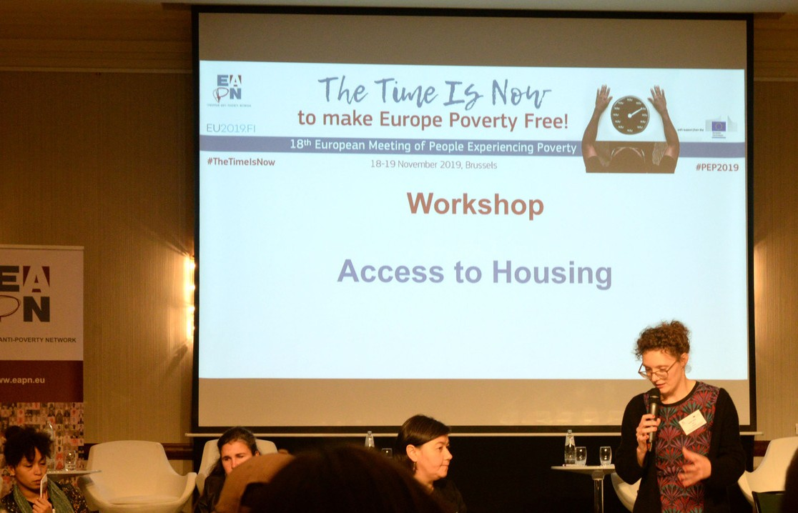
After the opening plenary, participants split into smaller groups in order to have more in- depth conversations about the 5 priorities discussed at the meeting.

The discussions were facilitated using the World Café methodology and they were a crucial step in the development of the key demands presented by the PEP.
THE WORLD CAFÉ

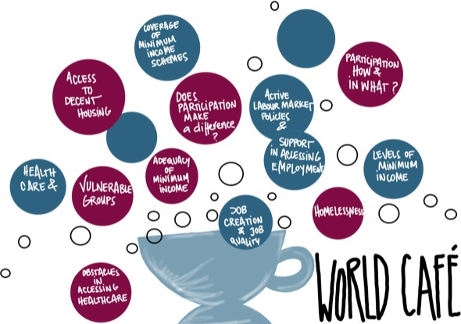
Andreaa Buzec

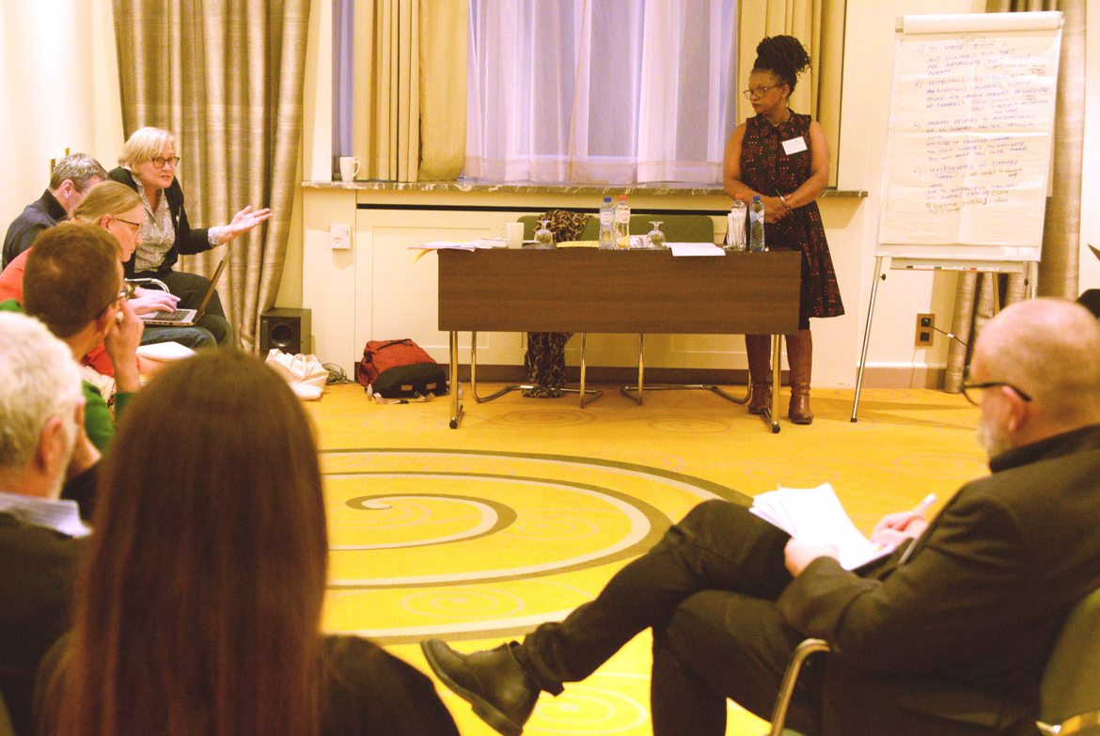
THE WORKSHOPS

After two rounds of World Café discussions, participants gathered in 5 groups, around the 5 priorities discussed at the meeting. Each of the 5 groups proposed, on the basis of the collective analysis done during the World Café sessions, key demands that they wanted policy makers to hear and act on.

THE VISIBILITY ACTION

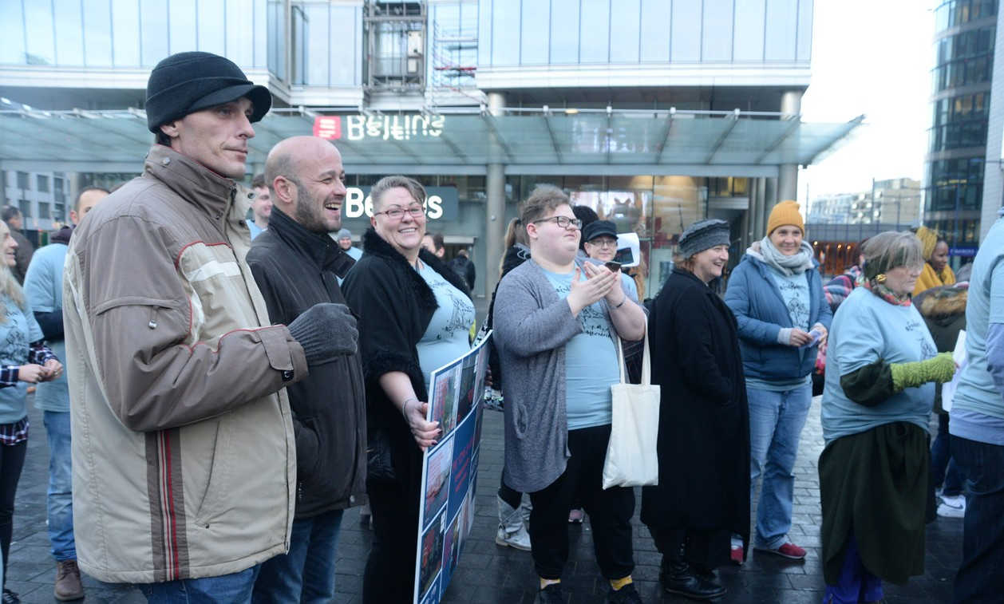
This year’s visibility action took place at Place Rogier on the 19th of November with the clear intention of amplifying the voices of people experiencing poverty attending the PEP Meeting and raising awareness of poverty and social exclusion in Europe by targeting the general public and key stakeholders and policy makers.

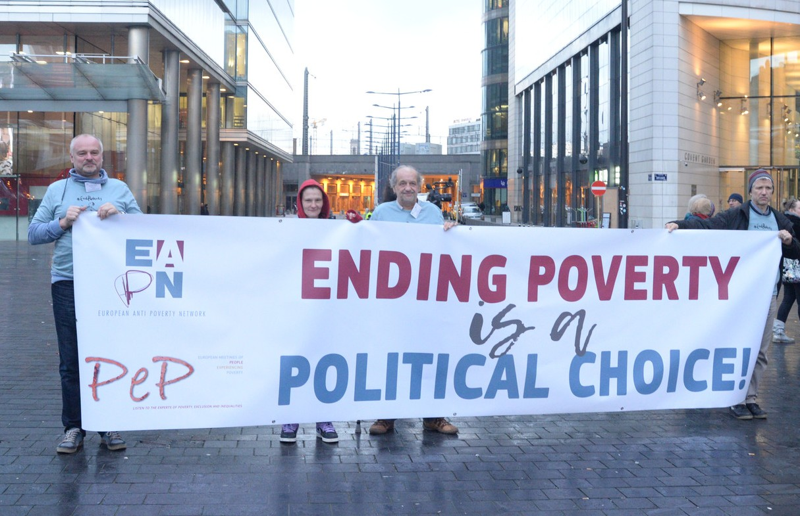
The goal was to make sure that everybody knew that the Time is now to make Europe Poverty Free! It was done through music with the song the Time is Now as well as handing out Christmas cards with messages from PEP from different countries that were prepared by each National Delegation in advance of the meeting. The action ended on a high note with forming the word NOW on the square whilst chanting “Eh Eh Oh Oh, Poverty has to go”.
THE CLOSING PLENARY

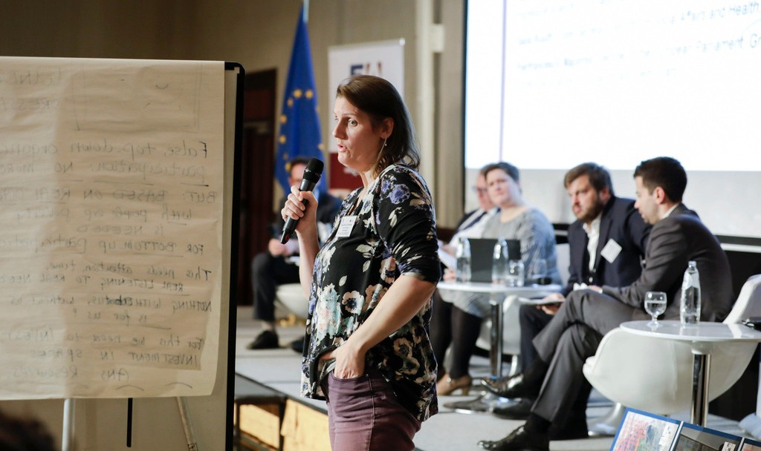
The key demands developed by more than a 100 people with direct experience of poverty were presented in a plenary session with high level policy makers:
Nicolas Schmit, Commissoner for Jobs and Social Rights
Saila Ruuth, State Secretary of Social Affairs and Health, Finland
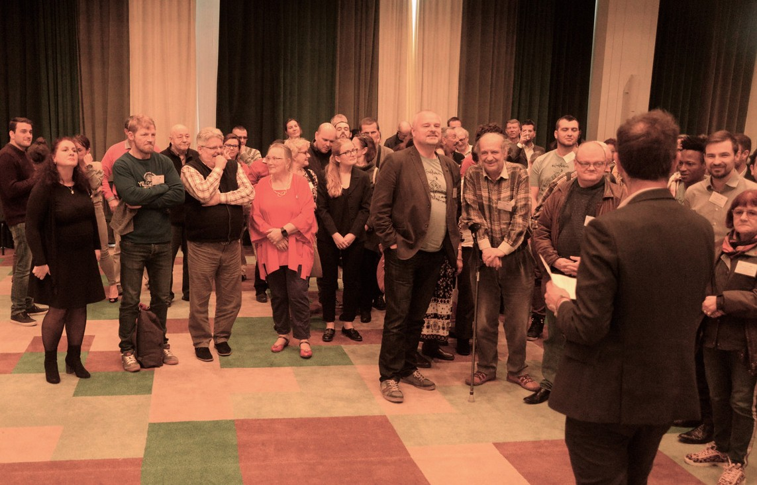
Pierfrancesco Majorino, Member of the European Parliament, S&D group, involved in restarting the intergroup on poverty.
Their responses to the demands presented stirred some further debate with the audience.

The Meeting ended with its traditional evaluation where participants shared their feedback on the two days.

KEY POLITICAL PRIORITIES

The World Café discussions as well as the workshops led to the definition and formulation of three to four key messages for each priority.

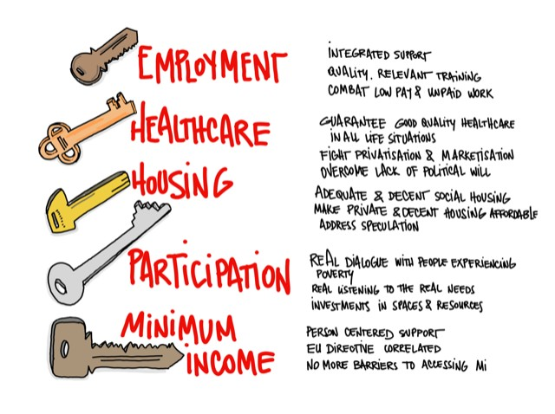

Andreaa Buzec

Access to Housing
1 S T P R I O R I T Y

. ENSU RE PEP HA V E A C C ESS T O DEC ENT

‘ What can you do to have access to housing? Just don’ t throw people
in the street.’ Participant from EAPN Ireland
SO C IA L HO U SING

Access to decent housing is very important for everybody. If you lose your home, you risk losing your social benefits, and this might lead to losing your children.
Having decent social housing at affordable rents lets people have stability, dignity, employment, health, education and family unity. To improve access to decent housing, especially for people experiencing poverty, we need:
Enough quality social housing in all Member States
Dedicated focus on those who cannot afford to rent a house
Participation of people in need of housing in decision making processes related to housing situations (e.g. in national, regional or local governments, or in local councils) ·
A European Indicator to monitor and compare social housing policies in different EU Member States, with the aim of increasing European understanding and comparability of how social housing works in different countries.

2 . M A KE DEC ENT PRIV A T E HO U SING A F F O RDA BL E

Provide incentives for owners to make their houses available for renting to people experiencing poverty, including by taxing vacant houses, establishing a rent cap in major cities and having a compulsory percentage of social housing in major housing developments.

3 . A DDRESS SPEC U L A T IO N O N T HE HO U SING M A RKET BY REG U L A T ING IT
4 . T REA T HO U SING A S A F U NDA M ENT A L RIG HT A ND NO T A S A F INA NC IA L G O O D

Participation of Pep in the L ives
of their Communities and Societies
- N D P R I O R I T Y

People experiencing poverty can provide efficient and cost-effective solutions in many areas that concern their lives – but false participation organised in a top- down way must stop. Bottom-up participation must be based on real dialogue with people experiencing poverty. This needs attention, investment (time, space, money) and real listening to real needs.

“ What was most important for me was that they l i stened to me.
It i s so important to be l i stened to. Make yourself visible.” Participant from EAPN Netherland

1 . W E NEED G O V ERNM ENT S A ND EU INST IT U T IO NS T O T RU ST PEO PL E
EXPERIENC ING PO V ERT Y A ND M A KE T HEM M O RE V ISIBL E

2 . W E NEED T HE ST IG M A T IZA T IO N O F
PEO PL E EXPERIENC ING PO V ERT Y T O ST O P

  - . W E NEED G O V ERNM ENT S A ND EU INST IT U T IO NS T O M A KE SO L ID
INV EST M ENT S IN PA RT IC IPA T IO N O F PEO PL E EXPERIENC ING PO V ERT Y, IN
T ERM S O F T IM E , SPA C E A ND RESO U RC ES, IN O RDER T O EM PO W ER PEO PL E ,
BU IL D ST RU C T U RES A ND BU IL D C A PA C IT Y

  - . W E NEED G O V ERNM ENT S A ND EU INST IT U T IO NS T O INT RO DU C E
“What was most important for me was that they listened to me. It is so
important to be listened. Make
yourself visible.”
REQ U IREM ENT S T O M EA NING F U L L Y
ENG A G E PEO PL E EXPERIENC ING PO V ERT Y IN REL EV A NT DEC ISIO N- M A KING
PRO C ESSES W HIC H A F F EC T T HEIR L IV ES ( E . G . DEV EL O PM ENT O F A NT I - PO V ERT Y
ST RA T EG IES) A ND HA V E C L EA R C RIT ERIA F O R W HA T C O U NT S A S M EA NING F U L
PA RT IC IPA T IO N O F PEO PL E EXPERIENC ING PO V ERT Y

Access to Adequate Minimum Income
- R D P R I O R I T Y

Minimum income is a foundation for social justice and social justice is a foundation for social peace and a more equal society. Dignity and respect should underpin all minimum income schemes in Europe. Asking and involving people who need minimum income schemes should be a core part of designing and monitoring minimum income schemes.

“ The complexity of the system together with the difficulty to have access to relevant information makes i t a complex task to know what allowances one i s entitled to.” Participant from EAPN Belgium

1 . W E NEED A N EU DIREC T IV E T O
G U A RA NT EE T HE RIG HT T O A DEQ U A T E M INIM U M INC O ME , WIT H A DE Q UA C Y
DE F INE D IN R E L A T IO N T O :

National Reference budgets – capturing the income needed for a dignified life, through a common calculation of a basket of goods and services
The ‘at risk of poverty’ threshold: the level should be above 60% of median disposable household income

. W E NEED T HE EU T O ENSU RE T HA T M EM BER ST A T ES REM O V E BA RRIERS T O
A C C ESSING M INIM U M INC O M E F O R SPEC IF IC G RO U PS – E . G . M IG RA NT S A ND HO M ELESS PEO PLE, DU E T O LA C K O F ID PA PERS A ND RESIDENC E PERIO D REQ U IREM ENT S F O R
EXA M PLE

  - . W E NEED G O V ERNM ENT S T O ENSU RE
PERSO N C ENT ERED SU PPO RT T HA T A V O IDS PU NIT IV E C O NDIT IO NA L IT Y A ND PRO V IDES C O NC RET E PA T HW A YS T O Q U A L IT Y JO BS
T HA T PA Y A REA SO NA BLE W A G E

Access to Good Quality Health Care Services
  - T H P R I O R I T Y

“ People that have money have a choice. People with no money, what are they going to do?”
Participant from EAPN Luxembourg

1 . W E NEED T HE EU A ND G O V ERNM ENT S T O G U A RA NT EE G O O D Q U A L IT Y
HEA L T HC A RE F O R V U L NERA BL E G RO U PS
( E . G . HO M EL ESS, RO M A , U NEM PL O YED) IN A L L L IF E SIT U A T IO NS BY:

Overcoming urban-rural divides and differences Strongly considering the gender division (e.g. single women, pregnant women)
Giving more attention to mental health issues Improving the reimbursement of dental care

2 . W E NEED G O V ERNM ENT S T O F IG HT A ND REV ERSE PRIV A T IZA T IO N A ND
M A RKET ISA T IO N O F HEA L T H C A RE BY:

Keeping universal access and coverage Strengthening access and reducing long waiting time and lists

3 . W E NEED G O V ERNM ENT S T O
O V ERC O M E T HE L A C K O F PO L IT IC A L W IL L T O IM PL EM ENT A ND U SE T HE EXIST ING
L EG ISL A T IO N:

Apply legislation or rules on non-discrimination, staffing or reimbursement of costs
Governments and public institutions in health must be accountable to people

Access to Decent Jobs and Equal Employment Opportunities
  - T H P R I O R I T Y

“ The job centres are not there to help you f ind work, they are there to make you f ind work” Participant from EAPN UK

1 . W E NEED PERSO NA L IZED, INT EG RA T ED SU PPO RT A LO NG T HE L INES O F
C O M PREHENSIV E “ A C T IV E INC LU SIO N” , W IT H A DEQ U A T E INC O M E SU PPO RT
HELPING PEO PLE T RA NSIT IO N INT O
DEC ENT JO BS. T HIS SU PPO RT SHO U LD BE PRO V IDED T HRO U G H SIM PLIF IED
BU REA U C RA C Y A ND C LEA R INF O RM A T IO N

2 . W E NEED Q U A L IT Y, R E L E VA NT
T R A INING F O R WO R K E R S ( P A ID F O R B Y E MP L O Y E R S DUR ING WO R K ING HO UR S ) A ND J O B S E E K E R S

3 . W E NEED G O V ERNM ENT S A ND EU
INST IT U T IO NS T O C O M BA T LO W PA Y A ND U NPA ID W O RK BY SU PPO RT ING
A DEQ U A T E W A G ES W HIC H A LLO W F O R A L IF E IN DIG NIT Y A ND ENDING
EXPLO IT A T IO N, M O DERN SLA V ERY A ND “ F O RC ED V O LU NT EERING ” T HRO U G H
U NPA ID ‘ W O RKF A RE’

I N F O R M A T I O N A N D C O N T A C T
For more information on EAPN's participation work, contact: Magda Tancau - EAPN Participation and Development Officer madga.tancau@eapn.eu - 0032 (2) 226 58 50
See all EAPN publications and activities on www.eapn.eu

The European Anti-Poverty Network (EAPN) is an independent network of non-governmental organisations (NGOs) and groups involved in the fight against poverty and social exclusion in the Member States of the European Union, established in 1990.

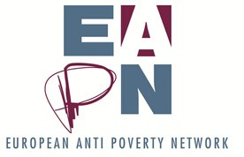
EUROPEAN ANTI-POVERTY NETWORK. Reproduction permitted, provided that appropriate reference is made to the source. February 2020.

This publication has received financial support from the European Union Programme for Employment and Social Innovation "EaSI" (2014-2020). For further information please consult: http://ec.europa.eu/social/easi

Neither the European Commission nor any person acting on behalf of the Commission may be held responsible for use of any information contained in this publication. For any use or reproduction of photos which are not under European Union copyright, permission must be sought directly from the copyright holder(s)

