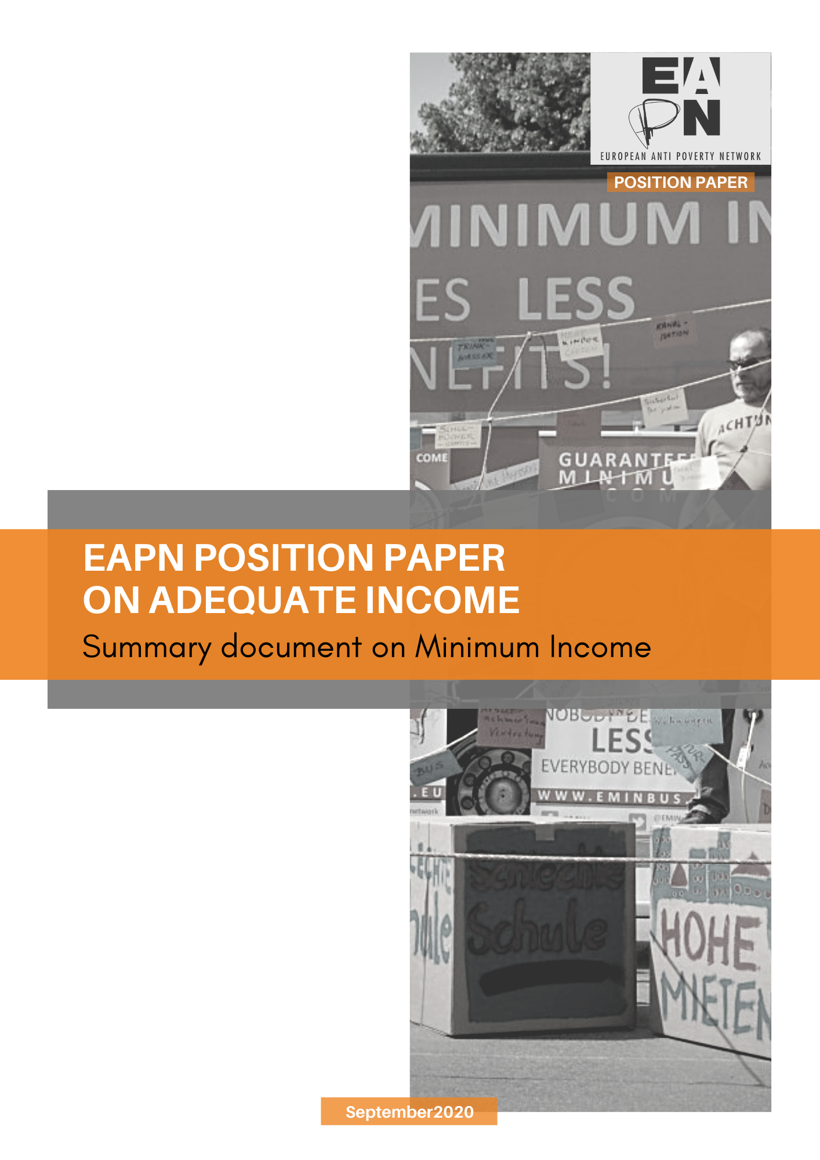

1 WHAT THIS DOCUMENT IS ABOUT?

In May 2020 EAPN issued a Position Paper on Adequate Income. It presents and updates EAPN’s priorities, proposals and demands in view of adequate income, covering both adequate minimum income (MI) and fair minimum wages (MW), including living wages, largely building upon earlier policy work by EAPN and the EMIN Network. This summary document presents key points to support the advocacy work of EAPN members. It exclusively deals with adequate minimum income.

2 MINIMUM INCOME BENEFITS AND SCHEMES – WHAT ARE WE TALKING ABOUT?

Minimum Income Schemes (MIS) are an integral part of comprehensive, rights-based, and universal social protection schemes. They help to guarantee a minimum standard of living and a decent life for all and enable people to fully participate in society, by targeting those people unable to work (currently or in the past) to access a decent job, but also those not gaining enough from employment and/or those not or no longer entitled to other types of social benefits (e.g. after expiration of unemployment benefits). Today all EU Member States (MS) have some form of MIS. Many of them, however, fail to lift those in need above the poverty line and/or leave the individuals lacking sufficient income stigmatised, isolated and trapped in a cycle of poverty and social exclusion.

3 REDUCING POVERTY – WHAT SHOULD MINIMUM INCOME BENEFITS/SCHEMES ACHIEVE?

EAPN believes that an adequate guaranteed minimum income is a social and human right for all people throughout their entire lives. This should be achieved by:
- Ensuring that MIS take people out of poverty and above the 60% median disposable household income poverty threshold (AROP), underpinned by national reference budgets capturing the real costs and price levels of essential goods and services.
- Providing comprehensive coverage and seamless transitions to other benefits at all stages.
- Supporting person-centred, integrated support as part of an “active inclusion approach” which is based on case-management approaches and personalised planning.
- Ensuring access to other key social rights for minimum income beneficiaries, e.g. decent housing, education, affordable healthcare, and not just as a “condition” or an “instrument” to get them into work. For EAPN, EU social standards must be rights, and should never be conditional or treated as a disincentive to work. Conditionality of this type is a contradiction to the rights-based approach that the EU has signed up to.
- Offering a positive hierarchy to minimum wages, in order to provide positive incentives to work. This also means minimum wages should be set higher than minimum income, rather than reducing minimum income.

4 GUARANTEEING RIGHTS – HOW SHOULD MINIMUM INCOME BENEFITS/SCHEMES BE DESIGNED?

EAPN has identified adequacy, accessibility and enabling capacity as the three key policy design criteria for universal minimum income schemes and benefits. Such schemes
- are essential to guarantee human and social rights, whereas denying people access to adequate income constitutes a violation of their human and social rights;
- ensure that people who need them can remain active and participate in society, help them reconnect to the world of work and allow them to live in dignity;
- are more likely to speed up integration into sustainable and quality employment, while inadequate MIS are likely to lock people in a cycle of dependency and undermine pathways to social inclusion and cohesion;
- would help to reverse the destructive trend of rising numbers of “working poor” and people in precarious employment arrangements and/or with low quality jobs;
- serve as macro-economic stabilisers and function as economic stimulus packages, as the money spent for minimum income benefits immediately re-enters the economy and is used for consumption expenditure, not for savings;
- help address income and social inequalities, and are indispensable for more equal societies and to ensure social cohesion within the EU MS and between them;
- strongly contribute to the economic, social, and territorial cohesion of European societies and upwards convergence in a context of increasing inequalities, between and within EU MS.

5 WHY DO WE NEED BINDING EU-LEVEL INSTRUMENTS, IN PARTICULAR A FRAMEWORK DIRECTIVE?

The number of people at risk of poverty or social exclusion (AROPE) across the EU remains extremely high, corresponding in 2018 to about 110 million people or nearly 22% of the total population. For EAPN, EU soft law thus has not allowed sufficient and sustainable progress on poverty reduction and the guarantee of decent employment, and working and living conditions for all Europeans (see Position Paper, 3.3). EAPN’s key demand is for a Framework Directive on Adequate Minimum Income to translate the right to an adequate minimum income for all over the life-course into a legally binding commitment for all. This demand becomes even more urgent to guarantee adequate income for everybody as a social and human right, given the consequences and challenges of the COVID-19 pandemic. The 2019 European Meeting of People Experiencing Poverty had recognised the adequacy and accessibility of minimum income schemes as key issues. It also called on MS and EU institutions to take urgent action to help make the related social and human rights a reality.

6 WHAT ARE EAPN’S MAIN DEMANDS FOR MEMBER STATES AND THE EUROPEAN INSTITUTIONS?

6.1. Recommendations addressed to the Member States
- All EU MS should guarantee the right to a minimum income, for everybody, throughout their lives, that is adequate, accessible, and enabling underpinned by a social-rights and human-rights approach (Principle 14, European Pillar of Social Rights (EPSR)).
- Minimum income schemes/benefits should be recognised as a core part of national universal social protection schemes to ensure adequate income and, as part of an integrated and person-centred active inclusion approach and a crucial element in multidimensional, integrated anti-poverty strategies both at national and EU level.
- All EU MS should be required to monitor and, if need be, address the problem of non-take-up of minimum income benefits as well as existing provisions on eligibility and/or conditionalities.
- All EU MS should be required to monitor and, if need be, adapt existing provisions to ensure the rights and the personalised, integrated support to empower people in need into accessing quality jobs and quality services.
- All EU MS should be required to ensure access to other key social rights for minimum income beneficiaries, e.g. decent housing, education, affordable health, and not just as a “condition” or an “instrument” to get them into work. They should also ensure a positive hierarchy between the income levels required to provide a minimum income and the level required for someone who is working, in order to provide positive incentives to work.
- All EU MS should be required
- to keep simple administrative and implementation procedures for MIS,
- to make them fully understandable to those in need,
- to adapt existing provisions to ensure non-discrimination against any group of (actual or potential) beneficiaries of minimum income benefits, and
- to provide the right of appeal as well as for effective adjudication by independent bodies.
- All EU MS should be required to monitor and, if need be, adapt existing policies or measures to cater for special and/or increased needs of individuals, households, or groups.
- All EU MS should be required to evaluate the actual costs of living for different household types, through a ‘reference budget methodology’ and to regularly/annually update minimum income benefits accordingly in a transparent and participatory process.
- All EU MS should further develop national reference budgets of baskets of goods and services to check the adequacy of minimum income schemes, for different household types and with the involvement of people, not only with those in poverty.
- All EU MS should ensure a sustainable funding base for the adequacy of the minimum income schemes/benefits, based on income redistribution mechanisms and progressive tax systems.

6.2. Recommendations addressed to the EU institutions, in particular the European Commission
- We call on the European Commission to develop and implement a European Framework Directive on Minimum Income
- to guarantee the right for everybody to an adequate minimum income,
- to provide a level playing field across the EU on minimum social standards and
- to support social and economic upwards convergence within and across the EU MS.
- The EU legislation/Framework Directive on Minimum Income should provide a common EU framework, setting out minimum requirements to guarantee everybody an adequate minimum income across the EU. It should
- elaborate and monitor common principles and definitions of adequacy, of accessibility/eligibility (including the issues of coverage, duration of benefit payment and benefit take-up) and of the enabling character of minimum income schemes/benefits.
- contain a robust non-regression clause in view of existing minimum income schemes and benefit levels.
- EU social standards must be rights, never to be conditional or treated as a disincentive to work. Conditionality of this type is a contradiction to the rights-based approach that the EU has signed up to.
- The EU legislation/Framework Directive should define the at-risk-of-poverty (AROP) threshold (60% of median disposable household income) as EU-level indicators for adequacy and underpin it by national reference budgets (as the achievement of the EU poverty threshold alone will in a number of EU MS not be sufficient to lift people out of poverty). A positive hierarchy between the income levels required to provide a minimum income and the level for someone who is working is needed.
- The European Commission should effectively monitor progress on the development of adequate, accessible, and enabling minimum income schemes/benefits with Country-Specific Recommendations in the European Semester.
- The European Commission should give better visibility to and mainstream EU-level indicators and benchmarks on minimum income via the Action Plan on the Implementation of the EPSR, the European Semester, the work of the SPC and of the public services network on minimum income. We also call on the European Commission to make progress on agreeing on a common EU wide framework and methodology on reference budgets.
- We call on the European Commission to target EU funds (including from the ESF+) to support the development of national minimum income schemes in line with the three main design criteria: adequacy, accessibility/eligibility and enabling character.
- The European Commission should continue to carry out and to support with EU funding (e.g. from the ESF+) research, awareness-raising, mutual learning and peer review activities on how to increase the adequacy of adequate minimum income, non-discriminatory access to quality and affordable essential services, on policies to positively support job search and labour market inclusion and on methods to improve the participation and involvement of people experiencing poverty and social exclusion.
- We call on the European Commission to meaningfully involve civil society organisations and people experiencing poverty in all EU-level policy and legislative initiatives in relation to minimum income, including requiring meaningful engagement at national level.

7 WHAT IS THE WAY FORWARD?

For EAPN, the European Pillar of Social Rights (EPSR) and the Action Plan to implement it as well as the revised European Semester integrating the Sustainable Development Goals (SGDs) as of 2020 present relevant “hooks” for policy change. All EU MS and the EU have existing commitments to effectively deliver on minimum income, on the basis of the 1992 Council Recommendation on common criteria concerning sufficient resources and social assistance in social protection systems, the 2008 Commission Recommendation on Active Inclusion and the 2017 EPSR, Principle 14. To achieve progress on adequate minimum income, the Europe 2020 Strategy would need to be updated and “re-confirmed” in the framework of a coherent, Europe 2030 Strategy, including ambitious poverty-reduction targets, benchmarks and indicators agreed at EU-level in the context of a renewed and comprehensive EU Anti-Poverty Strategy. A way forward towards adequate minimum income schemes therefore consists in pursuing a mix of legislation, a post Europe 2020 Strategy, ESF+ use, continued work of the Public Services Network on Minimum Income (with the extension to a key stakeholders network involving the EMIN partners), and the use of the reshaped European Semester.

For EAPN, EU-level binding instruments with a common set of such minimum requirements and provisions – considering coverage, accessibility, adequacy, enabling character and regular updates of amounts – are vital and necessary instruments to ensure adequate income for all across the EU. EAPN (and EMIN) suggest using art. 153(1)h TFEU on the “integration of persons excluded from the labour market” as legal basis for a Framework Directive on Minimum Income. A broadly shared political will to elaborate and implement EU legislation on minimum income would re-commit the European integration project to more “social and economic upwards convergence”, make social progress a reality and strengthen the rights basis of European citizenship. At the same time there needs to be continued improvement of “soft EU instruments” (see Position Paper, 2.1.1 and 3.3).

Please look up all relevant data, concepts, explanations and arguments in favour of an EU Framework Directive on Minimum Income there. The EAPN Position Paper also addresses frequently raised concerns as to the necessity, appropriateness, possible design, but also to the competence basis for binding EU-level initiatives in relation to minimum income and presents EAPN’s responses (see Position Paper, 3.4). It finally contains annexes and a detailed presentation of all activities and documents by EAPN and EMIN on minimum income in the last decade.
All demands are also included in the EAPN input to the EC consultation on the Action Plan to implement the European Pillar of Social Rights.
See EAPN’s recommendations to EU institutions and MS’ governments contained in a Report and presented at the 2020 Policy Conference.
This means combining 1) access to minimum income/financial resources which are sufficient to live in dignity with 2) the non-discriminatory access to quality and affordable essential services and 3) the promotion of labour market integration and quality employment for those who are able to work. And support for social participation for those who cannot.
The function of reference budgets is to more adequately reflect the living standard which can be afforded in a country with an income corresponding to this threshold and the actual price levels for specific goods and services.
Backed by the 2010 EAPN Working Document on a Framework Directive for Minimum Income, by a legal expert study commissioned by EAPN in 2010, An EU Directive on Adequate Minimum Income. A Legal Assessment, by the Final Report of the EMIN 2 Project, cf. “An EU Directive on adequate Minimum Income Schemes: why and what?” (pp. 37-38), and by other expert studies, including by Benz 2019.

