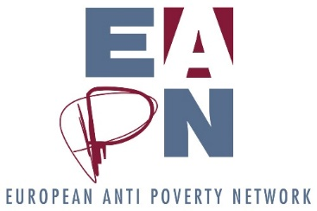

GA7c. Explanation of profit in 2020
Background
The 2020 accounts show a total profit of 118.411,68 Euro. This document aims to explain where the profit came from .

EASI Budget to EC 2020:
In balance (income = expense).
Result 0 Euro.

European Meeting of PeP:
Profit of 152,00 Euro: this money was left over from former years.

WORKYP (Working Yet Poor):
The project runs from 02/2020 until 01/2023. The advance we received will continue to be used in the following years, so no result yet.
Result 0 Euro.

Energy Poverty (= ASSIST) :
In balance (income = expense), and the project is finalized in 2020.
Result 0 Euro.

EMIN2:
The project ran from 2016 until 2019, and is finalized in 2020. Total amount of the project was 1.499.887,50 Euro for 2 years. Underspend of the total amount and result (profit) for this project: 116.292,20 Euro.
Profit of 116.292,20 Euro

ABSPO (Advisory Board on Poverty Indicators):
Profit of 1.575,00 Euro: more costs reimbursed from the EC than we needed to pay the expert.

Non eligible income/expenditure:
14.923,08 Euro of non-eligible expenses : 1.130 Euro creditline with Triodos, 2.209 Euro Platform fee 2020, 7.165 Euro audit 2016 EC (works to be depreciated), 2.166 Euro less received EC 2019 (outplacement expenses Fintan Farrell + expense budget line Triodos), 1680 Euro Energy Poverty (ASSIST) (correction interim report).
15.315,17 Euro of non-eligible income : 14.650,00 Euro (membership fees) + 665,57 Euro (EPSU donation and other non EC related small incomes).
Profit of 392,49 Euro.

