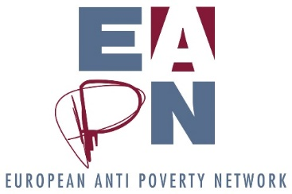

EC1. Agenda for the Ex Co Meeting

Date: 23 July 2021
Time: 14 00 – 17 30
Zoom link: https://us06web.zoom.us/j/82531824805
Registration link: https://forms.gle/51WzA5EMy378heK9A
Background documents: EC1. Agenda
Additional information documents: None

Chairs: Carlos

Objectives:
- To discuss the initial proposals to the FPA/SGA application, developed by the various groups in EAPN (EUISG, MDG, COMM’ON and National Pep Coordinators group)

SESSION 1. Welcome and Introduction (Carlos) (20 min)
14 00 – 14 20  (Chair: Carlos) | Introduction, aims of the session (Documents: EC1. Agenda)  - Welcome members  - Declaration of Conflicts of Interest  - Agreeing the agenda  - Round of introductions of members  (Documents: EC1. Agenda)
SESSION 2. Initial proposals to the FPA/SGA application – Policy and Participation (for discussion) (1h30mins)
14 20 – 15 50  (Chair: Carlos) | - Brief introduction on the FPA/SGA call application (10”)  - Presentation of proposals for Policy / Participation of PeP (20” + 10”)  - Group work to discuss the proposals for the two areas – (30”)  - Feedback from group work / discussion – (20“)
SHORT BREAK (10 mins)
SESSION 2. Initial proposals to the FPA/SGA application - Comms and Membership Development (for discussion) (70 min)
16 00 – 17 10  (Chair: Carlos) | - Presentation of proposals for Communications and Membership Development/Capacity Building – 15” + 10”)  - Group work to discuss the proposals for the two areas – (30”)  - Feedback from group work / discussion – (15“)
SESSION 3. AOB (20 mins)
Includes an oral evaluation round
CLOSE

